Flight
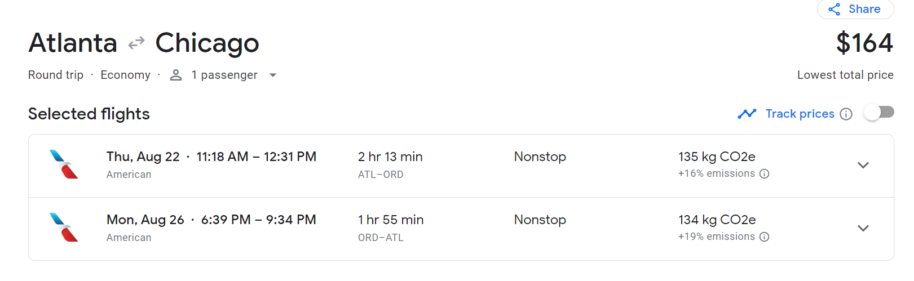

Travel to and from ATL
Groome – 102 dollars round trip
Hotel
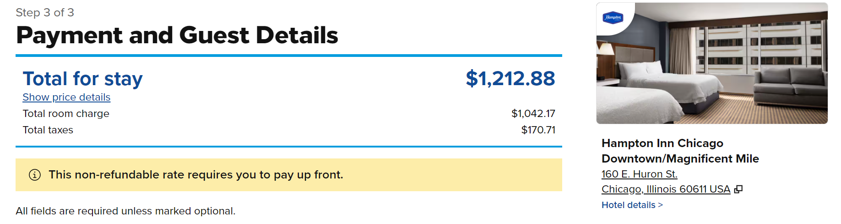

Registration – Free with presenting for students

