Travel Budget for American Society of Biomechanics Conference 2018

5.5 hour drive from Auburn University to Jacksonville, FL

Travel: $150 gasoline

Airbnb: $153 x 2 nights = $306/2 persons = $153.00 plus tax (5%) = approx. $160
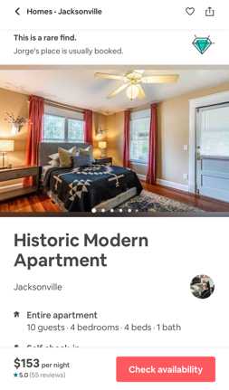

Conference Registration Fee: $55 (fees include add-ons: mentee breakfast and student lunch)

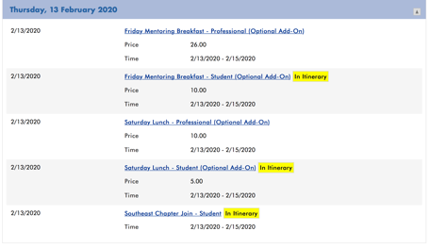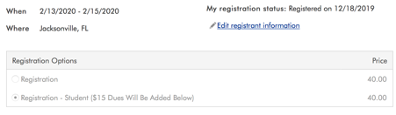

Projected Food Budget: $150.00

Breakfast = $15.00
Lunch = $15.00
Dinner = $20.00

Total $50.00 x 3 days = $150

