Budget for Conference Attendance at the Mid-South Educational Research Association (November 6–8, 2024, Chattanooga, TN)
Purpose: To present the paper titled "Enhancing STEM Education through Project-Based Learning: Insights from the iTEST Summer Academy."
1. Transportation
Driving from Auburn, AL to Chattanooga, TN
Estimated cost: $300
This includes fuel based on the distance from Auburn, AL to Chattanooga, TN. 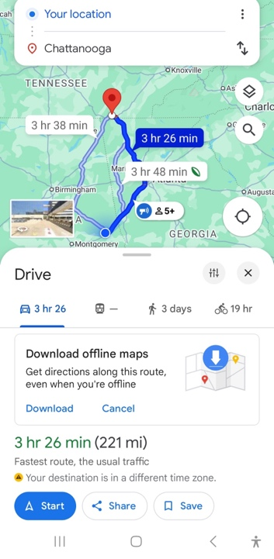
2. Lodging
Hotel: DoubleTree by Hilton Hotel Chattanooga Downtown [Conference-recommended hotel]
Dates: November 5–8, 2024 (3 nights)
Cost: $401
This rate is based on the official hotel recommendation from the conference organizers.
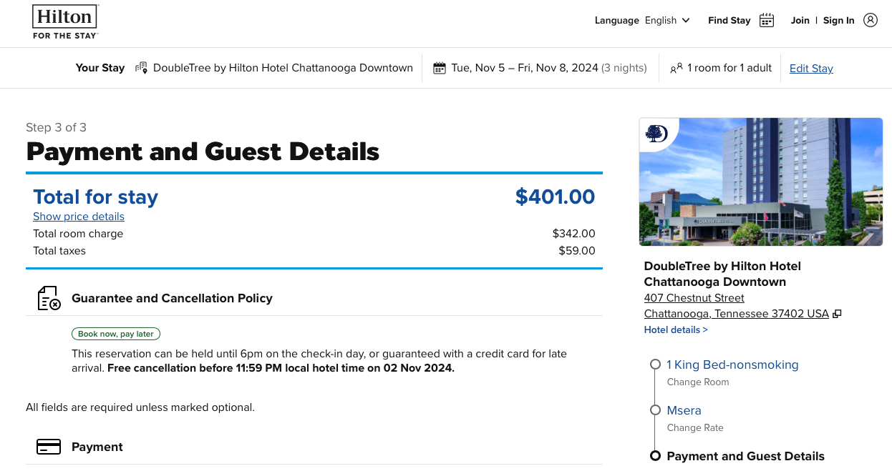
3. Meals
Per diem estimate: $60/day (based on GSA rates for Chattanooga, TN)
Total for 3 days: $240

4. Registration
Early registration fee: $75
Note: This applies if I receive funding by October 4, 2024. Otherwise, the standard student registration fee is $100.


