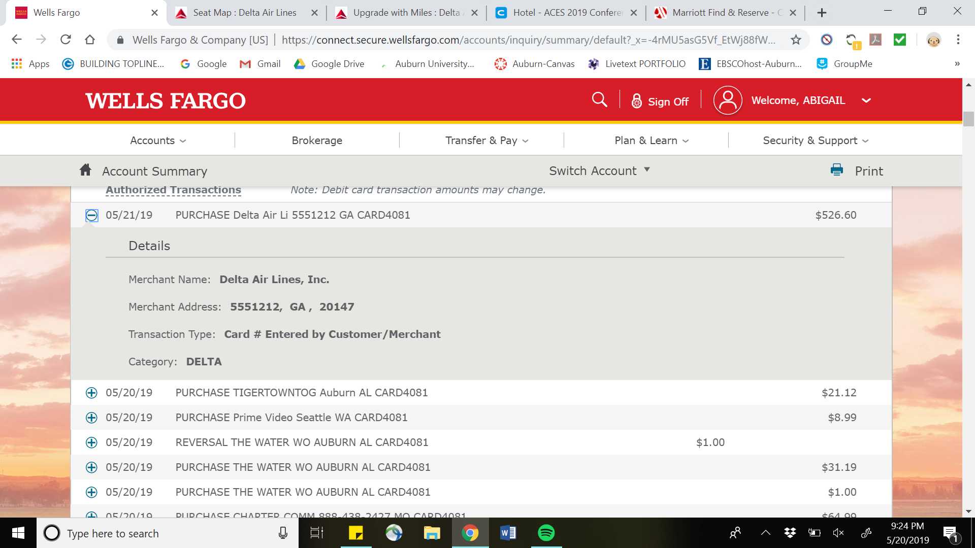

Flight $526.60 on wellsfargo