3/21/2019 Fwd: Experimental Biology 2019 - Notification of Abstract Acceptance

 Reply |  Delete Junk | 

Fwd: Experimental Biology 2019 - Notification of Abstract Acceptance

AA Adelola Adeyemo <ladeyemo@gmail.com>Today, 3:23 PM   Reply |

Adelola Adeyemo 

Inbox

---------- Forwarded message ---------

From: <EB2019Abstracts@mirasmart.com>

Date: Thu, Jan 31, 2019, 8:10 AM

Subject: Experimental Biology 2019 - Notification of Abstract Acceptance

To: <ladeyemo@gmail.com>

Cc: <ladeyemo@gmail.com>, <mdb0075@auburn.edu>

EXPERIMENTAL BIOLOGY 2019

Orange County Convention Center

Orlando, Florida, USA

April 6~~-~~9, 2019

NOTIFICATION OF ABSTRACT ACCEPTANCE

Dear Adelola Adeyemo,

Abstract Submission ID: 6950

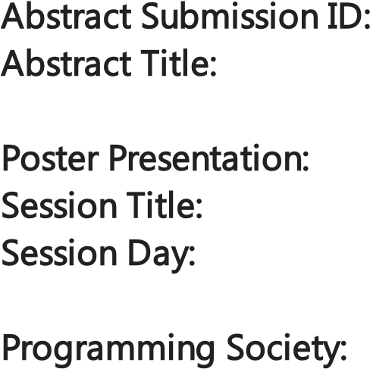Abstract Title~~:~~ C-Reactive Protein Levels and Blood Pressure Loads with Training

Poster Presentation:

Session Title~~:~~ Hypertension I

Session Day~~:~~ Monday, April 8, 2019

Programming Society~~:~~ The American Physiological Society

We are happy to inform you that your abstract, with the title shown above, has been accepted for poster presentation at Experimental Biology 2019. Final details including the session time, presentation time,

program number and poster board number (if applicable) will be sent to you in mid-February. Your abstract will be published in The FASEB Journal unless withdrawn by February 15, 2019. Fees apply for withdrawals.

Please note that individual requests for specific presentation dates and/or times cannot be addressed due to the very large number of presentations and other factors that the program committees must consider when scheduling the overall program.

https://outlook.office.com/owa/projection.aspx 1/2 3/21/2019 Fwd: Experimental Biology 2019 - Notification of Abstract Acceptance

If you have not already registered or made your hotel room arrangements, please do so now. The early Reply |  Delete Junk |  registration deadl~~i~~ne is Tuesday, February 5 ~~-~~ register early to rece~~i~~ve the best rate! Housing, transportation, registration and any additional expenses are your responsibility unless you have been otherwise notified. Links for these can be found on the [Experimental Biology 2019](http://www.experimentalbiology.org/) website.

Experimental Biology encourages you to start your visa application process as soon as possible to determine the requirements needed for your specific travel to the US. Requirements may include a faceto-face interview at an embassy or consulate, an Electronic System for Travel Authorization (ESTA) application, a machine-readable passport, an e-Passport with an integrated chip, and/or other regulations. Requirements vary per country.

For more information, please see the U.S. Department of State Web site, the ESTA website, the U.S. Customs and Border Protection, and the Experimental Biology website.

IMPORTANT DEADLINES

Late-breaking Abstract Submission: January 30, 2019

Early Registration: February 5, 2019

Abstract Withdrawal Deadline (Fees Apply): February 15, 2019

Registration Cancellation: March 4, 2019

Hotel Reservations: March 13, 2019 Advanced Registration: March 20, 2019

We look forward to seeing you in Orlando!

Best regards,

EB2019 Management Team

# Disclaimer

The information contained in this communication from the sender is confidential. It is intended solely for use by the recipient and others authorized to receive it. If you are not the recipient, you are hereby notified that any disclosure, copying, distribution or taking action in relation of the contents of this information is strictly prohibited and may be unlawful.

This email has been scanned for viruses and malware, and may have been automatically archived by **Mimecast Ltd**, an innovator in Software as a Service (SaaS) for business. Providing a **safer** and **more useful** place for your human generated data. Specializing in; Security, archiving and compliance. To find out more [Click Here.](http://www.mimecast.com/products/)