 Reply |  Delete Junk | 

Graduate Research and Travel Fellowship application

AS Auburn Graduate School <noreply@qualtrics-research.com>  Reply |

Today, 3:37 PM

Adelola Adeyemo 

Inbox

 Action Items 

. . . . . . . . . . . . . . . . . . . . . . . . . . . . . . . . . . . . . . . . . . . . . . . . . . . . . . . . . . . . . . . . . . . . . . . . . . . . . . . . . . . . . . . . . . . . . . . . . . . . . . . . . . . . . . . . . . . . . . . . . . . . . . . . . . . . . . . . . . . .

Adelola Adeyemo,

Thank you for submitting a Graduate Research and Travel Fellowship application. The Graduate School will contact you regarding your fellowship status as soon as a decision has been made -- generally within 2-3 weeks after the deadline (see the [Graduate Research and Travel Fellowship](https://proxy.qualtrics.com/proxy/?url=http%3A%2F%2Fwww.grad.auburn.edu%2Fforms%2Fbegin_travel_award.html&token=1qGx0iD%2BgTjYkyNEHefql2zOnkny2n2JGpTJ3ulRkkE%3D) website for the review periods and corresponding deadlines).

Below, you will see a summary of your responses on the application. If you need to modify your application, do not subm~~i~~t a second appl~~i~~cation. Simply email watsofd@auburn.edu and provide the Response ID listed below. A member of the Graduate School staff will then send you a link where you can modify your original application.

NOTE~~:~~ If for any reason your plans to attend this conference change, email dwatson@auburn.edu asap and request your application be withdrawn.

Sincerely,

The Graduate School

~~#~~D~~i~~str~~i~~buteSection, Rec~~i~~pientData~~#:~~

~~#~~D~~i~~str~~i~~buteSection, T~~i~~meF~~i~~n~~i~~shed~~#:~~ 2019-03-21 15:35:52 CDT

IP: 131.204.254.94

ResponseID~~:~~ R_3Hhl7bSJcBzAduW

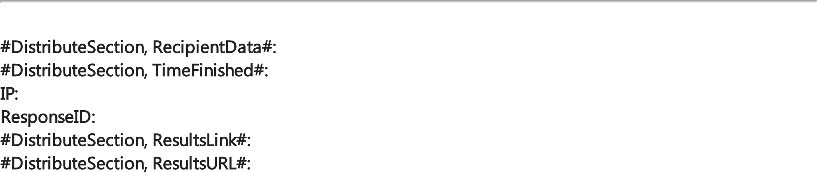~~#~~D~~i~~str~~i~~buteSection, ResultsL~~i~~nk~~#:~~ [#DistributeSection, DefaultLinkText#](https://proxy.qualtrics.com/proxy/?url=https%3A%2F%2Fauburn.qualtrics.com%2FCP%2FReport.php%3FSID%3DSV_eFm7YlXBDJtzzLf%26R%3DR_3Hhl7bSJcBzAduW&token=x%2BiEsixqWeDR2Bux%2BZttGfdCPTqPTAwCp%2FqtQTdnRhw%3D)  ~~#~~D~~i~~str~~i~~buteSection, ResultsURL~~#:~~ https://proxy.qualtrics.com/proxy/?

url=https%3A%2F%2Fauburn.qualtrics.com%2FCP%2FReport.php%3FSID%3DSV_eFm7YlXBDJtzzLf%26R% 3DR_3Hhl7bSJcBzAduW&token=x%2BiEsixqWeDR2Bux%2BZttGfdCPTqPTAwCp%2FqtQTdnRhw%3D

~~#~~

D

~~i~~

str

~~i~~

buteSection

,

ResponseSummary

~~#~~

~~:~~

First name and last name  Reply |  Delete Junk | 

Adelola Adeyemo

Student ID number 903964125

Auburn email address

aoa0005@auburn.edu

Phone number

678-431-9714

Department or schoole.g., Department of Economics, School of Nursing, etc.

Kinesiology

In which degree program are you currently enrolled? PhD

When is your anticipated graduation? Summer 2019

What is your cumulative GPA in your graduate program at Auburn? You can check this by going to AU...

4.0

Faculty advisor's name

Michael D. Brown

Faculty advisor's email address mdb0075@auburn.edu

Conference/meeting name Experimental Biology

For which travel period are you applying? In other words, please select the period during which y...

April-May 2019

Where will the conference/meeting be held? In the United States or Washington, D.C.

In which state will the conference/meeting be held? Florida

Please list the specific dates of the conference/meeting e.g., October 5-7, 2017; May 20-22, 2018...

April 6 - 6, 2019

Will you be giving a presentation?

Yes

What kind of presentation will you be giving?  Reply |  Delete Junk | 

Poster presentation

Are you presenting research related to your thesis or dissertation?

Yes

Travel budget

Transportation 297

Lodging 270

Meals 240

Registration 95 Other 0

Amount requested from the Graduate School?

$0

Are you receiving travel funding from other sources (e.g., your department, college, advisor, etc... No