|  |  |  |
| --- | --- | --- |
| APA Conference Budget 2018 | | |
| Transportation | 420.00 | Plane ticket |
| Lodging | 360.00 | 3 nights at a hotel |
| Food | 160.00 | $40 per day |
| Registration | 80.00 |  |
| Total | 1020.00 |  |

**Transportation**:

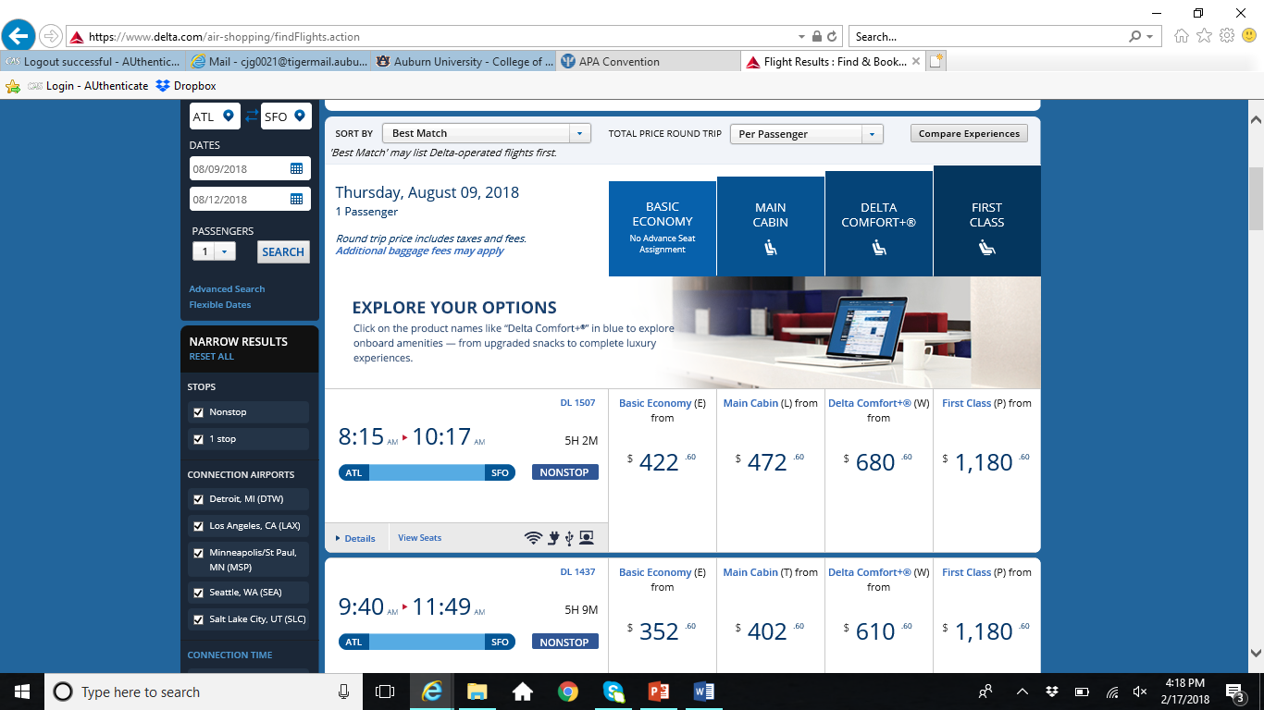

**Lodging**:

