Explanation for Travel application submitted

84 Redwine Overlook, Newnan, GA 30263 June 13, 2018

Ma’am/Sir,

Travel 505

Meals 136

Lodging 590

Conference 365 total 1596

My travel application has been submitted (6/13/18).

V/r

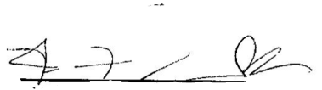

Fabian F. Cook