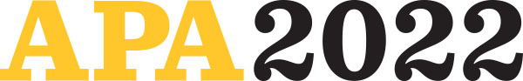

Dear Dr. Gabrielle Brown,
Thank you for participating in APA 2022! This year’s agenda features some of the most compelling psychology topics, scientific research, and thought leadership happening in the world. We’re honored to have you join us.
Please note that all individuals attending APA 2022 in Minneapolis must be fully vaccinated for COVID-19. Proof of COVID-19 vaccination will be required for entry into the Minneapolis Convention Center. See APA’s Health and Safety Protocols for more information.
Presenters must also register for APA 2022. Early bird registration ends on May 31. For details and to register, visit convention.apa.org.
Your session details are provided below — along with three steps you must complete.

STEP ONE
Request audiovisual equipment or room setup accommodation by June 15.
- Request an LCD projector with or without sound for sessions assigned to a hotel meeting room by sending an email with session details to the APA Convention Office.
- LCD projectors with sound will automatically be provided for Minneapolis Convention Center meeting rooms.
- Rental costs for additional AV equipment or hotel LCD projectors requested after June 15 must be covered by the requestor.
- If you require a ramp, lift to a stage, riser, or other accommodation for a physical disability, please send an email with session details to the APA Convention Office.

STEP TWO
Review each of your scheduled events listed below and notify the APA Convention Office via email of any corrections by May 20.
YOUR SCHEDULE
- Presentation Title: Stress Indicators in Minorities with Multiple Sclerosis (SIMMS)
- Date and Time: Sat, August 6, 11:00am-11:50am
- Location: Minneapolis Convention Center
- Session Type: Poster Session
- Session Title: Poster Session, Div 38
- Your Role: Participant/1stAuthor
- Sponsoring Division: Division 38--Society for Health Psychology

STEP THREE
Watch for emails in early June regarding managing your abstracts online.

For additional information and resources, please visit our online presenter hub.
Thank you once again for sharing your expertise at APA 2022. If you need additional information, please contact us at convention@apa.org. We can’t wait to see you in August!

Thank you,
Convention Office
American Psychological Association
202-336-6020

