EERA Conference

Heather Windham

2/19/20 – 2/23/20

Orlando, FL

Conference Registration: $115.00

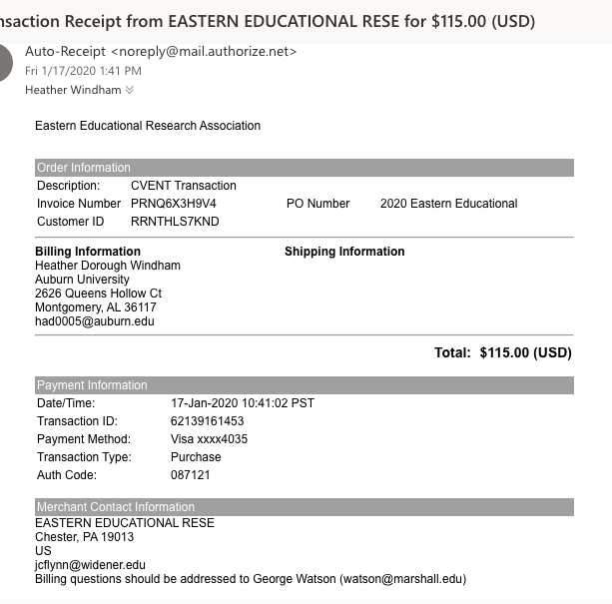

Hotel Information: 4 nights = $497.20 split 3 ways = $165.71 per person

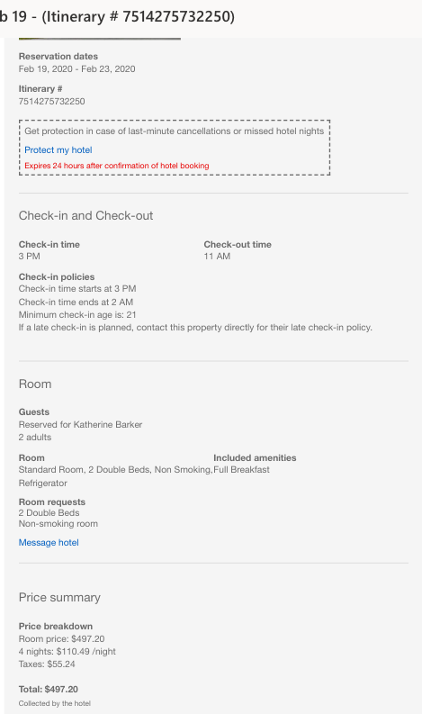

Mileage:

Hotel to Auburn University is 423 miles one way. 846 miles roundtrip x 0.575 = $486.45

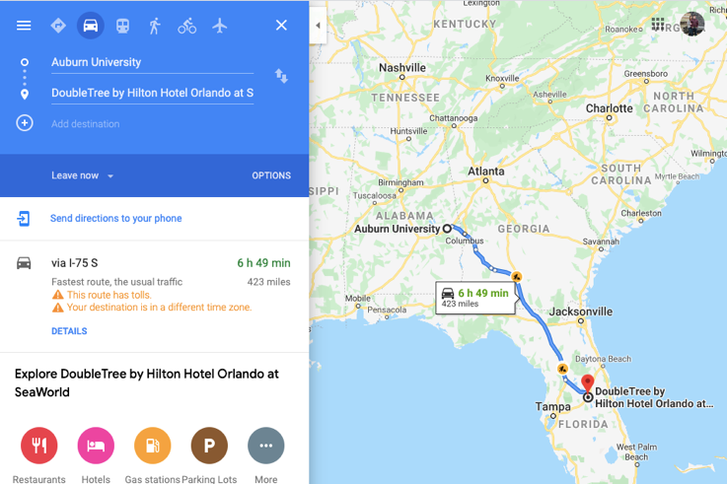

Meals: $60 per day for five days = $300.00