**From:** SACES Conference Staff <[sacesconference2018@gmail.com](mailto:sacesconference2018@gmail.com)>   
**Sent:** Monday, April 16, 2018 2:01 PM  
**To:** Hillary Ellerman <[hpe0002@tigermail.auburn.edu](mailto:hpe0002@tigermail.auburn.edu)>  
**Subject:** 2018 SACES Conference Proposal Notification

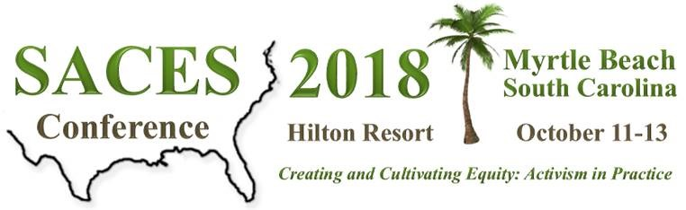

CONGRATULATIONS Hillary Ellerman,  
   
Your proposal, **Examining mental health and academic concerns of student parents in counselor education programs** (Session ID # 542), has been accepted as a **50-minute Roundtable Session** at the 2018 SACES conference in Myrtle Beach, South Carolina!

The conference committee received an unprecedented number of proposals, and all proposals were blind-reviewed by two individuals prior to disposition by the conference committee.  We are pleased to have your session represented at this conference.  
   
Please read on for important notes regarding your session:

* SACES will initiate communication only with primary presenters as listed in the program proposal submission.  Please notify any co-presenters regarding this acceptance.
* You will receive notification of the date and time for your presentation by May 15, 2018.  When you receive scheduling notification, you will have the opportunity to review title, abstract, and presenter information as will be printed in the conference program.  You may make necessary changes at that time.
* All presenters are responsible for registering for the conference by July 15, 2018.  We will notify you when conference registration is open.

We look forward to seeing you in Myrtle Beach!

This email is a service from Southern Association for Counselor Education and Supervision.