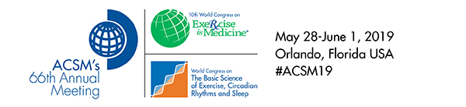

Top of Form

February 7, 2019  
  
                                                   Poster Presentation Notification  
  
**Please read all details carefully.**  
  
We are pleased to inform you that your abstract entitled “**A Comparison of Techniques for Estimating and Detecting Changes in Skeletal Muscle Cross-Sectional Area**” has been accepted for presentation in a**Free Communication/Poster** session at the 2019 Annual Meeting, World Congress on Exercise is Medicine®, and World Congress on the Basic Science of Exercise, Circadian Rhythms and Sleep of the American College of Sports Medicine being held at the Orange County Convention Center and Rosen Centre Hotel in Orlando, Florida, May 28-June 1, 2019.  Your abstract will be published in Medicine and Science in Sports and Exercise, Volume 51:5 Supplement.  Your presentation date and time are as follows:  
  
Author Block:                         Johnathon H. Moore1, Cody T. Haun2, Emily L. Grandprey3, Katelyn P. Joubert3, Christopher G. Vann1, Paul A. Roberson1, Petey W. Mumford1, Matthew A. Romero1, Shelby C. Osburn1, C Brooks Mobely1, Jordan R. Moon4, Michael D. Roberts5, Kaelin C. Young5. *1Auburn University, Auburn, AL. 2LaGrange College, LaGrange, GA. 3Edward Via College of Osteopathic Medicine-Auburn Campus, Auburn, AL. 4ImpediMed, Inc., Carlsbad, CA. 5Auburn University, Edward Via College of Osteopathic Medicine-Auburn Campus, Auburn, AL.*              
Session Title:                          Methodology  
Session Number:                    G-36  
Session Viewing Date/Time:  Saturday Jun 1, 2019 7:30 AM - 11:00 AM  
Presentation Time:                  8:00am - 9:30am

Bottom of Form