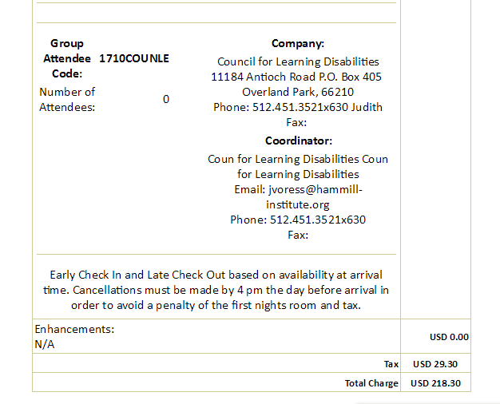I am requesting half of the hotel because I will be sharing with another doctoral student.