NSCA Budget

Transportation: Driving
363 miles from Auburn to Hyatt Regency
Gas is $3.60 (about) / gallon
My car gets 23 miles to the gallon and holds 16 gallons
It will cost around $58 per tank
Each tank will get me about 380 miles
Fill up my gas 2x for the whole trip: about $120 total

Lodging: Hyatt Regency
$175 a night + taxes & parking; 3 night stay
$619 total not including parking
Parking is $25 / 24 hours
$619 + $100 parking = $719 total

Meals: No meals provided
$10 day breakfast; $15 day lunch; $20 day dinner
4 days lunch and dinner; 3 days breakfast
$30 + $60 + $80 = $170

Registration:
Student registration + membership
$255

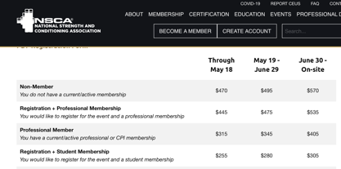
Conference Registration

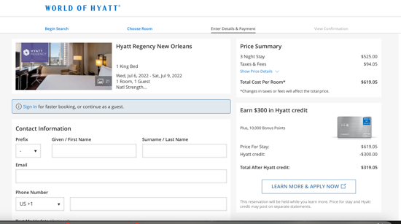
Hyatt Hotel Pricing

