ALCA 2023 Conference Itemized Budget
Madeline LaPolla

Food:
$26 per day (x3) = $78

Transportation:

-Gas
Miles (x 2; driving to and from) = 145.8mi miles ($0.625 x mi) = $91.13
I will be taking I-85S and I-65N as I live right by the highway
*See screenshot below for milage confirmation*

-Parking
$28 per day (will be parked there for 4 days (arrive Tuesday night, present Wednesday) = $112
*See screenshot below for parking prices confirmation*

Registration: $50
Student, early registration with discount
*See attachment of invoice for registration*

Total: $331.13

Screenshot of Miles: (Via I-85 & 1-65)

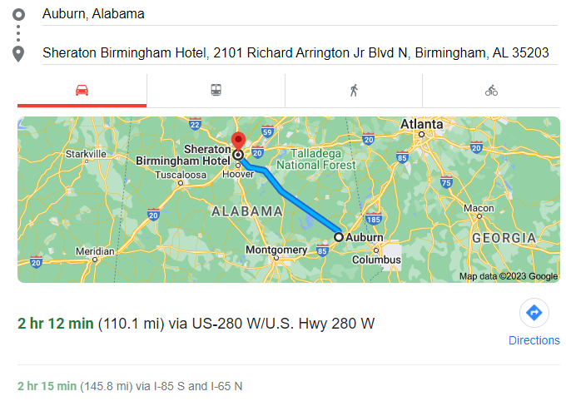

Parking prices screenshot for the Sheraton:
