Meals

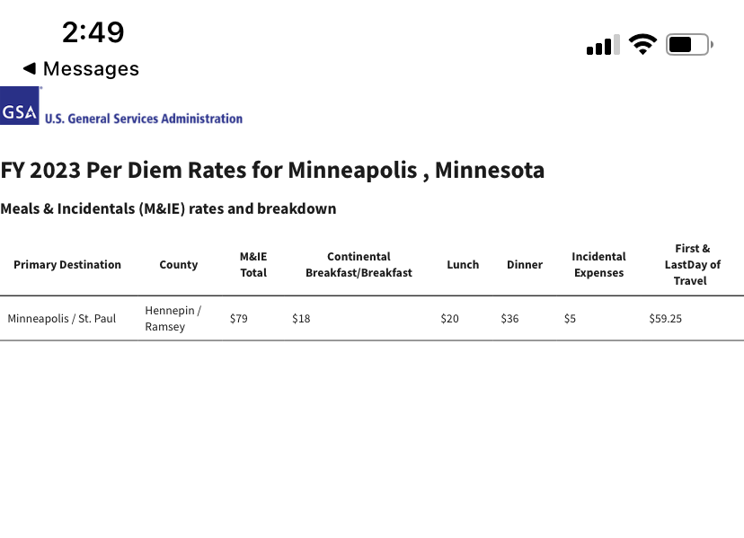

First Day of Travel (11/14): $59.25
Day 2 (11/15): $79
Day 3 (11/16): $79
Day 4 (11/17): $79
Day 5 (11/18): $79
Last Day of Travel (11/19): $59.25
Total: $434.50

