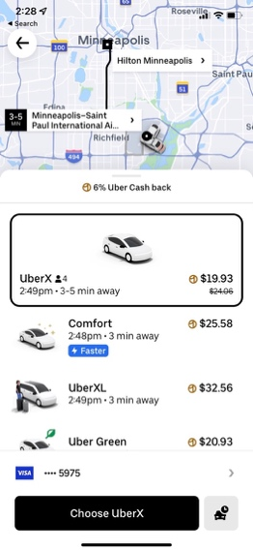
Transportation

Uber Estimate from Airport to Conference Hotel - $19-$33
Round Trip Estimate: $38-$66
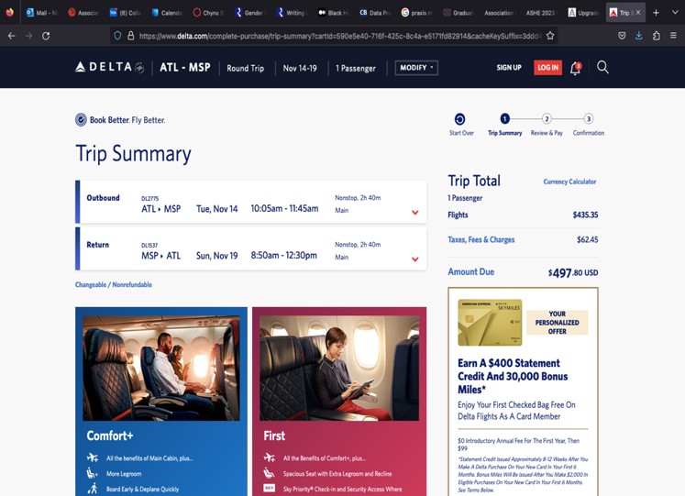

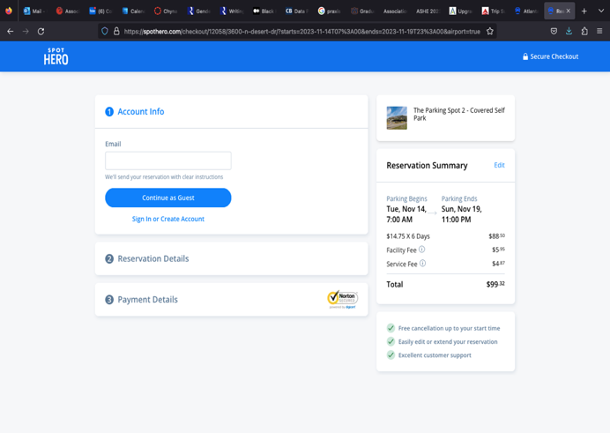
Airfare: $497.80 (round-trip)

Parking – $14.75/day * 6 days = $99.32

Average Price Per Gallon: $3.47
Round Trip from Auburn to ATL Airport: 200 miles
Personal Car MPG: 26
3.8 gallons/100 miles * 2 (for 200 miles) 7.6/gallon for round trip * 200 miles for round trip = $30.40
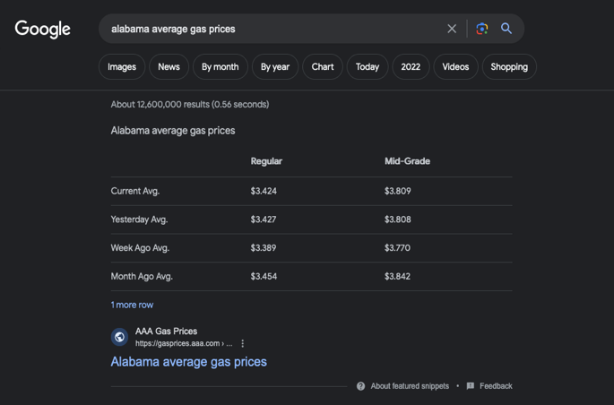

Transportation Total:
- Airfare: $497.80
- Airport Parking: $99.32
- Gas: $30.40
- Minneapolis Transportation: $66
- Exact Total: $693.54
- Budgeted for Transportation (after rounding): $700

