Registration

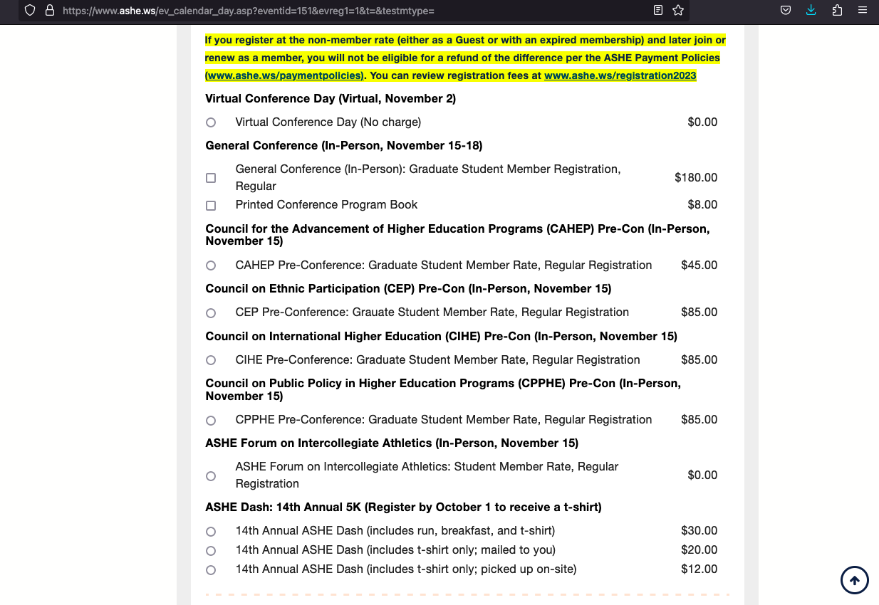
General Conference - $180.00
Council on Ethnic Participation (CEP) Pre-Con - $85.00
Total: $265.00

