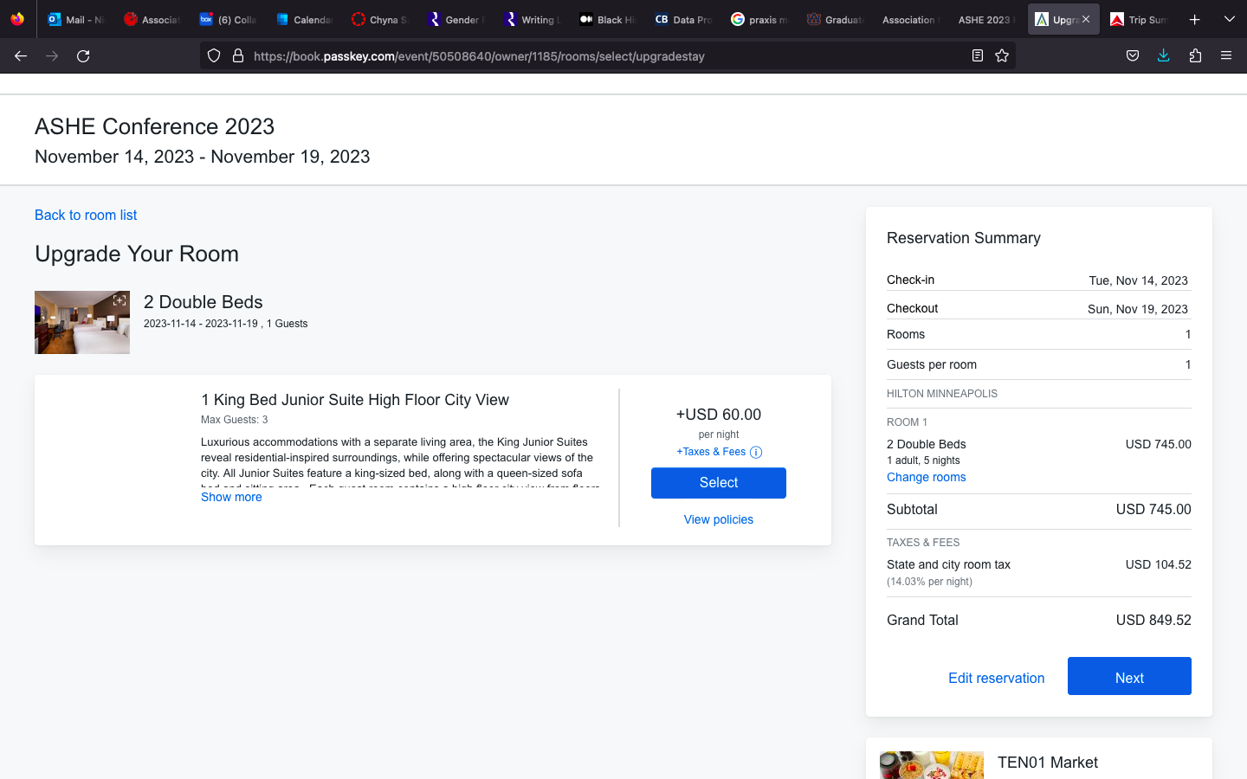
Lodging

Total: $849.53 (includes ASHE group rate)

