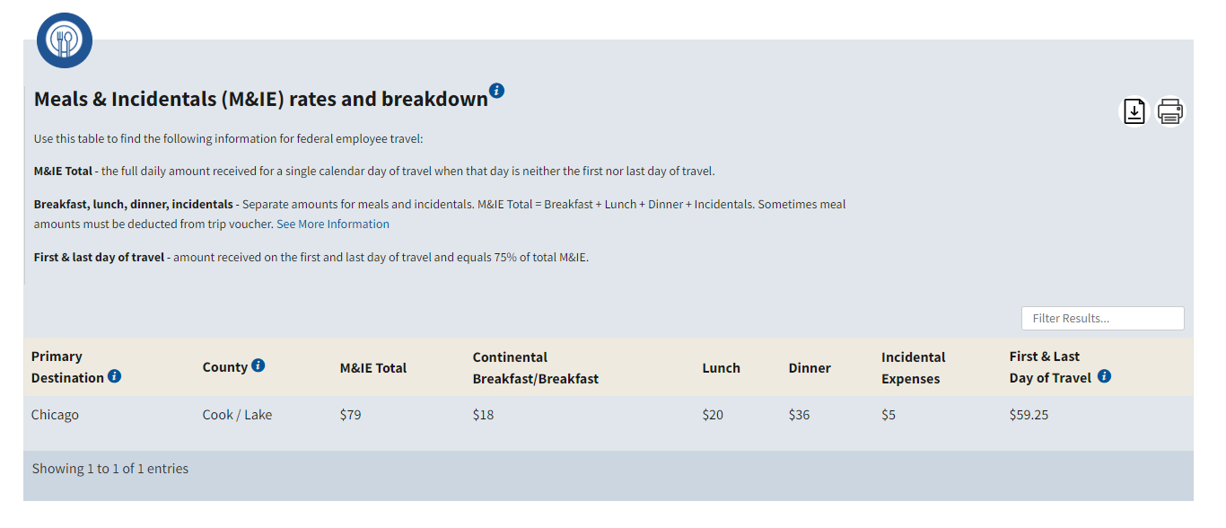**Meals**

First Day of Travel (03/17): $59.25

Day 2 (03/18): $79

Day 3 (03/19): $79

Day 4 (03/20): $79

Last Day of Travel (03/21): $59.25

**Total: $355.50**