**Lodging**

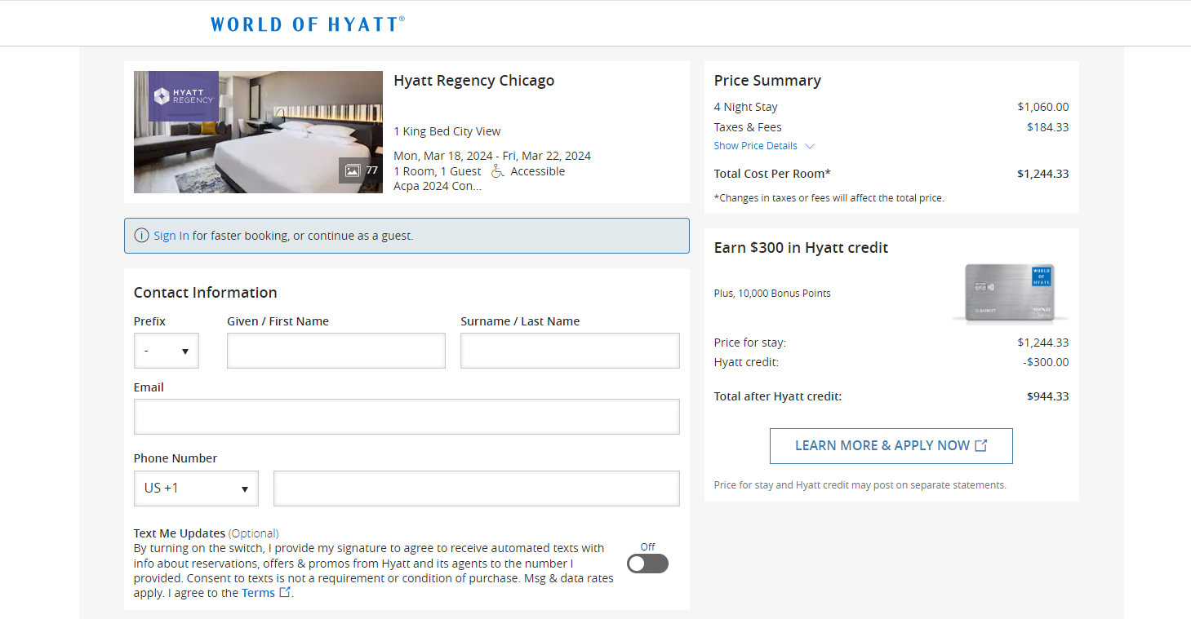

**Total: $944.33 (includes ACPA group rate)**