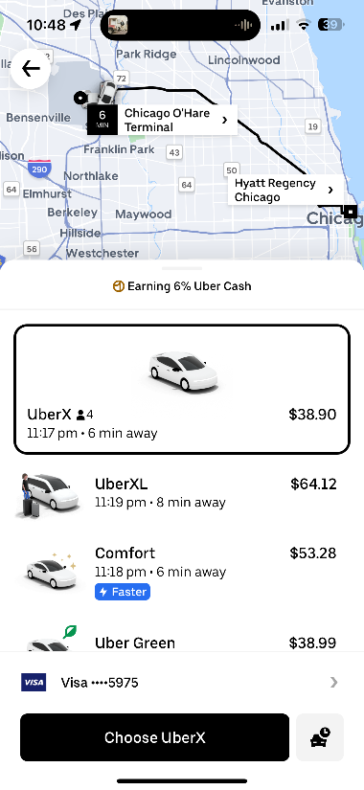**Transportation**

Uber Estimate from Airport to Convention Hotel - $38-$53

**Round Trip Estimate: $76-$106**

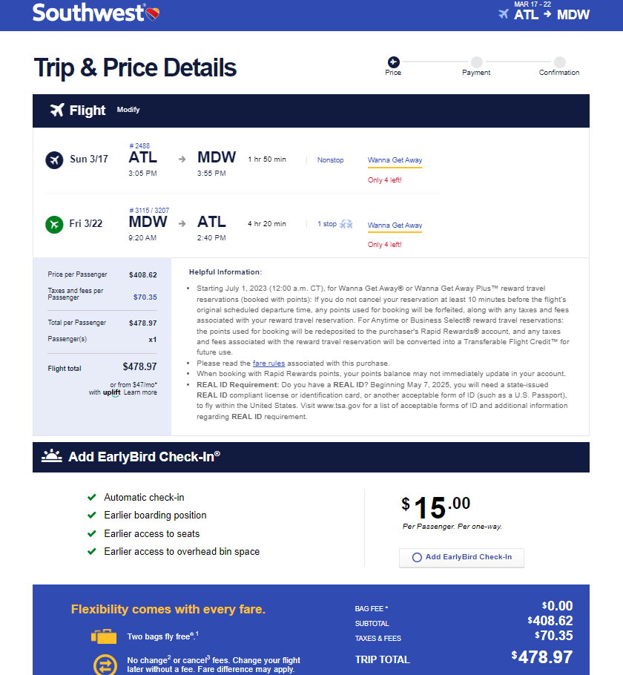

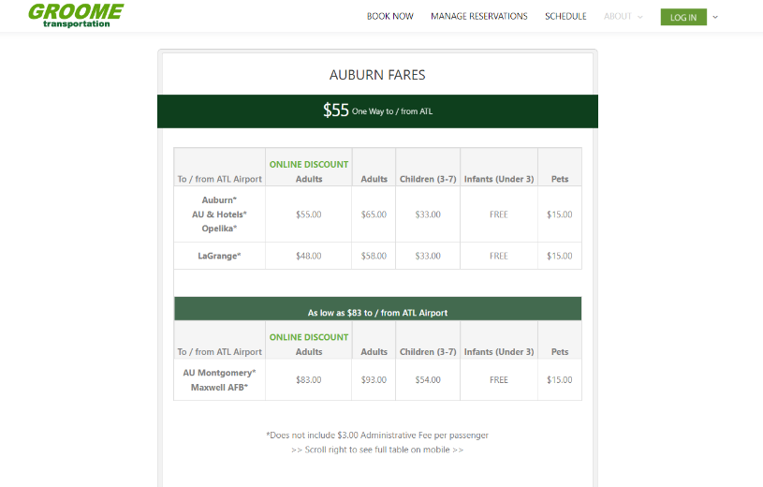

**Airfare: $478.97 (round-trip)**

**Groome – $58 (one-way) x 2 (round trip) = $116**

**Transportation Total:**

* Airfare: $478.97
* Groome: $116.00
* Chicago Transportation: $106
* **Exact Total: $700.97**