Registration

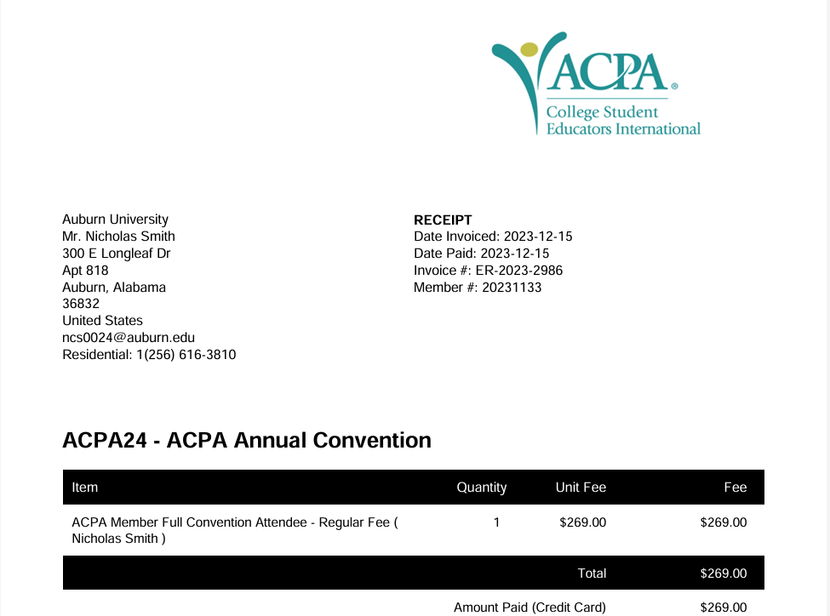
General Conference - $269.00
Total: $269.00

