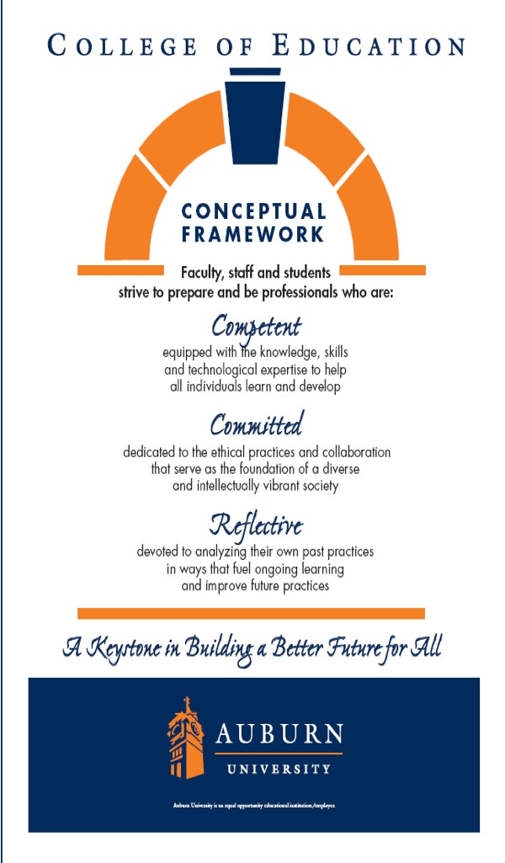ADED 7056

Methods of Teaching in Adult Education
Fall 2017

Department of EFLT
College of Education

Dr. Xi Lin
E-mail: xilin@auburn.edu

Office hours: By appointment

Course Room: Virtual on Canvas


Methods of Teaching in Adult Education
ADED 7056
Auburn University
Department of Educational Foundations, Leadership, and Technology College of Education
Fall 2017

Class Time: Online
Location: Virtual
Professor: Dr. Xi Lin
Office – Haley Center 2320 Email: xilin@auburn.edu
Office Hours: Scheduled by Appointment

1. | Course Number: | ADED 7056
 | Course Title: | Methods of Teaching in Adult Education
 | Credit Hours: | 3 semester hours
 | Pre/Corequisites: | None

Recommended Texts: Older versions of these texts will work sufficiently (match the chapter titles) and some of this information is available free online through various sources.

  - Galbraith, M.W. (Ed.) (2004). Adult Learning Methods: A Guide for Effective Instruction (3rd Ed.). Robert E. Krieger Publishing

  - Ko, S., & Rossen, S. (2017). Teaching online: A practical guide (4 ed.). Routledge.

Other Required Readings will be posted online or made available through eReserves and the Library.

Course Description:
Methods and techniques of instruction using appropriate instructional materials; planning and evaluation of instruction for adult education programs.

Course Objectives:

Upon completion of this course, students will be able to:

  - evaluate principles of teaching and learning.
  - evaluate effective teaching behaviors.
  - prepare and give a demonstration on how to perform a skill to a group of learners.
  - create an environment conducive to learning.
  - describe the relationship between the learning process and the problem-solving approach to teaching.
  - develop performance objectives for units of instruction.
  - describe how learning styles affects individuals’ teaching styles.

  - select and incorporate teaching strategies into your teaching style that will reach a culturally diverse group of learners.
  - determine the appropriate method to evaluate the learners.
  - develop an instructional strategy that utilizes the most effective teaching technique for the topic.
  - use a variety of instructional strategies in learning.
  - organize, allocate, and manage resources of time, space, and activities.
  - analyze and synthesize teaching techniques used in instructional settings.

Course Philosophy:

There are approximately 10 compressed sessions with a variety of topics related to workplace education and development. There will be online lectures and group activities and discussions. You are expected to read the assigned readings, participate and contribute to lecture presentations, collaborate in discussions, and submit assignments. A variety of media provided by the LMS (Canvas) are used for communication among class members and the instructor, along with additional resources.

This is a professional online education course in adult education. All participants are considered adults and are expected to not only study but also practice andragogy by taking responsibility for their learning. Thus, the participant is expected to participate regularly, contribute to the class setting by participating in online discussions and activities, and to be collaborative and supportive of all members of the learning setting. Adult education is not a place for passive learning but a place to explore, take risks and grow.

Additional course materials are made available through the university’s learning management system (LMS). Interactivity is possible through the LMS, which allows for online discussions, email, web conferencing and chats with the instructor, along with testing and submission of assignments. A student taking the online version of the course will need a reliable computer and will need to decide if online learning is a good option for them (for an assessment of the proper skills. If you have questions on this, please ask me the first week of class.

Please see Academic Calendar for Important Dates http://www.auburn.edu/main/auweb_calendar.html

Tentative - Course Content/Schedule: Online Weekly Sessions run from Mondays to Sundays.

Session Date Topic Activities

1 8/xx Overview and Introduction
Review Syllabus and Assignments; Introductions and Icebreakers

2
8/xx
Qualities of Effective Adult
Educators
Choose Topics and
Presentation Dates
3 8/xx Adult Learners and Teaching Styles
TBA

4 | 9/xx | Philosophy and Ethics | TBA
5 | 9/xx | Learning Styles | TBA
6 | 9/xx | Motivation | TBA
7 | 9/xx | Active Learning and Learning Contracts | TBA
8 | 10/xx | Evaluation of Learning | TBA
9 | 10/xx | Online Teaching | TBA
10 | 10/xx | Instructional Design | TBA
11 | 10/xx | ePortfolio | TBA
12 | 11/xx | Teaching Diverse populations | TBA
13 |  | Research Week | TBA
14 | 11/xx | Blended Learning | TBA
15 | Thanksgiving/Holiday Break | Enjoy the break & have FUN!

17 12/xx Final Exam/Projects Week – No Classes Scheduled
16
11/xx
Last Week of Classes – Wrap Up
and Summary – Last Week for Assignments. No Assignments accepted after December 4th.

- Course Requirements/Evaluation (General Information – more details provided in the Assignments area in Canvas):

Philosophy of Teaching (Individual – 10 points)
The assignment is intended to initiate your thinking about your own philosophy of teaching. You may already have one, it may be changing, or this may be the first time you have thought about it. Based on your readings, discussion, and course work this semester write a brief statement presenting/discussing your philosophy. Use Chapter 3 in the Gailbrath text to help, along with resources in Canvas Assignments. You will also participate in a discussion related to this philosophy.

ePortfolio (Individual with Peer Review – 20 points)
For this assignment, you can initiate the design of a professional portfolio or design a portfolio learning process you would use with your own students. In general, a portfolio should include (a) an introduction and focus, (b) a central theme, (c) a clearly organized method for navigation, (c) personal information such as vita/resume and bio of the developer. Please post a hyperlink to the

ePortfolio in the discussion forum. In addition, there will be a peer review requirement for this assignment.

The ADED ePortfolio provides you with the opportunity to consider some of the critical incidents, experiences and artifacts in your life and learning experiences and helps to apply that knowledge to practice.

Presentation of an Instructional Session (Team Assignment if possible – 30 points)
Each group will lead one instructional session in which the team will demonstrate how to facilitate learning using a method or technique of their choice (lecture, illustrated talk, demonstration, discussion, questioning techniques, collaborative learning, etc.) to the members of the class. This will be assigned starting week 3. This assignment will be evaluated on how well you implement the method and engage the learners. As this is an online class, please make sure to adapt the session to both the F2F (face-to-face) and online/blended format. This assignment will be recorded.

* **NOTE: The presentation (PowerPoint/Handouts/Agenda/Supporting Materials) is due to the instructor a minimum of one week prior to scheduled class delivery for these Presentations. See Late Assignments for more information.

Students will be provided a variety of options in terms of recording their presentations
for the online class. This information will be discussed posted in the course. The
resources to complete these presentations are available through the University’s LMS.

Research Paper – Instructional Method (team assignment if possible – 20 points)
Each team will develop a five to ten-page report on their chosen Instructional Method Session. Analyze and summarize the learning outcomes achieved through use of the technique, learning tasks students are engaged in, characteristics and skills of learners that are necessary for effective use of the technique, conditions necessary for effective use of the technique, teacher skills needed to expertly use the technique, and preplanning needed to use the technique expertly. Describe or illustrates how the strategy could be used to increase the retention of information and skills (long-term memory) among adult learners. This report should reveal techniques that should enhance the learners’ retention of information and skills. Provide supporting information on how the instructor or facilitator would incorporate the strategy into the teaching/learning process.

Evaluation Instrument/Rubric (10 points)
Create an evaluation instrument to assess the Instructional Methods Presentation. More information to follow.

F. Participation/Online Activities/Discussion Forum (10 points)

Participate in all class discussions and online activities. You will need to respond to a majority of weekly questions and discussions. Overall, discussions will be graded based upon the quantity and quality of the discussions posted as determined by the instructor. More information to follow in Canvas.

Evaluation of Assignments:

Assignment | Points
Presentation | 30
Evaluation Instrument/Rubric | 10
Research Paper | 20
Teaching Philosophy | 10
ePortfolio | 20
Participation (online discussions and activities) | 10
Total Points | 100

The following grading scale will be used:

90% - 100% / 90-100 points = A
80% - 89% / 80-89 points = B
70% - 79% / 70-79 points = C
60% - 69% / 60-69 points = D
Below 60% / Below 60 points = F

Class Policy Statements:

  - Absences/Inactivity in Class - You are expected to participate regularly in the weekly course discussions and readings, including an ad hoc exercises and requirements as scheduled. Login access is regularly monitored. It is your responsibility to contact me if assignment deadlines are not met and responsible for initiating arrangements for missed work. Attendance and participation in the online discussions will affect your grade as this is graduate learning course. Your participation is part of the course design and is directly correlated to academic success. THIS IS NOT A SELF-PACED COURSE and requires participation weekly. If you cannot participate regularly, please consider another course.

Students are granted excused absences from class for the following reasons: Illness of the student or serious illness of a member of the student’s immediate family, the death of a member of the student’s immediate family, trips for student organizations sponsored by an academic unit, trips for University classes, trips for participation in intercollegiate athletic events, subpoena for a court appearance, and religious holidays.
Students who wish to have an excused absence from this class for any other reason
must contact the instructor in advance of the absence to request permission. If
feasible, the student must notify the instructor prior to the occurrence of any excused absences, but in no case shall such notification occur more than one week after the absence.

Appropriate documentation for all excused absences is required. Please see the Student Policy eHandbook for more information on excused absences.

Late/Make-up Assignments:

Students may turn in assignments up to a week after the due date and not be penalized except for the Presentations. After the one-week grace period, students will lose 10% points for each week the assignment is late. Some assignments may not be accepted late (online presentations, etc.). A student who has an excused absence or illness will have the opportunity to earn credit for any missed assignments that are submitted late. Assignments turned in late due to a documented excused absence will be graded as initially assigned.

Late assignments due to unexcused absence may not be accepted or will lose 10 percent/per day the assignment is late. In some cases, there will be a make-up assignment required in addition to the regular assignment.

Again, appropriate documentation for all excused absences is required. Please see the Student Policy eHandbook for more information on excused absences.

C. Team Assignments

Team assignments receive grades based on group and individual work. It is possible that unsatisfactory participation in team assignments will result in a lower participation

grade or a lower grade on the team assignment itself. You may be called upon to evaluate your own or your team members' performance on group assignments.

- Accommodations: Students who need accommodations are asked to electronically submit their approved accommodations through AU Access and to arrange a meeting during office hours the first week of classes, or as soon as possible if accommodations are needed immediately. If you have a conflict with my office hours, an alternate time can be arranged. To set up this meeting, please contact me by e-mail. If you have not established accommodations through the Office of Accessibility, but need accommodations, make an appointment with the Office of Accessibility, 1228 Haley Center, 844-2096 (V/TT). Please visit their web site at: http://accessibility.auburn.edu/

- The Student Policy eHandbook rules and regulations pertaining to Academic Honesty will apply to this class. All coursework should be properly cited using APA format. Coursework from other classes cannot be used unless FIRST discussed with the professor and substantially revised or updated for the class.

- Professional Classroom Behavior: As faculty, staff, and students interact in professional settings, they are expected to demonstrate professional behaviors as defined in the College’s conceptual framework. These professional commitments or dispositions are listed below:

  - Engage in responsible and ethical professional practices
  - Contribute to collaborative learning communities
  - Demonstrate a commitment to diversity
  - Model and nurture intellectual vitality

These behaviors are especially important in terms of our graduate classroom and online discussions.

Justification for Graduate Credit:

Participants in this class must have an advanced knowledge level of the clientele for workforce education as provided in the required prerequisites. Participants will be required to demonstrate their ability to evaluate the completeness and appropriateness of a workplace basic skills education program based upon application and synthesis of principles associated with this course.

