ctec 3020

Primary Math and Science

Auburn University Syllabus, Fall 2020
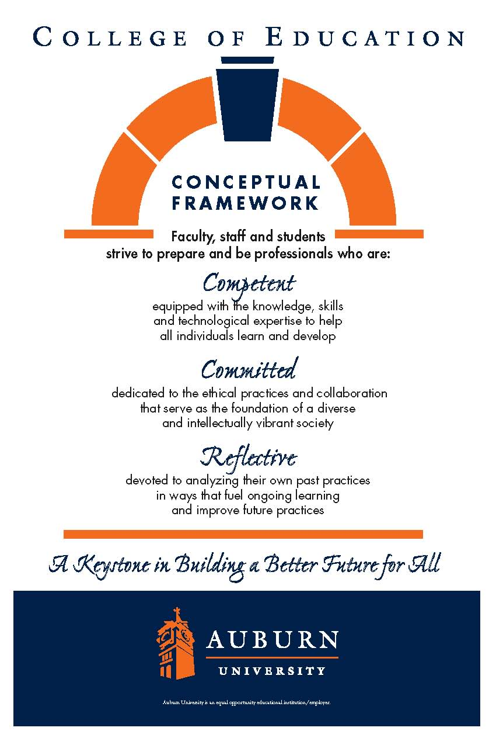
Credit Hours: 3 semester hours
Prerequisites: Admission to Early Childhood Teacher Education, Completion of CTEC 3030/4911 and CTEC 3200/4200
Co-requisites: CTEC 4912
Instructor: Dr. Angela Love, Ms. Nicole Mitchell, Ms. Kathleen Sacco, Ms. Sarah Crim, Ms. Ashton Leddon, & Ms. Madison Strichik
Office: 5018 Haley Center
E-mail: azl0009@auburn.edu
Office Hours: by appointment (see Canvas for appointment times to sign up)

Required Texts:
Chaille, C. M., & Davis, S. M. (2015). Integrating math and science in early childhood classrooms through big ideas: A constructivist approach. New York, NY: Pearson.

Parrish, S. (2010). Number talks: Whole number computation, grades K-5. Sausalito, CA: Math Solutions.

Van de Walle, J. A., Lovin, L. A. H., Karp, K. S., & Bay-Williams, J. M. (2018). Teaching student centered mathematics: Developmentally-appropriate instruction for grades pre-k – 2. New York, NY: Pearson.

You are required to have a composition notebook for your combined math journal and science notebook.

Required reading includes articles posted to Canvas. All readings will be announced on Canvas and provided whenever possible (in Files).

Recommended Texts:
TBA

*Important Websites:
*You will be expected to use these websites as resources for assignments and teaching, both in-class and for practicum.

*NAEYC Code of Ethics
https://www.naeyc.org/about-us/people/naeyc-gb/apply-for-board-service/code-of-ethics

*Claire Warden Mind-stretchers Academy: Bringing Learning Alive
https://mindstretchers.academy/
https://mindstretchers.academy/pages/reflective-practice-and-research

Investigations in Number, Data, & Space
- curriculum & the CCSS: https://investigations.terc.edu/CCSS/
- online games/activities. K-1: http://investigations.terc.edu/library/Games_K1.cfm
- online games/activities, 2-3: http://investigations.terc.edu/library/Games_23.cfm
- games/activities to do offline: http://investigations.terc.edu/families/doing_math/books_and_resources/
- Investigations support resources (number talks, blackline masters, CCSS, math links, etc): https://sites.google.com/site/get2mathk5/home/investigations-support
- Illuminations: http://illuminations.nctm.org
- Blackines: https://sites.google.com/site/get2mathk5/home/templates-graphic-organizers
Professional Development - inside mathematics (problem of the month by grade level, video: http://insidemathematics.org
Math Dictionary for Kids: http://www.amathsdictionaryforkids.com/dictionary.html
Next Generation Science Standards
- A Framework for K-12 Science Education: https://www.nap.edu/download.php?record_id=13165#
Children & Nature Network: http://www.childrenandnature.org
Engineering Toys for Girls
- GoldieBlox (Debbie Sterling, founder) website: http://www.goldieblox.com/pages/about
- GoldieBlox YouTube Channel: https://www.youtube.com/channel/UCJUn6QmXuFV9CkuJB9T7F_w
Academic Language
- New Teacher Center Oral Language Development: http://old.newteachercenter.org

Other Useful Websites
National Association for the Education of Young Children: http://www.naeyc.org
National Council of Teachers of Mathematics (NCTM): http://www.nctm.org
National Science Teachers Association (NSTA): http://www.nsta.org
National Council of Teachers of English (NCTE): http://www.ncte.org
Alabama Math, Science, and Technology Initiative: http://www.amsti.org
Alabama State Department of Education: http://www.alsde.org
American Montessori Society: http://www.amshq.org
North American Montessori Teachers Association: http://www.montessori-namta.org

COURSE DESCRIPTION
This course is to provide pre-service teachers opportunities to be more knowledgeable and practical in early childhood (Pre-K, K-3rd grade) curriculum and instruction in the areas of mathematics and science. Pre-service teachers will have a better understanding of children’s learning and development, curriculum development, and instructional methods. Based on their understanding of early learning standards as well as aforementioned areas, pre-service teachers will apply their knowledge to designing, implementing, and evaluating the interdisciplinary curriculum. In addition, through hands-on activities and teaching demonstrations, they will also develop effective teaching strategies working with young children that can be used in their future classrooms.

COURSE objectives
Upon completion of the course, students will be able to:
- Identify important mathematics /science content, process skills, and attitudes appropriate to young children. (NAEYC Standard 1b, 4a, 4b, 4c, & 4d)
- Become acquainted with the principles and elements of curriculum development (e.g., goal setting, planning, implementing, and assessing curriculum) in mathematics and science. (NAEYC Standard 1a, 1b, 1c, 4b, 4c & 4d)
- Develop an understanding that early childhood curriculum is an integrated curriculum, and that children’s learning in mathematics and science takes place in integrated learning experiences with concrete materials in a variety of contexts. (NAEYC Standard 4c)
- Design, implement, and evaluate developmentally appropriate curricular content, strategies, and instructional materials, and reflect on their performance. (NAEYC Standards 1a, 1b, 1c, 4b, 4c, & 4d)
- Understand how to record, report, and evaluate development level of young children through naturalistic/performance-based assessment and utilize developmentally appropriate assessment and reporting techniques. (NAEYC Standards 3a, 3b, & 3c)

Auburn College of EDUCATION-CONCEPTUAL FRAMEWORK
Competent
Competent professionals demonstrate the knowledge and skills needed to facilitate the learning of the individuals they serve. Their competence enables them to model and promote active, collaborative, and ongoing learning. Their efforts are enhanced by their abilities to foster learning communities that are safe, stimulating, and enriched with diversity; engage in reasoned and purposeful decision making; and implement their professional practices in proactive, flexible, and self-regulating ways.

We recognize that the development of professional competence is linked to levels of preparation and experience. We also acknowledge that competence continues to develop over the course of an entire career.

Committed
Committed professionals make reasoned decisions based on thoughtfully constructed values. As a College, we strive to nurture values that support the learning of all people, honor diversity, protect the integrity of learning, and expand the scholarship of our professions. We view these values as professional dispositions, and we define them as filters for responsible decision-making. Our College emphasizes the conscious development of commitments related to professional responsibilities and ethics, collaboration, diversity, and intellectual vitality.

Reflective
We choose to frame reflection as a critical and pervasive habit of mind that permeates and fuels the ongoing expansion of competence and the continued development of reasoned commitments. Reflective professionals subject their own competencies and commitments to continuous scrutiny as they systematically monitor the impact of their professional practices on the individuals they serve and make adjustments as needed. Thoughtful reflection emphasizes reviewing and analyzing past practices in ways that influence and improve future practices. This stance inspires self-initiated professional growth and results in increased capacities for addressing the complexities and dilemmas situated within the work of educational and human services professionals.

COURSE REQUIREMENTS
- Math Journal & Science Journal (50 Points):
- In class reflections (some you may have you will have to finish at home)
- Daily notes (on campus and in classroom)
- Your process for investigating how you plan your Integrated Science Unit
- Big Idea Chapter Presentations (group) (50 Points):
- Each person, with one or two others, will present and lead discussion of a chapter from Integrated Math and Science, including an activity and evaluation of student learning. Include meaningful discussion questions, additional resources, and suggested activities to be done, upon which each person will reflect and discuss online. Further instructions will be made available on Canvas.
- Weekly 1-hour synthesis of content meetings (group) (100 Points):
- Each week, a different person will be responsible for submitting their group’s discussion topics and notes
- Topics and readings will be assigned through Canvas
- Integrated Science Unit (100 Points):
- Further instructions will be provided for this practice edTPA assignment. Briefly, your integrated unit will be determined by the children’s interests in your classroom, and build on a nature-based science topic, integration of math, children’s literature, writing, and investigation. For example, this may be a project investigating an insect or butterflies found in the school yard, culminating with a book-making project that the children make using the photos and descriptions they take of the insects, its habitat, feeding habits, etc., including observations they do of the insect or tree or ant hill, etc. You will justify your decision based on your observations of the children’s interests and the Next Generation Science Standards, and the Alabama College and Career Ready State Standards for Math and Language Arts.
- 3 linked lessons integrating science, math, and literacy (including writing, but also will include at least one of the following — poetry, literature, research, music lyrics, all constructed by students)
- Video record and reflect on one of the three linked lessons (50/100 pts.)— required reflections will contain commentary on planning, implementing, and reflecting on student learning; upload video to GoReact link on Canvas.
- Number Talks (60 Points):
- Lesson plan design,
- Trial run with class peers,
- Implement in classroom or Zoom with students (video recorded and uploaded to ),
- Implementation and video reflection paper.
- Participation in class, via Zoom, in small groups, in section groups, and any other assigned meetings (40 points).
- Be sure you have read the policies related to COVID-19 regarding attendance and participation.
- You must enter Zoom (if you are participating remotely) ON TIME and keep you video on for the entire class/meeting as scheduled.
- You must mute unless you are adding to the discussion, and be ready to respond if called on.
- Offer insight from readings and video recordings required for outside reading and viewing.
- Be the emerging professional you are the semester before your internship.

GRADES
A = 91-100% (400- 360 points), B = 81-90% (359- 320 points), C=71-80% (319- 280 points), D=61-70% (279- 240 points), F=60% or below (239-0 points).

Class Policy Statements

Participation: Students are expected to participate in all class discussions and participate in all exercises. It is the student’s responsibility to contact the instructor if assignment deadlines are not met. Students are responsible for initiating arrangements for missed work. (See further information below related to COVID-19.)

Attendance/Absences: Attendance is required at each class meeting. If an exam is missed, a make-up exam will be given only for University-approved excuses as outlined in the Student Policy eHandbook. Arrangement to take the make-up exam must be made in advance. Students who miss an exam because of illness need a doctor’s statement for verification of sickness and should clear the absence with the instructor the day they return to class. Other unavoidable absences from campus must be documented and cleared with the instructor in advance. Each unexcused absence will result in 5 points deducted from the class participation grade. Tardy arrivals will result in 2 point deducted from the class participation grade. If points from absences and tardy arrivals exceed the 20 points allotted for class participation, the points will be taken from the final total. Three unexcused absences may result in a teacher candidate being dropped from the program.

Accommodations: Students who need accommodations are asked to electronically submit their approved accommodations through AU Access and to arrange a meeting during office hours the first week of classes, or as soon as possible if accommodations are needed immediately. If you have a conflict with my office hours, an alternate time can be arranged. To set up this meeting, please contact me by e-mail. If you have not established accommodations through the Office of Accessibility, but need accommodations, make an appointment with the Office of Accessibility, 1228 Haley Center, 844-2096 (V/TT). See https://fp.auburn.edu/disability/faculty/syllabus.asp

Honesty Code: The University Academic Honesty Code and the Student Policy eHandbook Rules and Regulations pertaining to Cheating and Plagiarism will apply to this class. See https://sites.auburn.edu/admin/universitypolicies/Policies/AcademicHonestyCode.pdf

Professionalism: As faculty, staff, and students interact in professional settings, we are expected to demonstrate professional behaviors as defined in the College’s conceptual framework. From NAEYC, early childhood professional commitments or dispositions are:
1. Creates a caring and supportive learning environment and encourages self-directed learning by ecah student..
2. Demonstrates behaviors that are consistent with the ideals of fairness and the belief that all students can learn.
3. Demonstrates, models, and exemplifies a commitment to diversity.
4. Engages in responsible and ethical professional practices (shows trustworthiness, nurtures professional relationships, maintains confidentiality regarding students and school matters).
5. Demonstrates professionalism by being prepared, dressing professionally, communicating appropriately, and fulfilling attendance expectations.
6. Shows respect for and cooperates with students, families, colleagues, and members of the community.
7. Shows initiative and self-direction in classroom activities (e.g., organization and management of classroom, planning and implementation of instruction).
8. Follows policy regarding use of digital tools and models digital citizenship and responsibility (e.g., the appropriate use of social media).
9. Contributes to collaborative learning community, models and nurtures intellectual vitality, and demonstrates interest and enthusiasm for the profession.
10. Accepts/acts on constructive criticism and suggestions in a professional way.
11. Monitors and adjusts own professional dispositions as necessary.
12. Reflects on and analyzes past practices to stimulate ongoing improvement for future practice.

Competent Professionals (See COE website: http://www.education.auburn.edu/about-the-college/conceptual-framework/conceptual-framework-background/proficiencies/
- Understand the central concepts, tools of inquiry, and structures of the content they teach or practice.
- Create learning experiences that make the content they teach or practice meaningful for individuals.
- Understand how individuals differ in their approaches to learning and create instruction or implement other professional practices adapted to this diversity.
- Use knowledge of how individuals learn and develop to provide educational opportunities that support intellectual, social, and personal development.
- Understand and use a variety of evidence-based professional practices in reasoned and flexible ways to encourage individual development of critical thinking, problem solving, and performance skills.
- Use an understanding of individual and group motivation and behavior to create a learning environment that encourages positive social interaction, active engagement in learning, and self-motivation.
- Use knowledge of effective verbal and non-verbal communication to foster active inquiry, collaboration, and supportive interaction in learning environments.
- Plan professional practices based upon knowledge of subject matter, individuals, the community, and identified goals.
- Understand and use formal and informal assessment strategies to evaluate and ensure continuous progress toward identified goals.
- Use technology in appropriate ways.
Committed Professionals
- Engage in responsible and ethical professional practices.
- Contribute to collaborative learning communities.
- Demonstrate a commitment to diversity.
- Model and nurture intellectual vitality.
Reflective Professionals
- Analyze past practices to stimulate ongoing improvement of future practices.

*Mobile Device Policy: Smartphone use or text messaging or unapproved iPad/Tablet or laptop usage during the class session is viewed as extremely unprofessional and will result in an automatic loss of 5 points of Class Participation and Professional Behavior grade points (under COURSE REQUIREMENTS) for the first occurrence; additional points will be deducted for repeated occurrences. It is best that phones, iPads, and laptops not be visible during the class session to avoid any misunderstanding of their use.

APPENDIX—PLEASE READ—YOU ARE RESPONSIBLE FOR THIS INFORMATION

Due to the Coronavirus pandemic, public health measures have been implemented across Auburn’s campus. Students should stay current with these practices and expectations through the campus reentry plan, A Healthier U: https://ahealthieru.auburn.edu/. The sections below provide expectations and conduct related to COVID-19 issues. The following statements are items that faculty can consider including in your syllabi.

Health and Participation in Class
You are expected to complete your Healthcheck screener daily.
Your health and safety, and the health and safety of your peers, are my top priorities. If you are experiencing any symptoms of COVID-19, or if you discover that you have been in close contact with others who have symptoms or who have tested positive, you must follow the instructions on the Healthcheck app. My hope is that if you are feeling ill or if you have been exposed to someone with the virus, you will stay home to protect others.

Please do the following in the event of an illness or COVID-related absence:
● Notify me in advance of your absence, if possible
● Provide me with medical documentation, if possible
● Keep up with coursework as much as possible
● Participate in class activities and submit assignments remotely as much as possible
● Notify me if you require a modification to the deadline of an assignment or exam
● Finally, if remaining in a class and fulfilling the necessary requirements becomes impossible due to illness or other COVID-related issues, please let me know as soon as possible so we can discuss your options.

Questions about COVID-related illnesses, you should reach out to the COVID Resource Center at (334) 844-6000 or at covidresourcecenter@auburn.edu.

Health and Well-Being Resources
These are difficult times, and academic and personal stress is a natural result. Everyone is encouraged to take care of themselves and their peers. If you need additional support, there are several resources on campus to assist you:
● COVID Resource Center (covidresourcecenter@auburn.edu)
● Student Counseling and Psychological Services (http://wp.auburn.edu/scs/)
● AU Medical Clinic (https://cws.auburn.edu/aumc/
● If you or someone you know are experiencing food, housing or financial insecurity, please visit the Auburn Cares Office (http://aucares.auburn.edu/)

A Healthier U Campus Community Expectations
We are all responsible for protecting ourselves and our community. Please read about student expectations for fall semester, including completing the daily GuideSafe™ Healthcheck (https://ahealthieru.auburn.edu/).
You are expected to (1) take your temperature daily and (2) complete your Healthcheck screener to receive your A Healthier U pass. You may be asked at any time during class to show your pass.

Course Expectations Related to COVID-19:
● Face Coverings: As a member of the Auburn University academic community you are required to follow all university guidelines for personal safety with face coverings, physical distancing, and sanitation. Face coverings are required in this class and in all campus buildings. Note that face coverings must meet safety specifications, be worn correctly, and be socially appropriate.

You are required to wear your face coverings at all times. If you remove your face covering or are non-compliant with the university’s policy on face coverings: https://ocm.auburn.edu/news/coronavirus/updates/20200618-face-masks-required.php?ref=coronavirus, you will be instructed to leave the classroom and will be held to the protocols outlined in the Auburn University Policy on Classroom Behavior: https://sites.auburn.edu/admin/universitypolicies/Policies/PolicyonClassroomBehavior.pdf. Any student who willfully refuses to wear a face covering and does not have a noted accommodation may be subject to disciplinary action.
● Physical Distancing: Students should observe appropriate physical distancing and follow all classroom signage/avoid congregating around doorways before or after class. If the instructional space has designated entrance and exit doors, you should use them. Students should exit the instructional space immediately after the end of instruction to help ensure social distancing and allow for the persons attending the next scheduled class session to enter.

● Course Attendance: If you are quarantined or otherwise need to miss class because you have been advised that you may have been exposed to COVID-19, you will be expected to develop a plan to keep up with your coursework during any such absences.

● Course Meeting Schedule: This course might not have a traditional meeting schedule in Fall 2020. Be sure to pay attention to any updates to the course schedule as the information in this syllabus may have changed. Please discuss any questions you have with me.
● Technology Requirements: This course may require particular technologies to complete coursework. If you need access to additional technological support, please contact the AU Bookstore at aubookstore@auburn.edu.

Disruptive or concerning classroom behavior involving the failure to wear a face covering, as directed by Auburn University, represents a potential Code of Student Conduct violation and may be reported as a non-academic violation. Please consult the Classroom Behavior Policy https://sites.auburn.edu/admin/universitypolicies/Policies/PolicyonClassroomBehavior.pdf.
Course Delivery Changes Related to COVID-19
Please be aware that the situation regarding COVID-19 is frequently changing, and the delivery mode of this course may adjust accordingly. In the event that the delivery method is altered, please be assured that the learning goals and outcomes of the course will not change; however, some aspects of the course will change in terms of the mode of delivery, participation, and testing methods. Those details will be shared via Canvas as soon as possible. Please be prepared for this contingency by ensuring that you have access to a computer and reliable Internet.

