Fall 2022 RSED 4140D Assessment in Special Education: Applications Part II Auburn University Department of Rehabilitation, Special Education, and Counseling

- Course Number: RSED 4140D Fall 2022

Course Title: Assessment in Special Education: Applications Part II Meeting Time/Place: ZOOM Synchronous Weekly Class Meetings
Wednesday 5:00 to 7:30pm

Office hours: ZOOM Class Office Hours or individual ZOOM meetings by appointment; Office Hours TBA
Credit: 3 semester hours
Instructor: Dr. Suzanne Woods-Groves, Ph.D. Instructor’s email: woodssu@auburn.edu
Instructor’s phone: 334-844-7621
Office location: Haley Center 1232C

- Date Syllabus Prepared: August 2022

REQUIRED TEXTBOOKS AVAILABLE VIA ALL ACCESS REDSHELF electronically:

Or order hard copies from another vendor

See the CANVAS HOME PAGE and the last pages of this syllabus for All Access information concerning costs and also how to OPT OUT if you are not interested in the All Access option.

Hosp, M. K., Hosp, J. L., & Howell, K. W. (2016). The ABCs of CBM: A practical guide to curriculum- based measurement, 2nd Edition. The Guilford Press. ISBN :9781462524662 ISBN-10: 1462524664.
Golden, C. (2017). The data collection toolkit everything you need to organize, manage, and monitor classroom data. Baltimore, Paul H. Brookes Publishing Co.
ISBN Identifiers: LCCN 2017020801 (print) | LCCN 2017042519 (ebook) | ISBN 9781681252537 (pdf) | ISBN 9781681252520 (epub) | ISBN 9781598579246
(paperback)

OTHER ASSIGNED READINGS
Additional readings will be announced and will be accessed via CANVAS

REQUIRED TECHNOLOGY:
All students in this course are expected to have all the equipment and software needed to be successful in the course. You will need to attend weekly synchronous ZOOM class meetings. In addition you will need a computer with a webcam and audio and video/audio recording capability to record your assessment administrations completed in our ZOOM class meetings. You will also need to access weekly recorded lectures, assignments, quizzes, and materials posted via CANVAS and PANOPTO. You will need to complete and submit your exams and assignments via CANVAS. Ensure you have a working computer and reliable internet connection. Be sure you have installed and have access to all of the software required to participate in the course and complete your assignments (Canvas, PDF reader, Panopto). Be sure you have access to a working printer. You will need to print assessment materials for assignments.

ZOOM MEETINGS AND BREAKOUT ROOM REQUIREMENTS

Review the ZOOM etiquette information below
http://academicsupport.auburn.edu/wp-content/uploads/2020/04/Zoom-Etiquette.pdf

- In addition, in our ZOOM meetings and breakout rooms when your camera is on you should use the virtual background “blur” feature offered in ZOOM which will blur your background environment. No other virtual background should be used.

COURSE DESCRIPTION:
- This course is designed as an online synchronous format with weekly ZOOM class meetings and assignments.
- Students are required to attend class weekly via ZOOM. Students are to view assigned lectures and assignment videos online via CANVAS and complete required assignments by the delineated due dates.
- Students will complete assessments in ZOOM class meetings and will work with peers in breakout rooms to administer, record, score, and upload their weekly assessments.
- The course will include weekly assigned readings, assignments, lectures, activities, and quizzes.
- The course is not self-paced and you will need to ensure you keep up with the pace of the course and to complete weekly assignments.
- This course is organized by modules to help with the organization of the information and assignments as we move through the course.

This course provides students with a framework for understanding the purposes and processes that underlie various forms of educational assessments, with emphasis on application assessment of students with disabilities. The course provides opportunities for application of concepts in assessment in special education as well as administration, review of curriculum based assessment data. The course covers how to use assessment data to inform instructional planning and IEP goal development.

COURSE OBJECTIVES: Upon completion of this course students will:
  - Describe, analyze, and demonstrate progress monitoring strategies and interpret data.
  - Use informal assessment procedures and interpret results.
  - Explain different purposes for informal assessment of students with disabilities
  - Demonstrate knowledge and sensitivity for conducting assessment methods.
  - Develop collaborative and consultation skills
  - Demonstrate an understanding of the fundamental concepts of assessment(e.g., terminology, reasons for testing, use of testing data)
  - Describe and discuss the legal and ethical considerations in assessment.
  - Review informal assessment methods and instruments directly related to the IEP of a school-aged student with a disability
  - Administer and interpret assessment procedures for a variety of curricular areas.
  - Develop standards-based IEP goals.
  - The Candidate understands formal and informal assessment strategies and selects appropriate assessments (4.1, CEC Standards)
    - Demonstrates understanding of the different kinds of assessment; can distinguish between different types of assessments; can match type of assessment with purpose. Determined by overall exam performance.
    - Selects appropriate assessments based on intended use of assessment, technical characteristics including validity, reliability, norms, and bias, and student characteristics, including cultural and linguistic characteristics. Determined by overall exam, application activity, and case study interpretation performance.
  - The Candidate accurately administers and interprets assessments (4.2 CEC Standards)
    - Accurately administers and scores four formal assessments to
school- age student following guidelines provided in administration manual.
Determined by CBM Administration, scoring, and interpretation project of four CBMs
    - Interprets assessment results accurately; identifies instructional implications, areas of instructional need, supports, and accommodations and/or modifications supported by data. Determined by application activities, case study interpretation, and IEP development.

  - The Candidate demonstrates professionalism throughout the assessment and decision- making process (4.3 CEC Standards)
    - Administers assessments in a professional manner using guidelines within the manual. Determined by CBM observation and fidelity of implementation project performance.
    - Demonstrates appropriate written communication; results communicated in a way that are culturally sensitive. Determined by Mock IEP demonstration.

- COURSE CONTENT SCHEDULE This syllabus is a tentative outline for the course and is subject to change with advance notice from the instructor.
Dates | Topic | Readings | Assignments & Due Dates
08/17  Wed  Week 1  MODULE 1 | Module 1: Overview CBM  - Describe use & purpose of CBMs  - Describe technical adequacy of CBMs  - Compare & Contrast General Outcome Skills- Based & Mastery Measures.  - Demonstrate writing instructional objectives | Hosp, Hosp, & Howell Textbook Chapters 1- 2  DIBELS 8th Edition Manual via CANVAS Module 1  Hosp & Ardoin (2008) article access via CANVAS Module 1  Ethics Guidelines via CANVAS Module 1 | DUE Tuesday 08/23 by 11:59pm via CANVAS  - Overview CBM Quiz 1  - Overview CBM Application Activity 1  - Participation Points Watch 100% of all Lecture videos in MODULE
08/24  Wed  Week 2  MODULE 2 | Module 2: Early Reading CBM  - Describe types of Early Reading CBMs  - Demonstrate administration & scoring procedures in class  - Demonstrate interpreting data & writing instructional objectives | Hosp, Hosp, & Howell Textbook Chapter 3  EBP for teaching PA  Onsets & Rimes  DIBELS 8 Assessment Materials  Read LNF and Phonemic Segmenting Fluency | DUE Tuesday by 08/30 11:59pm via CANVAS  - Quiz 2  - Application Activity 2  - Participation Points  watch 100% of all Lecture videos in MODULE
08/31  Wed  Week 3  MODULE 3 | Module 3: Early Reading CBM cont.  Data Collection  - Describe types of Early Reading CBMs  - Demonstrate administration & scoring procedures in class  - Demonstrate interpreting data & writing instructional objectives  - Administering LNF | - Textbook (Golden) Data Collection Tool Kit  Chapters 1-4  - Review Chapter 3 Hosp Early Reading CBM  Review LNF and Phonemic Segmenting Fluency DIBELS Administration Manual | DUE Tuesday 09/06 by 11:59pm via CANVAS  CANVAS  - Quiz 3  - Early CBM Application Activity 3  - LNF by yourself Exercise  Participation Points Watch 100% of all Lecture videos in MODULE

Dates | Topic | Readings | Assignments & Due Dates
09/07  Wed  Week 4  MODULE 4  EXAM 1  No Class Meeting | Module 4: Exam 1  No Class ZOOM Meeting  EXAM 1  Opens on 09/07 Complete online via CANVAS | - Exam 1 covers Modules 1- through 3 and all material addressed | Complete EXAM 1 via CANVAS  DUE Tuesday 09/13 by 11:59pm
09/14  Wed  Week 5  MODULE 5 | Module 5:  Administering Early Reading CBM  PSF  Demonstrate administration & scoring procedures for PSF | - Review LNF and Phonemic Segmenting Fluency DIBELS Administration Manual | DUE Tuesday 09/20 by 11:59pm  - Quiz 4  - PSF by yourself Exercise  Participation Points  Watch 100% of all Lecture videos in MODULE
09/21  Wed  Week 6  MODULE 6 | Module 6:  Administering Early Reading CBM  Demonstrate administration & scoring procedures for PSF & NWF | - Review Phonemic Segmenting Fluency DIBELS Administration Manual  - Read Nonsense Word Fluency DIBLES Administration Manual | DUE Monday 09/27 by 11:59pm via CANVAS  - Quiz 5  - NSF by yourself Exercise  Participation Points  WATCH 100% of videos in MODULE

Dates | Topic |  | Readings | Assignments & Due Dates
09/28  Wed  Week 7 MODULE 7 | Module 7: Reading CBM  - Demonstrate Reading CBMs’ their scoring & administration in class  - Demonstrate interpreting data & writing instructional objectives |  | Hosp, Hosp, & Howell  Textbook Chapter 4  Review Nonsense Word Fluency  DIBELS Manual  Read Word Reading Fluency DIBELS Manual | DUE Tuesday 10/04 11:59pm  via CANVAS  - Quiz 6  - Application Activity 4  - WRF by yourself exercise  - Participation Points  Watch 100% of all Lecture Videos in MODULE
10/05  Wed  Week 8  MODULE 8 |  | Module 8: Graphing CBM  - Describe the purpose of graphing CBM  - Demonstrate graphing skills Interpret graphed data & make instructional decisions | Hosp, Hosp, & Howell Textbook Chapters 10  - Review Word Reading Fluency DIBLES Administration Manual  - Read Oral Reading Fluency  DIBLES Administration  Manual | DUE Tuesday 10/11 by 11:59pm  - Quiz 7  - Graphing Application Activity 5  - ORF by yourself exercise  - Participation Points  Watch 100% of all Lecture videos in MODULE
10/12  Wed  Week 9  MODULE 9  EXAM 2  No Class Meeting |  | Module 9:  EXAM 2  Opens on Wed 10/19  No Class Meeting | Exam 2 covers Modules 5 through 8 and all material addressed | DUE Tuesday 10/18 by 11:30pm Via CANVAS  Complete EXAM 2 via Canvas

Dates | Topic | Readings | Assignments & Due Dates
10/19  Wed  Week 10  MODULE 10 | Module 10: Spelling  - Describe purpose & advantages of Spelling CBMs  - Demonstrate Spelling CBM scoring | Hosp, Hosp, & Howell Textbook Chapter 5  - Review Oral Reading Fluency DIBLES Manual  - Read MAZE  DIBLES Manual | DUE Tuesday 10/25 11:59pm via CANVAS  - Quiz 8  - Application Activity 6  - MAZE by yourself exercise  - Participation Points  Watch 100% of all Lecture videos in MODULE
10/26  Wed  Week 11  MODULE 11 | Module 11: Writing CBM  - Describe purpose & advantages Writing CBMs  - Demonstrate Writing CBM scoring | Hosp, Hosp, & Howell Textbook Chapter 6 | DUE Tuesday 11/01 11:59pm via CANVAS  - Quiz 9  - Application Activity 7  - Writing CBM by yourself  - Participation Points  Watch 100% of all Lecture videos in MODULE
11/02  Wed  Week 12  MODULE 12 | Module 12: Numeracy & Math  - Describe purpose of Numeracy CBMs  - List and describe types of CBMs & their scoring/administration | Hosp, Hosp, & Howell Textbook Chapters 7 & 8 | DUE Tuesday 11/08 by 11:59pm via CANVAS  - Numeracy Quiz 10  - Application Activity 8  - Math Quiz 11  - Application Activity 9  Participation Points Watch 100% of all Lecture videos in MODULE

Dates | Topic | Readings | Assignments & Due Dates
11/09  Wed  Week 13  Module 13  EXAM 3  No Class Meeting | Module 13:  EXAM 3  Opens on Wed 11/09  No Class Meeting | Exam 3 covers Modules 10 through 12 and all material addressed | DUE Tuesday 11/15 by 11:30pm Via CANVAS  Complete EXAM 3 via Canvas
11/16  Wed  Week 14  Module 14 | MODULE 14:  Projects  - Demonstrate interpreting data & writing objectives  - IEP Project |  | Participation Points Watch 100% of all Lecture videos in MODULE by Tuesday 11/29
11/30  Wed  Week 15  MODULE 14  Continued | MODULE 14 continued  Projects  - Demonstrate interpreting data & writing objectives  - IEP Project

COURSE REQUIREMENTS:
  - Exams (600 points)
Another requirement of this course is the completion of three approximately 50-minute online examinations (CANVAS) each worth 200 points. All Exams will consist 25 items which will include a variety of item times such as multiple choice, true/false, application activities, and matching questions. All students will access and complete their exams via CANVAS. These exams are timed and must be completed during the allotted time period and due date. All exams must be completed individually and must represent your own work and responses.
    - Exam 1 will cover all information in Modules 1-3
    - Exam 2 will cover all information in Modules 5-8
    - Exam 3 will cover all information in Modules 10-12

With a Peer CBM Administration with Fidelity of Implementation Check (400 points)
Each student will complete administration of six CBMs (listed below) to a peer enrolled in the course during their ZOOM weekly meeting. Recordings of administrations will be observed for fidelity of implementation by the administrator and instructor. Students will demonstrate the techniques in standardized administration and be evaluated with a fidelity of implementation checklist, correct administration and accurate scoring. The following CBMs will be administered:
    - Early Reading CBMs (50 points each)
- Letter Naming Fluency (LNF) CBM
- Phonemic Segmentation Fluency (PSF) CBM
- Nonsense Word Fluency (NWF) CBM
- Word Reading Fluency (WRF) CBM
- Reading CBM (100points)
- Oral Reading Fluency (ORF) CBM
- Writing CBM (100 points)
- Writing CBM scoring (TWW, WSC, CWS)

By Yourself CBM Administration and Scoring Exercises (280 points)
Students independently record their demonstration of CBM Standardized administration directions. Students score protocols while watching CBM administration videos provided by instructor.
    - Early Reading CBMs (40 points each)
- Letter Naming Fluency (LNF) CBM
- Phonemic Segmentation Fluency (PSF) CBM
- Nonsense Word Fluency (NWF) CBM
- Word Reading Fluency (WRF) CBM
- Reading CBM (40 points each)
- MAZE CBM
- Oral Reading Fluency (ORF) CBM
- Writing CBM (80 points)
- Writing CBM scoring (TWW, WSC, CWS)

Case Study Data Analysis and Instructional Recommendations (80 points)
Analyze case study data collected and make instructional decisions. Be specific in reporting and describing the data. Write instructional recommendations based upon the data presented and explain how you would plan specially designed instruction for each student.

Individualized Education Program (IEP) Project and Mock IEP (80 total points)
Each student will develop two measureable standard- based annual goals for the targeted student in your portfolio or from a case study provided by your instructor. Each student will develop one goal in two different subject areas based on the data provided. The annual goal page of the IEP must be completed in its entirety for both annual goals. This includes the Area, Present Level of Academic Achievement and Functional Performance, Measurable Annual Goal, Date of Mastery, Type(s) of Evaluation for Annual Goal, and if appropriate, Benchmarks. Keep in mind that the academic goals must be observable and measurable and must contain the key components (who, will do what, under what conditions, at what level, and what length of time). The two annual goals should be included in your progress monitoring portfolio. The annual IEP goals are due the same time as the progress monitoring portfolio. Mock IEP Each student will facilitate a selected section of an IEP in class. Each member in the group (2-3 members) will select and present a section of a sample IEP.

Application Activities (180 points)
There will be 9 Application Activities each worth 20 points. The Application Activities are designed for students to apply skills taught within the course through data interpretation and case study activities. The Application Activities can only be completed once. These activities are not timed.

Check for Understanding (CFU) Quizzes (110 points)
There will be 11 CFU quizzes each worth 10 points. The quizzes will focus on the required readings and scoring procedures. These CFU Quizzes are designed for you to evaluate your understanding of course material and assignments. You can take the Quiz up to three times to achieve the 100% score. Your highest grade will be recorded. The quizzes are timed.

Participation Points Watch Module Lectures (520 points)
You are required to WATCH ALL LECTURES IN THEIR ENTIRETLY within each MODULE. There are 13 MODULES with lectures in each MODULE. Each MODULE is worth 40 points. Participation points are earned by watching 100% of each lecture and by watching all of the lectures in each MODULE. CANVAS. Panopto statistics record individual views and the viewing length times for each lecture. Lectures must be watched by the due date indicated in the syllabus.

- EVALUATION: Final grades will be based on points assigned through completion and evaluation of course requirements and grades will be assigned on the basis of number of accumulated points, as follows:

ASSIGNMENTS | Points per activity | Total Points Possible | Approximate rounded % of final  grade
With a Peer CBMs Administration with Fidelity in ZOOM Class Meeting |  | 400 | 18.7%
Early Reading CBM & Reading CBMs (6) | 50
Writing CBM (1) | 100
By Yourself CBM Standardized Administration and Scoring Exercises (7) | 40 | 280 | 13.2%
Case Study Data Analysis & Instructional Recommendations | 80 | 80 | 3.7%
IEP Project and Mock IEP | 80 | 80 | 3.7%
Application Activity Assignments (9) | 20 | 180 | 8.4%
Check for Understanding Quizzes (11) | 10 | 110 | 6.1%
Weekly MODULE Participation Points (13) | 30 | 390 | 18.2%
Exams (3) 200 points each | 200 | 600 | 28%
Total Points |  | 2,120 | 100%

GRADING AND EVALUATION:

Student Evaluation: Student performance in the class will be determined according to the following point assignments and scale.

Letter Grade | Percentage | Points
A | 90-100 | 1,908 to 2,120
B | 80-89 | 1,696 to 1,886
C | 70-79 | 1,484 to 1,674
D | 65-69 | 1,378 to 1,462
F | 64 AND BELOW | 1, 356 and below

COURSE REQUIREMENTS:
Students are required to
- Successfully complete all required activities, quizzes, and projects and will submit their projects via CANVAS no later than the date designated for each project,
- Take and pass all required exams,
- Watch all class lectures,
- Read assigned materials within the delineated time.
- Attend each ZOOM weekly class session and complete in session activities

STUDENT EXECTATIONS
This is an online class. All of the class interactions will take place within the LMS system and any of the software utilized or linked within the course. You will be expected to log into the course weekly and on a regular basis and keep up with assignments as this course is not a self-paced course. If you have any problems logging into the course, be sure to contact OIT and alert me by regular email or voicemail (text, etc. depending on your desires as an instructor).
IT Service Desk links to IT Service Desk

Students are responsible for checking class emails and Canvas:
Students have control of the notification settings in their Canvas accounts. You should set up your notifications to alert you when an Announcement is posted, an Assignment is due, a grade is released, etc. If you are new to Canvas, please see this link to a 7 minute “Getting Started with Canvas” video (and transcript) (Links to an external site.) created by Canvas LMS.

STRUCTURE/SCHEDULE OF CLASS SESSIONS:

This course is designed as an online synchronous format with weekly ZOOM class meetings and assignments. Weekly ZOOM Office Hours are available by appointment. Email me, to make an appointment. I will send you a ZOOM link. You can attend via video or audio.

- CLASS POLICY STATEMENTS

Extra Credit: No extra credit opportunities will be provided. Final grades will be comprised of points earned on the activities, tests, and projects described in the syllabus.

COVID Related Policies
Due to the Coronavirus pandemic, public health measures have been implemented across Auburn’s campus. Students should stay current with these practices and expectations https://auburn.edu/covid-resource-center/

ACADEMIC INTEGRITY
Auburn University has adopted an Honor System proposed by its students and faculty to promote academic integrity and has enacted the following code:

“We, the faculty, instructors, and students of the (University course here) pledge to fulfill our mutual responsibilities to each other and the academic community at large with honor and integrity in order to build and maintain a climate of respect and trust that will enhance our research, teaching, and learning. We will support the Honor System of the School, and will not tolerate activities that undermine academic integrity.”
Academic dishonesty is an offense that will be reported to the Academic Honesty Committee. Please refer to the following document for further information regarding academic honesty: Auburn University Student Academic Honesty Code
Academic Honesty Policy: All portions of the Auburn University student academic honesty code (Title XII) found in the Student Policy eHandbook will apply to university courses. All academic honesty violations or alleged violations of the SGA Code of Laws will be reported to the Office of the Provost, which will then refer the case to the Academic Honesty Committee.

Honesty Code: The University Academic Honesty Code and the Tiger Cub Rules and Regulations pertaining to Cheating will apply to this class. The Auburn Academic Honesty Code is found in both the Tiger Cub and the Student Government Association’s Code of Laws. Students are to read the honor code carefully, making sure they understand the policy, its implications for their work (e.g. tests, reports, papers, projects), and the consequences of code violation. Non-compliance with this policy will result in formal action with the university academic honesty procedures. Among other things, students are responsible for understanding the definition of plagiarism. Individuals are to (a) reference materials they use, and (b) reference only material they access directly. Individuals who copy or use ideas from the works of others without properly acknowledging the author, risk grave consequences.

Excused Absences: Students are granted excused absences from class for the following reasons: Illness of the student or serious illness of a member of the student’s immediate family, death of a member of the student’s immediate family, trips for student organizations sponsored by an academic unit, trips for University classes, trips for participation in intercollegiate athletic events, subpoena for a court appearance and religious holidays. Students who wish to have an excused absence from this class for any other reason must contact the instructor in advance of the absence to request permission. The instructor will weigh the merits of the request and render a decision. When feasible, the student must notify the instructor prior to the occurrence of any excused absences, but in no case shall such notification occur more than one week after the absence. Appropriate documentation for all excused absences is required.

Make-Up Policy: Arrangements to make up missed major examination (e.g. hour exams, mid-term exams) due to properly authorized excused absences. Except in unusual circumstances, such as continued absence of the student or the advent of University holidays, a make-up exam will take place within two weeks from the time the student initiates arrangements for it. Except in extraordinary circumstance, no make-up exams will be arranged during the last three days before the final exam period begins. The format of the make-up exam will be (as specific by the instructor).

Accommodations: Students who need accommodations are asked to electronically submit their approved accommodations through AU Access and to arrange a meeting during office hours the first week of classes, or as soon as possible if accommodations are needed immediately. If you have a conflict with my office hours, an alternate time can be arranged. To set up this meeting, please contact me by e-mail. If you have not established accommodations through the Office of Accessibility, but need accommodations, make an appointment with the Office of Accessibility, 1228 Haley Center, 844-2096 (V/TT).

Assignments: All written assignments are expected to use person-first language (i.e. “child with a disability” rather than “disabled child”). Written assignments are expected to be typewritten, grammatically accurate, and free of spelling and typographical errors. Assignments are to be of a quality that would be expected of a professional. Please do not email me assignments, they will not be graded. All Assignments must be submitted via CANVAS or through Auburn BOX when indicated and typed.

All assignments must be turned in when due via CANVAS unless otherwise indicated. Assignments must be turned in by the student completing the assignment. No late assignments will be accepted unless the instructor has received prior notice of absence (via phone, email, etc…) that can be verified as a university approved excuse. When prior notice is provided and the student has a university approved excuse, he or she will have one week from the time he or she returns to class to turn in the assignment.

Professionalism: As faculty, staff, and students interact in professional settings, they are expected to demonstrate professional behaviors as defined in the College’s conceptual framework. These professional commitments or dispositions are listed below:
  - Engage in responsible and ethical professional practices
  - Contribute to collaborative learning communities
  - Demonstrate a commitment to diversity
  - Model and nurture intellectual vitality

Classroom Behavior: “Behavior in the classroom that impedes teaching and learning and creates obstacles to this goal [learning] is considered disruptive and therefore subject to sanctions… Students have the responsibility of complying with behavioral standards… Examples of improper behavior in the classroom (including the virtual classroom of e-mail, chat rooms, telephone, and web activities associated with courses) may include, but are not limited to the following: arriving after a class has begun; use of tobacco products; monopolizing discussion; persistent speaking out of turn; distractive talking including cell phone usage; audio or video recording of classroom activities or the use of electronic devices (including cell phones) without the permission of the instructor; refusal to comply with reasonable instructor directions; employing insulting language or gestures; verbal, psychological, or physical threats, harassment, and physical violence.” (See Tiger Cub).

Student Academic Grievance Policy: The purpose of this university policy is to “resolve academic grievances of students, which results from actions of faculty or administration. This resolution should be achieved at the lowest level and in the most equitable way. The burden of proof rests with the complainants.” See Tiger Cub for steps toward redress.

Confidentiality: Respect family rights to privacy, the identity of children and families will be confidential.

Emergency Contingency statement:
If normal class and/or lab activities are disrupted due to illness, emergency, or crisis situation, the syllabus and other course plans and assignments may be modified to allow completion of the course. If this occurs, an addendum to your syllabus and/or course assignments will replace the original material.

If you are experiencing stress that feels unmanageable (personal or academic) during the semester, Auburn University’s Student Counseling & Psychological Services (SCPS) offers a variety of services to support you. The mission of SCPS is to provide comprehensive preventative and clinical mental health services to enhance the psychological well-being of individual students, as well as the broader campus culture. As an instructor, I am available to speak with you regarding stresses related to your work in this course, and I can assist in connecting you with the SCPS network of care. You can schedule an appointment yourself with the SCPS by calling (334)844-5123 or by stopping by their offices on the bottom floor of Haley Center or the second floor of the Auburn University Medical Clinic. (Links to an external site.)
If you or someone you know needs to speak with a professional counselor immediately, the SCPS offers counseling during both summer term as well as the traditional academic year. Students may come directly to the SCPS and be seen by the counselor on call, or you may call 334.844.5123 to speak with someone. Additional information can be found at http://wp.auburn.edu/scs (Links to an external site.).
Please See the next pages for All Access information.

All Access Information RSED 4140D
What is All Access?
- All Access is Auburn’s program of delivering course materials to you digitally. Sometimes this will be a textbook, sometimes an access code. Your instructor has coordinated with the Bookstore to deliver this content for the course and help make sure you have what you need. All Access makes sure you are ready the first day of class, and the material is so much cheaper with this delivery that it’s the best way we can help you succeed in your courses at Auburn….financially and academically.
What content am I getting?
- For this course, RSED 4140, you’re getting access for the semester to two titles: The Data Collection Toolkit by Golden and The ABCs of CBM by Hosp is required content for the course.
How do I find it?
- Totally easy to find….look on the lefthand side of the course page in Canvas and you’ll find the content under the RedShelf link. If you have any trouble, check out this link: https://solve.redshelf.com/hc/en-us/articles/360007684453-How-to-Access-Through-Canvas (Links to an external site.)

What does it cost?
- For the first two weeks of class, everyone gets this content for free. All students in this course start as opted in to pay for the content for the course. The discounted price you’ll be billed is $41.95 for the Golden book and $43 for the Hosp book.

If you want to opt out and not be charged, all you have to do is follow the instructions
- (see https://www.aubookstore.com/t-txt_allaccessoptout1.aspx (Links to an external site.)). You’ll lose access at the end of the second week of class, unless you’ve purchased it on your own. You can opt out of one or both titles for this course, if needed.
How do I pay?
- If you’re still opted in on September 6, then we’ll send the charge to your next ebill. This will be labeled as the course on your ebill so you’ll know. You’ll get a reminder on September 2 to remind you about the deadline.
What if I’m on scholarship?
- We can charge All Access content to any scholarship that we charge at the Bookstore. Those will be done automatically when we bill. If you are a scholarship student and would prefer print, please email MNH0016@auburn.eduand we can order print copies for you. These are done as requested, and take three to five business days to arrive, and we will ship them to you. Most scholarships will not pay for All Access and a print copy of the book.
What is the refund policy?
- After the opt out deadline, we can only offer refunds to students who have dropped the course or withdrawn from the university. That’s why the opt out deadline will be crucial for you to decide if you want to be charged or not.
What if I need help?
- RedShelf customer service is always an option at http://solve.redshelf.com (Links to an external site.)
- For most digital content in All Access, Google Chrome works best as a browser and you’ll want to make sure it’s up to date.
- I’m always happy to help as well, especially if you have a question about All Access or something doesn’t look right.
- Russell Weldon books@auburn.edu or 844-1352
Also, http://aub.ie/allaccess (Links to an external site.)has more info as well.

To opt in or out of an All Access class:
1.Log into AU Access, and then Select Student Menu:
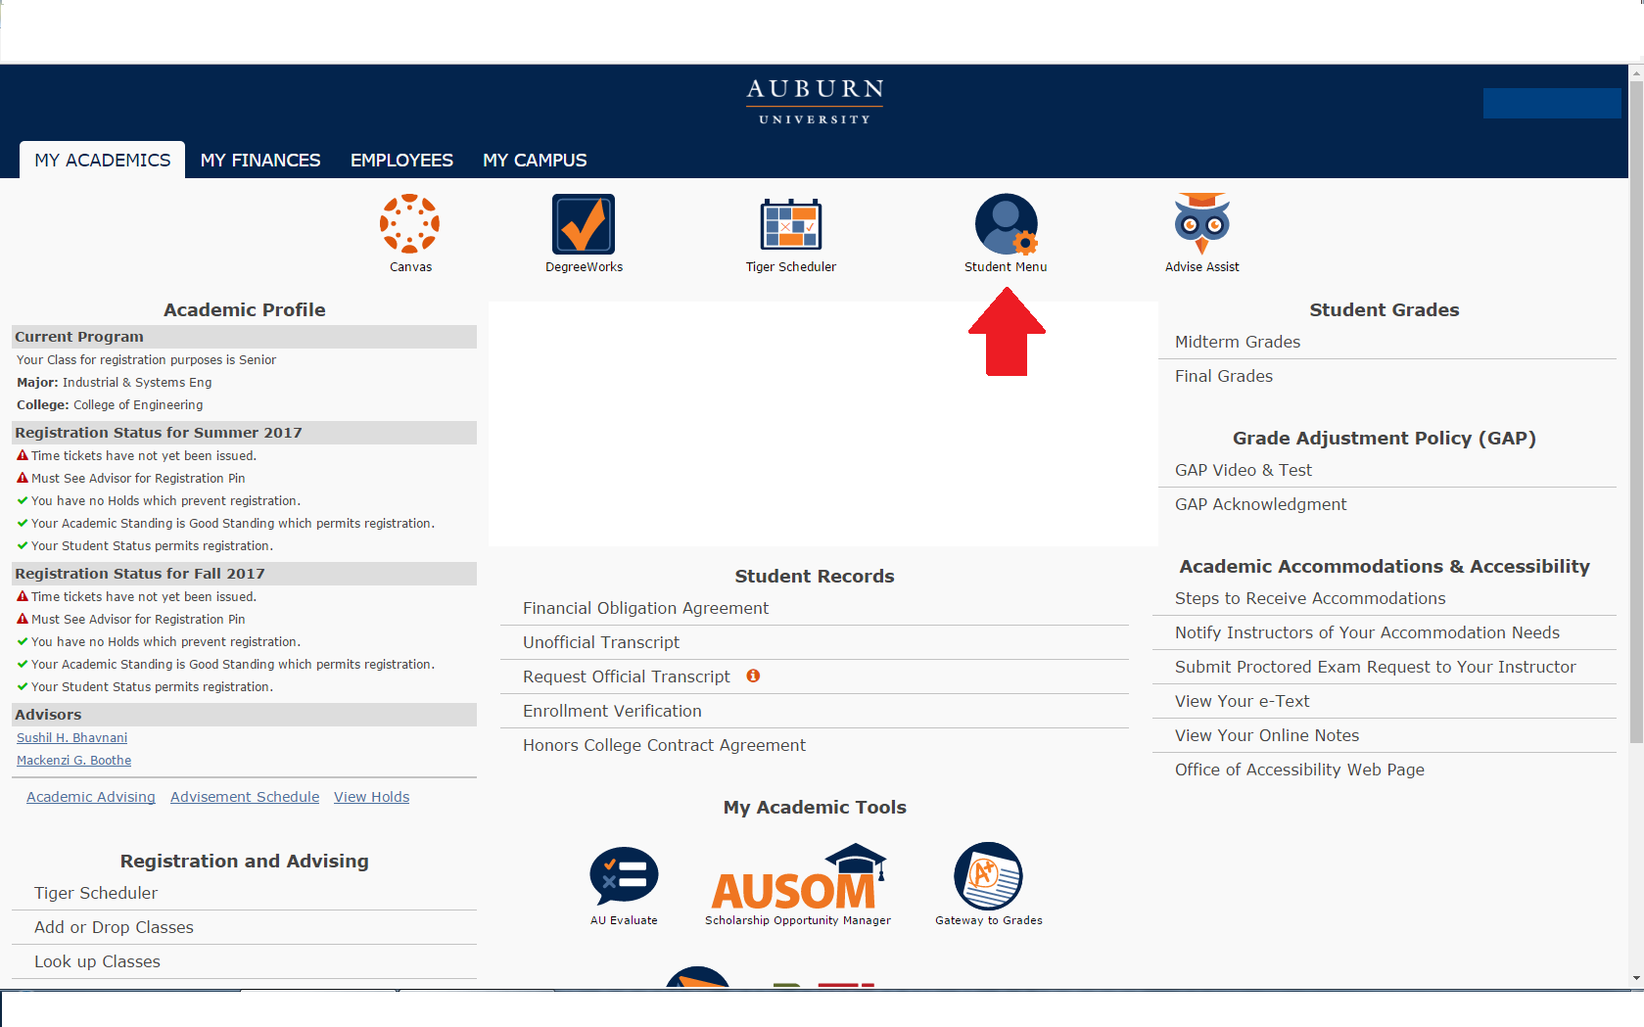
2. Near the bottom, students will see an All Access tab. Select it to view classes.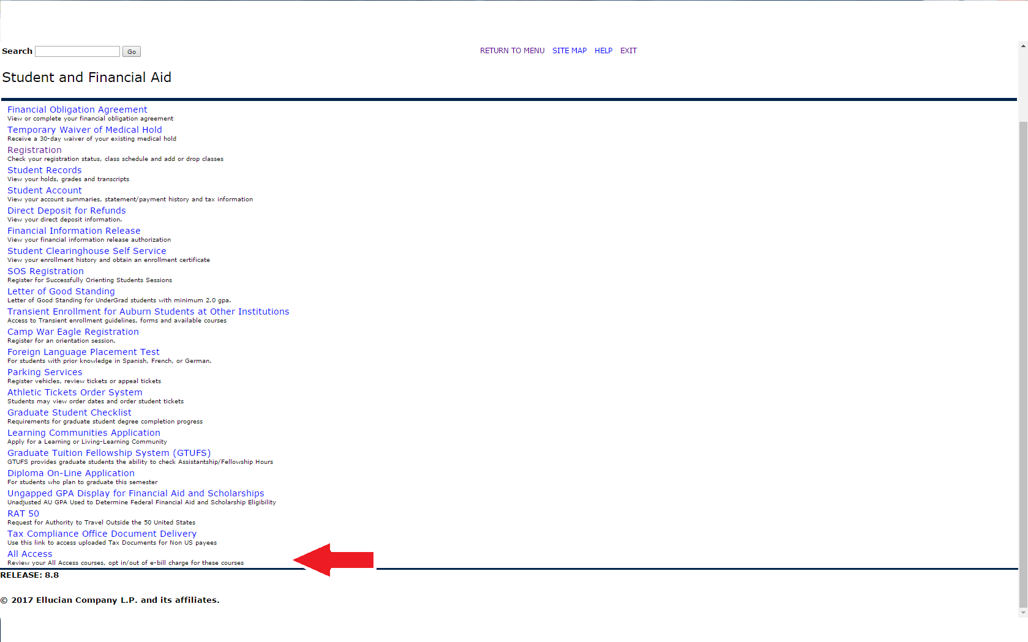
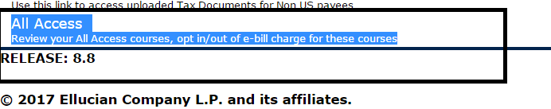

3. Once in here, they will select their the current term:
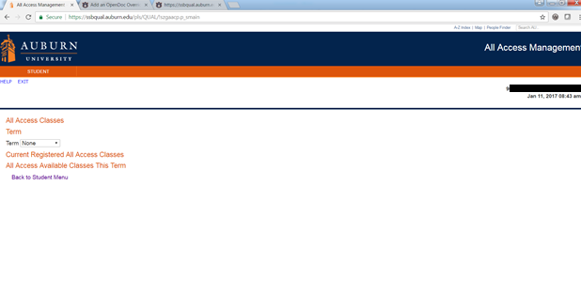
4. Once the current term is selected, All Access courses will populate with options to change out to the right.

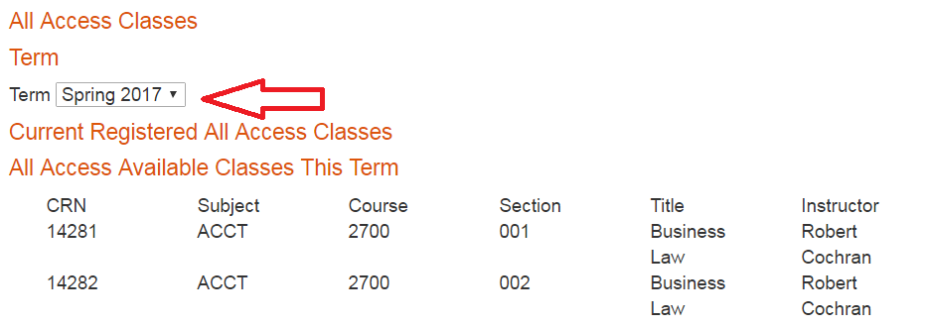

5. Students can click the change button to opt in or out of the All Access material. NOTE: This does not change your registration in the class, just your purchase option for the course materials.
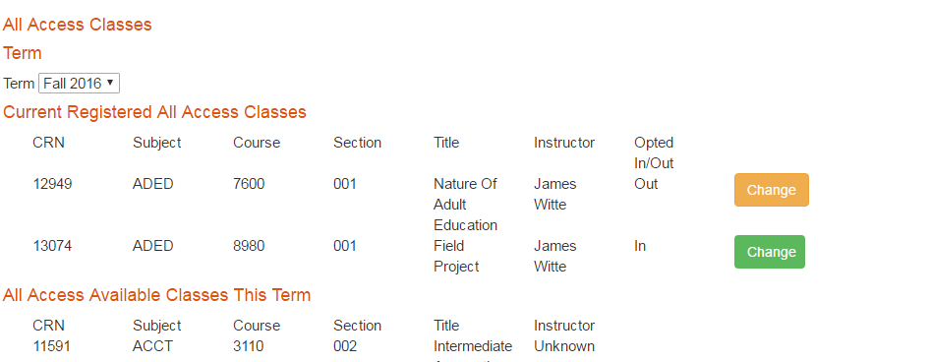

6. You will be prompted to provide a reason for opting out of the class.
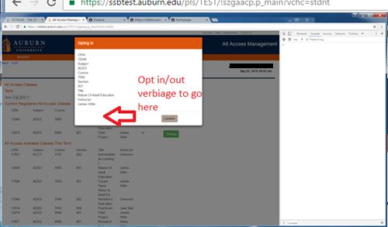

7. If completed correctly, there will be a green ‘Success’ near the middle of the page.
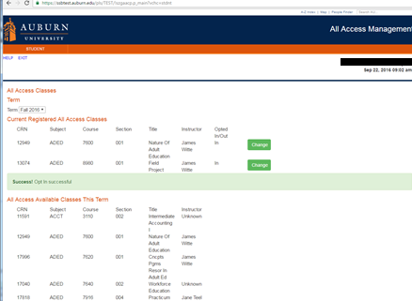

You may opt in or out at any time before the fifteenth class day. After that day, charges are sent to the Bursar to be applied to your e-bill. We may not be able to reverse the charge after that date.

We are able to apply All Access charges for course materials to scholarships that are normally handled through our scholarship counter in store. We will also apply charges for student athletes to the Athletic Department if a student’s scholarship covers course materials.

