AUBURN UNIVERSITY

Syllabus RSED 5010 & COUN 7010

Medical, Vocational, & Psychosocial Aspects of Disability

Department of Special Education, Rehabilitation, and Counseling

Professor: Jill M. Meyer, Ph.D., LCPC, CRC
Office: 2004 Haley Center
Email (best way to reach me): Jill.Meyer@Auburn.edu
Office Hours: By appointment

TA – Amanda Ezell - aed0132@auburn.edu
Office Hours: By appointment

COURSE SCHEDULE: Thursdays 9:00 – 11:30; Haley Center 3472.

You will find all materials, lectures, power points, articles, etc., in CANVAS by Module. We will use Modules to organize your materials which will be grouped by each of the 3 major exams. We will have a discussion board to promote clear communication and exchange of ideas and information for this course. You can find everything you need for this course in the Modules.

REQUIRED TEXTS:

Falvo, D.R. (2018). Medical and psychosocial aspects of chronic illness and disability
(6th ed.). Sudbury, MA: Jones and Bartlett Publishers.

Supplemental Readings/Reference:
American Psychological Association. (2020). Publication manual of the American Psychological Association (7th ed.). https://doi.org/10.1037/0000165-000
American Psychiatric Association. (2013). Diagnostic and statistical manual of mental
disorders (5th ed.): DSM-5. Washington DC: American Psychiatric Association.
Beers, M.H. & Berkow, R.(eds.). (2001). The Merck Manual of Diagnosis and Therapy.
Whitehouse Station, N.J.: Merck Research Laboratories.
Prendergast, A.V. (1991). Medical Terminology: A text/workbook. 3rd ed. Redwood
City: Addison/Wesley Nursing.

Additional material as assigned by the instructor.

Professionalism
As faculty, staff, and students interact in professional settings, they are expected to demonstrate professional behaviors as defined in the College’s conceptual framework. These professional commitments or dispositions are listed below:
- Engage in responsible and ethical professional practices
- Contribute to collaborative learning communities
- Demonstrate a commitment to diversity
- Model and nurture intellectual vitality

COURSE DESCRIPTION:
This class serves as an introduction to medical terminology, basic body systems, common physical and mental and cognitive conditions, therapeutic services, restorative techniques, and psychosocial and vocational considerations of disability. This course will introduce unique characteristics of various disability groups and discuss the vocational and psychosocial implications of each type of disability and/or condition.

CACREP Standards
Course Objectives: Upon completion of this course, students will be able to demonstrate these knowledge and skills related to these objectives:

3.A.1. history and philosophy of the counseling profession and its specialized practice areas
3.A.2. the multiple professional roles and functions of counselors across specialized practice areas
3.A.4. the role and process of the professional counselor advocating on behalf of and with individuals receiving counseling services to address systemic, institutional, architectural, attitudinal, disability, and social barriers that impede access, equity, and success
3.A.7. professional counseling credentialing, including certification, licensure, and accreditation practices and standards for specialized practice areas
3.A.10. ethical standards of professional counseling organizations and credentialing bodies, and applications of ethical and legal considerations in professional counseling and specialized practice areas
3.B.6 the effects of various socio-cultural influences, including public policies, social movements, and cultural values, on mental and physical health and wellness
3.B.9 strategies for identifying and eliminating barriers, prejudices, and processes of intentional and unintentional oppression and discrimination
3.C.8. models of psychosocial adjustment to illness and disability
3.C.10. biological, neurological, and physiological factors that affect lifespan development, functioning, behavior, resilience, and overall wellness
3.C.11. systemic, cultural, and environmental factors that affect lifespan development, functioning, behavior, resilience, and overall wellness
3.C.12. the influence of mental and physical health conditions on coping, resilience, and overall wellness for individuals and families across the lifespan
5.D. Clinical Rehabilitation Counseling Standards
5.D.1. effects of the onset, progression, and expected duration of disability on clients’ holistic functioning
5.D.2. environmental, attitudinal, and individual barriers for people with disabilities
5.D.3 impact of disability on sexuality
5.D.7. role of family, social networks, and community in the provision of services for and treatment of people with disabilities
5.D.8. assistive technology to reduce or eliminate barriers and functional limitations
5.D.10. strategies to advocate for people with disabilities related to accessibility, accommodations, and disability law adherence

INSTRUCTIONAL METHODS:
This course will be online (asynchronous) and on campus. In CANVAS you will find 3 Modules grouped by exam with all the content needed to study. The course objectives will be achieved through assigned readings, lectures, and discussions. The Modules will consist of lectures with discussions, and graduate student test-prep study guides and power points. This course covers a preponderance of information presented on a weekly basis, but is often a lifetime of study. Therefore, the instructor will focus the class lectures and textbook readings by providing an overview of those disease/disabling processes and psychosocial aspects most commonly encountered in counseling and rehabilitation practice. Due to the amount of information to be covered in these areas, a lecture format will be utilized, with liberal use of Power Points. The Power Points and lectures in Panopto are your primary resources for studying for quizzes and exams.

COURSE REQUIREMENTS:
Graduate Student Test Prep Guide:

Graduate Students are responsible for providing test prep information on the medical terminology of the body system and vocational and psychosocial implications being covered for each exam. Graduate students should develop PowerPoint slides or other format to accompany the test prep. “Think Medical Jeopardy.”- see example in Modules. Students in all sections will use this as a study guide for each of the three exams. This will need to be submitted 10 business days in advance of the exam to allow delivery to all students one week in advance of the test, so they have time to use it to study for the each of the three major exams.

**The Test Prep Guide must be uploaded in canvas and emailed to Dr. Meyer & Ms. Ezell at aed0132@auburn.edu
*** 10 business days PRIOR to the exam to allow the test prep to be posted in CANVAS. ***

DE graduate students can partner with on campus students and upload into CANVAS.

Students should provide an explanation of basic terms and definitions used with those body systems for the exam. In presenting the information for the body systems and vocational & psychosocial implications, students can make liberal use of technology. You can make it like a game show format.

Quizzes – ALL Students:
There are five quizzes, which should be taken after the class lectures.
Please bring/use a laptop or tablet to take the quiz. Each quiz is worth 5 points.

ALL Quizzes will be taken through CANVAS and will be timed for 30 minutes. The quizzes will be timed for all students. The quizzes are closed book, but they are timed, so proctoring is NOT required for quizzes.

ON-CAMPUS STUDENTS WILL TAKE QUIZZES IN CLASS AS SCHEDULED

ONLINE STUDENTS will have two days (Thursday & Friday) to take each quiz. There are five quizzes (5 quizzes).
The quizzes are timed; once you start you have to finish it. You cannot save and return. Once you open it you must finish. If you open you cannot return at another time. DO NOT open it until you are ready to take it. You have only one chance to take a quiz. See Schedule for dates.

EXAMS (THERE ARE THREE MAJOR EXAMS):
Online Students - Exams require PROCTORING. We will use Respondus Lockdown Browser + Monitor ($15 for the year)

ALL STUDENTS - YOU MUST USE A COMPUTER (not a phone)
FOR THE EXAMS.

On campus students will take the exams in class.
Online students will use Respondus LockDown Browser + Monitor

Three major exams are taken through CANVAS, in multiple-choice format with some true/false items. Questions will cover assigned readings and lecture-presented material from the last exam through the class prior to the test. The third and final exam will be given the last day of class for on-campus students (Online - the last Thursday and Friday) and will not be a comprehensive final, but instead will cover material after the second exam through the end of the semester.

ONLINE STUDENTS – your exams will be open for TWO days. Please see the weekly schedule for dates. All exams are closed book, no notes or internet use (no open browsers). No Cheating!
For Quizzes, you do not need to use proctoring, but the quizzes are timed and are closed book/notes. See the weekly schedule or CANVAS for times.

Class Participation:
While lecture formats often preclude extensive class discussion, it is anticipated that you will have a number of questions, comments, or personal knowledge of the information. Please share these thoughts, comments, or questions as you have them. You are encouraged to post your questions and comments on the discussion board in each Module.

Assignment | Possible Points | CACREP Standards
Quiz 1 | 5 points | 3.A.1, 3.A.2, 3.A.7, 3.A.10, 3.B.6, 3.B.9  3.A.4, 3.C.8, 3.C.10, 3.C.11, 3.C.12  5.D.1.,5.D.2, 5.D.3, 5.D.7., 5.D.8, 5.D.10
Quiz 2 | 5 points | 3.A.4, 3.C.8, 3.C.10, 3.C.11, 3.C.12  5.D.1.,5.D.2, 5.D.3, 5.D.7., 5.D.8, 5.D.10
Exam 1 | 25 points | 3.A.1, 3.A.2, 3.A.7, 3.A.10, 3.C.8  3.A.4, 3.C.8, 3.C.10, 3.C.11, 3.C.12  5.D.1.,5.D.2, 5.D.3, 5.D.7., 5.D.8, 5.D.10
Quiz 3 | 5 points | 3.A.4, 3.C.8, 3.C.10, 3.C.11, 3.C.12  5.D.1.,5.D.2, 5.D.3, 5.D.7., 5.D.8, 5.D.10
Quiz 4 | 5 points | 3.A.4, 3.C.8, 3.C.10, 3.C.11, 3.C.12  5.D.1.,5.D.2, 5.D.3, 5.D.7., 5.D.8, 5.D.10
Exam 2 | 25 points | 3.A.4, 3.C.8, 3.C.10, 3.C.11, 3.C.12  5.D.1.,5.D.2, 5.D.3, 5.D.7., 5.D.8, 5.D.10
Quiz 5 | 5 points | 3.A.4, 3.C.8, 3.C.10, 3.C.11, 3.C.12  5.D.1.,5.D.2, 5.D.3, 5.D.7., 5.D.8, 5.D.10
Exam 3 | 25 points | 3.A.4, 3.C.8, 3.C.10, 3.C.11, 3.C.12  5.D.1.,5.D.2, 5.D.3, 5.D.7., 5.D.8, 5.D.10
Test Prep Guide (grads only) | 10 pts | 3.A.1, 3.A.2, 3.A.7, 3.A.10, 3.C.8  3.A.4, 3.C.8, 3.C.10, 3.C.11, 3.C.12  5.D.1.,5.D.2, 5.D.3, 5.D.7., 5.D.8, 5.D.10
Total Points Possible | 100 (110 grads)

GRADES:
Undergraduates:
The grading for this course is based on the following criteria:

Quizzes (5): 25 points (5 points per quiz)
Exams (3): 75 points (25 points per exam)
TOTAL 100 points

Undergraduate Grading Scale:

A = 90 – 100 B = 80 - 89 points C = 70 - 79 points D = 60- 69 points F = 59

Graduate Students Only:

Test Prep covering course material for an exam: 10 points in addition to the 5 quizzes and 3 exams
GRADUATE STUDENTS TOTAL - 110 points

Quizzes (5): 25 points (5 points per quiz)
Exams (3): 75 points (25 points per exam)
Test Prep Guide 10 points for the group test prep
TOTAL 110 points

A = 100 - 110 B = 89 - 99 points C = 78 - 88 points F = 77 & below

Make-Up Policy:
Arrangements to make up a missed major examinations (i.e., hour exams - 1, 2, & 3) –
properly authorized excused absences must be initiated by the student within one week of the end of the period of the excused absence(s). Except in unusual circumstances, such as the continued absence of the student or the advent of university holidays, a make-up exam will take place within two weeks of the date that the student initiates arrangements for it. Except in extraordinary circumstances, no make-up exams will be arranged during the last three days before the final exam begins.

ACADEMIC INTEGRITY:
As students of Auburn University (Clinical Rehabilitation Counseling and Rehabilitation Counseling & Disability Studies), you will be held to the highest standards of academic conduct. Academic misconduct will be dealt with according to Auburn University Policy.

All your work in this class should be original to you and to this class. You are expected to explore, analyze, and discuss the ideas of others, but you must give them proper credit through citations and references. The bottom line is ALWAYS (on exams, on papers, on projects, on presentations) do your own, original work, give credit to others for their ideas, and if in doubt ask your professor. Do not acquire assignments from previous students. Using work from previous students is considered cheating/plagiarizing and will be addressed according to AU policy.

Plagiarism is a very serious offense, both in college and in the “real world.” When you consult sources for a paper, you must document ideas or words deriving from them both by listing the sources in a bibliography at the end of the paper and by citing sources in the text itself. To cite a source is to make clear to the reader 1) who originated the idea or quotation that you have used and 2) where it can be found. This then allows the reader to do further research or check your evidence. It also prevents you from taking credit—deliberately or inadvertently—for someone else’s work or ideas.”

Health and Well-Being Resources: These are difficult times, and academic and personal stress is a natural result. Everyone is encouraged to take care of themselves and their peers. If you need additional support, there are several resources on campus to assist you:
· Student Counseling and Psychological Services (http://wp.auburn.edu/scs/)
· AU Medical Clinic (https://cws.auburn.edu/aumc/)
· Auburn Cares Office (http://aucares.auburn.edu/)

Policy Related to the Use of AI for Classroom Assignments

The Counselor Education Programs (CED) has a comprehensive policy on the use of Artificial Intelligence (AI). As the acceptable use of AI varies, please consult your instructor on how AI can be used within specific courses and/or clinical settings. Please understand that violations of this policy can be considered a form of plagiarism. Please see the CED Programs Handbook for the full AI policy.

Policy Related to the Use of Zoom for Class Meetings
- Zoom participation requires you to keep your video on and your microphone muted when you are not speaking.
  - If you have a need for technology to support your participation in this class or do not have a space conducive for participating - SERC provides private individual counseling spaces (Counseling Lab) that you can reserve and use for class sessions.
  - Please know that you can blur your background if you are not comfortable sharing your space or environment during classes conducted online.
  - Please limit all distractions such as your phone or attending to other work on your computer. It is often very apparent that a student is distracted and that impacts the class environment for everyone.
  - Students can turn off their cameras briefly if needed (e.g., break). These pauses should be short. Having students on camera provides a higher level of engagement for all participants.
  - If you have questions during class, you can raise your hand (in real time or via Zoom).
  - Please know that sometimes it is challenging to be teaching and attending to students and reading messages in Chat, especially if I am also sharing content. If I don’t respond to a comment or discussion in Chat, please let me know.
- Although you may be participating from your domicile, our Zoom meetings are professional interactions.
  - You should dress and behave as you would in a normal F2F classroom.
  - Please minimize distractions in the background as much as possible.
  - Participating in spaces that are not conducive to zoom attendance (e.g., public spaces, vehicles) should be discussed with the instructor prior to the class session and should only be used when there are no other alternatives.
- Recording Sessions: Due to the nature of our classes and the possibility that we may be discussing content that is confidential in nature:
  - Instructors can record sessions and will notify students when the class session is being recorded (e.g., teaching demonstrations, making the session available to other students, speakers)
    - Confidential content (e.g., supervision sessions) will be retained following appropriate ethical and legal practices as well as CED policies (e.g., password protected BOX folders).
    - Students can request that the recording be stopped if they wish to discuss a topic that they do not want recorded. In areas such as supervision this may not be possible.
  - You should participate in spaces that allow for these discussions and do not have others present in the room while you are using it for class or supervision.
  - As per University policies, I reserve the right to dismiss anyone from a Zoom meeting whose environment or behavior is distracting or problematic.
  - If you have any issues with sharing your video feed, adhering to this policy, or anything else related to your use of Zoom please notify me via email in the first week of class so we can discuss if accommodations are possible.

CED Programs Diversity Statement
A central foundation of the mission of the Counselor Education programs is the preparation of counselors and counselor educators to work in an increasingly diverse society. The program’s understanding of diversity encompasses culture, sexual and gender identity, race, ethnicity, socioeconomic status, ability, and other aspects of individual identity. The program believes that meeting these goals requires that students and faculty engage in advocacy, equity, inclusion, and culturally sustaining practices. This includes students demonstrating these principles in their academic, clinical practice and professional development engagement.

These principles are in alignment with our professional, ethical, and accreditation standards including: Council for the Accreditation of Counseling and Related Programs (2024 standards) American Counseling Association’s Code of Ethics (ACA, 2016), American Rehabilitation Counseling Association (ARCA), the Commission on Rehabilitation Counselor Certification (CRCC), American Mental Health Counselors Association (AMCHA), and the American School Counselor Association (ASCA). Overall, we seek to create educational and learning environments that support, sustain, and challenge students to address their development as professionals related to and representative of culturally sustaining practice.

Diversity
The CED programs ensure respect for DEI based on the following accreditation standards:
Syllabi consistent with program delivery types are available to students enrolled in the course at the beginning of each academic term and include: 1.N.6 diversity, equity, inclusion, and accommodation statement;
1.M.8 The student handbook- includes diversity, equity, inclusion, and accessibility policies;
1.H The- program has a process for identifying underrepresented populations and makes continuous and systematic efforts to recruit, enroll, and retain students that enhance and support the diversity of the program.

Accommodations Statement
Auburn University and the Counselor Education program are committed to ensuring student success by providing them with the appropriate supportive resources when necessary. We encourage students to exercise their right under the Americans with Disabilities Act to access academic accommodations. Students who need accommodations should submit their approved accommodations through the AIM Student Portal on AU Access and follow up with the instructor about an appointment. It is important for the student to complete these steps as soon as possible; accommodations are not retroactive. Students who have not established accommodations through the Office of Accessibility but need accommodations should contact the Office of Accessibility at ACCESSIBILITY@auburn.edu or (334) 844-2096 (V/TT). The Office of Accessibility is located in Haley Center 1228. Once a student has begun the process for accommodations, they are responsible for scheduling a meeting with faculty to discuss how these accommodations will be implemented in practice. Faculty are committed to working with students to support their needs in conjunction with the Office of Accessibility.

Semester Outline
Online and On-campus Format

Class Topic Readings/ Assignments CACREP Standards

MODULE 1

1. 8/22 Introductions/Course Overview Falvo: Ch. 1, 2, & 3.A.1, 3.A.2, 3.A.7, 3.A.10, 3.B.6
Disability & Medical Terminology Appendix A & B 3.B.9, 3.C.8
Grads – 3 Groups Test-Prep Study Guide- Sign Up (4-5 per group)

ALL ONLINE/ DE Students – DOWNLOAD RLB

2. 8/29 Cardiovascular System & Falvo: Ch. 28 3.A.4, 3.C.8, 3.C.10, 3.C.11, 3.C.12
Vocational & Psychosocial Implications QUIZ 1 (Classes 1 & 2) 5.D.1.,5.D.2, 5.D.3, 5.D.7., 5.D.8, 5.D.10
(ONLINE - 8/29 & 8/30)

3. 9/05 Psychiatric Disabilities
Cancer & VPI Falvo: Ch. 13, 14 & 21, 22 3.A.4, 3.C.8, 3.C.10, 3.C.11, 3.C.12
5.D.1.,5.D.2, 5.D.3, 5.D.7., 5.D.8, 5.D.10

4. 9/12 Respiratory System & VPI Also known as Pulmonary 3.A.4, 3.C.8, 3.C.10, 3.C.11, 3.C.12
Review for Exam 1 Falvo: Ch. 29 5.D.1.,5.D.2, 5.D.3, 5.D.7., 5.D.8, 5.D.10
QUIZ 2 (Covers Classes 3 & 4)
(ONLINE - 9/12 & 9/13)

5. 9/19 Exam 1 (Conditions & VPI) EXAM 1 Includes the above cited standards
Disability (ONLINE - 9/19 & 9/20) for content (classes 1, 2, 3, & 4)
Medical Terminology for Exam 1
Cardiovascular System Online use RLB
Cancer with COMPUTER OR TABLET
Psychiatric Disabilities
Respiratory System
All VPI

MODULE 2

6. 9/26 Musculoskeletal System & VPI Falvo: Ch. 24 3.A.4, 3.C.8, 3.C.10, 3.C.11, 3.C.12
5.D.1.,5.D.2, 5.D.3, 5.D.7., 5.D.8, 5.D.10

7. 10/03 Hematology & Immunology & VPI QUIZ 3 (Covers Classes 6 & 7) 3.A.4, 3.C.8, 3.C.10, 3.C.11, 3.C.12
Endocrine System (ONLINE - 10/03 & 10/04) 5.D.1.,5.D.2, 5.D.3, 5.D.7., 5.D.8, 5.D.10
Falvo: Ch. 18, 19, 20, 23

10/10-10/11. FALL BREAK. FALL BREAK FALL BREAK. FALL BREAK FALL BREAK

8. 10/17 Amputation
Rheumatic Disorders Falvo: Ch. 25, 26, 27 3.A.4, 3.C.8, 3.C.10, 3.C.11, 3.C.12
Chronic Pain 5.D.1.,5.D.2,5.D.3, 5.D.7., 5.D.8, 5.D.10
& VPI

9. 10/24 Alcohol; Drug Abuse & VPI Falvo: Ch. 15 3.A.4, 3.C.8, 3.C.10, 3.C.11, 3.C.12
TA REVIEW for EXAM 2. QUIZ 4 (Covers Classes 8 & 9). 5.D.1.,5.D.2,5.D.3, 5.D.7., 5.D.8, 5.D.10
(Online- 10/24 & 10/25)

10. 10/31 Exam 2 (Conditions & VPI) EXAM 2 Includes the above cited standards
Endocrine (Online - 10/31 & 11/01) for content (classes 6, 7, 9, & 10)
Hematology/ Immunology for Exam 2
Musculoskeletal System
Rheumatic Disorders
Amputation
Alcohol & Drug Abuse Online/ DE Students use RLB
All VPI with Computer or tablet
Chronic Pain

MODULE 3

11. 11/07 Vision Falvo: Ch. 16, 17, & 30 3.A.4, 3.C.8, 3.C.10, 3.C.11, 3.C.12
Hearing 5.D.1.,5.D.2,5.D.3, 5.D.7., 5.D.8, 5.D.10
Renal System
& VPI

12. 11/14* Neurological System & VPI 3.A.4, 3.C.8, 3.C.10, 3.C.11, 3.C.12
*Watch Recorded Lecture Falvo: Chs. 3, 4, 5, 6, 8, 5.D.1.,5.D.2,5.D.3, 5.D.7., 5.D.8, 5.D.10
NO ON CAMPUS CLASS

13. 11/21 Back & Neck Falvo: Ch. 7 & 9 3.A.4, 3.C.8, 3.C.10, 3.C.11, 3.C.12
Spinal Cord Injury & VPI 5.D.1.,5.D.2,5.D.3, 5.D.7., 5.D.8, 5.D.10
(Neurological Conditions)
QUIZ 5 (Covers classes 11, 12, & 13)
REVIEW EXAM 3 (Online - 11/21 & 11/22)

11/28/2024 THANKSGIVING Study Exam 3 THANKSGIVING Study Exam 3 THANKSGIVING

14. 12/05 Exam 3 (Conditions & VPI) EXAM 3 Includes the above cited standards
Neurological System/Conditions (Online – 12/05 & 12/06) for content (classes 12, 13, & 14) for
Vision Exam 3
Hearing
Renal System
Back & Neck
Spinal Cord Injury Online / DE Students use RLB
With Computer or Tablet

Respondus Lockdown Browser + Monitor (RLB)

Online Students You will need Proctoring for your 3 major exams.

You will not use it with your 5 quizzes.

Download the Lockdown Browser for Canvas Exams ($15 per year)

If your test in Canvas requires the Lockdown Browser, you can download and install the browser through Canvas (NOT through AU Install).
Within your course, navigate to the exam you want to take. Although the button is labeled “Take the Quiz,” it will not actually begin the quiz/exam.
To download the browser, click “Take the Quiz.”
Note: If the Lockdown Browser is required, this button does not start the quiz/exam.
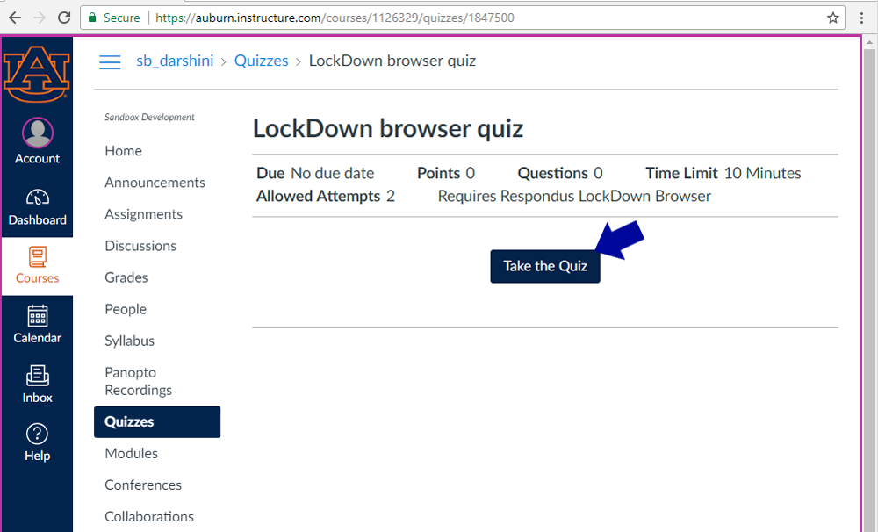

Click the link “Take the Quiz” to the download page. Follow the instructions on the following page for PC or Mac. Once installed, launch the Lockdown Browser, log into Canvas using the Lockdown Browser, and then take the exam.
Note: If you have trouble installing the Lockdown Browser, please contact the OIT Service Desk at 844-4944 or servicedesk@auburn.edu. We also recommend informing your instructor of any issues, if they occur.
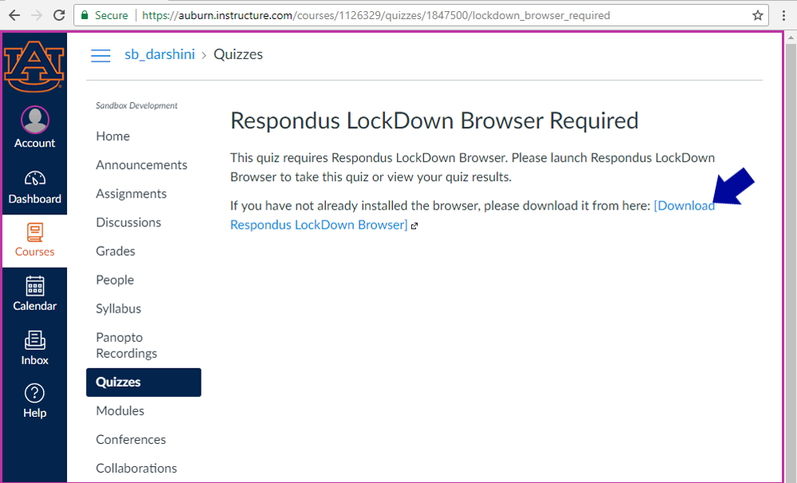

Respondus Monitor
Students will need to purchase a yearly license for $15 dollars through Respondus the first time they take a quiz.
https://web.respondus.com/student-help/
Live help is also available 24/7 through Respondus.

From the FAQ:
How do students purchase a Respondus Monitor subscription?
Students make the purchase the first time Respondus Monitor is required by an exam in a course. The process is simple, and payment can be made via credit card, debit card, or Paypal.
How many exams or courses can you use with a Respondus Monitor subscription?
A student-purchased subscription of Respondus Monitor is valid for 12 months (365 days) and can be used with any online course or exam requiring it at the institution.

Help Center for LockDown Browser & Respondus Monitor
Note to students: The LockDown Browser download link and application are different for each institution. Contact your institution's help desk to obtain the correct download URL. View more LockDown Browser Student Help here.
Help Center is a feature for LockDown Browser and Respondus Monitor that enables students and help desks to more easily troubleshoot technical issues with a student's computer.
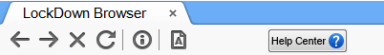
The Help Center button will appear on the toolbar in LockDown Browser once a student has accessed a course in their LMS.
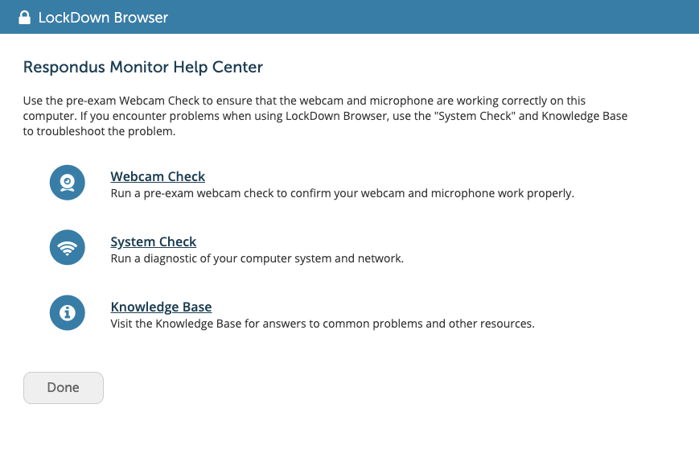
The Respondus Monitor Help Center contains three areas:
- Pre-exam Webcam Check – Enables a student to check their webcam functionality, prior to an exam.
- System & Network Check – Runs a series of diagnostic checks to make sure the student's computer is functioning properly and meets the minimum requirements. The results of the system check can be emailed to a help desk for further troubleshooting.
- Knowledge Base – This student-centric knowledge base provides answers to the top questions or issues that relate to using LockDown Browser and a webcam (ie. Respondus Monitor).

