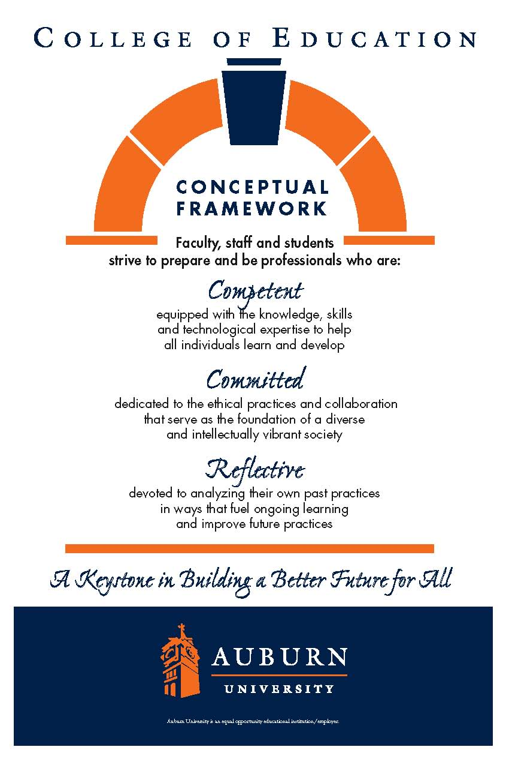
CTES 7920
Auburn University

Department: Curriculum & Teaching
Program: English to Speakers of Other Languages Education
Course Title: cLINICAL rESIDENCY IN esol education
Course Number: CTES 7920
Course Credit: 3 or 6 hours
Semester: Spring 2025
Instructor | Gwendolyn M. Williams, Ph.D
Email Address | gmw0015@auburn.edu
Phone number | (Office) 334-844-6775
Office | 5078 Haley Center
Office Hours | By appointment
Schedule | In the classrooms

1.COURSE DESCRIPTION
Catalog Description:
Supervised on-the-job experience in a school, college, or other appropriate setting, accompanied by regularly scheduled, on-campus discussion periods.

Overview
The Clinical Residency in ESOL education (certification track) may be completed by working with students in a public-school setting, the Summer English School setting, and/or private tutoring sessions. The non-certification track may utilize Auburn Global or another adult education setting to fulfill requirements. On-the-job experiences are accompanied by scheduled observations and discussions that allow the university supervisor and the interning teacher to analyze and evaluate teaching experiences and abilities to apply research-based practices and knowledge base addressed in objectives and content for courses in the reading program.

The Clinical Residency experience is set up in three unique stages. 1) observations in ESL classes that encompass the wide range of language levels and language domains 2) shadowing/assisting practicing teachers with all aspects of ESOL teaching, and/or tutoring one-on-one in class and private settings 3) small group teaching and full-time teaching of at least one class of students for the duration of at least one unit. Each stage is comprised of at least 100 hours but may be split up throughout the entire course of study.
Students working toward Alabama’s Class A ESOL Education certification must complete all three options. Students wishing to develop expertise in other areas of reading education may work with a university supervisor to create additional Clinical Residency options (e.g., teaching reading to children with special needs, working with adult readers).

Required Text-none required.

Student Learning Outcomes: Course objectives include a subset of key indicators from the Alabama Quality Teaching Standards and program-specific indicators. Indicators assigned to CTES 7920 are highlighted on the performance assessment templates included in the attachments. [Or noted below.]
Alignment of objectives with the Alabama Quality Teaching Standards (AQTS) is noted.
- Students will be introduced to the ethical standards for professionalism.
- Students will demonstrate the ability to apply course material (to improve thinking, problem solving, and decisions); related to the principles and methods of teaching and learning of English language.
- Students will develop and demonstrate skills, competencies, and points of view needed by professionals; related to lesson planning, classroom management, and student peer relationships.
- Students will develop an appreciation for the breadth of the field in terms of the four language modalities + grammar, pronunciation, and vocabulary teaching, as well as integrated approaches.
- Students will use the practicum to gain competence in the field and use course work to support the development of effective teaching as well as the ability to reflect critically about their own teaching techniques and the teaching of others.

2. COURSE REQUIREMENTS
Students will work with the university supervisor to develop weekly plans for addressing and demonstrating competence in the objectives listed above.
The entire clinical residency will consist of 3 credit hours, with 100 clock hours per stage. Additional clock hour configurations can be made on individual basis in consultation with university supervisor. Requirements for each option include weekly entries in a professional journal that include annotations to standards or theory, self-evaluations completed at midterm and at the end of the term, and participation in professional conversations about the Clinical Residency.

Course Requirements

- Goal Statement
By the end of week 2, please make a list of at least three personal goals for this stage of the internship that you hope to accomplish by the end of the current semester. These goals can focus on teaching skills, classroom management skills, lesson planning, facilitating student interaction, etc. Just make sure the goals are important to you and are areas that you have not already mastered. Please be realistic and set goals that you can achieve within the prescribed period. Please submit them to Canvas by the end of the second week so that your supervisor can help you move towards accomplishing your goals by the end of the semester.

This assignment addresses TESOL Standards 2.c, 3.d, 4.b, 5.e.

- Teaching Philosophy Statement
First you should read the following article that is available in Canvas: Waller et al.,
(2017). Then consider responses to the following questions:
- How do you perceive the role of the teaching context as influencing your teaching practices for multilingual learners?
- How do you incorporate the language backgrounds, histories and life experiences of your students into your instruction?
- What practices do you adopt to maintain multilingual student engagement in classroom learning?
- How do you analyze your own teaching beliefs and how do you incorporate your teaching beliefs into your instruction?

Waller, L., Wethers, K, & De Costa, P.I. (2017). A critical praxis: Narrowing the gap between identity, theory, and practice. TESOL Journal, 8(1), 4-27. https://doi.org/10.1002/tesj.256

This paper should be 5 pages long.
This assignment addresses TESOL Standards 2a, 2b, 2e, and 5c

- Classroom Observation Activities (5 are required)
For this assignment, you will be completing a series of classroom observations to focus on various aspects of the teaching and learning processes of multilingual learners. To start, everyone must complete the following activity (and this activity counts as one of the total number of activities):

A. Learner Level (Activity 1.4 in Wajnryb)
For this exercise, you will observe an ML student who is participating in a learning experience in the classroom. Observe the lesson from the standpoint of what the student actually does. Please fill out the following chart:

Pseudonym of Student | WIDA Level | Signs/Indicators of Level | Teacher Strategies/ Scaffolds
1.

2.

- How aware are you of the levels of your students?
- How is this reflected in your teaching?
- What aspect of your lesson most reflects this awareness?
- How can you extend this awareness to other elements of the learning environment?

For your remaining observations, you will select classroom observation tasks from the book “Classroom Observation Tasks: A resource book for language teachers and trainers” by Ruth Wajnryb which will be on reserve in the library. The book contains 7 different categories of tasks: the learner, language, learning, the lesson, teaching skills and strategies, classroom management, and materials and resources. Each task that you choose should be from a different category (from categories 2-7). You should complete any graphic organizer that appears within the task and answer all of the reflection questions from the task.

This assignment addresses TESOL Standards 1.c, 1.d, 3.c, 4.b, 4.c, 5.c

- Classroom Profiles Assignment
Write a description of the multilingual learners in your practicum experience. Each student should be referred to by a pseudonym in order to protect their identity. You will create an avatar for each learner at https://avatarmaker.com/. The learner profiles should include details at the class level and address all relevant subgroups and/or individuals (e.g., available student-level data, proficiency score information, informal observations). Descriptions must address sociocultural aspects and identity of learners and the linguistic aspects of the learners with specific reference to relevant language assessments (e.g., WIDA) and/or standards/frameworks. You should address any language transfer issues that might influence the ML’s learning. Your description of learners must also provide enough information on learners to allow for planning for differentiation. Your profile may include.

- Background information on their family, culture, and community
- Academic strengths, knowledge, and skills
- Leadership and character traits
- Other gifts and unique potential
- Learning style and motivation
- Passions and interests as well as their dislikes
- Goals and dreams
- Academic, social, and emotional needs
- Challenges and what they struggle with in school.
- Their best environment for learning

You will then identify 3 teaching strategies per student and explain how each strategy will support that student’s learning.

This assignment addresses TESOL Standards 1.a, 1.b, 2.a, 2.c, 2.d.

- Formal Classroom Observations of Your Teaching
Each intern will be observed twice by your supervisor throughout the course of the semester.. Each lesson must address at least one language domain (listening, speaking, reading, writing) and all domains must be represented among the lessons. Lessons could address multiple domains, but you must address all four domains. The lesson should be a complete lesson that can be evaluated as a stand-alone lesson or activity. Each observation must be scheduled and confirmed with your supervisor at least 48 hours before the lesson is actually taught. On the day of the observation, each intern should provide the supervisor with a copy of the lesson plan that is being taught, and the completed pre-observation report with a blank copy of the evaluation rubric. Please see Canvas for the rubric. After the observation, a time must be scheduled shortly thereafter to discuss the observation with your supervisor. The observations are designed to help you analyze and improve your teaching skills.The observations will be spaced throughout the semester, so it is important to make sure that you meet your deadlines.

This assignment addresses TESOL Standards 3.a, 3.b, 3.c, 4.a, 5.c, 5.d,

- Community Engagement Activity
You will attend an event of your choice that helps you to engage with the community connected to your placement at the school and gain a deeper understanding of how the community influences the learning of the multilingual students. Activities could include participating in extracurricular school sponsored events, attending a teacher meeting about multilingual students, SAMUEL training, multicultural fair, schoolwide sporting event, etc. Please confer with your supervisor before attending an event.

After attending the event, you will write a reflection paper about the experience. You should describe the experience, and your affective reactions to how the event contributes to your understanding of the environmental influences on your multilingual students’ learning. You should analyze how your experience is connected to the theories and practices that you have learned from your ESOL Education coursework.

This assignment addresses TESOL Standards 2.a, 2.b, 2.d, 5.b

- Professional Growth Paper
In this paper you will reflect on the professional growth in reflective teaching that you have achieved throughout the semester. Please connect your reflections back to theory or standards. This paper should be 5 pages long. Questions that should be answered are:

- Describe the journey that you have taken towards the goals that you set at the beginning of the semester. How did you meet these goals, or what challenges prevented you from meeting these goals?
- What did you learn from this internship that surprised you the most?
- Describe a critical incident that occurred in your ESOL classroom this semester and explain how this event changed your views on teaching MLs.
- Describe how your connection with the institution and community in which you were teaching has influenced your professional growth.
The rubric is on Canvas.

This assignment addresses TESOL Standards 5.a, 5.c, 5.d

- Class Attendance- We will have occasional scheduled Zoom sessions throughout the semester. The meetings will not last more than an hour and are designed to provide you with information that would be relevant to your time in the schools. The dates of the meetings are 1/13/25, 3/17/25, and 4/28/25. The Zoom links will be posted on Canvas.

Tentative Schedule for the Semester
 | Week of | 3 credit track
 | 1/13/2025 | Zoom Meeting Monday at 4:30 PM
 | 1/20/2025 | MLK Jr Holiday on Monday  Goal Statement due on 1/25/2025
 | 1/27/2025
 | 2/3/2025 | Teaching Philosophy Statement Due
 | 2/10/2025
 | 2/17/2025 | Classroom Profiles Assignment Due
 | 2/24/2025 | Two Observation Tasks due 2/22/25
 | 3/3/2025 | Formal Observation # 1 Teach Small Group Lesson
 | 3/10/2025 | Spring Break
 | 3/17/2025 | Zoom Meeting 3/17/2025 4 PM
 | 3/24/2025
 | 3/31/2025 | Three Observation Tasks due 4/4/25
 | 4/7/2025
 | 4/14/2025 | Formal Observation #2
 | 4/21/2025 | Community Engagement Activity Due 4/25/25
 | 4/28/2025 | Zoom Meeting 4/28/25 4 PM
 | Finals Week | Professional Growth Paper due May 2

Grading and Evaluation Procedures:
A grade of Satisfactory or Unsatisfactory is assigned. Students must satisfy all objectives to receive a satisfactory grade.
The final Clinical Residency grade (S, U) is determined by the university supervisor and the cooperating teacher based on the key assessments which include a holistic evaluation of the student’s performance throughout the semester (e.g., Inventory of Candidate Proficiencies).

3. University and College Policies

- Attendance: Attendance is required for all classes unless excused prior to class meeting.
  - Students are expected to attend all their scheduled classes. College work requires regular class attendance as well as careful preparation. Specific policies regarding class attendance are the prerogative of individual faculty members. Faculty shall inform each class in writing at the beginning of the course regarding the effect of absences on the determination of grades.
The student is expected to complete all assigned work and to take examinations at the class period designated by the instructor. Failure to complete these assignments or to take examinations at the designated times may result in an appropriate reduction in grade, except as provided below.
Instructors shall determine the policy regarding grading which they feel is best for the course. This policy shall be presented to the class, in writing, at the beginning of the term and will govern the actions of the instructor in the course.
Instructors are expected to excuse absences for:
    - Illness of the student or serious illness of a member of the student’s immediate family. The instructor may request appropriate verification.
    - The death of a member of the student’s immediate family. The instructor may request appropriate verification.
    - Trips for members of the student organizations sponsored by an academic unit, trips for university classes, and trips for participation in intercollegiate athletic events. When feasible, the student must notify the instructor prior to such absences, but in no case more than one week after the absence. Instructors may request formal notification from appropriate university personnel to document the student’s participation in such trips.
    - Religious holidays. Students are responsible for notifying the instructor in writing of anticipated absences due to their observance of such holidays.
    - Subpoena for court appearance.
    - Presentations at professional meetings or conferences.
    - Any other reason the instructor deems appropriate.
  - If the instructor does not appear within 20 minutes after the designated class hour, it may be assumed the class is canceled.
  - It is university policy that all classes will meet as scheduled on the last day before and the first day after holiday periods designated by the university.
  - Unresolved problems regarding class attendance or procedures should be referred to the University Student Academic Grievance Committee.
  - Make-Up Policy: Arrangement to make up missed work due to properly authorized excused absences must be initiated by the student within one week of the end of the period of the excused absences(s). Except in unusual circumstances, such as the continued absence of the student or the advent of university holidays, make-up work will be completed within two weeks of the date that the student initiates arrangements for it. Except in extraordinary circumstance, no make-up work will be arranged during the last three days before the final exam period begins.

- Campus Policy on Accessibility for Students
It is my goal to create a learning experience that is as accessible as possible. If you anticipate any issues related to the format, materials, or requirements of this course, please meet with me outside of class so we can explore potential options. You may also wish to work with the Office of Accessibility, located in Haley Center, Room 1228, Phone: (344) 844-2096 to discuss a range of options to removing barriers in this course, including official accommodations. Use of OA services, including testing accommodations, requires prior authorization by the Office of Accessibility. For more help see Steps to Receive Accommodations https://cws.auburn.edu/Accessibility/cm/prospective.

- Academic Integrity
Students should be familiar with the university’s Academic Honesty Code https://sites.auburn.edu/admin/universitypolicies/Policies/AcademicHonestyCode.pdf. Your own commitment to learning, as evidenced by your enrollment at Auburn University, and the university’s policy, require you to be honest in all your academic course work. Instances of academic dishonesty will not be tolerated. Cheating on exams or plagiarism (presenting the work of another as your own, or the use of another person’s ideas without giving proper credit) will result in a failing grade and sanctions by the university. For this class, all assignments are to be completed by the individual student unless otherwise specified.

- Additional Resources
  - Miller Writing Center-The Miller Writing Center helps Auburn University students become better writers and produce better written documents. The MWC has multiple locations: RBD Library, SADC, Multicultural Center, Forestry & Wildlife Building, and Auburn Global. The knowledgeable and friendly tutors can help you with a wide array of concerns, from generating good ideas and organizing papers more clearly to learning citation formats and using semi-colons correctly. Visit the Writing Center website http://wp.auburn.edu/writing/writing-center/ for more information on how to schedule time with a tutor. Please see the flyer for the Writing Center on Canvas for more information.

  - Student Counseling Services (SCS)- SCS is a unit of the Auburn University Medical Clinic. SCS offers confidential counseling to students experiencing personal problems that interfere with their academic progress, career or well-being. The SCS website http://wp.auburn.edu/scs/ provides information only. If you would like to talk with someone or make an appointment, please call (344) 844-5123 during business hours, or (344) 501-3100 after hours or on weekends.

- As faculty, staff, and students interact in professional settings, they are expected to demonstrate professional behaviors as defined in the College’s conceptual framework. These professional commitments or dispositions are listed below:
  - Engage in responsible and ethical professional practices.
  - Contribute to collaborative learning communities.
  - Demonstrate a commitment to diversity.
  - Model and nurture intellectual vitality.

- Professionalism Conduct Code
  - Clothing should be neat and professional.
    - Men should wear pants (not jeans) and a shirt/sweater- T-shirts and sweatshirts are inappropriate.
    - Women can wear pants or skirts; however, they should not be really tight or short. T-Shirts, and spaghetti strap shirts are not appropriate for the classroom. Wear clothing that is not too low-cut.
  - You should take off your coat during classroom teaching and observations.
  - You should be punctual in arriving at the placement, in getting to the class for your lessons, and in the discharge of all professional duties. If you are running late, you should notify your cooperating teacher. You are not allowed to leave early as this disrupts the students’ learning.
  - You must notify the instructor if you are ill and unable to report to class. If you are scheduled to teach on a particular day and are unable to attend, you still must submit lesson plans so that the instructor can teach the class in your absence.
  - Please remember you are a guest at your placement. You are to treat the faculty and students with the utmost respect and not interfere with the daily learning practices that the program has set in place. If a difficulty arises, you may be reassigned to a different placement.
  - You are to be actively engaged in the classroom either through observation or interacting with students or faculty throughout your time in the classroom. Your hours in the classroom are not to be spent doing outside assignments or computer work. This is not a study period.

- Zoom Policies
When we meet on Zoom, your attendance, attention, and participation are expected.
Zoom participation requires you to keep your video on and your microphone muted
when you are not speaking. Although you may be participating from your residence, our
Zoom meetings are professional interactions. You should dress and behave as you
would in a normal F2F classroom. To the extent possible, please minimize distractions
in the background. I reserve the right to dismiss anyone from a Zoom meeting whose
environment or behavior is distracting or problematic. If you have any issues with
sharing your video feed, adhering to this policy, or anything else related to your use of
Zoom please notify me via email in the first week of class. I’m happy to consider and
provide accommodations, but you will need to be in communication with me.

Justification for Graduate Credit:
CTES 7920 provides students with the opportunity to develop graduate-level skills in a professional context through supervised experience. The Clinical Residency promotes the integration of theory, research, and practice in a professional context and fosters self-directed professional development.

