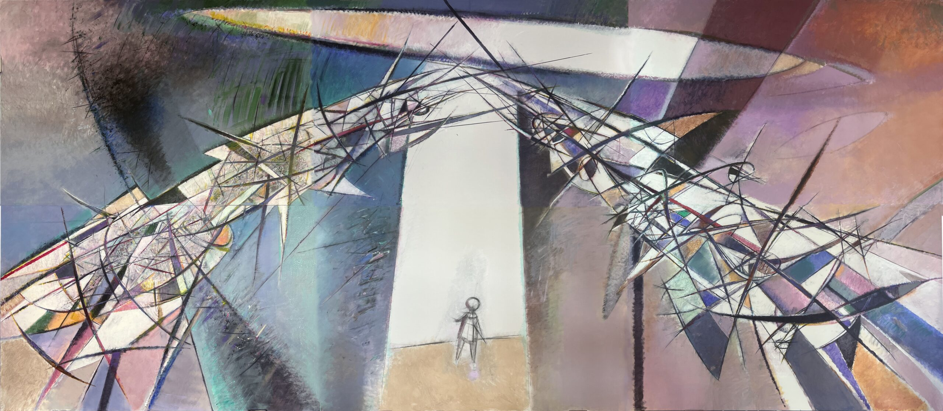

Yerbolat Tolepbay, "New child Rebirth", 2023-24

Practicum in Social Science Education

CTSE 4910 Fall 2025

Dr. Jesús A. Tirado Office Hours:
Jat0088@auburn.edu Wednesdays 9-11am.
203-809-5429

Course Description
CTSE 4910 is designed to apply pedagogical principles learned in CTSE 4050 to field examples of implementation of problem-based historical inquiry (PBHI). Students will analyze the strengths and challenges of designing and implementing PBHI in the Social Studies. Students will experience PBHI instruction, then identify the learning challenges facing students. Students will then analyze the role of scaffolding, teacher implementation decisions, and assessment in supporting students in PBHI.

Course Objectives: Upon completion of this course, students will be able to:
- Identify the instructional triangle: intellectual demand of task, depth of student thinking, role of teacher in influencing student thinking.
- Explain the different levels of Bloom’s Taxonomy.
- Apply EdTPA rubrics to lessons implemented in social studies classrooms.
- Analyze the instructional triangle and explain how to raise student thinking in problem-based inquiry-based instruction.

Course Requirements and Evaluation
Task | % of Course Grade
I. Participation in class pedagogy experiences and reflection | 30%
II. Video Case written analysis and EdTPA scoring | 30%
III. Professionalism* | 30%
IV. Final Reflection on instructional triangle | 10%
* Core Competency--See # 1 in General Policies and Professional Performance Index
Texts: Materials on Canvas

General Class Policies: BE PROFESSIONAL
- Core Competency: Professionalism
  - Students must receive at least an “Approaching Competence (C)” assessment of competency on the Professional Performance Index to exit the course.
  - Assignments are due on announced dates. Unexcused late assignments are unacceptable. Students are responsible for initiating arrangements for missed work due to excused absences.
  - Cell phones and other mobile media devices should not be used during F2F class or in field experiences. Devices should be turned off and put away during all professional meetings at AU or in the field. Laptops or iPads should not be left open throughout class but used only to access material directly related to class activities.
  - Attendance is required. Punctuality is essential. Those with more than one unexcused absences can receive no more than a “D” for the course. Three unexcused tardies are the equivalent of an absence. E-mail or phone and leave a message at my office number above if you are going to miss class.
    - Excused absences: Students are granted excused absences from class for the following reasons: illness of the student or serious illness of a member of the student’s immediate family, the death of a member of the student’s immediate family, trips for student organizations sponsored by an academic unit, trips for university classes, trips for participation in intercollegiate athletic events, subpoena for a court appearance, and religious holidays. Students who wish to have an excused absence from class for any other reason must contact the instructor in advance of the absence to request permission. The instructor will weigh the merits of the request and render a decision. When feasible, the student must notify the instructor prior to the occurrence of any excused absences, but in no case shall such notification occur more than one week after the absence. Appropriate documentation for all excused absences is required. Please see the Student Policy eHandbook and A Healthier U for more information on excused absences.
    - Make-Up Policy: Arrangement to make up missed work due to properly authorized excused absences must be initiated by the student within one week of the end of the period of the excused absences(s). Except in unusual circumstances, such as the continued absence of the student or the advent of university holidays, make-up work will be completed within two weeks of the date that the student initiates arrangements for it. Except in extraordinary circumstance, no make-up work will be arranged during the last three days before the final exam period begins.
- Texts will be heavily used in class. BRING ASSIGNED READINGS EACH DAY.
- Monitor your AU e-mail account regularly for class messages.
- Academic Honesty Policy: All portions of the Auburn University student academic honesty code (Title XII) found in the Student Policy eHandbook will apply to university courses. All academic honesty violations or alleged violations of the SGA Code of Laws will be reported to the Office of the Provost, which will then refer the case to the Academic Honesty Committee.
- Disability Accommodations: Students who need accommodations are asked to electronically submit their approved accommodations through AU Access and to arrange a meeting during office hours the first week of classes, or as soon as possible if accommodations are needed immediately. If you have a conflict with my office hours, an alternate time can be arranged. To set up this meeting, please contact me by e-mail. If you have not established accommodations through the Office of Accessibility, but need accommodations, make an appointment with the Office of Accessibility, 1228 Haley Center, 844-2096 (V/TT).

AI Policy

Lesson planning is integral to teaching. It requires deep knowledge of a discipline, the modes of inquiry in that discipline, and complex understandings of one’s students (Pedagogical Content Knowledge). It is also hard. LLMs may be useful tools in developing components of a lesson plan (questions for a document, prompts for a rubric, models of a poem, etc.) but they are not a replacement for the deep thinking and procedural processing of a strong lesson based in the PIH design principles.

If you use AI generative tools for any materials for this course, it must be cited as you would cite any reference. Please use this format: OpenAI, chatGPT. Response to prompt: “Write five analytical questions for document X.” or “can you generate a letter by Charles Talleyrand that argues in favor of France negotiating a truce with Toussaint L'Ouverture in Haiti on a 7th Grade Reading level? (February 15, 2023, https://chat.openai.com/).

The material generated by these AI LLMs may be inaccurate, incomplete, or otherwise problematic. Beware that use may also stifle your own independent thinking and creativity. It is each student’s responsibility to assess the validity and applicability of any AI LLM output that is submitted; you bear the final responsibility for the quality of your work.

Course contingency: If normal class and/or lab activities are disrupted due to illness, emergency, or crisis situation, the syllabus and other course plans and assignments may be modified to allow completion of the course. If this occurs, an addendum to your syllabus and/or course assignments will replace the original materials.

Professional Performance Index (PPI): Descriptive Evaluation Criteria

For use in Assessing Contributions to Class Activities and Professionalism

Exemplary
93-100 A Exceptional organization and performance in all facets of the course.
90-92 A- Defines own standards beyond those established. Work reflects serious consideration of
readings and shows substantial variety and significant creativity. Demonstrates ability to ask pertinent questions as well as answer them. Demonstrates holistic view of the subject and of secondary students in instructional decisions. Significant leadership in contributing to content of class sessions.

Competent
87-89 B+ Formulates useful questions. Shows creativity.
83-86 B Physically and mentally alert to standards. Places subject in context of social studies content
courses. Answers questions independently.
80-82 B- Draws some parallels to other experiences and readings.

Functional
76-69 C+ Participates with cueing.
70-75 C Physically and mentally present. Passive acceptance of subject.

Minimal
60-69 D Inability to understand or accept basic standards. Physically and/or mentally absent too
often.

Unsatisfactory
59 F Massive indifference to standards of professional behavior and scholarship or professional
negligence in a laboratory experience.

COURSE SCHEDULE

Due Date | Reading and Lesson Assignments
8/19 | Syllabus Intro to Congressional Hearing Lesson
8/21 | Prepare expert presentation for Congressional Hearing
8/26 | Perform Congressional Hearing
8/28 | Analyze Learning Challenges in Congressional Hearing  HW: View video clips and post reflections in Canvas
9/2 | Discuss instructional triangle reflections on Congressional Hearing video case  Show EdTPA lesson plan and instruction rubrics
9/9 | Intro to India Lesson and expert group document analysis
9/16 | Make persuasive billboards and present  HW: assess video clips with EdTPA rubrics
9/23 | Discuss scores for EdTPA rubrics on Imperialism lesson implementation  HW: assess lesson materials of NY EdTPA lesson
9/30 | Discuss scores of teacher implementation of NY EdTPA rubrics.  HW: assess lesson implementation of SC lesson with EdTPA planning and instruction rubrics
10/14 | Discuss EdTPA rubric scoring and final reflection on instructional triangle from SC video case.
10/21 | FINAL REFLECTION PAPER DUE  Submit over canvas

