AUBURN UNIVERSITY
SYLLABUS
- Course Number: CTSE 5000/6000
- Course Title: Technology and Applications in Science
Credit Hours: 2 Semester Hours
Prerequisites: None
Corequisites: None

- Term: Spring 2025
Instructor: Mr. Michael Moultrie (Undergraduates) and Dr. Melody Russell (Graduates)
Day/Time: Tuesdays 6:00pm – 7:50pm
Place: EDUC 2114
Contact Information: mdm0030@auburn.edu and russeml@auburn.edu
Preferred method of contact: Michael’s Email

Office Hours: By appointment. Email me, and we will set something up. I will be on campus Tuesdays and Wednesdays.

In case we need to have a Zoom meeting, meet me here:

https://auburn.zoom.us/j/3152478231

3. Texts: None required. Readings will be provided through Canvas.
This course will require the use of the learning management system, Canvas which can be accessed from the Auburn University website (www.auburn.edu). An orientation can be provided if requested.
Computer requirement: You need a laptop computer you can bring to class (Mac or PC) and install software on for use. Please see your instructor if you do not have a laptop computer that you can bring to class and install software on. iPads or tables may work, but then again, they may not work for all applications.
4. Course Description:
This course serves as an introduction and application of current and emerging instruction and communication technologies for integration in the secondary science program. It is an introduction to technology tools supporting inquiry, the Alabama Course of Study, the Next Generation Science Standards, and the National Science Education Standards in the secondary science classroom.
5. Course Objectives
- Facilitate and inspire student learning and creativity by providing a variety of learning environments that foster collaboration and innovative thinking to solve real world issues and authentic problems using digital tools and resources. 290-3-3-.42 (4)(b)1.
- Design, develop, use, manage, and assess authentic digital-age learning experiences that are aligned with subject-area content and the Alabama Course of Study: Technology Education to maximize content learning and address diverse learning styles, incorporating the use of formative and summative measurement tools to better inform learning. 290-3-3-.42 (4)(b)2.
- Model and facilitate innovative digital-age work and learning experiences through the effective use of current and emerging tools to ensure success in a global and digital world whereby the teacher and learner locate, analyze, evaluate, manage, and report information as well as communicate and collaborate online fluently using a variety of technology-based media formats. 290-3-3-.42 (4)(b)3.
- Promote, model, and communicate the safe, legal and ethical principles of digital citizenship, equitable access, digital etiquette, and responsible online social interactions in a global culture including respect for copyright, intellectual property, the appropriate documentation of sources, and Internet user protection policies. 290-3-3-.42 (4)(b)4.
- The role, nature, limitations, and use of media and technology for instruction and scientific investigation, including the use of virtual labs, computers, probeware, and other emerging technologies. 290-3-3-.14 (2)(e)2.(ii)
- Engage in professional growth and leadership activities, including modeling lifelong learning by participating in face to face and online learning communities to continuously improve professional practice using existing and emerging digital tools, resources, and current research that focuses on improved student learning, as well as promotes professional development of other educators. 290-3-3-.42 (4)(b)5.
- Include active inquiry lessons where students collect and interpret data in order to develop and communicate concepts and understand scientific processes, relationships and natural patterns from empirical experiences. Applications of science-specific technology are included in the lessons when appropriate. AS 2.2
- Design instruction and assessment strategies that confront and address naïve concepts/preconceptions. AS 2.3
- Use a variety of strategies that demonstrate the candidates’ knowledge and understanding of how to select the appropriate teaching and learning activities – including laboratory or field settings and applicable instruments and/or technology- to allow access so that all students learn. These strategies are inclusive and motivating for all students. AS 3.1
- Develop lesson plans that include active inquiry lessons where students collect and interpret data using applicable science-specific technology in order to develop concepts, understand scientific processes, relationships and natural patterns from empirical experiences. These plans provide for equitable achievement of science literacy for all students. AS 3.2
- Collect, organize, analyze, and reflect on diagnostic, formative and summative evidence of a change in mental functioning demonstrating that scientific knowledge is gained and/or corrected. AS 5.1

All students in this course are expected to have all the equipment and software needed to be successful in the course.
All students are expected to contribute to their own learning as active and well-prepared participants. Weekly modules will provide various opportunities for reading, reflection, applied experiences, collaboration, and writing. You should plan on spending the same amount of time outside of class working on technological tasks as you do in class.

6. Course Content Outline (subject to change)

Class | Date | Module Due | In-Class Activities | Homework due that day at 6:00
1 | 8/19 | 1 | Overview of Course  Inventory of skills.  Introductions.  How have you seen technology change in schools?  Syllabus  Canvas  Show how to use library to access NSTA articles  Presentation Tools  Sway  Google Tool  Assessment  PollEverywhere | none
2 | 8/26 | 2 | Intro to design for 3D printing.  Show how to use TinkerCAD  How to use 3D printer, Thingiverse  Other Tools  TinkerCAD  Google  Google Classroom | Make a presentation to introduce yourself. We will all look at these to study for the Name Quiz. Post URL on Canvas in Announcements.
3 | 9/2 | 3 | Observation and Inference  windy.com  Stellarium  ExploreLearning  phet  Animal cams  Name Quiz  Google Tool  Google Earth | Complete Google Units 1 and 2  Name Quiz
4 | 9/9 | 4 | Lesson planning  Research on Simulations  Moon inquiry with Stellarium  Turn in your Moon inquiry | Read one NSTA article on technology and submit summary.  Complete Google Unit 3
5 | 9/16 | 5 | Inquiry  Observation and Inference mini-lessons  Show ExploreLearning  and PhET and teach a demo lesson. Have Ss grade me.  Show lesson plan examples. | Prepare for Observation and Inference mini-lesson.  Complete Google Unit 4
6 | 9/23 | 6 | Flipping the Classroom  Google Tool  Google Slides and Slido  Subscribe to YouTube Channels like Kurzgesagt  NearPod  Paleobiology Database  Google Earth  Screencastify  Best practices for using PowerPoint  Improving a PPT | Complete Google Unit 5  Submit name of simulation
7 | 9/30 | 7 | Google Tool  Google Slides and Slido  NearPod  Paleobiology Database  Google Earth  Screencastify | Screencastify mini video due  Submit your Google Form URL  Complete Google Unit 6  Submit name of simulation
8 | 10/7 | 8 | 3D printing Week (OPTIONAL ATTENDANCE) | Complete Google Unit 7
Fall Break October 9th & 10th
9 | 10/14 | 9 | Assessment  Kahoot  Plickers  Flipgrid  ZipGrade  Quizlet  Quizizz  Socrative  Google Forms  Screencastify | Turn in simulation lesson plan.  Complete Google Unit 8
10 | 10/21 | 10 | PhyPhox  Science Journal  Do probe activity | Install Phyphox and Arduino Science Journal on your phones  Start sharing your Google Form  Draw to Design Due.
11 | 10/28 | 11 | Little Robots & Scratch | Complete Google Units 9 & 10  First Print due.
12 | 4/8 | 12 | Explore Learning Lessons | Complete Google Units 11 and 12  Thingiverse Thing due.
13 | 11/4 | 13 | Science teaching videos | Present Leftover Simulation Lesson
14 | 11/11 | 14 | Communication  Show teacher portfolio examples  Remind  Google Hangouts | Design a Thing due  Complete Google Unit 13  Start Portfolio. Submit URL
15 | 11/25 | 15 | Excel for gradebooks and test analysis  Analyze test data. | Consider doing Google Level 1 Certified Educator Test (Due before the end of the semester)  Turn in Excel data analysis
16 | 12/2 | 16 | Submit Screencasted lesson and Teacher Portfolio and pass Google Exam. | Pass Google Level 1 Certified Educator Test.  Teacher Portfolio due.  Science Video due.

Additional Course Requirements for CTSE 6000 (Graduate Students in the MS or PhD or Traditional MEd)
Graduate Students- Article Critique from article on technology in the science classroom from Science Education journal . More details will be provided

7. Grading

Undergrads
Google Education Prep Assignments 5pts
Class activities (See Canvas for details) 25pts
Home activities (See Canvas for details) 20pts
Article Critique (See Canvas for details) 10pts
Science video (See Canvas for details) 10pts
Teacher portfolio (See Canvas for details) 10pt
Google Certification 10pt
Pop 2 quizzes (5 pts each) 10pts

A = 90% or higher
B = 80% - 89%
C = 70% - 79%
D = 65% - 69%
F = below 65%

Any assignment presented or turned in late without a valid excuse will be penalized 1 pt for each day late. Late assignments presented or turned in late after 3 days will not be accepted.

Class Activities:

- Introductory Sway: Your homework is to make a Sway presentation about yourself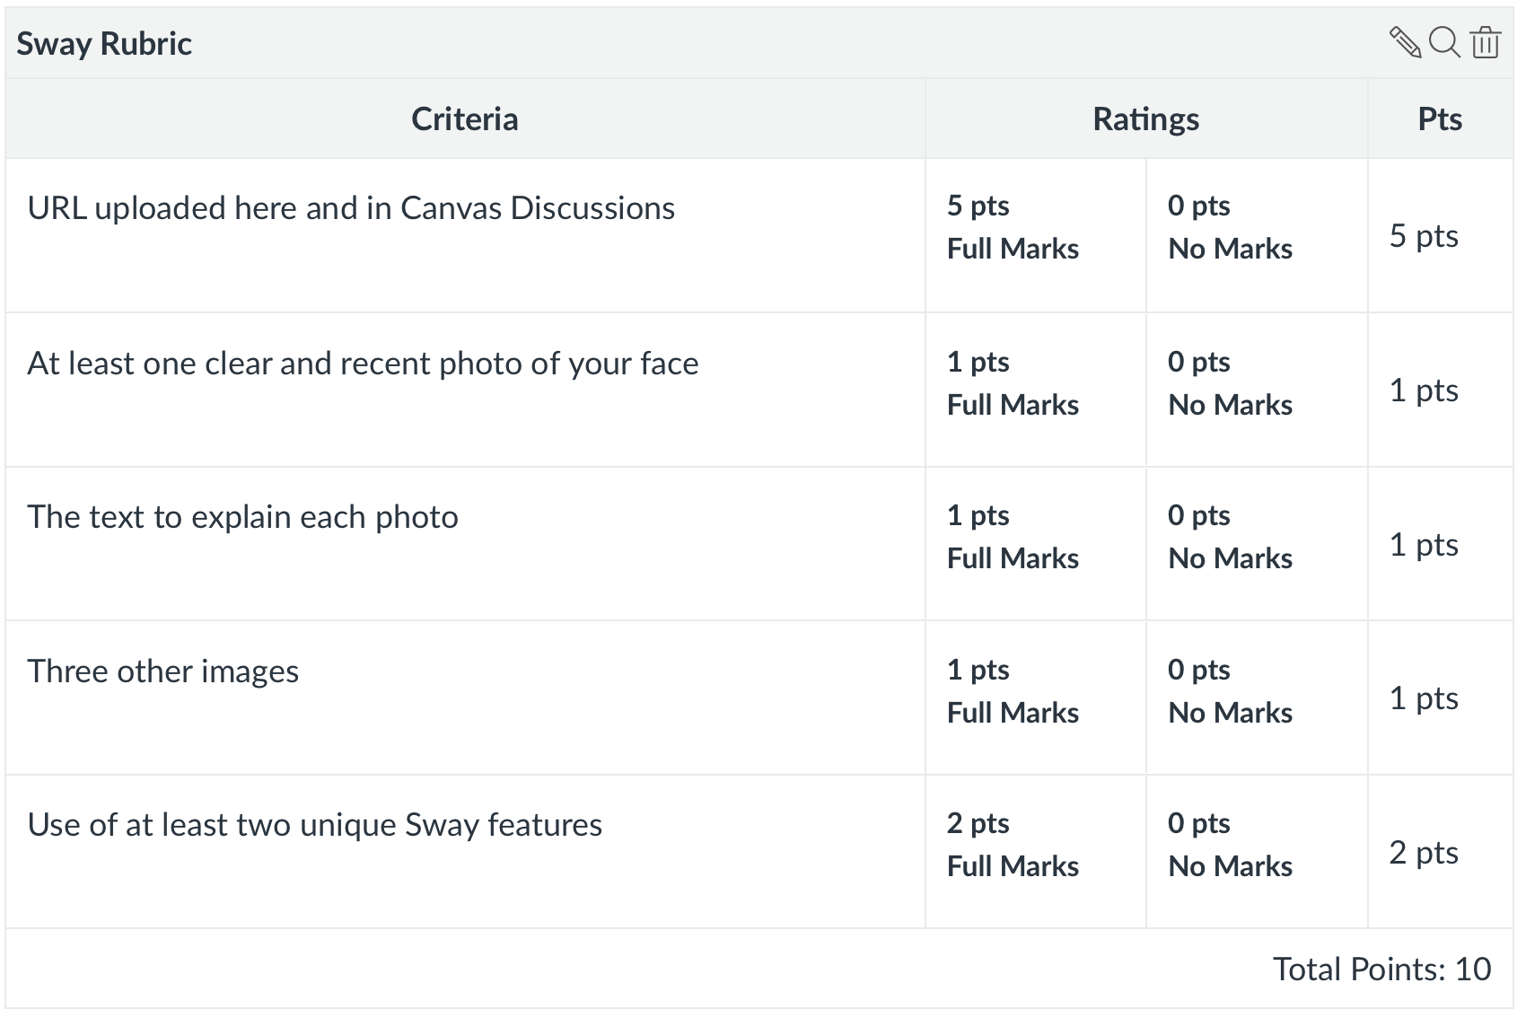
- Join my Google Classroom: It is important to know what it’s like to be a student in a Google Classroom- what permissions you have, how to submit assignments, and how to communicate with the teacher and peers. Join my Google Classroom and see what it’s like to be a student.
  - Google Classroom Joined: 5 points.
- Create your own google classroom: It is also important to know how to run a Google Classroom as the teacher. Many schools use it like we use Canvas at Auburn. I want you to set up a Google Classroom of your own and invite me to be a student in your class.
  - Instructor can join your google classroom: 10 points
- Name Quiz: You will need to name each of your classmates by first and last name through recognizing a picture of them.
  - Total: 10 points
- Observation and inference image: This is a peer-teaching activity. The purpose is to practice leading students in a simple activity which is fundamental to science. Find an image or a gif which is compelling and has a scientific component. Upload the image by 3pm so that I can compile all the images and videos into a presentation for class. Include a list of the questions you plan to ask. 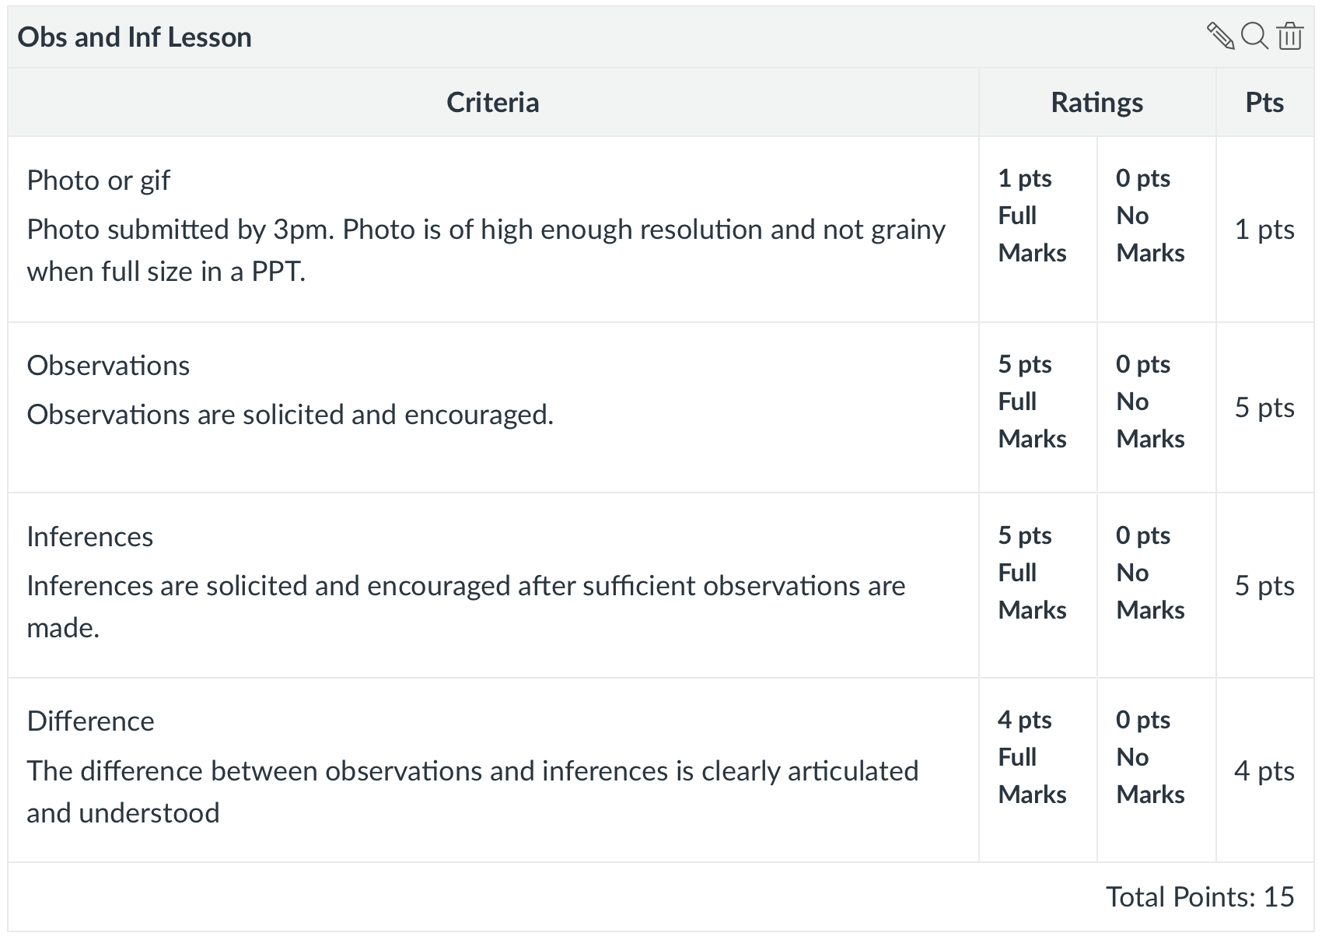
- Inquiry with PhyPhox and/or Arduino Science Journal: Using PhyPhox or Arduino Science Journal, collect data in order to answer a scientific question. For example, you might ask, "Where in an elevator is the EMF strongest? or "How does air pressure change as you ascend the stairs in a 9 storey building?" or "If I spin around in a chair, how does my velocity change as I pull my arms and legs in?" 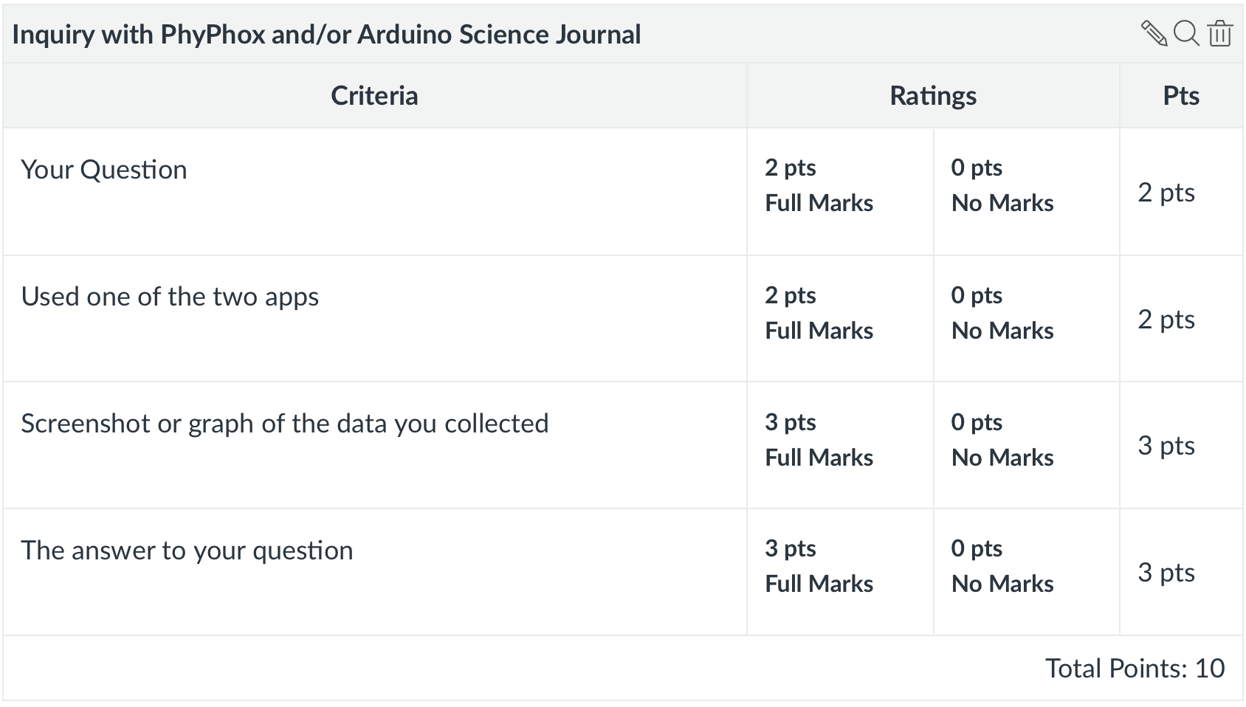
- Scratch Embedded in Website: You were asked in class to embed the code of a Scratch animation into a website. Scratch animations are great for teaching a topic that is hard to visualize, and I want you to practice creating an animation and embedding it in a website. In the future, you might have a website for your students with animations you collect or create.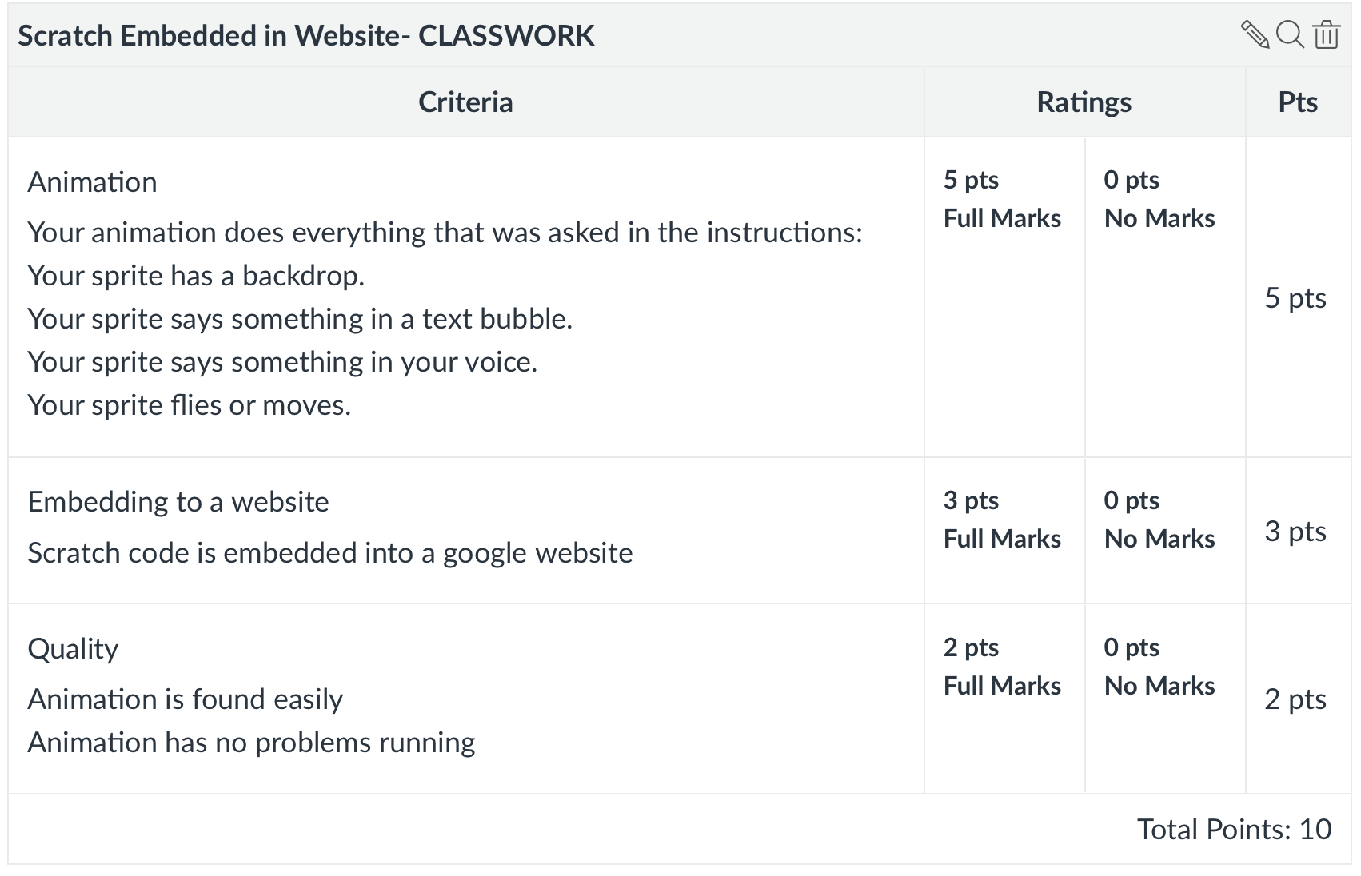
- Simulation Presentation: You will be presenting the simulation of your choice to your classmates today in a lesson that you design. The goal of this activity is to give you practice teaching in a safe environment. You will need to practice engaging your students, teaching them something in that process, and evaluating their learning.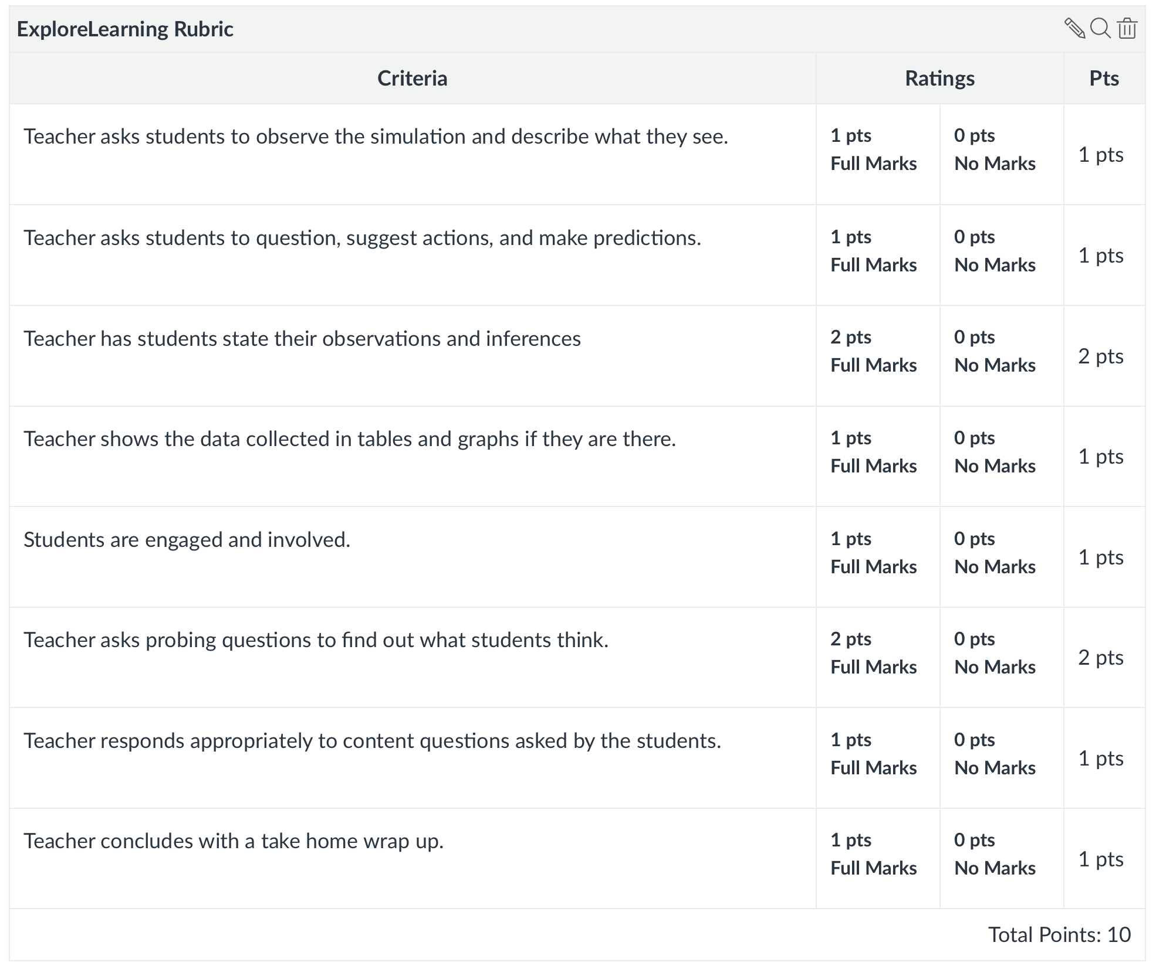
- Analyze Data with Excel: The point of this activity is to teach you how you can analyze student test data. You will be able to compute descriptive statistics for your class as well as compute measures on each of your test questions. This process helps you decide if all your test questions were fair, and helps a teacher know when to discard a question that is flawed.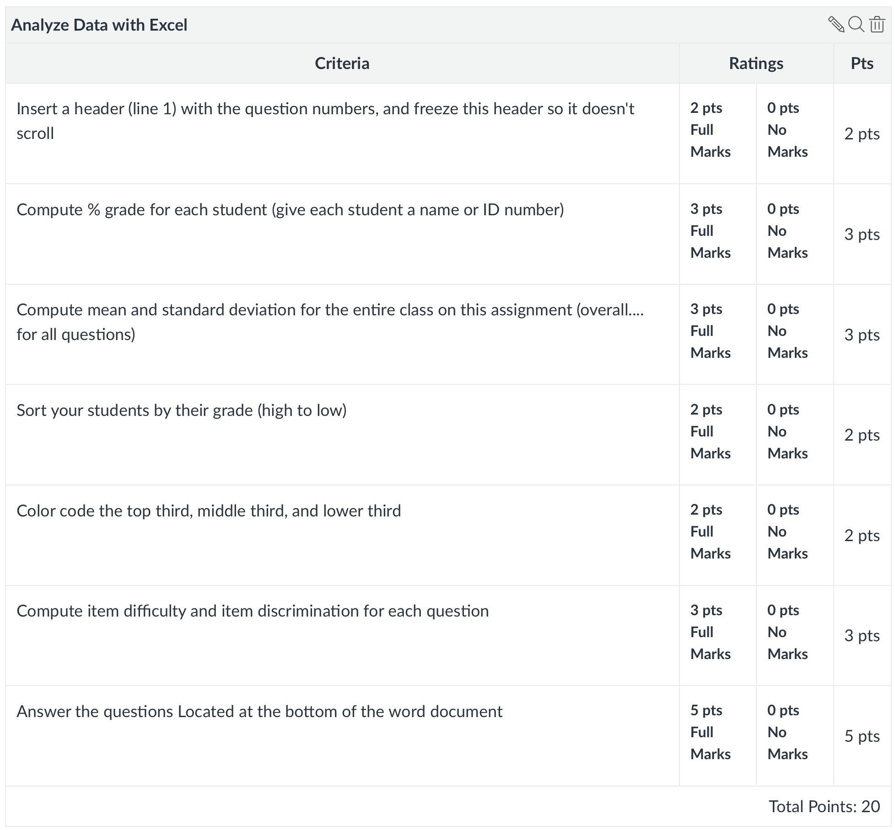

Home Activities:

- Google Educator Assignments(6 Assignments, 1 Test): This semester, you will take the Google Educator Level 1 exam, a multiple-choice exam that takes between 1 and 2 hours. Passing this exam will certify you as a Google Educator, which will earn you respect from teachers and school administrators. The skills you learn in order to pass this exam will help you teach, assess, and manage a classroom.
  - Afterwards, write about any new skills you learned (Reporting), what you found challenging about the new skills (Responding), and three ways you might use what you learned with your future students (Relating).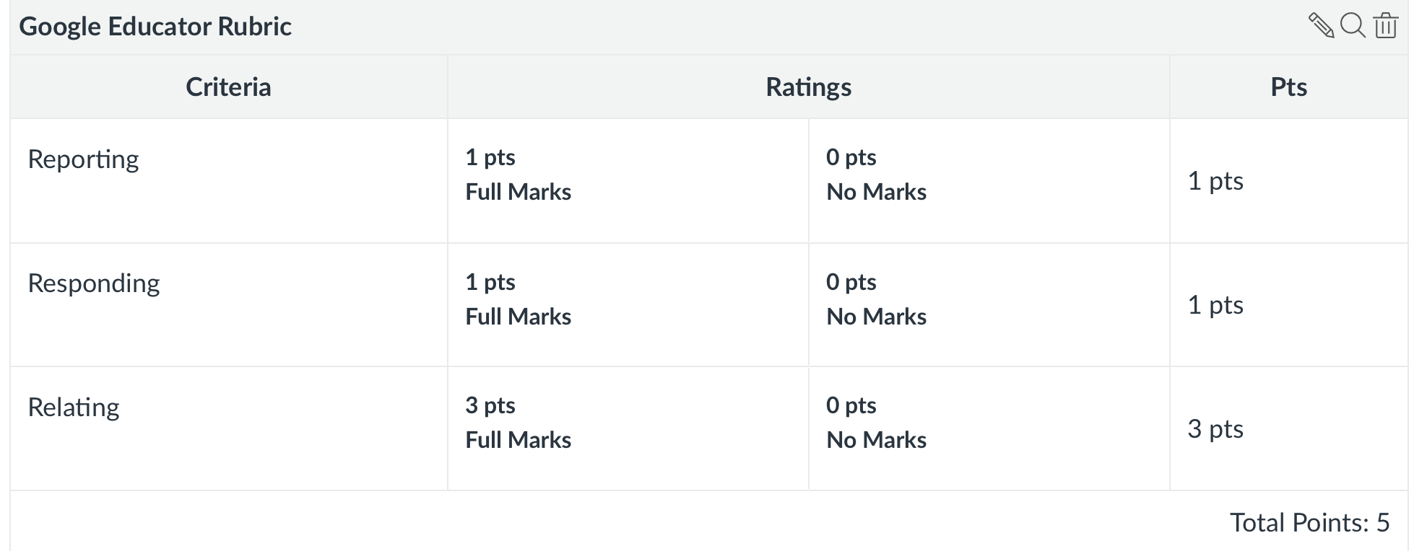
- 3D Printing Assignments:
  - Draw to Design: Sometimes the thing you need most to 3D print cannot be easily drawn in TinkerCAD. This exercise takes you through the steps of designing a printable item on PAPER.
  - Your First Print: You need to get over any fears of the 3D printer, so this assignment encourages you to just print something- it can be an item already on your thumb drive, or an item you download from the Internet. This allows you to practice what you learned, and also solve any problems you may encounter. It prepares you for future assignments with the printer.
  - Thingiverse Thing: The point of this assignment is to give you practice finding a design you like, and modifying something about it, and printing it. Thingiverse is a repository for .stl files of items created by other people. But sometimes, you find something useful that isn’t quite what you need. 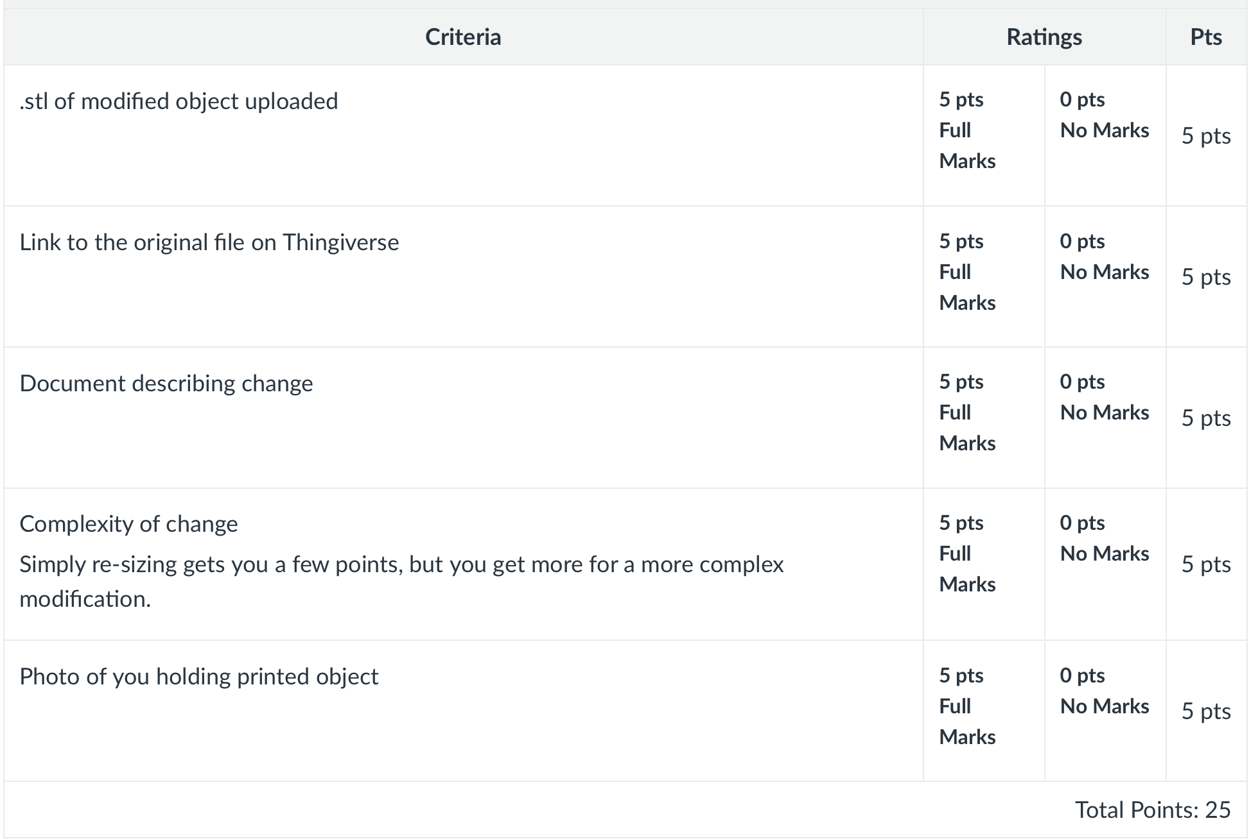
  - Design a Thing: The objective of this assignment is to encourage you to apply everything you have learned about Tikercad and 3D printing. You can get some ideas from www.thingiverse.com Links to an external site. but I want you to go through the entire process yourself. This is an opportunity for you to design something from scratch and see how it turns out. It really ought to be something useful- not something that will get tossed in the trash after class. Doing this will help you feel confident enough to really use 3D printing in the future.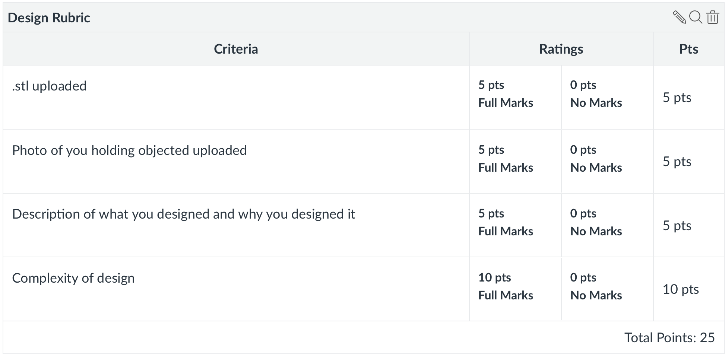
- Moon Inquiry: The purpose of this assignment is for you to learn about the research-based best practices for using simulations in science teaching so that you can eventually design a lesson using a computer simulation, and deliver this lesson to your peers.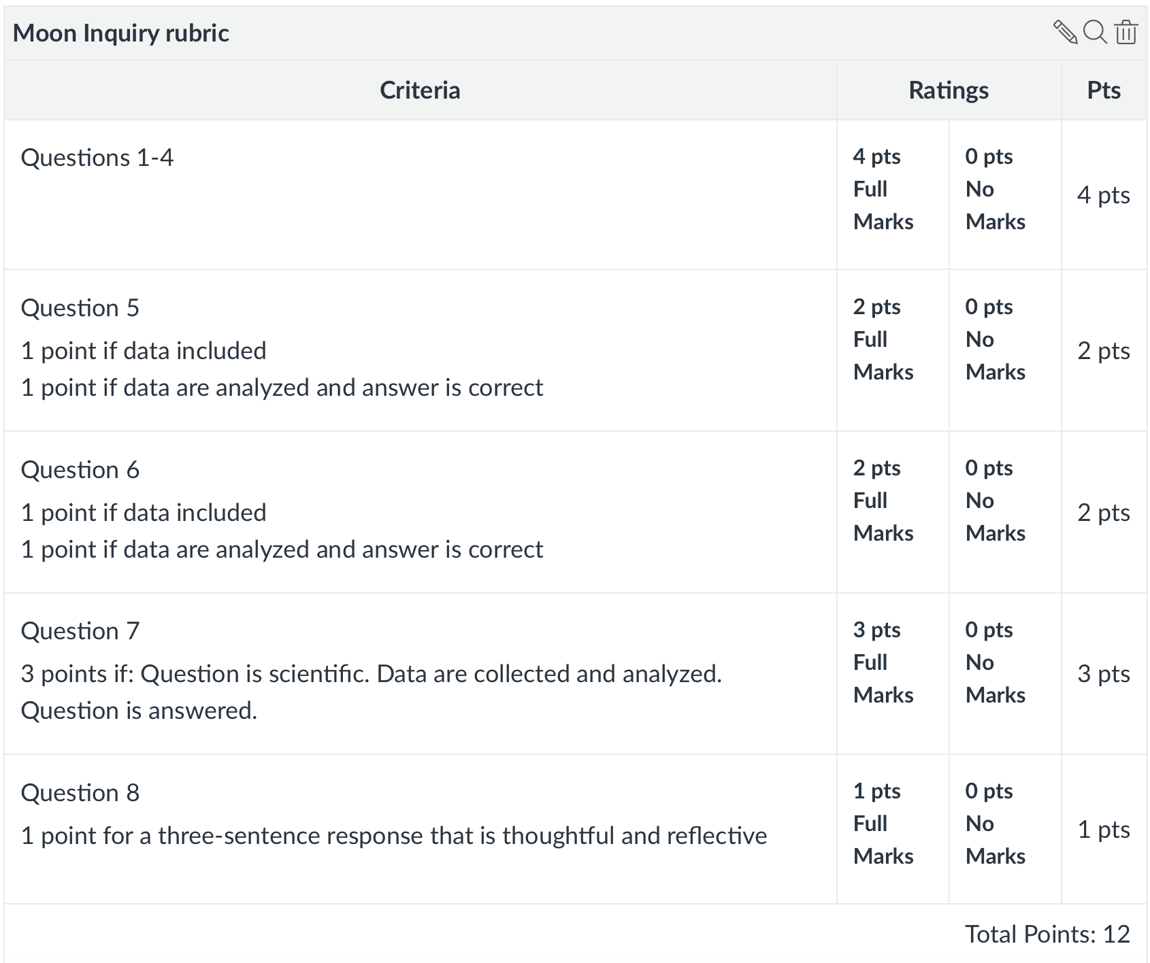
- Choose a simulation (5 points): Soon you will be teaching a lesson to students in class, pretending that they are middle or highschool students. This gives you practice in the comfortable environment of your friends, and adds a lesson to your database for teaching in the future! You will choose a simulation, write a lesson plan, and after it’s approved, teach it to a section of students. You will be evaluated by your instructor as well as by your students!
- Google Form (10 points): Later in the semester, you are going to learn how to use Excel to analyze test data. You will do much more than compute averages, you’ll be able to calculate item difficulty and discrimination values. However, I want you to be able to analyze your own test data. So, the purpose of this assignment is to make a test and administer it to people--- get them to take your test!
- Mini Screen Capture Video: This week I want you to install and play with Screencastify. The objective is to get you comfortable with all the features it has, so you can use it in the future whenever you need to teach someone something and send a screencast. Also, your final project in this class will be to make an instructional video, and Screencastify can be super helpful in capturing anything you have on your computer.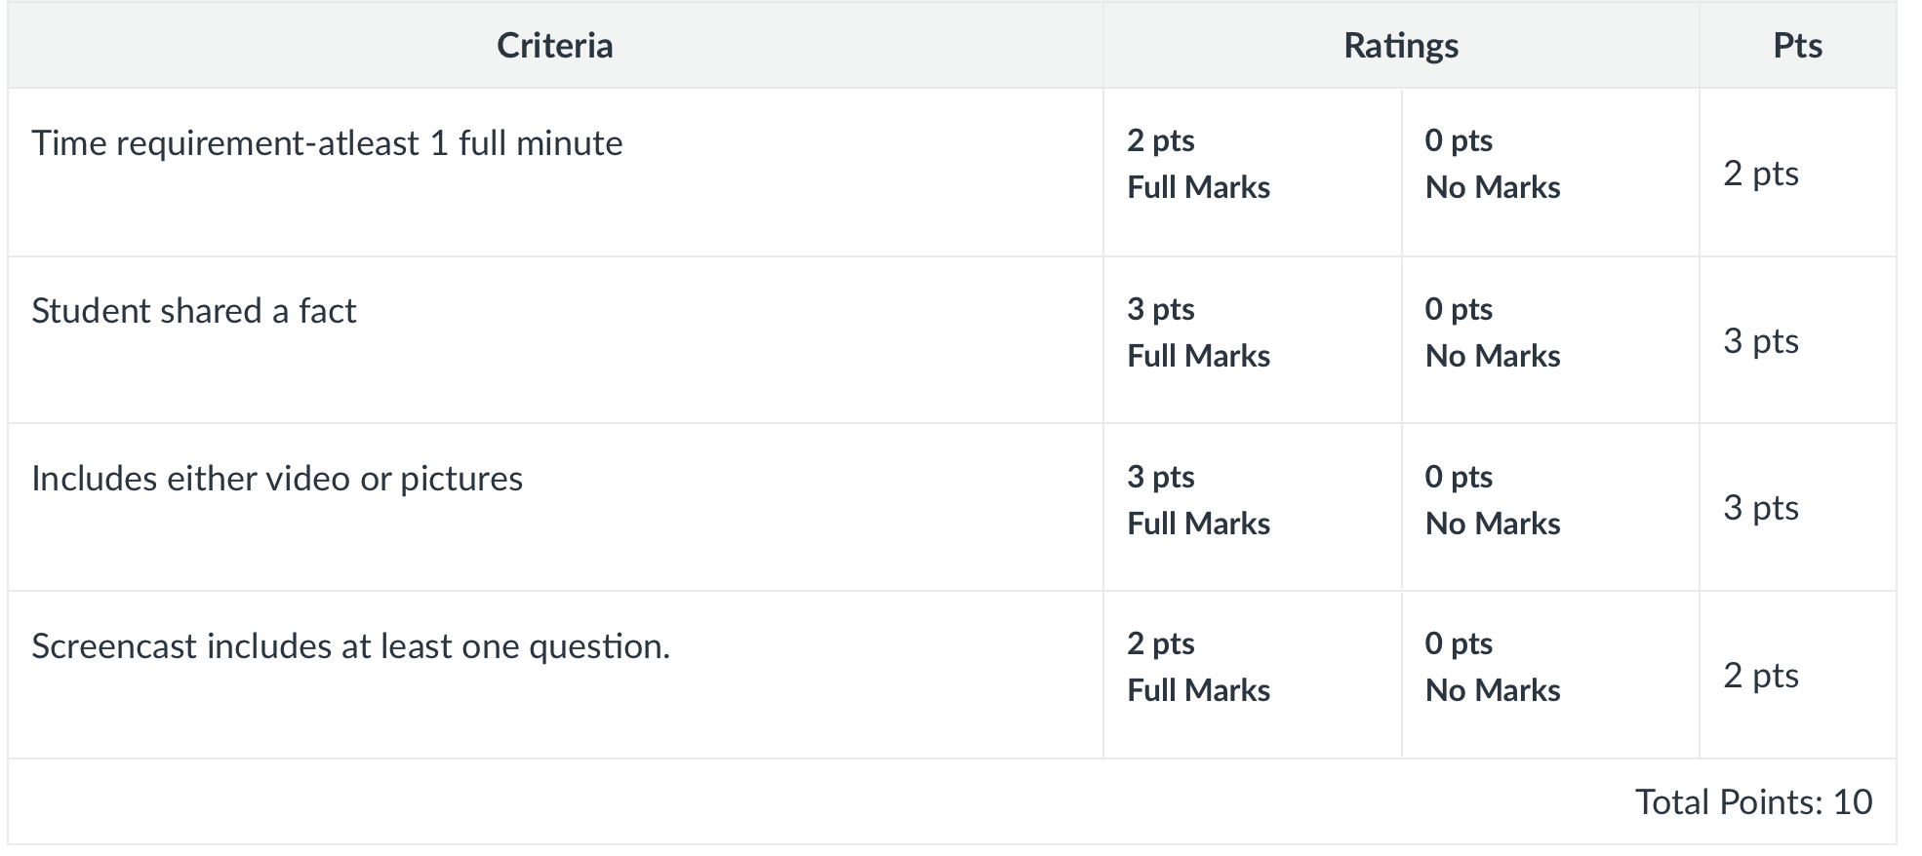
- Lesson Plan: Create a lesson plan for your simulation lesson. You will be teaching this lesson to the technology class. It should take no more than 15 minutes, so include planned timing in your lesson. You will start your lesson with an Engage phase activity where you determine what your students already know about the topic, and get them interested in learning. Write down all the questions you plan to ask on your lesson plan. Then, you will transition to the Explore phase where students are not necessarily learning new ideas or concepts, but they are EXPLORING a new idea or concept with you as the guide. Include all the questions you plan to ask on your lesson plan. 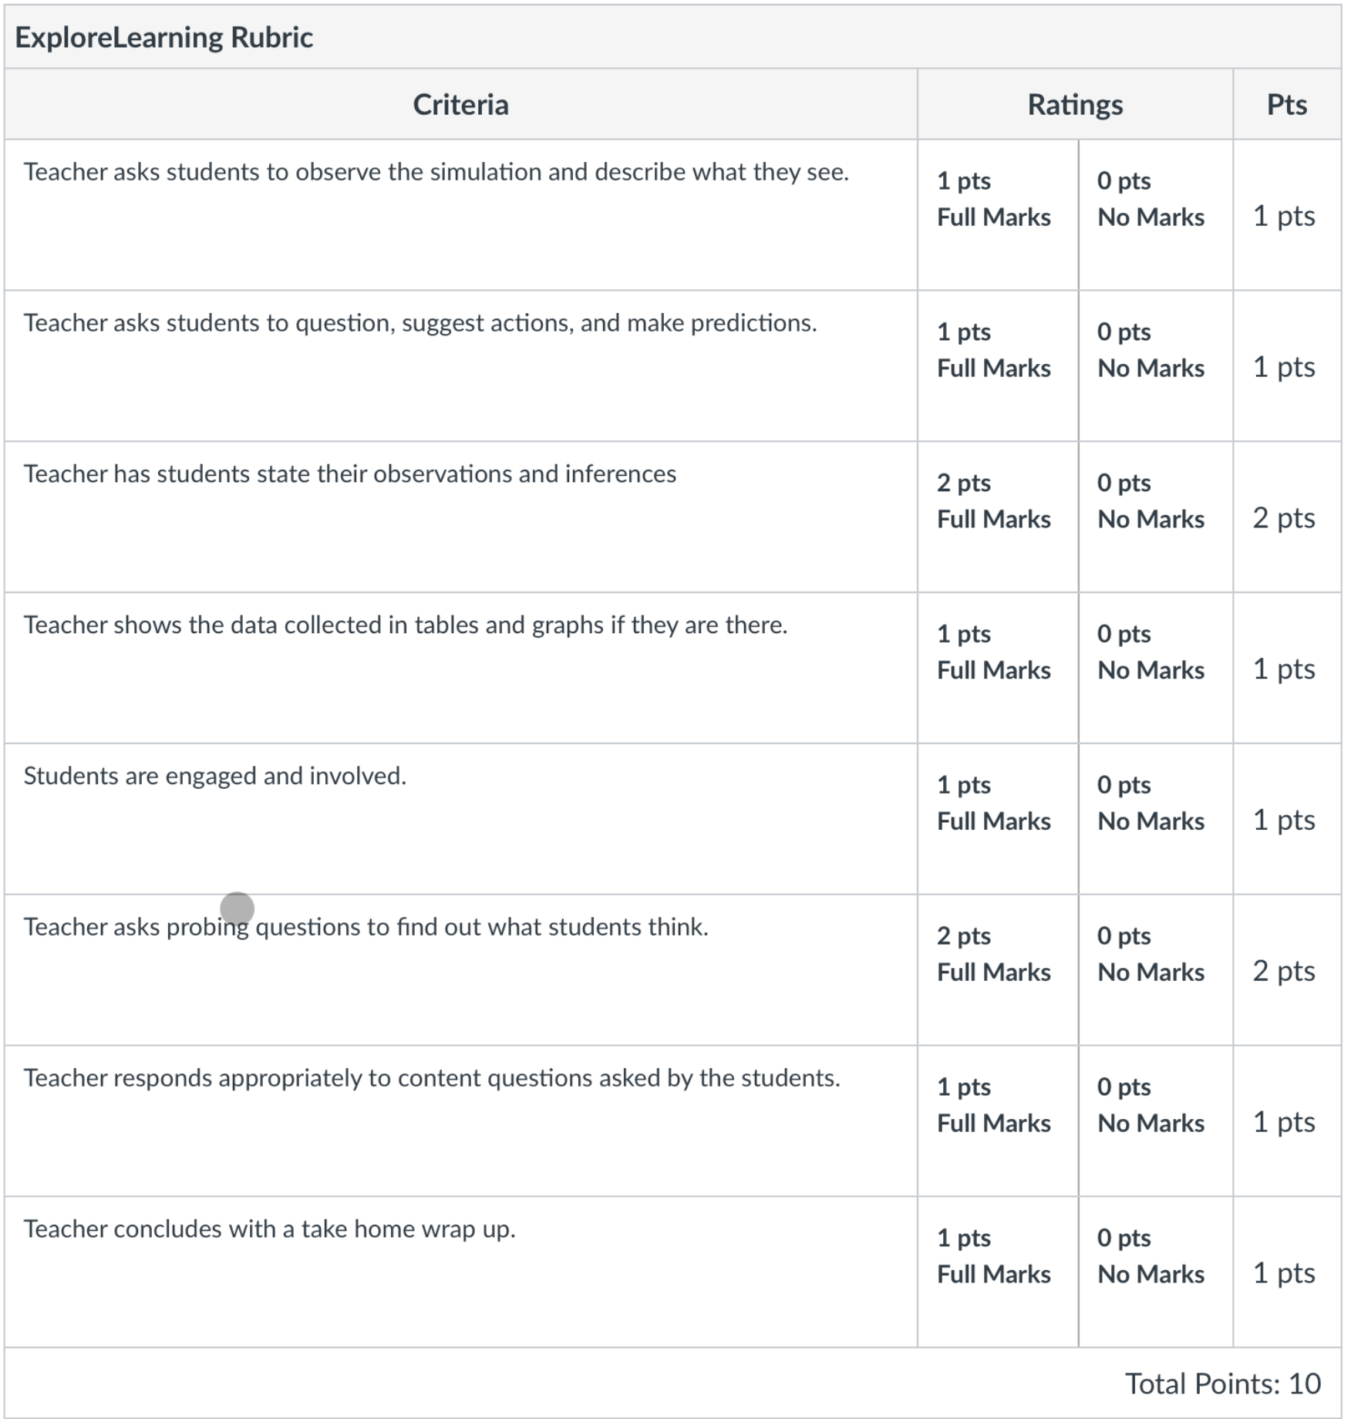
- Start your Teacher Portfolio! : This week, I want you to get started designing and building your teacher portfolio. You may use Google Sites or Weebly Weebly, Wix, or your own method. Submit your URL so I can see what you've started to do.
  - URL for website submitted and works: 10 points
- Make a Nearpod (10 points): Last week you used a Nearpod to learn about science videos. Create an account for yourself and be a teacher! Make a Nearpod to teach somebody something and find out what they learned! Submit the url here. Click Teach and Student Paced and copy the url.
- Teacher Portfolio: The purpose of this assignment is to 1) help you know how to make a website, 2) allow you to demonstrate some of the skills you have learned in this class, 3) encourage you to create your own portfolio you can keep updated. It will help you in the future when you apply for teaching jobs. 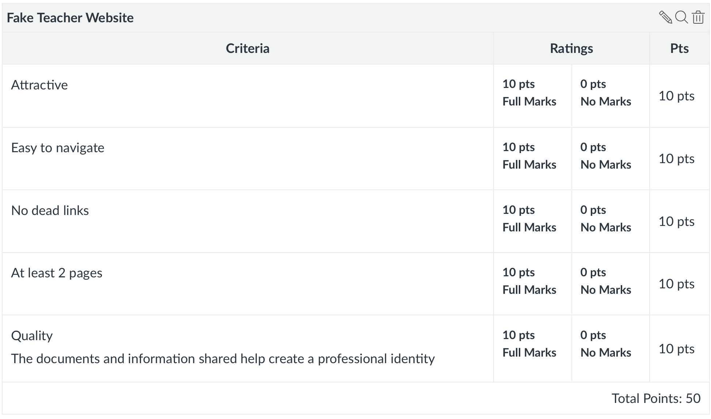
- Teaching Video, Final Exam: The point of this assignment is to encourage you to apply all that you learned in this class to the actual teaching of a science topic. Instead of teaching to a classroom of students, think of videos as a way to teach any topic to a broader audience. In any job you have, whether teaching or otherwise, you will likely need to teach something over and over. Think of this as a way to practice that skill. You will create a teaching video that teaches a science concept to a YouTube audience of people who have very little prior knowledge of the concept. Think along the lines of "middle school age-8th & 9th grade." Use the tools you learned about in class this semester. I want to see you SHOWCASE what you have learned. I'll be looking at your communication skills, your use of simulations, your use of authentic images, your use of formative assessment tools, etc. Post a URL of your video to our class Google Classroom. It can be a Zoom link, a screencastify link, or a YouTube link, etc. It needs to be more engaging than a Khan Academy video.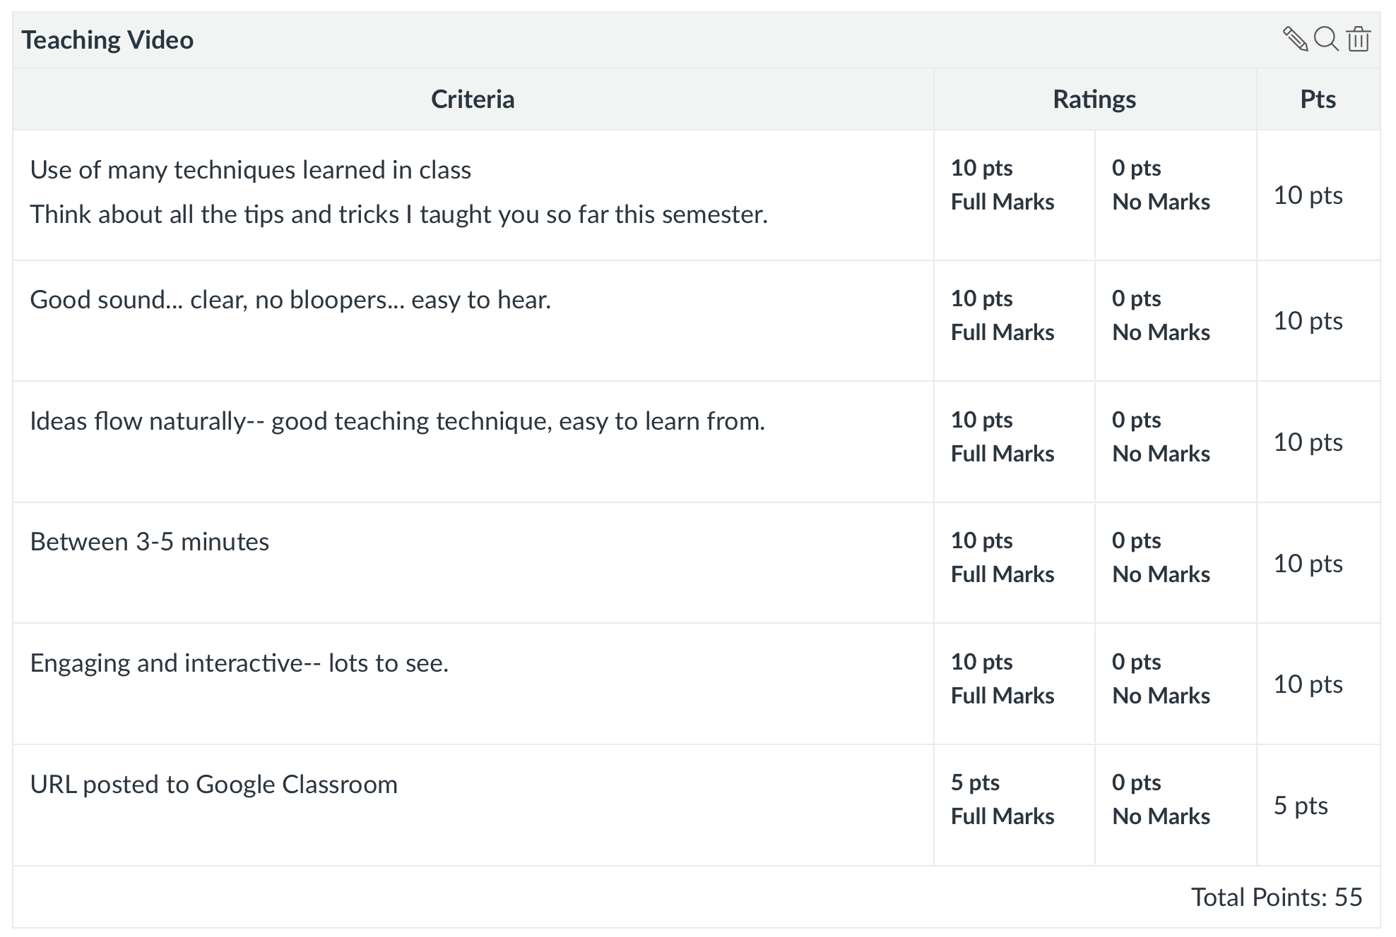

8. Class Policy Statements:
A. Participation: Students are expected to participate in all class discussions and participate in all exercises.
B. Assignments: It is the student’s responsibility to contact the instructor if assignment deadlines are not met. Students are responsible for initiating arrangements for missed work, if extensions are given for very difficult situations. If work is not turned in on time, points will be deducted. One point for each day the assignment is late, and the assignment will not be accepted after 3 days (this includes weekends)..
C. Excused Absences: Attendance is required at each class meeting. If you cannot attend class, contact your instructor immediately and explain the situation. Students are granted excused absences from class for the following reasons-See AU official absence policy: Illness of the student or serious illness of a member of the student’s immediate family, the death of a member of the student’s immediate family, trips for student organizations sponsored by an academic unit, trips for university classes or research presentations, trips for participation in intercollegiate athletic events, subpoena for a court appearance, and religious holidays. Unexcused absences may result in 5 points deducted per absence from your final grade at the discretion of the instructor for this section. Appropriate documentation for all excused absences is required. Please see the Student Policy eHandbook for more information on excused absences (http://www.auburn.edu/student_info/student_policies/). Email documentation to your professor as soon as it is acquired.
D. Make-Up Policy: If an exam or assignment is missed, a second chance will be given only for university-approved excuses as outlined in the Student Policy Handbook www.auburn.edu/studentpolicies . Arrangement to take the make-up exam or turn in assignments late must be made in advance or as soon as possible if illness occurs. Students who miss an exam or assignment because of illness need a doctor’s statement for verification of sickness and should clear the absence with the instructor the day they return to class. Late, unexcused assignments should be turned in for feedback, even when points are deducted.
E. Unannounced quizzes: There will be 2 unannounced quizzes on the reading assignments.
F. Accommodations: Students who need accommodations are asked to electronically submit their approved accommodations through AU Access and to arrange a meeting during office hours the first week of classes, or as soon as possible if accommodations are needed immediately. If you have a conflict with my office hours, an alternate time can be arranged. To set up this meeting, please contact me by e-mail. If you have not established accommodations through the Office of Accessibility, but need accommodations, make an appointment with the Office of Accessibility, 1228 Haley Center, 844-2096 (V/TT).
G. Honesty Code: All portions of the Auburn University student academic honesty code (Title XII) found in the Student Policy eHandbook will apply to this class. All academic honesty violations or alleged violations of the SGA Code of Laws will be reported to the Office of the Provost, which will then refer the case to the Academic Honesty Committee. Assignments WILL be run through the university’s plagiarism detector. Plagiarism is a SERIOUS issue, and because of that, all incidents will be reported to the Office of the Provost. (What I put above in parentheses is a citation, and below, is a reference. Get used to doing this. Google Scholar makes it easy to copy and paste the APA reference.)
Park, C. (2006). In other (people's) words: Plagiarism by university students--literature and lessons. Assessment & Evaluation in Higher Education, 28(5), 471-488.
F. Course contingency: If normal class and/or lab activities are disrupted due to illness, emergency, or crisis situation, the syllabus and other course plans and assignments may be modified to allow completion of the course. If this occurs, and addendum to your syllabus and/or course assignments will replace the original materials. If class is cancelled, a notice will be sent out over Canvas, so make sure your settings route all announcements to your email.
G. Professionalism: As faculty, staff, and students interact in professional settings, they are expected to demonstrate professional behaviors as defined in the College’s conceptual framework. These professional commitments or dispositions are listed and paraphrased below.
- Engage in responsible and ethical professional practices in class, in schools, and in the community. Behave yourself in the schools, and in the community. Follow the rules. Do not break laws. Be a role model.
- Contribute to collaborative learning communities in class and in schools. Get along with your peers and your professors.
- Demonstrate a commitment to diversity in class, in schools, and in the community. Respect each other. Celebrate our differences. Listen. Care.
- Model and nurture intellectual vitality. Care about learning. Show your students this! Demonstrate your curiosity!

Course Contingency: If normal class activities are disrupted due to illness, emergency, or crisis situation, the syllabus and other course plans and assignments may be modified to allow completion of the course. If this occurs, an addendum to your syllabus and/or course assignments will replace the original materials.
Health and Participation in Class
You are expected to monitor your health. Your health and safety, and the health and safety of your peers, are my top priorities. If you are experiencing any symptoms of COVID-19, or if you discover that you have been in close contact with others who have symptoms or who have tested positive, you must notify me. My hope is that if you are feeling ill or if you have been exposed to someone with the virus, you will stay home to protect others and arrange to participate in class virtually. Please do the following in the event of an illness or COVID-related absence:
● Notify me in advance of your absence, if possible
● Provide me with medical documentation, if possible
● Keep up with coursework as much as possible
● Participate in class activities and submit assignments remotely as much as possible
● Notify me if you require a modification to the deadline of an assignment or exam
● Finally, if remaining in a class and fulfilling the necessary requirements becomes impossible due to illness or other COVID-related issues, please let me know as soon as possible so we can discuss your options.
Health and Well-Being Resources
College is difficult, and academic and personal stress is a natural result. Everyone is encouraged to take care of themselves and their peers. If you need additional support, there are several resources on campus to assist you:
● Student Counseling and Psychological Services (http://wp.auburn.edu/scs/)
● AU Medical Clinic (https://cws.auburn.edu/aumc/
● If you or someone you know are experiencing food, housing or financial insecurity, please visit the Auburn Cares Office (http://aucares.auburn.edu/)

Per the Biggio Center Suggestions:

AI Policy: Permitted when Assigned in this Course with Attribution
In this course, students are permitted to use Generative AI Tools such as Microsoft Copilot, ChatGPT, Claude, or Gemini for specific assignments, as designated by the instructor. To maintain academic integrity, students must disclose any use of AI-generated material. As always, students must properly use attributions, including in-text citations, quotations, and references. Students should exercise caution and avoid sharing any sensitive or private information when using these tools. Examples of such information include personally identifiable information (PII), protected health information (PHI), financial data, intellectual property (IP), and any other data that might be legally protected.
A student should include the following statement in assignments to indicate use of a Generative AI Tool: “The author(s) would like to acknowledge the use of [Generative AI Tool Name], a language model developed by [Generative AI Tool Provider], in the preparation of this assignment. The [Generative AI Tool Name] was used in the following way(s) in this assignment [e.g., brainstorming, grammatical correction, citation, which portion of the assignment].”

