RSED 5140/6140/6146 SEVERE DISABILITIES CURRICULUM
Auburn University Department of Special Education, Rehabilitation, & Counseling

- Course Number and Title: RSED 5140/6140/6146 SEVERE DISABILITIES

CURRICULUM
Meeting Times: Thurs 4:00-6:30 pm in HC 1218
Credit: 03 semester hours
Instructor: Dr. Suzanne Woods-Groves woodssu@auburn.edu
Office: 1232C Haley Center Phone: (334) 844- 7621
Office Hours: TBA in person and by appointment ZOOM Audio or Video meetings email for appointment

- Date syllabus prepared: Jan 2020
- Required Textbooks:

ALL ACCESS TEXT:
Instruction of Students with Severe Disabilities
Freeda Brown, John McDonnell, & Martha E. Snell Publisher: PEARSON Edition: 9thPublished: 2020

Please review ALL ACCESS information attached to this syllabus and located in your CANVAS course home page.
Systematic Instruction for Students with Moderate and Severe Disabilities By Collins, Belva C., Published by Brookes Publishing, Publication Date: Jan. 1, 2012 ISBN 9781598571936

Any Additional supplemental and required readings will be posted on Canvas:

- COURSE DESCRIPTION: Understanding of a functional/developmental approach to the selection, development, implementation, and evaluation of appropriate curriculum activities for the instruction of students who have severe or profound disabilities, behavior disorders, learning disabilities, intellectual disabilities, and multiple disabilities (physical, sensory, communication, cognitive and behavioral) with concomitant disabilities; emphasis on education grades N-12. Content includes extensive exploration of various curricular theories focusing on individual and group approaches.

- COURSE OBJECTIVES: This course is designed to teach university students to:
  - Demonstrate knowledge of the characteristics and service needs of individuals of varying ages and a variety of types of severe/profound behavior disorders, learning disabilities, intellectual disabilities, and multiple disabilities.

  - Demonstrate knowledge of administrative arrangements, service delivery systems, school-care giver relationships, and curricular content bases related to educational services for individuals’ birth through 21 years of age who have severe/profound behavior disorders, learning disabilities, intellectual disabilities, and multiple disabilities.

  - Describe the impact of cognitive and affective manifestations on learning, curriculum and program development, and needed services and supports for students with

RSED 5140/6140/6146 SEVERE DISABILITIES CURRICULUM Page 2 of 12

severe/profound behavior disorders, learning disabilities, intellectual disabilities, and multiple disabilities. Rules 35(1)(a)1, 36(1)(a)1.

  - Identify the array of residential, vocational, and leisure services available for students with severe/profound behavior disorders, learning disabilities, intellectual disabilities, and multiple disabilities.

  - Demonstrate knowledge of assessment and intervention procedures appropriate for evaluation and educational programming with infant, toddler, preschool children, school- aged children, and youth who have severe/profound behavior disorders, learning disabilities, intellectual disabilities, and multiple disabilities.

  - Describe technological advances and their impact on individuals with severe/profound levels behavior disorders, learning disabilities, intellectual disabilities, and multiple disabilities. Rule 34(1)(a)12.

  - Identify the mandates of PL 94-142 and other legislation and their impact on services provided to individuals with severe/profound behavior disorders, learning disabilities, intellectual disabilities, and multiple disabilities. Rule 34(1)(a)1.

  - Describe various curricula, teaching techniques/methods, and materials of instruction for students with severe/profound behavior disorders, learning disabilities, intellectual disabilities, and multiple disabilities.

  - Identify resource agencies that provide personnel and services for improving and strengthening educational programs for individuals with severe/profound behavior disorders, learning disabilities, intellectual disabilities, and multiple disabilities. Rule 34(1)(a)8.

  - Develop and implement appropriate school healthcare plans and specialized instruction and therapeutic techniques including physical and behavior management. Rules 35(1)(b)9, 36(1)(b)9.

  - Supply the most common definitions and characteristics of children with severe/profound affective/social/behavioral disorders as well as how those characteristics impact learning, curriculum development and needed services and supports. Rule 35(1)(a)1, 36(1)(a)1.

  - Describe the most common theories and educational approaches used with children with severe/profound affective/social/behavioral disorders. Rule 35(1)(a)1, 36(1)(a)1

  - Identify cultural and socioeconomic factors and their impact on eligibility and programming. Rule (1)(a)9.

  - Identify resource agencies that provide personnel and services for improving and strengthening educational programs for individuals with severe/profound learning disabilities. Rule 34(1)(a)8.
  - Observe, interact with, and respond to infants, toddlers, preschoolers, elementary-school, middle-school, and high-school individuals who have severe/multiple disabilities.

- COURSE CONTENT SCHEDULE This syllabus is a tentative outline for the course and is subject to change with advance notice from the instructor. No late assignments accepted without university approved excuse.

Dates | Topic | Readings | Assignments & Due Dates
01/09 | Module 1: Overview  - Course Overview Routine  - Syllabus Review  - Foundational components in teaching students with severe disabilities  - Fostering mutualistic partnerships | Review Syllabus  Brown, McDonnell, & Snell Chapter 1
01/16 | Module 2: Foundations continued & IEP Planning  - Working with families  - Fostering mutualistic partnerships  - Alternative Standards  - Using MAP Planning | Brown, McDonnell, & Snell Chapters 1 & 2 | Due 01/22 by 11:59pm via CANVAS  - Quiz 1  - Application Activity 1  - In class activity
01/23 | Module 3: Families & Assessment  - Fostering mutualistic partnerships with families  - Assessment and Planning  - Task Analysis & Video Modeling | Brown, McDonnell, & Snell Chapter 3 | Due 01/29 by 11:59pm via CANVAS  - Quiz 2  - Application Activity 2  - In class activity
01/30 | Module 4: Measuring Skills  - Components in measuring behaviors  - Task Analysis & Video Modeling  - Systematic Instruction & Data Collection | Brown, McDonnell, & Snell Chapter 4  Systematic Instruction (Collins) Chapters 1 & 2 | Due 02/05 by 11:59pm via CANVAS  - Quiz 3  - Application Activity 3  - In class activity

Dates | Topic | Readings | Assignments & Due Dates
02/06  No Class Complete Activities online via CANVAS | Module 5: Self Determination  - Self-determination  - Person –Centered Planning  - Watch/Review Module | Brown, McDonnell, & Snell Chapter 4  Systematic Instruction (Collins) Chapters 3 | Due 02/12 by 11:59pm via CANVAS  - Quiz 4  - Application Activity 4  - In class activity
02/13  No Class Exam 1  via CANVAS | Module 6: Exam 1 | Exam 1 covers Modules 1 through 6 and all material addressed | No Class  Complete EXAM 1 via CANVAS DUE 02/19
02/20 | Module 7: Strategies/Environment  - Instructional Strategies Proactive Environmental Supports Task Analysis & Video Modeling | Brown, McDonnell, & Snell Chapter 5  Systematic Instruction (Collins) Chapters 4 & 5 | Due 02/28 by 11:59pm via CANVAS  - Quiz 5  - Application Activity 5
02/27 | Module 8: Strategies continued  - Systematic Instruction  - Inclusive Strategies  Task Analysis & Video Modeling | Brown, McDonnell, & Snell Chapters 5 continued & 6  Systematic Instruction (Collins) Chapters 6 & 7 | Due 03/04 by 11:59pm via CANVAS  - Quiz 6  - Application Activity 6  - In class activity
03/05 | Module 9:  - Positive Behavior Supports  - Teaching Self-Care Skills | Brown, McDonnell, & Snell Chapters 7 & 10  Systematic Instruction (Collins) Chapters 8 & 9 | Due 03/18 by 11:59pm via CANVAS  - Quiz 7  - Application Activity 7  - In class activity
03/12  NO CLASS | SPRING BREAK

Dates | Topic | Readings | Assignments & Due Dates
03/19 No CLASS  Complete ONLINE  via CANVAS | Module 10:  - Developing Social Competence  - Teaching Communication Skills  - Assistive Technology Supports | Brown, McDonnell, & Snell Chapters 11 & 12  Systematic Instruction (Collins) Chapters 10 & 11 | Due 03/25 by 11:59pm via CANVAS  - Quiz 8  - Application Activity 8
03/26  No Class Complete Exam via CANVAS | Module 11: Exam 2 | Exam 2 covers Modules 8 through 10 and all material addressed | No Class  Complete EXAM 2 via CANVAS  DUE 04/01
04/02 | Module 12:  - Developing Skills for Home & Community Living  - Transition Planning Postsecondary Goals | Brown, McDonnell, & Snell Chapters 14 & 15  Student Presentations | Due 04/08 by 11:59pm via CANVAS  - Quizzes 9 & 10  - In class activity  ▪  Due 04/02 Student presentations
04/09 | Module 13:  - Adulthood  - Self-Determination & Independence  - Health Care & Supports | Brown, McDonnell, & Snell Chapters 16 & 8 | Due 04/15 by 11:59pm via CANVAS  - Quizzes11 & 12  - Application Activity 9  - In class activity  Due 04/09 Student presentations

Dates | Topic | Readings | Assignments & Due Dates
04/16 | Module 14:  - Health Care & Supports continued  - Developing Motor Skills | Brown, McDonnell, & Snell Chapters 16 continued & 9 | Due 04/22 by 11:59pm via CANVAS  - Quiz 13  - Application Activity 10  - In class activity Due 04/16 Student presentations
04/23  No Class Complete Exam via CANVAS | Module 15: Exam 3 | Exam 3 covers Modules 12- 14 and all material addressed | No Class  Complete EXAM 3 via CANVAS  DUE 04/29

- COURSE REQUIREMENTS: Students are required to:
- read assigned materials prior to attending classes;
- attend class and participate in class discussions and activities;
- successfully complete all required projects and
- give to the instructor no later than the date designated for each project;
- NO late assignments will be accepted unless accompanied by a university-approved excuse;
- take and pass all required exams,
Confidentiality: Because professionals must respect families' rights to privacy, RSED students will keep the identity of children and families confidential.

COURSE ASSIGNMENTS: Submit all work through Canvas assignments unless otherwise directed.

Exams (300 points)
A requirement of this course is the completion of three approximately 50- minute online examinations (CANVAS) each worth 100 points. All Exams will consist 25 items which will include a variety of item times such as multiple choice, true/false, application activities, and matching questions. All students will access and complete their exams via CANVAS. These exams are timed and must be completed during the allotted time period and due date. All exams must be completed individually and must represent your own work and responses.
  - Exam 1 will cover all information in Modules 1-6
  - Exam 2 will cover all information in Modules 8-10
  - Exam 3 will cover all information in Modules 12-14

Check for Understanding (CFU) Quizzes (117 points)
There will be 13 quizzes each worth 9 points. The quizzes will focus on the required readings, PowerPoints, and other assigned readings. These Check for Understanding Practice Quizzes are designed for you to evaluate your understanding of course material and assignments. You can take the Quiz as many times as you want to achieve the 100% score. Your highest grade will be recorded.

Application Activities (128 points)
There will be 10 Application Activities each worth 12.8 points. The Application Activities are designed for students to apply skills taught within the course through data interpretation and case study activities. The Application Activities can only be completed once.

In Class Participation Activities (10 activities, 20 points each = 200 points)
Each in class session will include an in class participation activity for on campus students this can only be completed during class time. For distance education students you will submit your assignment online at a designated time/date.

In class participation assignment can be made up and only with an APPROVED UNIVERSITY EXCUSE. Each activity is worth 20 points. There will be 10 in class participation activities.

Instructional Planning Project (Total 300 points)

- For on campus students a prerequisite to complete the project is to apply, be admitted, and successfully complete Wings online training.

- For Graduate distance education students you will complete your service hours in an approved field placement. You will complete your project with an individual with a disability from your field placement. You will obtain prior approval from me, the supervisor of your field placement, the parent/legal guardian, and the student PRIOR to beginning your Graduate level project (see description of Graduate project below).

- Undergraduate Level Teaming Instructional Planning Project
You will complete an instructional planning project. You will team with a student from EAGLES and work within your group to collaborate in identifying a skill to assess and teach. First, you will create an assessment instrument (i.e., task analysis, self-monitoring tool) to use to measure pre-requisite skills and to monitor performance for skill acquisition. Second, you will create a long-term measurable Goal with all SMART components. Third, you will create three objectives that include SMART components that use your assessment instrument as a baseline and progress monitoring tool. Fourth, you will design an intervention plan with your team members where you will use a systematic instructional method(s) to teach the target skill and video modeling. The intervention plan will include the following components: AT supports, accommodation supports to develop independence and autonomy, evidence-based steps in fading supports and promoting generalization of the skill. Fifth, you will collect data as the skill is taught and used. Throughout this project you will present each completed component in sequential class presentations.

Graduate Level Teaming Instructional Planning Project
Graduate students will complete ALL COMPONENTS of Instructional Planning Project included in the undergraduate level description above. In addition, graduate students will identify three published peer-reviewed articles that pertain to an experimental study conducted with individuals with severe disabilities that investigated the systematic instructional method that is used in their Instructional Planning Project. Graduate students will complete article discussion questions, synopsis of articles, and deliver a brief presentation to the class of their findings.

ON CAMPUS EAGLES Field Experience (10 hrs. minimum) (117 points)
Students will complete a minimum of 10 clock hours in the EAGLES Program at Auburn University. Students will apply to the WINGS program, complete training and be approved to work with the program. If accepted, each student is required to provide documentation of hours completed with the program to your professor on an assigned

date. Student’s cooperating teacher/site manager will also provide documentation of student’s attendance.

- Distance Education Graduate Field Experience (10 hrs. minimum) (117 points) Students will complete a minimum of 10 clock hours in a program that serves individuals with disabilities (i.e., developmental disabilities). You are required to provide documentation of hours completed with the program to your professor on an assigned date. Student’s cooperating teacher/site manager will also provide documentation of student’s attendance. You will write a reflection concerning your field experience.

Exceptionality Project (100 points)
Students will each complete a project for a specific exceptionality. The project will include a report/synopsis and a presentation.
- EVALUATION: All assignments must be completed and submitted to calculate Final Grade. Final grades will be based on points assigned through completion and evaluation of course requirements and grades will be assigned on the basis of number of accumulated points, as follows:
Final course grades will be assessed based on the student’s performance in the following items:

ASSIGN MENTS | Points per activity | Total Points Possible | Approximate  % of final grade
Online Check for Understanding quiz (13) | 9 | 117 | 6.7%
Application Assignments (10) | 12.8 | 128 | 7.2%
In Class Participation Activities for on- campus students (10)  Distance Education Students will have assigned activities to complete (10) | 20 | 200 | 11.5%
10 Hour Service Hour Requirement | 200 | 200 | 11.5%
Undergraduate & Graduate Level Instructional Planning Project All Components Includes Peer to Peer Evaluation |  | 300 | 17.2%
Exceptionality Project (All Components) | 200 | 200 | 11.5%
Exams (3) | 200 | 600 | 34.4%
Total Points: |  | 1,745 | 100%

Final Course Grades will be Assigned for Undergraduate or Graduate as follows:
Letter Grade | Percentage | Points
A | 90 - 100 | 1,569 to 1,745
B | 80- 89 | 1,396 to 1,568
C | 70-79 | 1,221 to 1,395
D | 65-69 | 1,134 to 1,204
F | 64 and below | 1,116 & BELOW

GRADING CRITERIA: Projects turned in late with the instructor’s approval will be worth 80% of their on-time value. Projects turned in late without the instructor's prior approval will not be accepted.
** Quizzes Administered: via Canvas during the semester.

COURSE EVALUATION: Student perception and evaluation of the course is valued by the instructor, the department, and the university. Three specific methods for obtaining student perception and evaluation of the course are requested. These evaluation procedures are both formative and summative in nature. Students will be asked to complete the Auburn Course Evaluation Survey (ACES). The computer scored results are summarized for the department and submitted to the department chairman and the instructor.
- CLASS POLICY:
METHODOLOGY USED BY PROFESSOR IN CLASS: A variety of teaching methods are used in this class. They include, but are not limited to, lecture, discussion, viewing and discussion of course materials, videotapes, case studies, and completion of projects.

ATTENDANCE: The attendance policy is that only one (1) unexcused absence is permitted for the semester. Failure to meet this standard will result in a grade of “FA” (failure for excessive absences) unless the student withdraws from the class prior to the withdrawal date (see university semester calendar). At the discretion of individual instructors, verified absences may be excused under unusual circumstances (see Tiger Cub). In order for the absence to be considered excusable, however, the instructor must be in receipt of the documentation within seven days from the class in which the absence occurred.

ASSIGNMENTS: All written assignments are expected to conform to the current style manual of the American Psychological Association (APA). This includes the use of person-first language (i.e. “child with a disability” rather than “disabled child”). Written assignments are expected to be typewritten, grammatically accurate, and free of spelling and typographical errors. Assignments are to be of a quality that would be expected of a professional.
All assignments must be turned in the day each are due. Assignments must be turned in by the student completing the assignment and submitted via CANVAS. No late assignments will be accepted unless the instructor has received prior notice of absence (via phone, email, etc…) that can be verified as a university approved excuse. When prior notice is provided and the student has a university approved excuse, he or she will have one week from the time he or she returns to class to turn in the assignment.
NOTE: Any assignments completed and/or submitted that do not comply with the above requirements will be returned and will not be accepted for credit.
EXAMS, QUIZZES, & APPLICATION ACTIVITIES: Arrangements to make up missed major examinations (e.g. hour exams, mid-term exams) due to properly authorized excused absences shall be initiated by the student within one week from the end of the period of the excused absence.

ACCOMMODATIONS: Students who need accommodations are asked to contact me during the first week of class or arrange a meeting during office hours the first week of classes, or as soon as possible if accommodations are needed immediately. If you have a conflict with my office hours, an alternative time can be arranged. To set up this meeting, please contact me by e-mail. Bring a copy of your Accommodation Memo and an Instructor Verification Form to the meeting. If you do not have an Accommodation Memo but need accommodations, make an appointment with the Program for Students with Disabilities at 1244 Haley Center, 844-2096 (V/TT).

PROFESSIONALISM: As faculty, staff, and students interact in professional settings, they are expected to demonstrate professional behaviors as defined in the College’s conceptual framework. These professional commitments or dispositions are listed below:
- Engage in responsible and ethical professional practices
- Contribute to collaborative learning communities
- Demonstrate a commitment to diversity
- Model and nurture intellectual vitality

CLASSROOM BEHAVIOR AND HONESTY: Students are expected to read and adhere to all classroom polices in the Auburn University’s Tiger Cub regarding classroom behavior and honesty.

Active participation is defined as volunteering during discussion, ongoing contribution to group work, remaining on task throughout activities etc… Using class activity time to check email, visit websites, and send messages, complete work for other courses etc… is not an appropriate professional behavior.

CLASSROOM BEHAVIOR: “Behavior in the classroom that impedes teaching and learning and creates obstacles to this goal [learning] is considered disruptive and therefore subject to sanctions… Students have the responsibility of complying with behavioral standards… Examples of improper behavior in the classroom (including the virtual classroom of e-mail, chat rooms, telephony, and web activities associated with courses) may include, but are not limited to the following: arriving after a class has begun; use of tobacco products; monopolizing discussion; persistent speaking out of turn; distractive talking including cell phone usage; audio or video recording of classroom activities or the use of electronic devices (including cell phones) without the permission of the instructor; refusal to comply with reasonable instructor directions; employing insulting language or gestures; verbal, psychological, or physical threats, harassment, and physical violence.” (See Tiger Cub).

HONESTY CODE: The University Academic Honesty Code and the Tiger Cub Rules and Regulations pertaining to Cheating will apply to this class. The Auburn Academic Honesty Code is found in both the Tiger Cub and the Student Government Association’s Code of Laws. Students are to read the honor code carefully, making sure they understand the policy, its implications for their work (e.g. tests, reports, papers, projects), and the consequences of code violation. Non-compliance with this policy will result in formal action with the university academic honesty procedures. Among other things, students are responsible for understanding the definition of plagiarism. Individuals are to (a) reference materials they use, and (b) reference only material they access directly. Individuals who copy or use ideas from the works of others without properly acknowledging the author risk grave consequences. Students should check their citations and submit their written products for a plagiarism check and yield a software plagiarism check report. You are responsible for properly citing any sources that are not original and that are included in your written products.

ALL ACCESS INFORMATION

What is All Access?

All Access is Auburn’s program of delivering course materials to you digitally. Sometimes this will be a textbook, sometimes an access code. Your instructor has coordinated with the Bookstore to deliver this content for the course and help make sure you have what you need. All Access makes sure you are ready the first day of class, and the material is so much cheaper with this delivery that it’s the best way we can help you succeed in your courses at Auburn….financially and academically.

What content am I getting?

For this course, RSED 5140/6140/6146, you’re getting access for the semester to Instruction of Students with Severe Disabilities by Brown, and is required content for the course.

How do I find it?

Totally easy to find….look on the lefthand side of the course page in Canvas and you’ll find the content under the Copia Class link. You’ll have to create an account at Copia to get access. See attached file for more info about setting up and using Copia.

What does it cost?

For the first two weeks of class, everyone gets this content for free. All students in this course start as opted in to pay for the content for the course. The discounted price you’ll be billed is
$29.95. The print price used to be $114.95, so you’re saving a chunk of money.

- If you want to opt out and not be charged, all you have to do is follow the instructions (see attached file with this email). You’ll lose access at the end of the two weeks, unless you’ve purchased it on your own.

How do I pay?

If you’re still opted in on January 29, then we’ll send the charge to your next ebill. This will be labeled as the course on your ebill so you’ll know. You’ll get a reminder on January 28 to remind you about the deadline.

What if I’m on scholarship?

We can charge All Access content to any scholarship that we charge at the Bookstore. Those will be done automatically when we bill. If you are a scholarship student and would prefer print, please come by the textbook customer service window and we can order print copies for
you. These are done as requested, and take three to five business days to arrive. Most scholarships will not pay for All Access and a print copy of the book.

What is the refund policy?

After the opt out deadline, we can only offer refunds to students who have dropped the course or withdrawn from the university. That’s why the opt out deadline will be crucial for you to decide if you want to be charged or not.

What if I need help?

- Copia customer service is always an option at https://support.thecopia.com/hc/en- us/requests/new (Links to an external site.)
- For most digital content in All Access, Google Chrome works best as a browser and you’ll want to make sure it’s up to date.
- I’m always happy to help as well, especially if you have a question about All Access or something doesn’t look right.

Russell Weldon books@auburn.edu or 844-1352

- You can also come see us at the Bookstore for in-person help.

- Also, http://aub.ie/allaccess (Links to an external site.) has more info as well.

To opt in or out of an All Access class:

Log into AU Access, and then Select Student Menu:
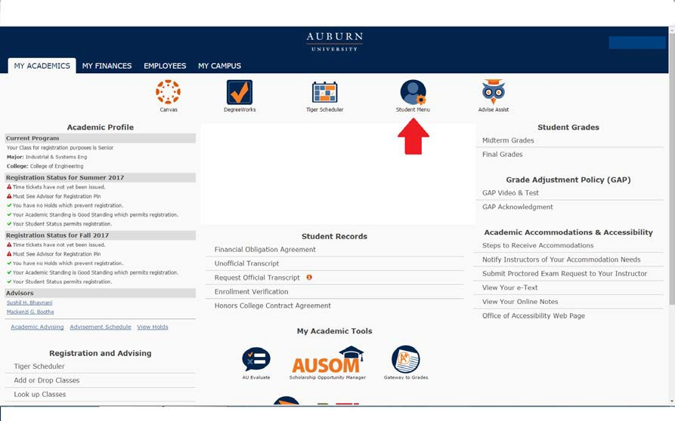
- Near the bottom, students will see an All Access tab. Select it to view classes.
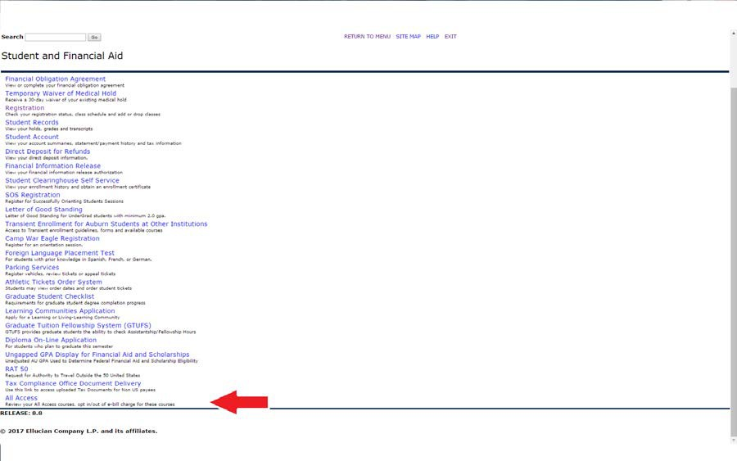

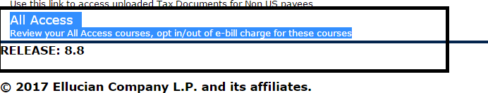

- Once in here, they will select their the current term:
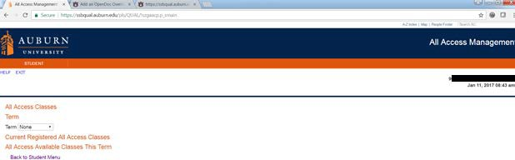
Once the current term is selected, All Access courses will populate with options to change out to the right.

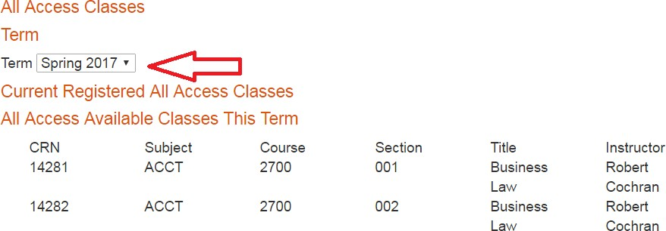

- Students can click the change button to opt in or out of the All Access material. NOTE: This does not change your registration in the class, just your purchase option for the course materials.
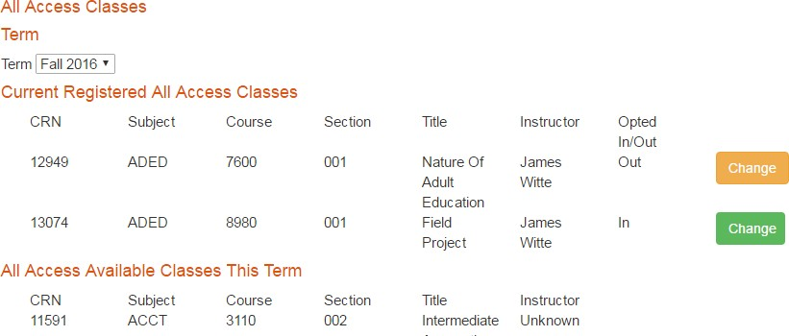

- You will be prompted to provide a reason for opting out of the class.
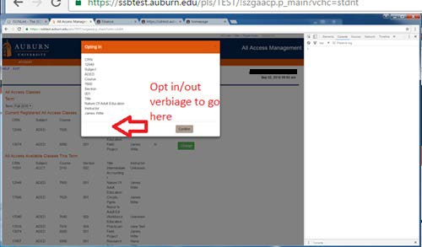

- If completed correctly, there will be a green ‘Success’ near the middle of the page.
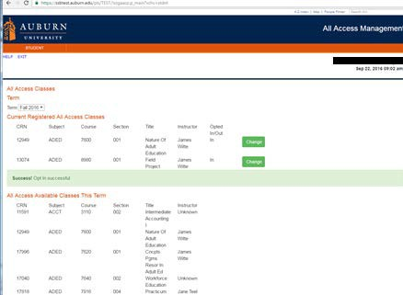

You may opt in or out at any time before the fifteenth class day. After that day, charges are sent to the Bursar to be applied to your e-bill.
We may not be able to reverse the charge after that date.

We are able to apply All Access charges for course materials to scholarships that are normally handled through our scholarship counter in store. We will also apply charges for student athletes to the Athletic Department if a student’s scholarship covers course materials.

