
CTES7400_7406 Spring 2021
Auburn University

Department: Curriculum & Teaching
Course Title/Credit: Techn & Media in ESL Education; 3 hrs
Room and Schedule: Haley 2435; Thur 4:00 – 6:50 p.m.
Instructor: Dr. Jamie Harrison jlh0069@auburn.edu
Phone Number: 334-844-8278
Office: Haley Center 5080
Office Hours: Tu/Th 2 – 3:30 p.m.

1. COURSE DESCRIPTION
This course is a study of technology and media applications for teaching English to Speakers of Other Languages (ESOL). Students will examine ways to effectively incorporate technology and media into the ESL/EFL classroom.
You will come away from this course with a better understanding of yourself as a user of technology, the ways techonolgy enhances the language learning process, and a battery of techonological resources to support teaching and learning.
Text:
Walker, A. & White, G. (2013). Technology enhanced language learning: Connecting theory and practice. Oxford, United Kingdom: Oxford University Press.
Other readings as provided by instructor.
Course Objectives:
Engaged learners in this course can look forward to:

- Identifying and utilizing Internet-based and software resources for teaching ESL/EFL.
- Evaluating the effectiveness and appropriateness of a variety of technologies for teaching the English language student.
- Using computer and media technologies to address the ESL/EFL language domains of listening, speaking, reading and writing.
- Selecting and integrating appropriate instructional materials, media, and technology for ELL students at various language proficiency and age levels.
- Reflecting on the way technology can enhance the learning experience of ELLs of variety of levels in multiple contexts.
- Documenting your own growth as a user of technology in the classroom. You wil gain online group interaction skills, increasing your comfort in both areas.
- Developing a positive relationship with technology from the perspective of a language instructor.

Active Learning Environment
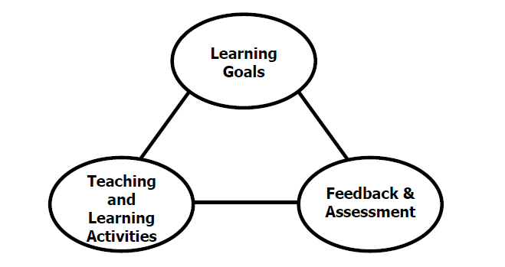
Figure 1. The key components of an integrated course design. (Fink, 2003).
This course has been designed with an active learning framework intended to integrate learning goals, teaching & learning activities, and feedback & assessment. This means you should expect to see a direct relationship between course goals, what we do in class, and how you are assessed. My hope is that you can use this course as a guide for developing your own English language courses.
A variety of teaching and learning experiences have been designed for this course to support the six key dimensions of significant learning (Fink, 2003).
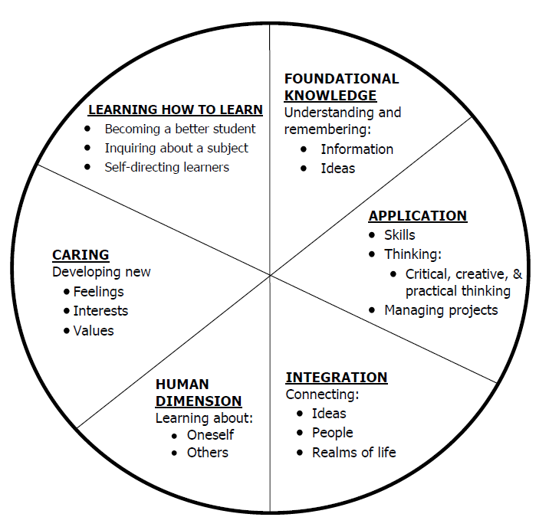
Figure 2. The taxonomy of significant learning (Fink, 2003).
Fink, L.D. 2003. A Self Directed Guide to Designing Courses for Significant Learning. San Fransisco: Jossey-Bass, pp. 37.

2. COURSE REQUIREMENTS
A. Preparation and Participation

Attendance (10%) Your active participation in this course is essential to getting the most out of it and attending the actual class (F2F or virtually) is imperative. Attendance per class session will be awarded 5 points per class. All class sessions will be recorded. If you are a distance student if will be most effective for you to attend synchronously via Zoom. If you are not able to do this, please contact me so that I am aware of your intentions to participate asynchronously. If you do not attend the F2F session or participate synchronously via Zoom (for whatever reason) you will be expected to submit a summary of the class session that you view. There will be an assignment portal created for this and you will have one week after the missed class to submit the summary. A template will be provided.
Participation: Preparation/Discussion Posts/In-class activities (20%) Attending class is just one aspect of being successful in this course and your active participation is vital to your success in and benefit from the course. Participation will include: preparing prior to class, contributing to tech task discussion boards and participating in in-class activities.
Tech task discussion boards: Students will participate in a variety of technology tasks throughout the semester. Most topics will have options, and up to 10 tasks will be completed. Plan to share completed tasks and reflection with your classmates. Reflection questions include: *What was your overall impression of this task? What challenged you? What went as expected? *How would you use this task in a language learning classroom?

Weekly Nearpod Lesson (20%): Students will sign up with a partner for one Nearpod lesson of the technology topic assigned for the week. The lesson will be based on the course text reading plus one other outside reading (academic journal article that contributes a critical perspective on the topic) and should be interactive and include a variety of Nearpod features (poll, open-ended questions, quiz, video, etc.). The Nearpod lesson will be delivered in class either F2F or online. Guidelines for the Presentation forthcoming.

B. Assignments

1. ESOL Education Website Collaboration:
Students will collect and vet a variety of tech apps and tools to share via a newly developing ESOL Education website. Students will use/modify/develop an appropriate rubric for technology, media, website evaluation. Individually students will identify 10 - 15 different language learning apps, software, websites, etc. addressing all language domans and reflect a variety of language levels for evaluation and review.
50 points

2. Electronic Village Online Participation:
Students will choose and participate in one TESOL Electronic Village Online professional development opportunity. http://evosessions.pbworks.com/w/page/10708567/FrontPage Sign up between Jan 5 – 11.
Participate fully in the online course, document your participation (in-course badges, assignments, products, discussions, etc.) and prepare a presentation to share back with the class about what you learned and how you can apply this to your future classroom.

EVO Minecraft ($)
Flipped Learning in Language Teaching
Immersive Storytelling in Virtual Worlds
M4TEVO2021 (Moodle for Teachers)
Synchronous Online Flipped Learning Approach
Techno CLIL 2021
TEFL2YL (Teaching English as a Foreign Language to Young Learners)
Tools for Student Collaboration
Technology for Spoken English

C. Final Exam (20%)
1. Digital Portfolio and reflection:
Students will develop a portfolio of work showcasing the ways technology can be used to enhance language learning and teaching. More details to be given at a later date.

Grading and Evaluation:
The grading scale will be:
A = 100 – 90 average
B = 89 – 80 average
C = 79 – 70 average
D = 69 – 60 average
F = 59 or below average

Attendance and Participation: Active learning experiences are only as powerful as you, the students in class, make them. Therefore, it is really important that you come to class each week and that you come prepared for group interactions and class discussions. As graduate level students, you should be able to prepare outside of class up to three hours per hour in class. That is up to nine hours of preparation. So, as part of this weekly preparation, please be sure to read and view any required material prior to class each week, participate in online discussions, and spend time delving into the variety of technology resources we will be discovering together.
*Special note: anyone absent from the F2F session will be allowed to make up their participation points by joining in with the distance discussion board during the week of absence.

Distance Student Requirements: The distance section is "asynchronous" for distance students. The following will be available to distance students:
- opportunity to participate live via Zoom during F2F course
- full Panopto recording of weekly F2F class sessions
- Canvas modules that outline weekly expectations
- Canvas distance discussion boards
- 3 set 1 hour live "drop in" office hours via Zoom (details will be sent later)
- other Zoom chat sessions as requested

Distance students follow the same weekly schedule as F2F students, and adhere to all assignment due dates as listed in the syllabus or outlined in Canvas as the course proceeds. Attendance and participation: distance students will be expected to either Zoom in live with us during the F2F class session or participate weekly in Distance Discussion Boards.

Late Assignments: Late assignments lose 10% credit per unexcused day late to a maximum of 30% lost credit.

Assigned Readings: Beyond the required textbooks, some additional readings will be available in Canvas. Readings will be discussed in various manners ranging from course Canvas discussions to embedded in class assignments. These readings contain information that will be included in the group quizzes, reflections, projects, examinations, and other course requirements.

Justification for Graduate Credit: CTES 7400 is a comprehensive course of study in technology and media applications for teaching English to Speakers of Other Languages (ESOL). Students will examine ways to effectively incorporate technology and media into the ESL/EFL classroom. You will come away from this course with a better understanding of yourself as a user of technology, the ways techonolgy enhances the language learning process, and a battery of techonological resources to support teaching and learning. The rigorous examination of technology and its implications for teaching and learning English as a second language justify the placement of this course at the graduate level.
.

2. COLLEGE AND UNIVERSITY POLICIES

Participation: Students are expected to attend class and participate in all class discussions, exercises, and activities.
It is the student’s responsibility to contact the instructor if assignment deadlines are not met. Students are responsible
for initiating arrangements for missed work.

Attendance/Absences: Excused Absences: Students are granted excused absences from class for the following reasons: Illness of the student or serious illness of a member of the student’s immediate family, death of a member of the student’s immediate family, trips for student organizations sponsored by an academic unit, trips for University classes, trips for participation in intercollegiate athletic events, subpoena for a court appearance and religious holidays. Students who wish to have an excused absence from this class for any other reason must contact the instructor in advance of the absence to request permission. The instructor will weigh the merits of the request and render a decision. When feasible, the student must notify the instructor prior to the occurrence of any excused absences, but in no case shall such notification occur more than one week after the absence. Appropriate documentation for all excused absences is required.

Make-Up Policy: Arrangements to make up missed major examination (e.g. hour exams, mid-term exams) due to properly authorized excused absences. Except in unusual circumstances, such as continued absence of the student or the advent of University holidays, a make-up exam will take place within two weeks from the time the student initiates arrangements for it. Except in extraordinary circumstance, no make-up exams will be arranged during the last three days before the final exam period begins. The format of the make-up exam will be (as specific by the instructor).

Late Assignments: Late assignments lose 10% credit per unexcused day late to a maximum of 30% lost credit.

Unannounced Quizzes: There will be no unannounced quizzes.

Accommodations: Students who need special accommodations in class, as provided for by the American Disabilities Act, should arrange a confidential meeting with the instructor during office hours the first week of classes – or as soon as possible if accommodations are needed immediately. You must bring a copy of your Accommodation Memo and an Instructor Verification Form to the meeting. If you do not have these forms but need accommodations, make an appointment with the Program for Students with Disabilities, 1244 Haley Center, 844-2096.

Academic Honesty Policy: All portions of the Auburn University student Academic Honesty Code (Title XII) will apply to this class. All academic honesty violations or alleged violations will be reported to the Office of the Provost, which will then refer the case to the Academic Honesty Committee.
Professionalism: Faculty, staff, and students in professional settings are expected to demonstrate professional behaviors as defined in the College’s conceptual framework. These professional commitments or dispositions are as follows: Engage in responsible and ethical professional practices; contribute to collaborative learning communities; demonstrate a commitment to diversity; model and nurture intellectual vitality.
Writing Center: The Miller Writing Center provides free support on any writing you are doing while at Auburn, whether for a course or not. Trained consultants are available to work with you as you plan, draft, and revise your writing. For students in distance courses and students temporarily away from Auburn’s campus, the Miller Writing Center offers synchronous online consultations. Please check the Miller Writing Center website (www.auburn.edu/writingcenter) for instructions and information about scheduling online appointments. If you have questions about the Miller Writing Center, please email writctr@auburn.edu or call 334-844-7475 M-F 7:45am-4:45pm.

Student eHandbook: Please refer to http://www.auburn.edu/student_info/student_policies/ for all AU student policies.

Distance Learning Students: Unless specific instructions have been given for a designated course, students in distance education courses shall take all closed resource examinations under the supervision of an approved proctor. Examples of approved proctors include a school superintendent, a principal of a high school, or a dean or department head of a college. Proctors shall be verified and exams shall be sent directly to the proctor who will manage the examination in a secure manner, requiring students to present a picture ID.

Additional Resources:
Student Policy eHandbook: http://www.auburn.edu/student_info/student_policies/
Health and Wellness Resources https://cws.auburn.edu/studentAffairs/healthAndWellness/
Academic Support Services: http://www.auburn.edu/academic/provost/undergrad_studies/support/

4. TENTATIVE SCHEDULE
Please note that this is a tentative summary of the schedule and activities/due dates may change during the semester. Follow the assignments as posted on the weekly modules in Canvas. For reference, here is the link to the AU academic calendar: http://www.auburn.edu/main/auweb_calendar.php
Weeks marked with asterisk (*) will be online only. There might be others held online due to unforeseen circumstances as well.

Week | Topics | Prior to Class Meeting | In Class Plan | Assignments
1: 1/11 – 1/17*  Class held on 1/14 | Digital Introduction  SYLLABUS  Tech Standard Questionnaires | Download and read syllabus  Order textbook  Register and begin EVO professional development course | Course introduction  EVO Q&A and time
2: 1/18 – 1/24*  Class held on 1/21 | Topics vary based on EVO PD selection | EVO course participation and reflection | Digital competencies survey and reflection  Sign up for presentation topics  Tech spotlight: Voki | Tech task 1: Voki Introduction
3: 1/25 – 1/31  Class held on 1/28 | Topics vary based on EVO PD selection  Learning in the digital age | EVO course participation and reflection  Read chapter 1 (W&W) | Tech spotlight: Nearpod
4: 2/1 – 2/7  Class held on 2/4 | Topics vary based on EVO PD selection  Communicating in the digital age | EVO course participation and reflection  Read chapter 2 (W&W) | Tech spotlight: Gamification  Visions non-profit organization introduction & lesson overview | Tech task 2: Visions non-profit tech support – lesson analysis
5: 2/8 – 2/14  Class held on 2/11 | Topics vary based on EVO PD selection | EVO course participation and reflection  Read Toolkit | Tech spotlight: Perusall
6: 2/15 – 2/21  Class held on 2/18  Wellness day: 2/16 | Chapter 3  Listening+ Speaking | Read Chapter 3 (W&W)  Read Article 2 (Student assigned) | Listening Nearpod (Student assigned)  Tech spotlight: TBA | Tech task 3: TBA
7: 2/22 – 2/28  Class held on 2/5 | Chapter 3  Listening+ Speaking | Read Article 3 (Student assigned) | Speaking Nearpod (Student assigned)  Tech spotlight: TBA | Tech task 4: TBA
8: 3/1 – 3/7  Class held on 3/4 | Chapter 4 & 5 Reading & Writing | Read Chapter 4 (W&W)  Read Article 4 (Student assigned) | Reading Nearpod (Student assigned)  Tech spotlight: TBA | Tech task 5: TBA
9: 3/8 – 3/14  Class held on 3/11  Wellness day: 3/10 | Chapter 4 & 5 Reading & Writing | Read chapter 5 (W&W)  Read Article 5 (Student assigned) | Writing Nearpod (Student assigned)  Tech spotlight: TBA | Tech task 6: TBA
10: 3/15 – 3/21  Class held on 3/18 | Chapter 6 Multimodal | Read chapter 6 (W&W)  Read Article 6 (Student assigned) | Multimodal Nearpod (Student assigned)  Tech spotlight: TBA | Tech task 7: TBA
11: 3/22 – 3/28  Class held on 3/25 | Chapter 7 Study Skills | Read chapter 7 (W&W)  Read Article 7 (Student assigned) | Study Skills Nearpod (Student assigned)  Website Resource Evaluation  EVO Demonstration  Tech spotlight: TBA | Tech task 8: TBA
12: 3/29 – 4/4  Class held on 4/1  Wellness day: 4/1 | Chapter 8 Young Learners | Read chapter 8 (W&W)  Read Article 8 (Student assigned) | Young learners Nearpod (Student assigned)  Website Resource Evaluation  EVO Demonstration  Tech spotlight: TBA | Tech task 9: TBA
13: 4/5 – 4/11  Class held on 4/8 | Chapter 9  Assessment | Read chapter 9 (W&W)  Read Article 9 (Student assigned) | Assessment Nearpod (Student assigned)  Website Resource Evaluation  EVO Demonstration  Tech spotlight: TBA | Tech task 10: TBA
14: 4/12 – 4/18  Class held on 4/15 | Chapter 10 Teaching using Technology | Read chapter 10 (W&W)  Read Article 10 (Student assigned) | Teaching w Tech Nearpod (Student assigned)  Website Resource Evaluation  EVO Demonstration  Tech spotlight: TBA
15: 4/19 – 4/25  Class held on 4/22 | Chapter 11 Choosing Teaching Material | Read chapter 11 (W&W)  Read Article 11 (Student assigned) | Choosing Teaching Material (Student assigned)  Website Resource Evaluation  EVO Demonstration  Tech spotlight: TBA
FINAL EXAMS  Apr 26 – Apr 30 |  |  |  | Digital portfolio due

Important dates
Jan 11 Classes begin
Jan 18 MLK Jr Day
Feb 16 Wellness Day 1
Mar 10 Wellness Day 2
Apr 1 Wellness Day 3
Apr 22 Last day of class
Apr 23 – 25 Study/reading days
Apr 26 – 30 Final Exams
May 1 – 3 Commencement

