CTEE 4030: Natural Science Spring 2022

 | Class Time: Spring 2022  Class Location: Haley Center 2414  Credit Hours: 3 semester hours  Prerequisites: Admission to Teacher Education | 

Instructor: Dr. L. Octavia Tripp
Office: 5028Haley Center
Phone: 334.844.6799
Email: tripplo@auburn.edu
Office Hours: Wednesday – Face to Face by Appointment Only
Via Zoom by Appointment Only
Tuesday 1:00 – 3:00 pm
Required Texts
- Lever-Duffy, J., McDonald, J., Bass, J., Carin, A. & Contant, T. (2018). Teaching Science Through Inquiry-Based Investigation. Pearson Education. 13th edition. ISBN-13: 9780134515472 or ISBN-10: 0134515471.

COVID 19 Policy – Mask mandate is in effect for CTEE 4030 Cohort A. This mask mandate for my class may last the duration of this course. You are required to wear a mask in CTEE 4030 correctly, over nose and mouth. Please make sure you are wearing a N94/95.

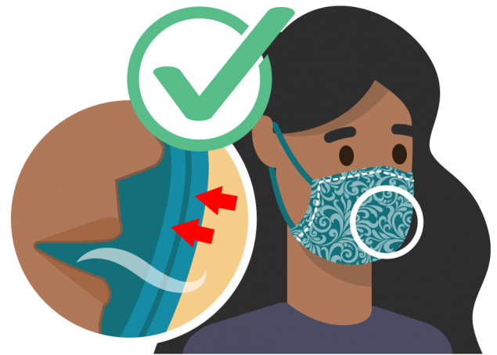
Have two or more layers of washable, breathable fabric

Completely cover your nose and mouth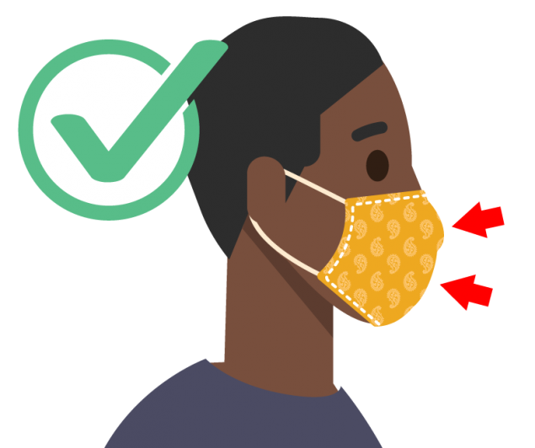
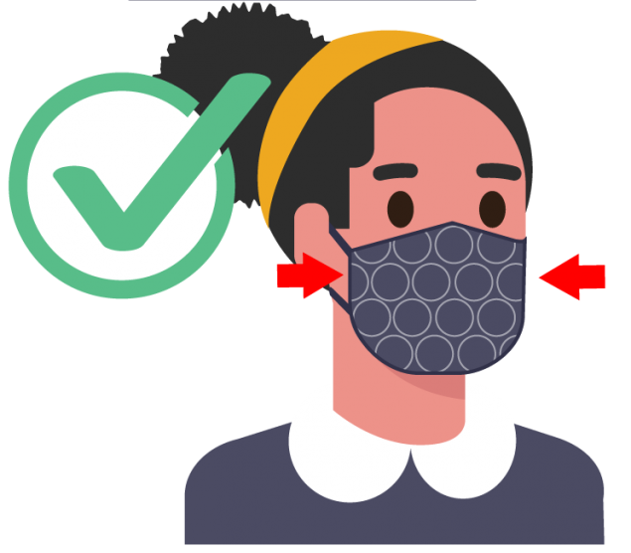
Fit snugly against the sides of your face and don’t have gaps
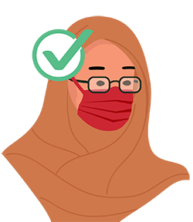
Have a nose wire to prevent air from leaking out of the top of the mask

(Please learn how to wear your mask so that it fits over your mouth and nose correctly. This may mean that you must tie the loops tighter to ensure the fit is proper). Failure to wear mask correctly will result in you being asked to leave the class. This will result in you being absent from the class. If you test positive for COVID, do not report to class until you have met the following recommendations by the Auburn Medical Team and CDC requirements. You will have a chance to follow class via zoom but there will not be any interaction with the zoom. Zoom will be on so that you can hear the lecture and see any activities that are being conducted in class. For you to make up work you will have to show documentation that you have met the requirements for COVID 19. To return to class you must show you are negative of COVID.

The Office of Accessibility
The Office of Accessibility provides academic services and accommodations for students with diagnosed disabilities. The Americans with Disabilities Act (ADA) defines a disability as a physical or mental impairment that substantially limits one or more major life activities. In order to receive academic accommodations, the student must submit comprehensive documentation describing the current functional limitations that impact the student in an academic setting. Documentation serves as the basis for decision-making about a student's needs for accommodations in a challenging and competitive academic environment. AU policy for students with disabilities or special needs will be followed. "Students who need accommodations are asked to electronically submit their approved accommodations through AU Access and to arrange a meeting during office hours the first week of classes, or as soon as possible if accommodations are needed immediately. If you have a conflict with my office hours, an alternate time can be arranged. To set up this meeting, please contact me by e-mail. If you have not established accommodations through the Office of Accessibility, but need accommodations, make an appointment with the Office of Accessibility, 1228 Haley Center, 844-2096 (V/TT)."

Class Policy Statements
- Attendance Policy: Students are expected to attend all class meetings and scheduled labs. Provisions for excused absences will follow procedures that are outlined in the Tiger Cub.

- Academic Honesty: Refer to the Tiger Cub

Instructor Availability and Response Time:
Your class interaction with the instructor and your classmates will take place on a regular, ongoing basis. Your instructor will be actively engaged within the course throughout the week. You will normally communicate with your instructor in the weekly discussions or the General Questions discussion topic so that your questions and the instructor’s answers benefit the entire class. You should feel free, however, to communicate with me via AU email at any time, particularly when you want to discuss something of a personal or sensitive nature. Your instructor will generally provide a response within 24 - 48 hours.

Notes for consideration by the instructor:

Changes in the syllabus: The instructor has the privilege and right to make necessary changes to the course outline in order to provide the best possible teaching and learning situation for students in 4030.

All assignments are not listed on the syllabus. As with any teachable moment, the instructor may assign an assignment that will enhance the instruction of a concept.

All discussions will be preceded by questions and concluded with a quiz if necessary. Be prepared for these based on your readings and discussion of the course material.

You will be allowed to make up work if you have an excuse or if you have discussed the issue with the instructor.

Course Description

This course explores teaching science as inquiry. It introduces preservice teachers to science content, teaching strategies, and inquiry activities. The course focuses on developing inquiry-based lessons for students to investigate science, using educational technologies to support science lessons, integrating other subject matter areas with science, designing lessons that include all students in learning science, and assessing student understanding of science and the nature of science. The teachers will plan and teach lessons for students to learn science, observe students learning, and conduct research on student learning.

In addition the course will engage students in learning how temperament styles, teaching styles, and learning styles are essential to having successful student learning. National Science Standards and Alabama Course of Study Standards are infused in each lesson to provide students with a useful framework for making instructional decisions.

Course Objectives

- Demonstrate the ability to use a variety of resources and instructional strategies in planning and teaching inquiry based hands-on elementary science lessons consistent with the Alabama Course of Study.

- Demonstrate the ability to design and implement authentic assessment strategies for science knowledge and skills.

- Demonstrate the ability to use computer technology to access information for planning lessons, to communicate via e-mail, and to integrate into the elementary science curriculum.

- Demonstrate an understanding of environmental education and the ability to use community agency resources in planning and implementing an environmental lesson.

- Demonstrate an understanding of how temperament styles, teaching styles and learning styles are connected in teaching science.

- Demonstrate an effective way of helping students learn to construct their own understanding by connecting their many ideas into concepts, attitudes, and skills.

COURSE SCHEDULE – See Canvas
Course Requirements:

Class Attendance: Class attendance is required. Arriving late, leaving early, or missing a class will result in lowering your grade.

Assignments: All written assignments must be typed and should adhere to Standard English usage and conventions. Assignments must be presented on time. Two points will reduce late assignments for each day they are late.

Class Participation – Involves readings and discussion in class.

Science Autobiography – Canvas Files
Science Project Folder – Canvas files
Develop a controlled experimental investigation to answer a scientific question that you have about the world. The product you will produce is a scientific investigation report on a colored file folder. This should be formatted as follows:
Front of File Folder
Problem: Put the problem in question form. Both the independent (manipulated) and dependent (responding) variables are typically mentioned in the problem.
Hypothesis: This is a statement of the relationship that you expect to find between the independent (manipulated) and dependent (responding) variables. It should describe what you thought the outcome of the experiment would be and why.
Operational Definitions: State any definition of terms that appear in the problem or hypothesis that you need to clarify (such as “fastest,” “strongest,” “softest,” etc.).
Inside Left of File Folder
Materials List: List ALL of the materials you will need including such things as pen and paper, etc.
Procedure: Step by step plan for carrying out your experiment. It should include sufficient detail that someone else could replicate what you have done without seeing you do it.
Variables:
Independent (Manipulated): What the experimenter changes on purpose.
Dependent (Responding): Data you are collecting (should be quantitative for this investigation).
Controlled: Variables that you keep constant so that it is a “fair test.”
Inside Right of the File Folder
Data: A chart that represents at least three trials of each level of the independent variable with the levels of the independent variable down the left column and the data about the dependent variables for each trial and then the average to the cells to the cells to the right. Include title and labels for numbers that you use (Ex: 1 mm, 5 grams, etc.)
Graph: Bar or Line Graph of the average for each level of the independent variable with the independent (manipulated) variable represented on the x-axis and the dependent (responding) variable represented on the y-axis. Be sure to include a title for the graph and label the axes (including the units).

Back of the Folder
Statement of Results: This should be a written description of what your data and graph show about the answer to your stated problem.
Conclusion: Statement telling whether your hypothesis was correct and why or why not. What variables you didn’t control that should have been controlled. What would you do differently next time? What other questions emerged from your experiment?
Throughout the Folder
Include pictures and/or drawings that would help make the folder more informative and attractive.

Science Journal Critiques
You will be assigned several critiques to read and critique. Critiquing means you will use the format as a guide to prepare your critique. Further discussion will be given in class.

Science Concepts Interviews

In order to better understand the conceptual understanding students hold about a science idea you will conduct a structured interview with 5 students at your school. You will follow a protocol developed by C. Barman and others and presented in Science and Children to identify student’s perceptions about Plants, Animals, or Science and Scientists.

These articles can be viewed in the Science and Children Archives in the NSTA Website if you are a member of NSTA.
September 1996 – How Do Students Really View Science and Scientists
September 1999 – Assessing Students’ Ideas about Animals
September 2003 – Students’ Ideas about Plants

First you will discuss this project with your mentor and decide which of the interviews (Plants, Animals, or Science and Scientists) you will conduct. Next, you will determine which students to interview and when these individual interviews can occur without interrupting instruction. You will need to prepare the interview materials and demonstrate the procedure to your mentor teacher, so he/she is aware of the process involved. Write a paragraph describing the discussions with your mentor and the decisions that were made regarding topic, subjects, and timing. Ask your mentor to sign and date it.

Conduct 5 student interviews, compile your data, analyze your data, then write a description of your findings, compare and contrast the ideas your subjects had, and record your reflections of what surprised you and what you learned.

Professional Development Activity (AMSTI)

You are expected to be involved in at least 6 hours of professional development activities related to science education during this semester. This can be accomplished by going to an all-day conference presented by a local, state, or national science teachers association; or by attending several shorter events such as lectures at libraries, museums, workshops at school districts, or even by serving as a judge as a science fair.

The report you turn in about your experiences should include a general overview of your experiences:

Overview / Introduction (9 points possible)

Describe your personal participation in the conference and or activities. Include the name, date(s), and location of the events and an agenda showing how you spent your time. The expectation is that you will participate in at least 6 hours of activities.

Tell what part of the experience was most useful to you (explain why). Give at least three (3) reasons why a beginning elementary teacher should attend these kinds of professional development activities. Attach a copy of your registration receipt or name badge for each of the events.

Select three (3) of the presentations or events you attended. (7 points possible for each presentation)

At a conference, these would be 3 different sessions, for science fair judging this could be the training session and the actual judging, for a lecture (it would be the whole event).

For each:

list the title and presenter(s),

describe the objective(s) / purpose(s) of the presentation,

list three (3) things you learned,

consider the concepts/processes that were emphasized, then decide for a teacher in what grade level would this session be of most interest. Use specific references to state science standards (with coding and written out text) to support your choice.

Total points possible 30

Standards Portfolio

Field Experience 5E Lesson Plans and Reflections

You are expected to submit two (2) lesson plans that apply the 5E instructional model with reflections for science lessons that you teach during your field experience. Each is worth 50 points.

As was discussed in class, all lesson plans should include some basic components:
- Title
- Grade Level
- Duration
- Objective(s) (should be "behavioral objective(s) that clearly describe what you expect students to know and be able to do after the instruction has taken place.)
- State Standards for Science (please write the codes and also write out the words of the emphasized Standard)
- Materials (be specific - how much/many do you need)
- Safety Issues
- Instructional Activities (in this lesson plan these should be organized by the 5E's - Since Evaluate is the last E and already included you don't need to state a separate assessment strategy.
- References (please give credit to any sources you used to develop your lesson)

If activity sheets, overhead transparencies, etc. are necessary materials for your lesson, please include a copy of them so I can see what you are using. Such materials are not needed if they are not being used in your lesson.

Also, include selected samples (copies) of completed student work to illustrate the spectrum of the levels of mastery your students have achieved.

A detailed rubric is attached. It describes the criteria for scoring. A separate rubric will be completed for each of the two 5E lessons taught in the field.

Rubric for Field Experience 5E Science Lesson Plan & Reflections
(One rubric required for each lesson taught.)
Criteria | Score | Superior (3) | Proficient (2) | Needs Improvement (1)
Basic components |  | All basic components included effectively (see assignment sheet for list) | Most basic components included effectively | Few basic components included
Instructional Materials (if needed) |  | All included, appropriate, instructionally significant | Most included, or if all included they are only somewhat appropriate or instructionally significant | Few included, or not really appropriate, or not instructionally significant
Objectives |  | Clearly describe what students will know and be able to do after instruction. measurable | Suggest what students will know and be able to do after instruction | Not measurable or describe activity rather than what students will know and be able to do after instruction
Grade Level/Duration |  | Grade level and duration is clearly appropriate | Grade level and/or duration seems appropriate | Grade level and/or duration is inappropriate
Instructional Grouping Strategies |  | Are appropriate and are described in detail for each phase of the lesson | Are mentioned but not in detail and/or not for all phases of the lesson | Are not described or are not appropriate for the lesson
Detail |  | Clearly appropriate, not scripted but enough detail that another teacher could successfully present lesson | Is appropriate, another teacher could probably successfully complete the lesson | Lesson is presented in too much or not enough detail
Appropriate 5E Activity Phases |  | (3) | (2) | (1)
Engage |  | All student and teacher actions appropriate | Most student and teacher actions appropriate | Many student and teacher actions appropriate
Explore |  | All student and teacher actions appropriate | Most student and teacher actions appropriate | Many student and teacher actions appropriate
Explain |  | All student and teacher actions appropriate | Most student and teacher actions appropriate | Many student and teacher actions appropriate
Elaborate |  | All student and teacher actions appropriate | Most student and teacher actions appropriate | Many student and teacher actions appropriate
Evaluate |  | All student and teacher actions appropriate | Most student and teacher actions appropriate | Many student and teacher actions appropriate
Reflections |  | (3) | (2) | (1)
What worked? Why? What didn’t work? Why? |  | Clearly and thoroughly discussed, convincing reasons given | Adequately discussed, reasons okay | Discussion incomplete, reasons unrelated or not given
How well did the class master the objective(s)? How do you know? Attach student work. |  | Clearly and thoroughly discussed, convincing reasons given | Adequately discussed, reasons okay | Suggestions inappropriate, or not supported by reasons.
What would you do differently if teaching the lesson again? Why? |  | Specific suggestions are clearly stated, convincing reasons given | Suggestions are stated, but reasons aren’t convincing | Suggestions inappropriate, or not supported by reasons
Technical Issues |  | (2) | (1) | (0)
Grammar/Spelling |  | Flawless | One or two errors | Three or more errors

Classwork (Hands-on, Minds-on):
There will be several assignments that will be created in the classroom. For example:
- The Science of Bubbles (primary K-1)
- Rocketry (Intermediate 4-6)
- The Science of Green Energy (Elementary 2-3)
These activities model hands on/ minds on activities.

Grade Definitions
All students are expected to complete all assignments, attend all classes, and participate fully. This class is all about helping you become a teacher. Consider your priorities.

“A” An “A” indicates that a student is extremely well qualified as evidenced by exceptional performance in all aspects of the class. This student shows excellence and thoroughness in planning, interacting with students, command of subject matter and discusses issues and research in science education. All of these have been well-demonstrated by an active participation in class sessions. This person would never give the impression of being a passive learner “who learns best by just listening.” This person uses research findings to support statements and shows a strong commitment to education.

“B” A “B” indicates that this student has done a good job of demonstrating an ability at planning, interacting and dealing with issues in science education. This individual has a good grasp of the subject matter and can implement effective lessons but, curriculum design is more simplistic and written work lacks depth and/or does not consistently use research as evidence. The “B” student shows every sign of being able to become an “A” teacher.

“C” A “C” is earned by a person who has not fully demonstrated competencies deemed necessary for secondary school science teaching. This student may be quite successful in some areas and not so successful in others and most likely will write incomplete lesson plans and lack a solid personal rationale. A “C” student will probably need special attention during student teaching to insure success and certification. (Note: a “C” is not considered a passing grade in graduate school.)

“F” A “F” is earned by a person who has met none of the minimum competencies deemed necessary for middle school science teaching. An “F” student cannot teach and must plan Adapted from Sterling, D, and Varrella, G, syllabi, 2002. 4 to retake this course, passing with a grade of “C” or better.

Due Dates & Assignment Points Breakdown
Item Due When? What’s It Worth (pts.)?
- Science Autobiography 25
- Field Experience Science Focus Lesson Plans
- Science Video Teaching Presentation (based on COVID if necessary)
- Science in the News Tuesdays Complete S/U
- Critiques 30
- Notebook Check TBA 35
- Classwork Activities Tuesdays 100
- Concepts Interview 25
- Science Project Folder
- Standards Portfolio TBA
- Field experience observations TBD
Approximate Total TBD
____________________________________________________________________________

