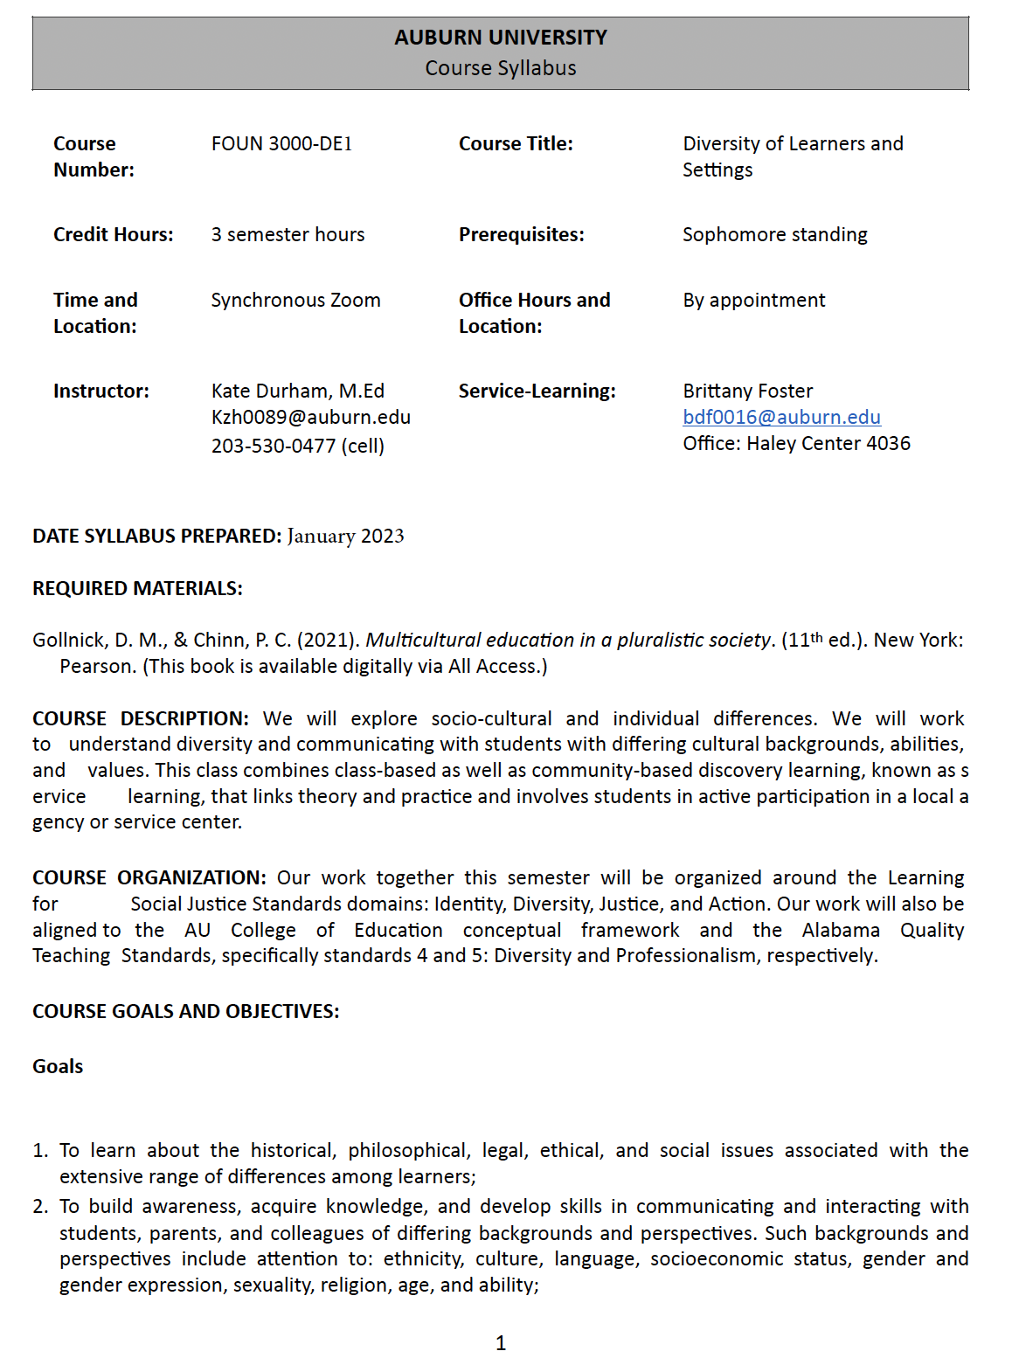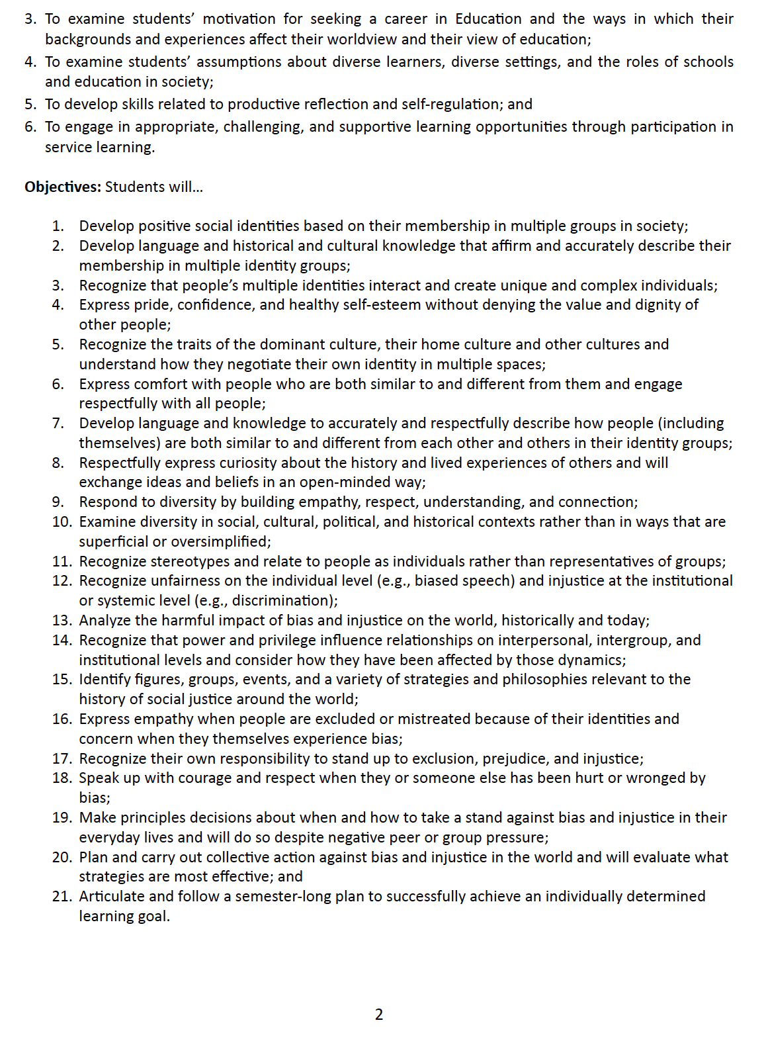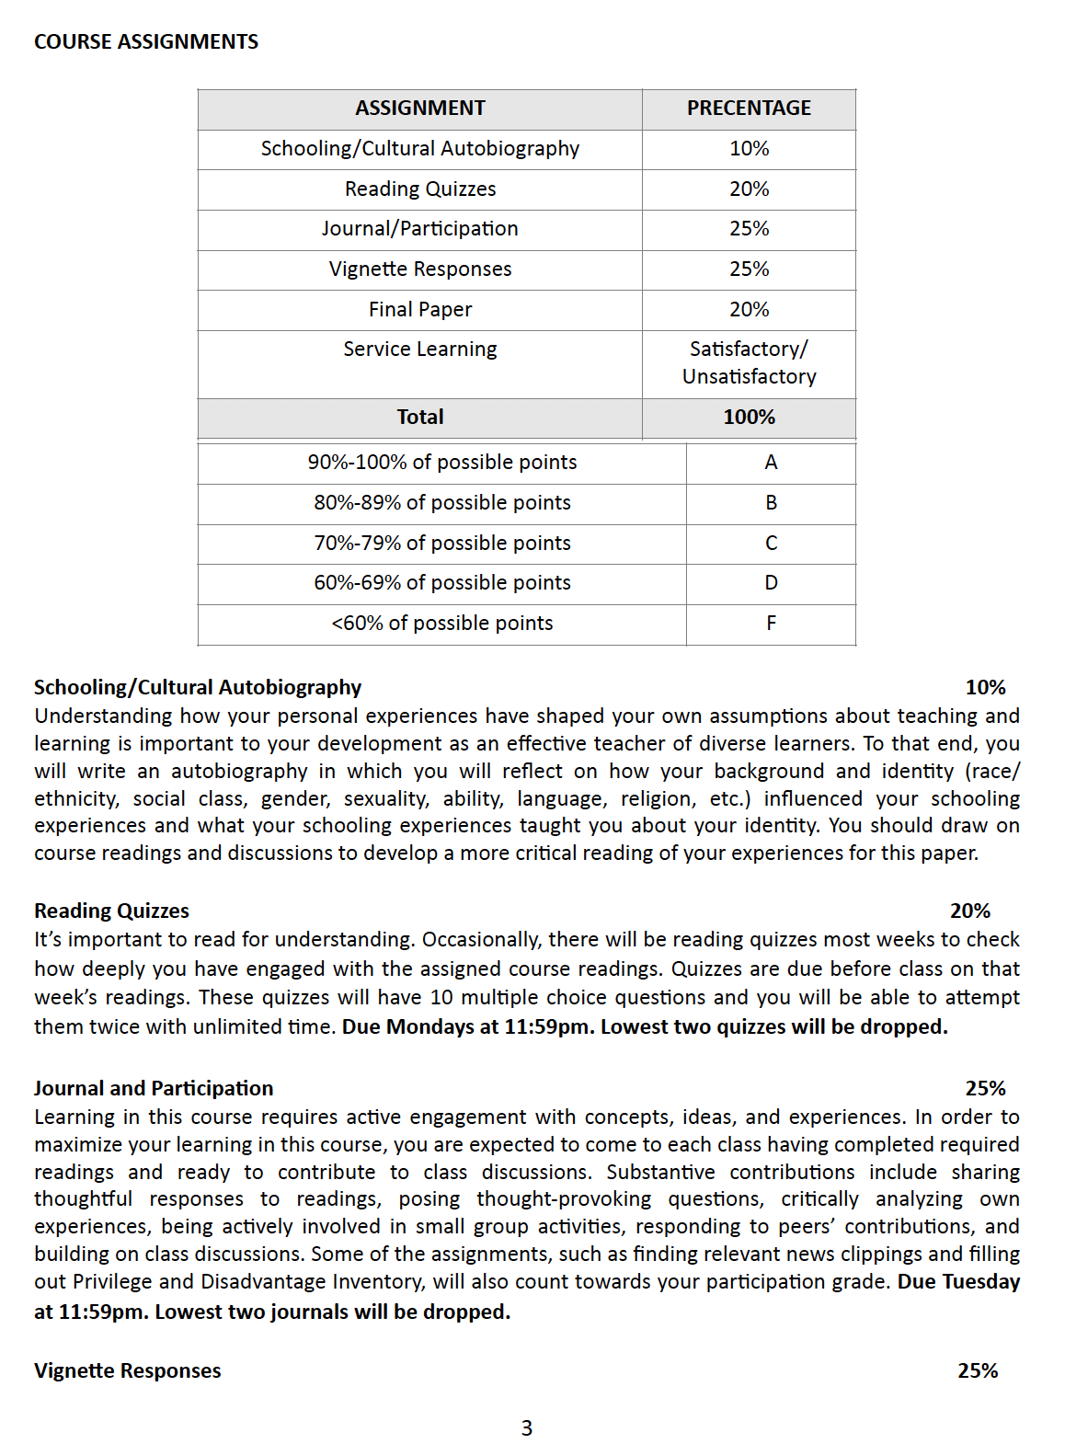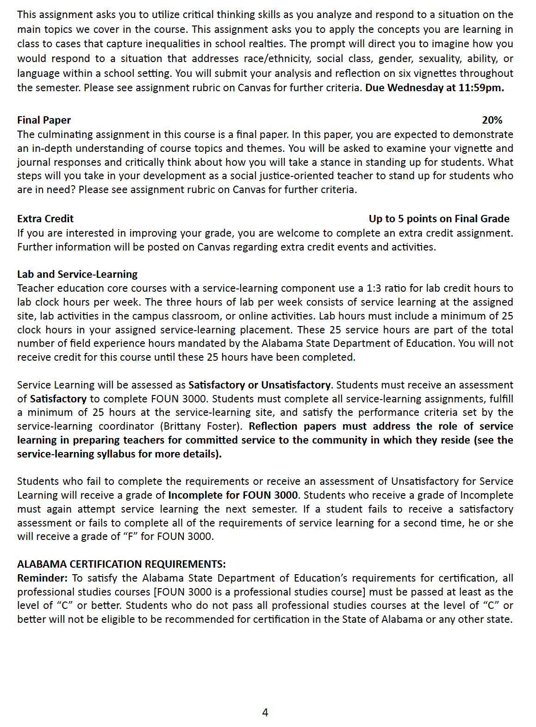COURSE CALENDAR

TOPIC & WEEK | READINGS | ASSIGNMENTS DUE
Week 1  January 17th  Orientation & Naming | Kohli & Solórzano (2012) in Canvas
Week 2  January 24th  Identity | Chapter 1 in ME | - Week 2 Reading Quiz  - Journal Entry 1
Week 3  January 31st  Intersectionality | Chapter 4 in ME | - Week 3 Reading Quiz  - Journal Entry 2
February 1st Last day to drop with the possibility of a refund and no grade assignment
Week 4  February 7th  Privilege & (Implicit) Bias | See Canvas for various readings | - Schooling/Cultural Autobiography Paper  - Journal Entry 3
Week 5  February 14th  Exploitation & Powerlessness | Chapter 5 in ME | - Week 5 Reading Quiz  - Journal Entry 4  - Vignette Response 1
Week 6  February 21st  Marginalization & Cultural Imperialism | Chapter 8 in ME | - Journal Entry 5
Week 7  February 28th  (Micro) Aggression & Violence | Chapter 10 in ME | - Week 7 Reading Quiz  - Journal Entry 6  - Vignette Response 2
Week 8  March 7th  No Class Spring Break |  | - Watch Precious Knowledge  - Journal Entry 7
Week 9  March 14th  Curriculum | Chapter 11 in ME | - Week 9 Reading Quiz  - Journal Entry 8
Week 10  March 21st  Achievement, Discipline, & Opportunity Gaps | Chapter 6 ME  Ladson-Billings, G. (2006) in Canvas | - Week 10 Reading Quiz  - Journal Entry 9  - Vignette Response 3
Week 11  March 28th  School Integration & Inclusion | Chapter 2 in ME | - Week 11 Reading Quiz  - Journal Entry 10  - Vignette Response 4

TOPIC & WEEK | READINGS | ASSIGNMENTS DUE
Week 12  April 4th  School Funding & Zoning | Chapter 3 in ME | - Week 12 Reading Quiz  - Vignette Response 5  - Journal Entry 11
Week 13  April 11th  Policy Barriers | Chapter 9 in ME | - Week 13 Reading Quiz  - Journal Entry 12  - Vignette Response 6
Week 14  April 18th  Work for Teachers | Grantham, T.C. (2011)  Grantham & Biddle (2014) | - Week 14 Reading Quiz  - Journal Entry 13
April 21st Last day to withdraw from course with no grade penalty
Week 15  April 25th  No Class |  | - Final Paper Due by 11:59pm

