SPRING 2023: RSED 5140/6140/6140D SEVERE DISABILITIES CURRICULUM

Auburn University Department of Special Education, Rehabilitation, & Counseling

Course Number: RSED 5140/6140/6140D
Course Title: Severe Disabilities Curriculum

Meeting Time/Place: For RSED 5140 & 6140 we will meet on campus in person
Tuesdays 12:30pm to 2:50pm in Haley Center 1218

For RSED 6140D Graduate distance education
Asynchronous weekly material posted via CANVAS by Wed.

Office hours: After class on Tuesday and email for ZOOM Appointment
Credit: 3 semester hours
Instructor: Dr. Suzanne Woods-Groves, Ph.D.
Instructor’s email: woodssu@auburn.edu
Instructor’s phone: 334-844-7621
Office location: Haley Center 1232C

- Date Syllabus Prepared: January 2023

REQUIRED TECHNOLOGY:
All students in this course are expected to have all the equipment and software needed to be successful in the course. You will need to access weekly assignments, quizzes, and materials posted via CANVAS and PANOPTO. You will complete and submit your exams and assignments via CANVAS. Ensure you have a working computer and reliable internet connection. Be sure you have installed and have access to all of the software required to participate in the course and complete your assignments (Canvas, PDF reader, Panopto). On campus students should bring their laptops and or tablets to class each week. Your device should have a webcam and with video and audio capability.

REQUIRED TEXTBOOKS:
Obtain your textbooks before the first day of class.

ALL ACCESS TEXT:
Please review ALL ACCESS information attached to this syllabus and located in your CANVAS course home page.

Instruction of Students with Severe Disabilities, Freeda Brown, John McDonnell, & Martha E Snell Publisher: Pearson Edition: 9th Published: 2020

Systematic Instruction for Students with Moderate and Severe Disabilities Collins, Belva C., Published by Brookes Publishing, Publication Date: Jan. 1, 2012 ISBN 9781598571936
ADDITIONAL READINGS available via CANVAS

COURSE DESCRIPTION:

This is a lecture course with a 10-hour lab experience for observation. This course provides an understanding of a functional/developmental approach to the selection, development, implementation, and evaluation of appropriate curriculum activities for students with disabilities. Students’ instructional methods for supporting students who have severe or profound disabilities, behavior disorders, learning disabilities, intellectual disabilities, and multiple disabilities (physical, sensory, communication, cognitive and behavioral) with concomitant disabilities. There is an emphasis on education grades Pre-K-12 and postsecondary. Content includes extensive exploration of various curricular theories focusing on individual and group approaches. (Below see objectives & state standards addressed).

Student Learning Outcomes/ Course Objectives: After completing this course you will:
  - Demonstrate knowledge of the characteristics and service needs of individuals of varying ages and a variety of types of severe/profound, and multiple disabilities. (1.1.2)

  - Demonstrate knowledge of a variety of assessment types when working with severe/profound and multiple disabilities. (4.1.1)

  - Demonstrate current knowledge of administrative arrangements and ethics, issues, service delivery systems, school- care giver relationships, and curricular content bases related to educational services for individuals’ birth through 21 years of age who have severe/profound, and multiple disabilities. (6.1.1 & 6.1.2)

  - Describe the impact of cognitive and affective manifestations on learning, curriculum and program development, and needed services and supports for students with Severe/profound and multiple disabilities. (3.1.3)

  - Identify the array of residential, vocational, and leisure services available for students with severe/profound and multiple disabilities.

  - Demonstrate knowledge of assessment and intervention procedures appropriate for evaluation and educational programming with infant, toddler, preschool children, school- aged children, and youth who have severe/profound and multiple disabilities. Discuss how to Interpret the assessment results (4.1.2)

  - Describe technological advances and their impact on individuals with severe/profound and multiple disabilities to support instructional assessment, planning and delivery (5.1.2)

  - Identify the mandates of PL 94-142 and other legislation and their impact on services provided to individuals with severe/profound and multiple disabilities. (6.1.2)

  - Describe various curricula engaging and instructional interventions, methods of how to adapt to various learning environments, implement teaching techniques/methods (assistive technologies), and materials of instruction for students with severe/profound and multiple disabilities, plan functional life skills, adaptive behavior across environments that will enhance the individual student’s social participation (2.1.2, 2.4.1, 3.1.2, 5.1.1, 5.1.3)

  - Identify resource agencies that provide personnel and services for improving and strengthening educational programs for individuals with severe/profound, and multiple disabilities. Indicators 6.1.5, 7.1.2
  - Demonstrate knowledge of best practices in development and implementation of appropriate school healthcare plans, specialized instruction, and therapeutic techniques including physical and behavior management.

  - Supply the most common definitions and characteristics of children with severe/profound disabilities as well as how those characteristics impact learning, curriculum development and needed services and supports.

  - Describe the most common theories and educational approaches used with children with severe/profound disabilities.

  - Identify cultural and socioeconomic factors, consider language and family influences and their impact on eligibility and programming. Indicator 1.1.1

  - Identify resource agencies to participate as an advocate or mentor to assist in providing personnel and services for improving and strengthening educational programs for individuals with severe/profound disabilities which include being a resource to other teachers (6.1.5 &7.1.2)

  - Observe, interact with, and respond to infants, toddlers, preschoolers, elementary-school, middle-school, or high-school individuals who have severe/multiple disabilities.

  - Observe appropriate safety procedures for lifting, positioning, and seating during the field experience and demonstrate in class your understanding of the proper position techniques.

  - Describe the concepts of the discipline and how to develop learning progressions for learners.

  - Describe the steps of how to intercede safely with students in a crisis. (2.1.3)

Justification for Graduate Credit:
This is course is taken by undergraduates at the 5000 level and graduate students at the 6000 level. Some assignments and evaluations will differ for undergraduate and graduate students. Graduate students will sequentially progress through graduate level course material and will acquire knowledge and apply learned concepts within activities or projects. Graduate students will exhibit a synthesis of their independent learning by creating and presenting a cumulative project that supports learners with disabilities. Graduate learners will include evidence-based methods in their project and will provide a synopsis of area specific current research.

- COURSE CONTENT SCHEDULE This syllabus is a tentative outline for the course and is subject to change with advance notice from the instructor.
Dates | Topic | Assigned Readings | Assignments & Due Date Quizzes & Exams will close after due  date and will NOT REOPEN
01/17  Tues  Week 1  MODULE 1 | Module 1:  Course Introduction  Learners with developmental disabilities (DD)  Legislation, IDEA, FAPE, Ethics  Fostering family partnerships  Service Systems  Standards Addressed (a.1.1.2; c. 6.1.1 & 6.1.2; d. 3.1.3; h.6.1.2; l.; m; n. 1.1.1) | Review Syllabus  Textbook:  Instruction of Students with Severe Disabilities Chapters 1 & 2 | DUE Mon. 01/23 by 11:59pm via CANVAS  - Quiz  - Application Activity  - Participation Points (Watch all videos)  - Graduate Distance students critical thinking activity  RSED 5140/6140 on campus class Complete critical thinking activity in person in class 01/17
01/24  Tues.  Week 2  MODULE 2 | Module 2:  Summative & Formative Assessment  Task analytic measurement Data-Driven decision making; Social Validity, Graphing Data  Foundational Components of Instruction Task analytic measurement  Standards Addressed (b. 4.1.1; d. 3.1.3; f. 4.1.2; i. 2.1.2, 2.4.1, 3.1.2, 5.1.1, 5.1.3) | Textbook:  Instruction of Students with Severe Disabilities  Chapters 3 & 4  Systematic Instruction for Students with Moderate and Severe Disabilities  Chapter 1 | DUE Mon. by 01/30 11:59pm via CANVAS  - Quiz  - Application Activity  - Participation Points (Watch all videos)  - Graduate Distance students critical thinking activity  RSED 5140/6140 on campus class Complete critical thinking activity in person in class 01/24

Dates | Topic | Assigned Readings | Assignments & Due Date Quizzes & Exams will close after due  date and will NOT REOPEN
01/31  Tues.  Week 3  MODULE 3 | Module 3:  Person-Centered Planning  Working with families  Alternative Standards  Using MAPS planning  Standards Addressed (a.1.1.2; b. 4.1.1;d. 3.1.3; f. 4.1.2; h. 6.1.2; j. 6.1.5; 7.1.2; m.; o.1.1.1; p. 6.1.5.; 7.1.2) | Textbook:  Instruction of Students with Severe Disabilities  Chapters 15 & 16  Readings in MODULE 3 | DUE Mon. 02/06 by 11:59pm via CANVAS  - Quiz  - Application Activity  - Participation Points (Watch all videos)  - Graduate Distance students critical thinking activity  - RSED 5140/6140 on campus class Complete critical thinking activity in person in class 01/31

02/07  Tues  Week 4  MODULE 4  EXAM 1 | Module 4:  EXAM 1 OPENS Tuesday, Feb. 7th  No Class meeting | EXAM 1 covers all information from class, readings, activities, & modules. | DUE Mon. 02/13 by 11:59pm  Complete EXAM 1 via CANVAS  Exam 1 will close after due date and will NOT REOPEN.
02/14  Tues  Week 5  MODULE 5 | Module 5:  Theoretical basis for Video Modeling Components of Video Modeling Types of Video Models  Steps in creating video prompting models Create a task analysis  Systematic Instruction  Standards Addressed (g. 5.1.2; i. 2.1.2, 2.4.1, 3.1.2, 5.1.1, 5.1.3) | Textbook:  Instruction of Students with Severe Disabilities  Chapters 5 & 6  Systematic Instruction for Students with Moderate and Severe Disabilities  Chapter 2 & 3  Readings in MODULE 5 | DUE Mon. 02/20 by 11:59pm  - Quiz  - Application Activity  - Participation Points (Watch all videos)  - Graduate Distance students critical thinking activity  RSED 5140/6140 on campus class Complete critical thinking activity in person in class 02/14

Dates |  | Topic |  | Assigned Readings | Assignments & Due Date Quizzes & Exams will close after due  date and will NOT REOPEN
02/21  Tues  Week 6  MODULE 6 |  | Module 6:  Video Modeling  Systematic Instruction  Implementing Inclusive Education & Positive Behavior Support  FBA & BIP  Assessment & Behavioral Intervention Plans  Standards Addressed (a. 1.1.2; b. 4.1.1; c. 6.1.1. & 6.1.2; d. 3.1.3;  f. 4.1.2; h. 6.1.2; i. 2.1.2, 2.4.1, 3.1.2, 5.1.1, 5.1.3; k; m; n.1.1.1; s. 2.1.3) |  | Textbook:  Instruction of Students with Severe Disabilities  Chapters 7 & 8  Systematic Instruction for Students with Moderate and Severe Disabilities  Chapter 4 | DUE Mon. 02/27 by 11:59pm  - Quiz  - Application Activity  - Participation Points (Watch all videos)  - Graduate Distance students critical thinking activity  RSED 5140/6140 on campus class Complete critical thinking activity in person in class 02/21
02/28  Tues  Week 7  MODULE 7 | Module 7:  Teaching Video Modeling  Systematic instruction  Visual Cues  Technology  Standards Addressed (a.1.1.2; f 4.1.2.; g. 5.1.2; i. 2.1.2, 2.4.1, 3.1.2, 5.1.1, 5.1.3; n. 1.1.1; r.) |  | Textbook:  Readings in Module 7 |  |  | DUE Mon 03/13 by 11:59pm via CANVAS  - Quiz  - Application Activity  - Participation Points (Watch all videos)  - Graduate Distance students critical thinking activity  - RSED 5140/6140 on campus class Complete critical thinking activity in person in class 02/21

Dates | Topic | Assigned Readings | Assignments & Due Date Quizzes & Exams will close after due  date and will NOT REOPEN

Week 8 03/07 Tues Spring Break no Class Meeting

03/14  Tues  Week 9  MODULE 8  EXAM 2 | Module 8:  EXAM 2  Opens on Tues 03/14  No Class Meeting | Exam 2 covers all information introduced after Exam 1 | DUE Mon. 03/20 by 11:59pm  Via CANVAS  Complete EXAM 2 via Canvas
03/21  Tues  Week 10  MODULE 9 | Module 9:  Naturalistic Language Strategies  Supporting Communication  Resource agencies  Supporting Peer interactions  Standards Addressed (a. 1.1.2.; b. 4.1.1.; d. 6.1.1, 6.1.2; d. 3.1.3; f. 4.1.2; g.5.1.2; i.2.1.2, 2.4.1, 3.1.2, 5.1.1, 5.1.3; j. 6.1.5, 7.1.2; l., m, n.1.1.1.; o. 6.1.5., 7.1.2, r.) | Textbook:  Instruction of Students with Severe Disabilities  Chapters 12 & 13  Systematic Instruction for Students with Moderate and Severe Disabilities  Chapter 6 | DUE Mon 03/27 by 11:59pm via CANVAS  - Quiz  - Application Activity  - Participation Points (Watch all videos)  - Graduate Distance students critical thinking activity  RSED 5140/6140 on campus class Complete critical thinking activity in person in class 03/21
03/28  Tues  Week 11 MODULE 10 | Module 10  Academic Strategies  ACCESS Writing framework  Using graphic organizers  Using task analysis  Instructional Design  Standards Addressed (a,1.1.2; d, 3.1.2; f. 4.1.2; g. 5.1.2; i. 2.1.2, 2.4.1, 3.1.2, 5.1.1, 5.1.3;r.) | Textbook:  Instruction of Students with Severe Disabilities  Chapter 14  Systematic Instruction for Students with Moderate and Severe Disabilities  Chapter 7, 8, & 9 | DUE Mon 04/03 by 11:59pm via CANVAS  - Quiz  - Application Activity  - Participation Points (Watch all videos)  - Graduate Distance students critical thinking activity  RSED 5140/6140 on campus class Complete critical thinking activity in person in class 03/28

Dates | Topic | Assigned Readings | Assignments & Due Date Quizzes & Exams will close after due  date and will NOT REOPEN
04/04  Tues  Week 12  MODULE 11 | Module 11  Safety procedures for lifting/positioning  Supporting students’ mobility  Health Care Needs  Supporting students’ mobility  Crisis support  Self Care  Standards Addressed (o. 6.1.5, 7. 1. 2; q; s) | Textbook:  Instruction of Students with Severe Disabilities  Chapters 9, 10, & 11  Systematic Instruction for Students with Moderate and Severe Disabilities  Chapters 10 & 11 | DUE Mon. 04/03 by 11:59pm  - Quiz  - Application Activity  - Participation Points (Watch all videos)  - Graduate Distance students critical thinking activity  RSED 5140/6140 on campus class Complete critical thinking activity in person in class 04/04
04/11  Tues  Week 13  MODULE 12  EXAM 3 No Class Meeting | MODULE 12  EXAM 3  Opens on Tues 04/11 | EXAM 3 Complete via CANVAS  Exam 3 covers all information introduced after Exam 2 | DUE Mon 04/17 by 11:59pm via CANVAS
04/18  Tues  Week 14  MODULE 13 | Module 13:  Fostering Self-Determination & Independence in home & community  Project Work  Standards Addressed (a. 1.1.2.; b. 4.1.1.; c. 6.1.1., 6.1.2; d. 3.1.3; e.; g. 5.1.2.; h. 6.1.2; j. 6.1.5., 7.1.2.; o. 6.1.5, 7.1.2) | Textbook:  Instruction of Students with Severe Disabilities  Review chapters 15 & 16  Readings in Module 13 | DUE Mon. 04/24 by 11:59pm  - Quiz  - Application Activity  - Participation Points (Watch all videos)  - Graduate Distance students critical thinking activity  RSED 5140/6140 on campus class Complete critical thinking activity in person in class 04/24

Dates | Topic | Assigned Readings | Assignments & Due Date Quizzes & Exams will close after due  date and will NOT REOPEN
04/25  Tues  Week 15  MODULE 14 | Module 14  Project Demonstrations & Discussions | READINGS located in Module 14 | Due 04/25 Tues  Projects Due

5

COURSE REQUIREMENTS/EVALUATION:
Students are required to
- Successfully complete all required activities, quizzes, and projects and will submit their projects via CANVAS no later than the date designated for each project,
- Take and pass all required exams,
- Watch all class lectures,
- Read assigned materials within the delineated time.
- Attend weekly class sessions and participate in discussions and activities

STRUCTURE/SCHEDULE OF CLASS SESSIONS:
- For students in RSED 5140 undergraduate level and RSED 6140 graduate level, you will attend the on campus weekly class meetings

- For students in RSED 6140D graduate level your material will be posted each Wed. via CANVAS.

- This course is presented in a flipped classroom format. A portion of class material is recorded and posted on CANVAS. Weekly course meetings will include critical thinking activities that RSED 5140 and 6140 students must complete during in person class. RSED 6140D distance students will complete their critical thinking activities via CANVAS

- The course will include weekly assigned readings, assignments, lectures, activities, and quizzes. The course is not self-paced and you will need to ensure you keep up with the pace of the course and to complete weekly assignments. This course is organized by modules to help with the organization of the information and assignments as you move through the course.

- Weekly ZOOM Office Hours are available by appointment. Email your instructor, to make an appointment. The instructor will send you a ZOOM link. You can attend via video or audio.
- Exams (600 points)
Another requirement of this course is the completion of three 50-minute online examinations. All Exams will consist 25 items which will include a variety of item times such as multiple choice, true/false, applied activities, and matching questions. All students will access and complete their exams via CANVAS. These exams are timed and must be -completed during the allotted time period and due date. All exams must be completed individually and must represent your own work and responses.

- Check for Understanding Quizzes (100 points)
There will be 10 online quizzes each worth 10 points. The quizzes will focus on the required readings, course materials, and class activities. These Check for Understanding Quizzes are designed for you to evaluate your understanding of course material and assignments. You can take the Quiz up to 3 times to achieve the 100% score. Your highest grade will be recorded. You should complete these quizzes individually with your answers representing your own work.

- Undergraduate Level Instructional Planning Project (300 points)
Demonstrate knowledge of mobility and positioning. You will complete an instructional planning project. You will identify a skill to assess and teach. First, you will create an assessment instrument (i.e., task analysis, self- monitoring tool) to use to measure pre-requisite skills and to monitor performance for skill acquisition. Second, you will create a long-term measurable Goal with all SMART components. Third, you will create three objectives that include SMART components that use your assessment instrument as a baseline and progress-monitoring tool. Fourth, you will design a systematic instructional plan where you will use a systematic instructional method(s) to teach the target skill and video modeling. The systematic instructional plan will include the following components: AT supports, accommodation supports to develop independence and autonomy, evidence-based steps in systematic instruction including fading supports and promoting generalization of the skill. Fifth, you will graph and interpret data.

Graduate Level Instructional Planning Project (300 points)
Graduate students will complete ALL COMPONENTS of Instructional Planning Project included in the undergraduate level description above. In addition, graduate students will read two published peer-reviewed articles. The articles will pertain to an experimental study conducted with individuals with severe disabilities that investigated the systematic instructional method that is used in their Instructional Planning Project. Graduate students will complete article discussion questions, synopsis of articles, and deliver a brief presentation of their findings.

- Participation Points Watch Module Lectures (400 points)
You are required to WATCH ALL LECTURES IN THEIR ENTIRETLY within each MODULE. Each MODULE is worth 40 points. Participation points are earned by watching 100% of videos and by watching all of the lectures in each MODULE. CANVAS. Panopto statistics record individual views and the viewing length times for each lecture. Lectures must be watched by the due date indicated in the syllabus.

- Exceptionality Project (200 points)
Students will complete online modules, review online resources, and complete a portfolio. This project is designed for students to create a useful resource and supports portfolio.

- Field service 10-hour requirement (400 points)
Students in this course will complete 10 field hours within approved placements in classrooms that serve students with severe disabilities. Five hours will be completed at the elementary level and five hours will be completed at the secondary level. Students will complete required documentation and activities.

- Critical Thinking Activity (10 Critical Thinking Activities = 50 points each) Total Points = 500
For RSED 5140 and 6140 on campus students, you will complete each Critical Thinking Activity during the in-person meetings. These activities provide the student with hands-on learning experiences where they will apply concepts learned through lectures, readings, application activities, and other class materials. RSED 6140D students will complete their critical thinking activities via CANVAS.

- Application Activities (10) worth a total of 400 points.
Application activities are designed so students can apply the knowledge and concepts learned within this courses. Application activities can only be completed once.

- EVALUATION: Final grades will be based on points assigned through completion and evaluation of course requirements and grades will be assigned on the basis of number of accumulated points, as follows:

ASSIGNMENTS | Points per  activity | Total Points Possible | Approximate  % of grade
Check for Understanding Quizzes (10) | 10 | 100 | 3.4%
Critical Thinking Activities (10) | 50 | 500 | 17.2%
10 Hour Field Service Requirement |  | 400 | 13.8%
Application Activities (10) | varies | 400 | 13.8%
Participation Points Watch All Lectures (MODULES) | 40 | 400 | 13.8%
Instructional Planning Project Graduate/Undergraduate | 300 | 300 | 10.3%
Exceptionality Project | 200 | 200 | 7%
Exams (3) |  | 600 | 20.7%
- Exam 1 | 200
- Exam 2 | 200
- Exam 3 | 200
Total Points |  | 2,900 | 100%

Final Course Grades will be Assigned for Undergraduate or Graduate as follows:

Letter Grade | Percentage | Points
A | 90 - 100 | 2,610 to 2,900
B | 80- 89 | 2,320 to 2,899
C | 70-79 | 2,030 to 2,319
D | 65-69 | 1,885 to 2,029
F | 64 and below | 1, 884 and below

CLASS POLICY:
Extra Credit: No extra credit opportunities will be provided. Final grades will be comprised of points earned on the activities, tests, and projects described in the syllabus.

COVID Related Policies
Due to the Coronavirus pandemic, public health measures have been implemented across Auburn’s campus. Students should stay current with these practices and expectations https://auburn.edu/covid-resource-center/

ACADEMIC INTEGRITY
Auburn University has adopted an Honor System proposed by its students and faculty to promote academic integrity and has enacted the following code:

“We, the faculty, instructors, and students of the (University course here) pledge to fulfill our mutual responsibilities to each other and the academic community at large with honor and integrity in order to build and maintain a climate of respect and trust that will enhance our research, teaching, and learning. We will support the Honor System of the School and will not tolerate activities that undermine academic integrity.”
Academic dishonesty is an offense that will be reported to the Academic Honesty Committee. Please refer to the following document for further information regarding academic honesty: Auburn University Student Academic Honesty Code
Academic Honesty Policy: All portions of the Auburn University student academic honesty code (Title XII) found in the Student Policy eHandbook will apply to university courses. All academic honesty violations or alleged violations of the SGA Code of Laws will be reported to the Office of the Provost, which will then refer the case to the Academic Honesty Committee.

Honesty Code: The University Academic Honesty Code and the Tiger Cub Rules and Regulations pertaining to Cheating will apply to this class. The Auburn Academic Honesty Code is found in both the Tiger Cub and the Student Government Association’s Code of Laws. Students are to read the honor code carefully, making sure they understand the policy, its implications for their work (e.g. tests, reports, papers, projects), and the consequences of code violation. Non-compliance with this policy will result in formal action with the university academic honesty procedures. Among other things, students are responsible for understanding the definition of plagiarism. Individuals are to (a) reference materials they use, and (b) reference only material they access directly. Individuals who copy or use ideas from the works of others without properly acknowledging the author, risk grave consequences.

Excused Absences: Students are granted excused absences from class for the following reasons: Illness of the student or serious illness of a member of the student’s immediate family, death of a member of the student’s immediate family, trips for student organizations sponsored by an academic unit, trips for University classes, trips for participation in intercollegiate athletic events, subpoena for a court appearance and religious holidays. Students who wish to have an excused absence from this class for any other reason must contact the instructor in advance of the absence to request permission. The instructor will weigh the merits of the request and render a decision. When feasible, the student must notify the instructor prior to the occurrence of any excused absences, but in no case shall such notification occur more than one week after the absence. Appropriate documentation for all excused absences is required.

Make-Up Policy: Arrangements to make up missed major examination (e.g. hour exams, mid-term exams) due to properly authorized excused absences. Except in unusual circumstances, such as continued absence of the student or the advent of University holidays, a make-up exam will take place within two weeks from the time the student initiates arrangements for it. Except in extraordinary circumstance, no make-up exams will be arranged during the last three days before the final exam period begins. The format of the make-up exam will be (as specific by the instructor).

Accommodations: Students who need accommodations are asked to electronically submit their approved accommodations through AU Access and to arrange a meeting during office hours the first week of classes, or as soon as possible if accommodations are needed immediately. If you have a conflict with my office hours, an alternate time can be arranged. To set up this meeting, please contact me by e-mail. If you have not established accommodations through the Office of Accessibility, but need accommodations, make an appointment with the Office of Accessibility, 1228 Haley Center, 844-2096 (V/TT).

Assignments: All written assignments are expected to use person-first language (i.e. “child with a disability” rather than “disabled child”). Written assignments are expected to be typewritten, grammatically accurate, and free of spelling and typographical errors. Assignments are to be of a quality that would be expected of a professional. Please do not email me assignments, they will not be graded. All Assignments must be submitted via CANVAS or through Auburn BOX when indicated and typed.

All assignments must be turned in when due via CANVAS unless otherwise indicated. Assignments must be turned in by the student completing the assignment. No late assignments will be accepted unless the instructor has received prior notice of absence (via phone, email, etc…) that can be verified as a university approved excuse. When prior notice is provided and the student has a university approved excuse, he or she will have one week from the time he or she returns to class to turn in the assignment.

Professionalism: As faculty, staff, and students interact in professional settings, they are expected to demonstrate professional behaviors as defined in the College’s conceptual framework. These professional commitments or dispositions are listed below:
  - Engage in responsible and ethical professional practices
  - Contribute to collaborative learning communities
  - Demonstrate a commitment to diversity
  - Model and nurture intellectual vitality

Classroom Behavior: “Behavior in the classroom that impedes teaching and learning and creates obstacles to this goal [learning] is considered disruptive and therefore subject to sanctions… Students have the responsibility of complying with behavioral standards… Examples of improper behavior in the classroom (including the virtual classroom of e-mail, chat rooms, telephone, and web activities associated with courses) may include, but are not limited to the following: arriving after a class has begun; use of tobacco products; monopolizing discussion; persistent speaking out of turn; distractive talking including cell phone usage; audio or video recording of classroom activities or the use of electronic devices (including cell phones) without the permission of the instructor; refusal to comply with reasonable instructor directions; employing insulting language or gestures; verbal, psychological, or physical threats, harassment, and physical violence.” (See Tiger Cub).

Student Academic Grievance Policy: The purpose of this university policy is to “resolve academic grievances of students, which results from actions of faculty or administration. This resolution should be achieved at the lowest level and in the most equitable way. The burden of proof rests with the complainants.” See Tiger Cub for steps toward redress.

Confidentiality: Respect family rights to privacy, the identity of children and families will be confidential.

Emergency Contingency statement:
If normal class and/or lab activities are disrupted due to illness, emergency, or crisis situation, the syllabus and other course plans and assignments may be modified to allow completion of the course. If this occurs, an addendum to your syllabus and/or course assignments will replace the original material.
If you are experiencing stress that feels unmanageable (personal or academic) during the semester, Auburn University’s Student Counseling & Psychological Services (SCPS) offers a variety of services to support you. The mission of SCPS is to provide comprehensive preventative and clinical mental health services to enhance the psychological well-being of individual students, as well as the broader campus culture. As an instructor, I am available to speak with you regarding stresses related to your work in this course, and I can assist in connecting you with the SCPS network of care. You can schedule an appointment yourself with the SCPS by calling (334)844-5123 or by stopping by their offices on the bottom floor of Haley Center or the second floor of the Auburn University Medical Clinic. (Links to an external site.)
If you or someone you know needs to speak with a professional counselor immediately, the SCPS offers counseling during both summer term as well as the traditional academic year. Students may come directly to the SCPS and be seen by the counselor on call, or you may call 334.844.5123 to speak with someone. Additional information can be found at http://wp.auburn.edu/scs (Links to an external site.)complainants.” See Tiger Cub for steps toward redress.

All ACCESS Redshelf RSED 5140/6140/6140D
What is All Access?
All Access is Auburn’s program of delivering course materials to you digitally. Sometimes this will be a textbook, sometimes an access code. Your instructor has coordinated with the Bookstore to deliver this content for the course and help make sure you have what you need. All Access makes sure you are ready the first day of class, and the material is so much cheaper with this delivery that it’s the best way we can help you succeed in your courses at Auburn….financially and academically.

What content am I getting?
For this course, RSED 5140/6140/6140D you’re getting access for the semester to two titles:
1. Instruction of Students with Severe Disabilities by Brown
2. Systematic Instruction for Students with Severe and Moderate Disabilities by Collins

How do I find it?
Totally easy to find….look on the left hand side of the course page in Canvas and you’ll find the content under the RedShelf link. If you have any trouble, check out this link: https://solve.redshelf.com/hc/en-us/articles/360007684453-How-to-Access-Through-CanvasLinks to an external site.

What does it cost?
For the first two weeks of class, everyone gets this content for free. All students in this course start as opted in to pay for the content for the course. The discounted price you’ll be billed is $35.50 for the Brown book and $53.95 for the Collins book.
  - If you want to opt out and not be charged, all you have to do is follow the instructions (see https://www.aubookstore.com/t-txt_allaccessoptout1.aspx Links to an external site.). You’ll lose access at the end of the first week of class, unless you’ve purchased it on your own.

How do I pay?
If you’re still opted in on February 1, then we’ll send the charge to your next ebill. This will be labeled as the course on your ebill so you’ll know. You’ll get a reminder on January 31 to remind you about the deadline.

What if I’m on scholarship?
We can charge All Access content to any scholarship that we charge at the Bookstore. Those will be done automatically when we bill. If you are a scholarship student and would prefer print, please email MNH0016@auburn.edu and we can order print copies for you. These are done as requested, and take three to five business days to arrive, and we will ship them to you. Most scholarships will not pay for All Access and a print copy of the book.

What is the refund policy?
After the opt out deadline, we can only offer refunds to students who have dropped the course or withdrawn from the university. That’s why the opt out deadline will be crucial for you to decide if you want to be charged or not.
What if I need help?
- RedShelf customer service is always an option at http://solve.redshelf.com Links to an external site.
- For most digital content in All Access, Google Chrome works best as a browser and you’ll want to make sure it’s up to date.
- I’m always happy to help as well, especially if you have a question about All Access or something doesn’t look right.
Russell Weldon books@auburn.edu or 844-1352
- Also, http://aub.ie/allaccess Links to an external site.has more info as well.

To opt in or out of an All Access class:
1.Log into AU Access, and then Select Student Menu: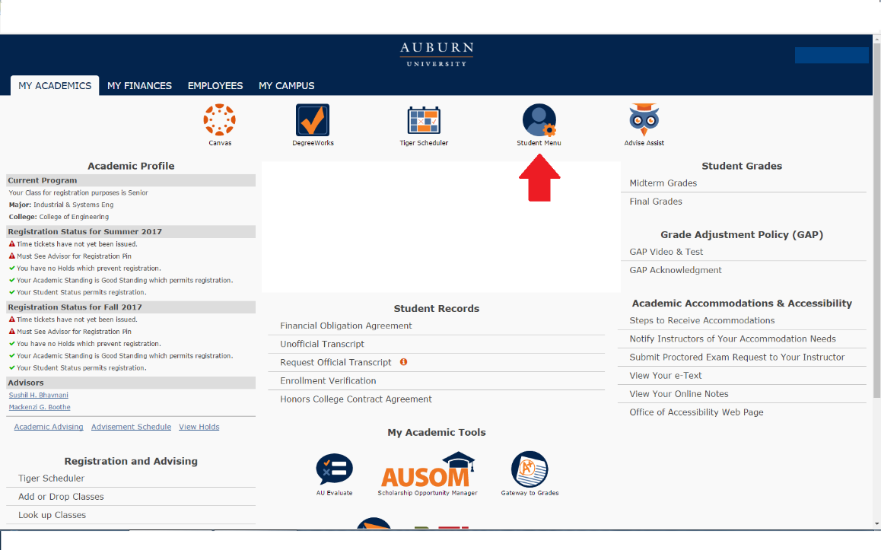
2. Near the bottom, students will see an All Access tab. Select it to view classes.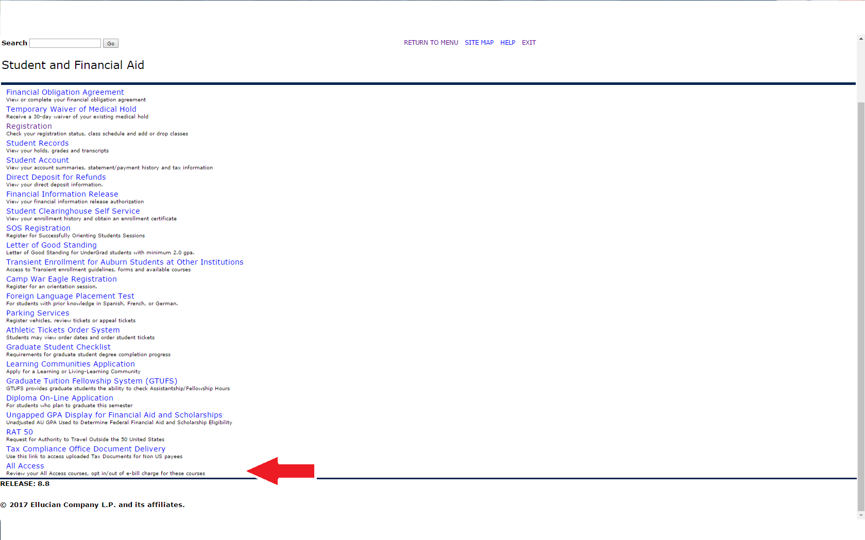
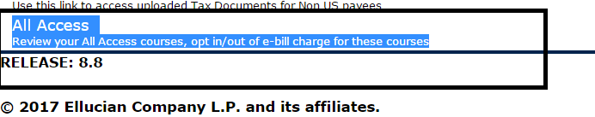

3. Once in here, they will select their the current term:
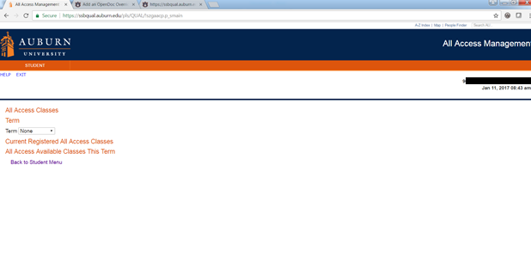
4. Once the current term is selected, All Access courses will populate with options to change out to the right.

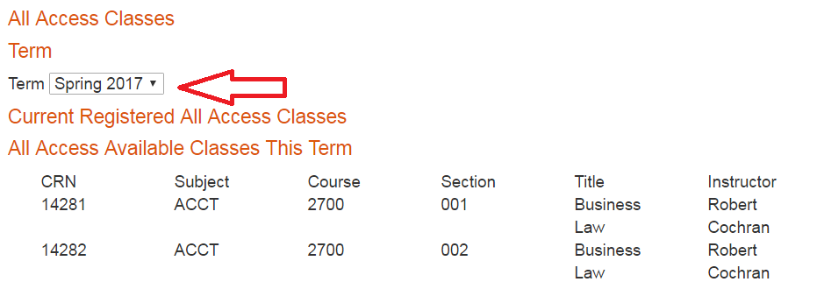

5. Students can click the change button to opt in or out of the All Access material. NOTE: This does not change your registration in the class, just your purchase option for the course materials.
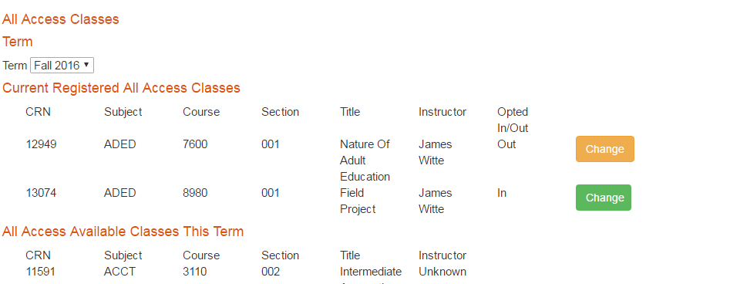

6. You will be prompted to provide a reason for opting out of the class.
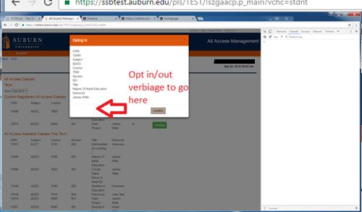

7. If completed correctly, there will be a green ‘Success’ near the middle of the page.
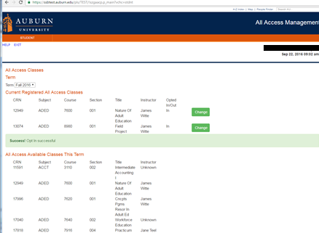

You may opt in or out at any time before the fifteenth class day. After that day, charges are sent to the Bursar to be applied to your e-bill. We may not be able to reverse the charge after that date.

We are able to apply All Access charges for course materials to scholarships that are normally handled through our scholarship counter in store. We will also apply charges for student athletes to the Athletic Department if a student’s scholarship covers course materials.

