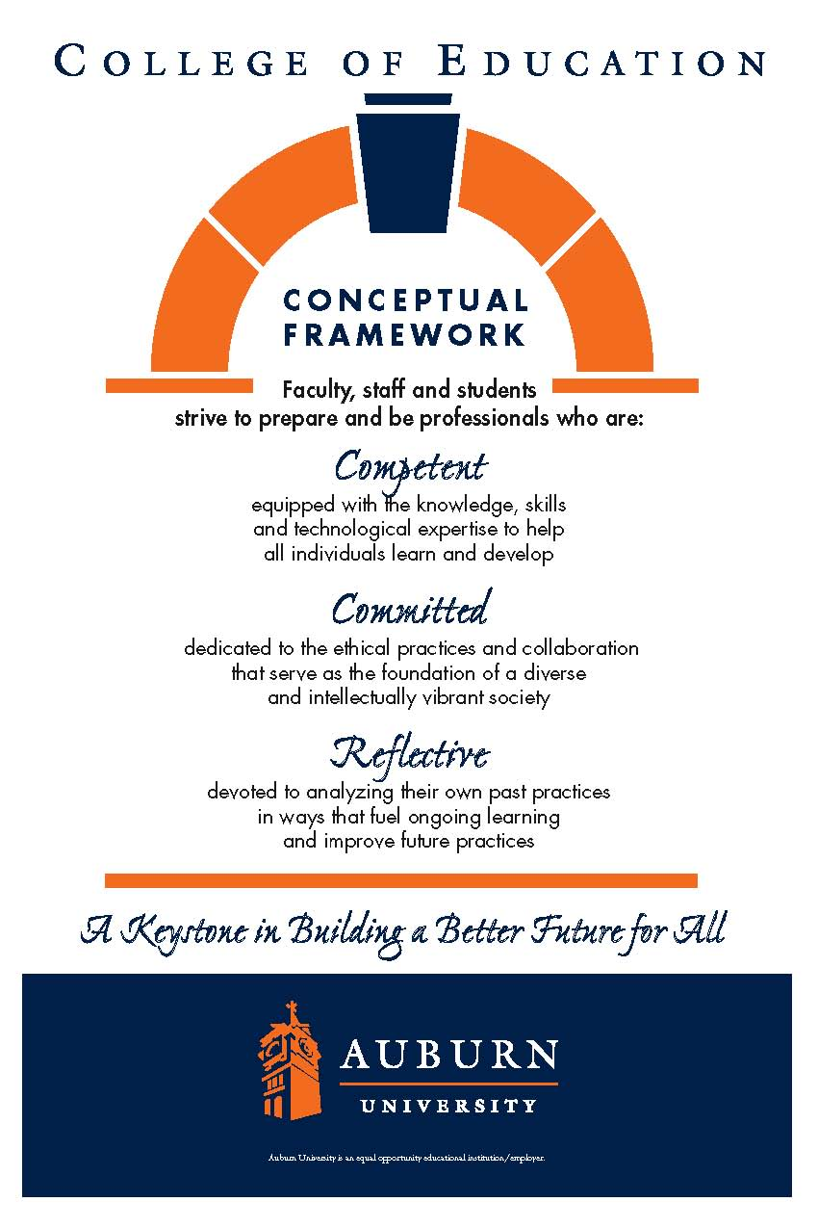
CTSE7000_7006 Summer 2021
Auburn University

Department: Curriculum & Teaching
Course Title & Credit: Orientation to Teaching & Learning
Room and Schedule: Haley Center 2406
Monday 5:00p.m. – 5:50 p.m.
Instructor: Dr. Jamie Harrison jlh0069@auburn.edu
Phone Number: 334-844-8278
Office: Haley Center 5080
Office Hours: By appointment

1. COURSE DESCRIPTION
This course is an orientation to teaching and learning and will give the student an opportunity to explore the Department of Curriculum and Teaching and the various graduate programs offered while engaging in graduate level discourse about general topics related to curriculum and teaching. Students will be guided in aspects of graduate research and will have multiple experiences to support their upcoming work in their chosen degree program.

Text:
*Flinders, D. & Thornton, S. (Eds; 2017). The Curriculm Studies Reader. New York, NY: Routledge.
*Note: this text will also be used in CTSE7800

Course Objectives:
1. Develop an appropriate plan of study
2. Successfully navigate the AU library
3. Employ APA for writing style
4. Implement appropriate educational technology
5. Evaluate current and past research
6. Develop an appropriate research proposal
2. COURSE REQUIREMENTS
Description | Percentage
CITI Training Completion | 10%
Technology Assignment | 10%
Plan of Study | 10%
Annotated Bibliography | 20%
Research Proposal Presentation | 15%
Reflective Journal | 15%
Learning Module Discussions | 15%
ePortfolio analysis | 5%
Total | 100%

CITI TRAINING: Complete CITI training to facilitate obtaining appropriate permission as needed to work in schools and study human subjects. Submit completed CITI training documents to Canvas.
REFLECTIVE JOURNAL: This semester, you will be asked to keep an individual reflective journal. Your reflective journal is a place to document your reading from The Curriculum Studies Reader and develop your rationale for your own classroom teaching. You will begin the journal in CTSE7000 and continue it in CTSE7800. Note: If you are taking the courses concurrently, you will be expected to do the assignments as listed in both courses. Learn to use your journal as a habitual way of jotting down your thoughts, questions, and notes for later application to your graduate school objectives. Be sure to document dates and times of your entries. This assignment will be assessed based on the degree to which it is complete, comprehensive, and detailed, and the extent to which it reveals your own thinking and growth as a graduate student and researcher.
TECHNOLOGY ASSIGNMENT: Students will conduct a review of educational technology as relevant to their teaching field and present their findings.
PRESENTATION OF RESEARCH IDEA: Students will develop a short presentation about a research idea to share with the class. Students will write a proposal describing the study/project and a plan for completing and evaluating the study/project. Students will synthesize current research to justify the study that they design.
ANNOTATED BIBLIOGRAPHY: Students will prepare an annotated bibliography using the Publication Manual of the American Psychological Association (6th edition). Students will use library resources and evaluate prior research.
ePORTFOLIO ANALYSIS: Students will analyze an ePortfolio in preparation for creating their own in CTSE7800
LEARNING MODULE: Students will complete all learning modules as provided in Canvas. Students will be expected to participate in both online and face-to-face discussions as provided and offered.
Grading and Evaluation:
The grading scale will be:
A = 100 – 90 average
B = 89 – 80 average
C = 79 – 70 average
D = 69 – 60 average
F = 59 or below average

Attendance and Participation: This is a one-hour course. We will meet weekly for one hour, but you should plan to spend up to three hours outside of class preparing for class or doing work for the class. Be prepared to participate in class as a group, individually, or online in discussion posts.

Distance Student Requirements: The distance section is "asynchronous" for distance students. The following will be available to distance students:
- full Panopto recording of weekly F2F class sessions
- Canvas modules that outline weekly expectations
- Canvas distance discussion boards
- 3 set 1 hour live "drop in" office hours via Zoom (details will be sent later)
- other Zoom chat sessions as requested

Distance students follow the same weekly schedule as F2F students, and adhere to all assignment due dates as listed in the syllabus or outlined in Canvas as the course proceeds. Attendance and participation: distance students will be required to participate weekly in Distance Discussion Boards.

Late Assignments: Late assignments lose 10% credit per unexcused day late to a maximum of 30% lost credit.

Assigned Readings: Readings will be available in Canvas. Readings will be discussed in various manners ranging from course Canvas discussions to embedded in class assignments.

Justification for Graduate Credit: CTSE 7000 is an orientation course for a graduate level teaching and learning degree program. During the semester students will (a) select a topic of study related to their area of specialization, (b) prepare an annotated bibliography, and (c) write a proposal to include a description of the study, objectives, methodology (including resources), and evaluation. Students will become informed consumers of applicable teacher education research.
.
3. COLLEGE AND UNIVERSITY POLICIES

Participation: Students are expected to attend class and participate in all class discussions, exercises, and activities.
It is the student’s responsibility to contact the instructor if assignment deadlines are not met. Students are responsible
for initiating arrangements for missed work.

Attendance/Absences: Excused Absences: Students are granted excused absences from class for the following reasons: Illness of the student or serious illness of a member of the student’s immediate family, death of a member of the student’s immediate family, trips for student organizations sponsored by an academic unit, trips for University classes, trips for participation in intercollegiate athletic events, subpoena for a court appearance and religious holidays. Students who wish to have an excused absence from this class for any other reason must contact the instructor in advance of the absence to request permission. The instructor will weigh the merits of the request and render a decision. When feasible, the student must notify the instructor prior to the occurrence of any excused absences, but in no case shall such notification occur more than one week after the absence. Appropriate documentation for all excused absences is required.

Make-Up Policy: Arrangements to make up missed major examination (e.g. hour exams, mid-term exams) due to properly authorized excused absences. Except in unusual circumstances, such as continued absence of the student or the advent of University holidays, a make-up exam will take place within two weeks from the time the student initiates arrangements for it. Except in extraordinary circumstance, no make-up exams will be arranged during the last three days before the final exam period begins. The format of the make-up exam will be (as specific by the instructor).

Late Assignments: Late assignments lose 10% credit per unexcused day late to a maximum of 30% lost credit.

Unannounced Quizzes: There will be no unannounced quizzes.

Accommodations: Students who need special accommodations in class, as provided for by the American Disabilities Act, should arrange a confidential meeting with the instructor during office hours the first week of classes – or as soon as possible if accommodations are needed immediately. You must bring a copy of your Accommodation Memo and an Instructor Verification Form to the meeting. If you do not have these forms but need accommodations, make an appointment with the Program for Students with Disabilities, 1244 Haley Center, 844-2096.

Academic Honesty Policy: All portions of the Auburn University student Academic Honesty Code (Title XII) will apply to this class. All academic honesty violations or alleged violations will be reported to the Office of the Provost, which will then refer the case to the Academic Honesty Committee.
Professionalism: Faculty, staff, and students in professional settings are expected to demonstrate professional behaviors as defined in the College’s conceptual framework. These professional commitments or dispositions are as follows: Engage in responsible and ethical professional practices; contribute to collaborative learning communities; demonstrate a commitment to diversity; model and nurture intellectual vitality.
Writing Center: The Miller Writing Center provides free support on any writing you are doing while at Auburn, whether for a course or not. Trained consultants are available to work with you as you plan, draft, and revise your writing. For students in distance courses and students temporarily away from Auburn’s campus, the Miller Writing Center offers synchronous online consultations. Please check the Miller Writing Center website (www.auburn.edu/writingcenter) for instructions and information about scheduling online appointments. If you have questions about the Miller Writing Center, please email writctr@auburn.edu or call 334-844-7475 M-F 7:45am-4:45pm.

Student eHandbook: Please refer to http://www.auburn.edu/student_info/student_policies/ for all AU student policies.

Distance Learning Students: See section 2.

Additional Resources:
Student Policy eHandbook: http://www.auburn.edu/student_info/student_policies/
Health and Wellness Resources https://cws.auburn.edu/studentAffairs/healthAndWellness/
Academic Support Services: http://www.auburn.edu/academic/provost/undergrad_studies/support/

4. TENTATIVE SCHEDULE
*Please note that this is a tentative summary of the schedule and activities/due dates may change during the semester. Follow the assignments as posted on the weekly modules in Canvas.

Week | Module Topics | Module Activities | Reading | Assignments
1: 5/24 | Module: Orientation to Curriculum & Teaching  Guest: Ms. Lisa Ross, Administrator III, Academic Programs, Department of Curriculum and Teaching | Review syllabus  Review AU College of Education and Curriculum & Teaching Websites: http://www.education.auburn.edu/curriculum-and-teaching  Review Auburn University Graduate School Website: http://graduate.auburn.edu/current-students/  Note: 3 interesting facts from C&T website  Note: 3 interesting facts from graduate school website | Reading 1  Curriculum Studies Reader (CSR) ch 3: My Pedagogic Creed by John Dewey  Also Read: The Top 10 Characteristics of High Performing Graduate School Students https://education.cu-portland.edu/blog/admissions-tips/top-10-characteristics-of-high-performing-graduate-school-students/ | Assignment 1: Create and Begin Reading Journal  Reading Journal Question 1 – DUE Week 2: Discuss the main tenets of John Dewey’s beliefs – how do these resonate with you? Choose 1 to describe and make personal applications to.  Week 1 Discussion Topic: Introduce yourself, your background, your educational goals. What characteristics do you have that will help you be successful in graduate school?  Assignment 2: Create and Submit a Tentative Plan of Study
2: 5/31 | Memorial Day  Module: Navigating Research in Curriculum & Teaching | City Holiday – no in-class meeting  Review the research of your major professors. What topics do they explore? Conduct some simple searches of research in your field of education. What topics stand out? | Reading 2  CSR ch 7: Basic Principles of Curriculum and Instruction by Ralph W. Tyler | Assignment 3: CITI Training – Complete and submit documents of completion to Canvas  Week 3 Discussion Topic: What are some of the major topics in your field? What is most interesting to you?  Reading Journal Question 2 – Due Week 5: Agree or disagree with the following statement: “Education is a process of changing the behavior patterns of people.”
3: 6/7 | Module: Navigating Technology in Teaching  Guest: Ms. Jessica Garrett | Tech Tools for Education - Search and explore a variety of tech tools. Share a list of what you find for this week’s discussion. | Reading 3  CSR ch 8: Was there Really a Social Efficiency Doctrine? The uses and abuses of an idea in educational history by T. Fallace & V. Fantozzi | Reading Journal Question 3 – Due Week 6: Describe the Social Efficiency doctrine. How do we or do we not see it in use today?  Assignment 4: Technology Assignment – due week 6, 7, or 8 (varies according to student sign up) Plan to demonstrate one with the class. Why do you like it? How can it be useful in a classroom? What are benefits to students? What are challenges for teachers?
4: 6/14 | Module: Navigating the AU Library & Its Resources  Guest: Mr. Todd Shipman, Education and Foreign Languages and Literature Librarian III/Associate Professor of Research and Instruction | Review Auburn University Library Website http://www.lib.auburn.edu/  Take a virtual tour: http://www.lib.auburn.edu/tour/  Conduct more in-depth searches into your field of study. Limit your search to the past 5 years. Be ready to discuss. | Reading 4  CSR ch 5: The Public School and the Immigrant Child | Reading Journal Question 4 – Due Week 6: How are the words of Jane Addams still relevant (or not) today?  Week 4 Discussion Topic: What are you interested in about ‘teaching’? teaching your subject area?  What research topic are you interested in? What are you curious about? What question do you want to answer in your research?  Assignment 5: Submit research topic and question for approval along with a list of 5 articles you plan to use for review
5: 6/21 | Module: Navigating APA & Avoiding Plagiarism  Guest: Dr. Susan Bannon, EFLT Associate Professor and Director of the Learning Resources Center | View: https://study.com/academy/lesson/what-is-apa-format-style-definition-quiz.html  Read: Plagiarism article provided | Reading 5:  CSR ch X: Student Choice | Reading Journal Question 5 – Due Week 7: Write the APA reference for the chosen chapter. Write a summary and critical response.  Week 5 Discussion Topic:  Define plagiarism and discuss its importance in higher education. Is the concept of ‘plagiarism’ cultural? Discuss.
6: 6/28 | Module: Navigating doctoral programs  Guest: Dr. Gwendolyn Williams, Associate Professor of ESOL Education, Curriculum & Teaching | Tips for applying for doctoral programs  Reference Letters,who, when, how? | Reading: By this time you should be actively reading and summarizing your chosen articles related to your research interest, so there will be no additional readings.
7: 7/5 | Independence Day Holiday | City Holiday – no in- class session | Reading: By this time you should be actively reading and summarizing your chosen articles related to your research interest, so there will be no additional readings.
8: 7/12 | Module: Navigating Academic Writing  Guest: Miller Writing Center representative | Review Auburn University’s Miller Writing Center website:  http://wp.auburn.edu/writing/  Read: https://www.gradschools.com/get-informed/surviving-graduate-school/study-skills-grad-school/10-rules-graduate-level-writing | Reading: By this time you should be actively reading and summarizing your chosen articles related to your research interest, so there will be no additional readings. | Assignment 6: ePortfolio analysis
9: 7/19 | Module: Navigating Issues of Diversity  Guest: TBD | Review a set of curriculum objectives for your field.  Read Luis Moll article provided | Reading: By this time you should be actively reading and summarizing your chosen articles related to your research interest, so there will be no additional readings. | Week 7 Discussion Topic: What are some challenges with your curriculum and objectives in relation to aspects of diversity? How can you use funds of knowledge in your teaching field and context?  Assignment 7: Annotated bibliography due
10: 7/26 | Final Presentations |  |  | Student presentations of potential research proposals

Important dates
Semester Start Date: 5/19
Memorial Day Holiday: 5/31
Semester End Date: 7/30
Final Exams: 8/4 – 6
Commencement: 8/7

