
COUNSELOR EDUCATION & SUPERVISION PH.D.
Department of Special Education Rehabilitation and Counseling

COUN 8920 Counselor Education Internship Syllabus

Course Number: | COUN 8920
Course Title: | Counselor Education Internship
Credit Hours: | 3 Semester hours
Prerequisites: | Doctoral standing in Counselor Education

Date Syllabus Revised: January 2025

Instructor: Lindsay Portela, Ph.D., LPC, NCC
Email: lkp0004@auburn.edu
Office Hours: By appointment

Required Texts: Articles posted on Canvas

Recommended Texts
Kelsky, K. (2015). The professor is in: The essential guide to turning your Ph.D. into a job. New York, NY: Three Rivers Press.

West, J. D., Bubenzer, D. L., Cox, J. A., & McGlothlin, J. M. (2013). Teaching in counselor education: Engaging students in learning. Alexandria, VA: American Counseling Association.

CACREP Standards (2024) https://www.cacrep.org/for-programs/2024-cacrep-standards/

ACA Code of Ethics https://www.counseling.org/docs/default-source/default-documentlibrary/ethics/2014-aca-code-of-ethics.pdf?sfvrsn=55ab73d0_1

* Additional research and professional development materials are provided in the CANVAS resource page. This includes materials related to professional development, dissertation/research process, professional job skills/competencies, and supporting materials for teaching, research, counseling, supervision, and leadership/advocacy.

Course Description
The doctoral internship in counselor education and supervision provides a supervised experience in the areas of Counseling, Teaching, and Supervision as well as cognate areas of
Leadership/Advocacy and Research. The internship provides an opportunity for students to apply the knowledge/skill base required through didactic coursework with oversight and mentoring from a group faculty supervisor in addition to individual fieldwork supervisors. Students in this course will record and maintain hours accruing a total of 600 hours of Counselor Education Internship Experiences over a minimum of three consecutive semesters.

Class Format
This course is designated as a digitally delivered course that is provided synchronously in an in-person format. The course meets throughout the course of the semester for a minimum of 1.5 hours a week for group supervision. The course also utilizes digitally delivered content and evaluation formats (Tevera, Canvas, Box and Zoom).

Prerequisites
- Prior to the internship, the counselor education program assesses doctoral students’ counseling skills to ensure preparedness for the doctoral counseling internship (CACREP 6.C.1.)Successful completion of the COUN 8910 – Advanced Practicum course is a requirement
- Doctoral students are covered by individual professional counseling liability insurance policies at any time they are providing counseling or supervision as part of their doctoral program. (CACREP 6.C.3.)

Student Learning Outcomes
The curriculum is designed to enhance a student’s professional identity and build on their counseling knowledge base to prepare them for a future in the field of counseling or counselor education. Upon completion of this course, students will be able to demonstrate these knowledge and skill learning outcomes under group and individual supervision in line with CACREP 2024 standards:
- Demonstrate the development of collaborative relationships with faculty in targeted counselor education work (teaching, supervision, counseling practice, research competencies, service to the profession and the public) related to professional goals.
- Demonstrate knowledge and understanding of, and ability to implement, advanced counseling skills.
- Develop an understanding of course development and demonstrate graduate level teaching skills and abilities in master’s level counseling courses.
- Strengthen their understanding of supervision theory and demonstrate ethical and appropriate supervision strategies in individual and/or triadic supervision.
- Demonstrate knowledge and understanding of research methodologies through the development and evidence of research manuscript proposals, IRB protocols, conference presentations and publications.
- Demonstrate effective feedback techniques – both in giving and receiving.
- Demonstrate ability to incorporate culturally sustaining and competent practices to counselor education work (teaching, supervision, counseling practice, service, and research competencies)
- Apply ethical and legal considerations to counselor education work (teaching, supervision, counseling practice, service, and research competencies)
- Demonstrate familiarity with and knowledge of current trends and technology use in the delivery of counseling services, counselor education, and counselor supervision.

The internship process integrates accreditation and program priorities while also incorporating the student’s professional goals. Students are required to complete a minimum of 600 hours in Internship. Specific information about hours, requirements and areas of internship practice are included in in this document as well as the CED Fieldwork Experiences Handbook. Please note internship has required areas and minimum requirements of 150 hours in these areas: Counseling, Teaching and Supervision. Students will be able to complete additional hours in any of these areas and/or in one or both Cognate areas: Leadership/Advocacy, Research.

Internship Practice Areas
- Teaching: Students can engage in teaching at Auburn University or other institutions with approval. These activities can include online and distance education courses. In addition to direct instruction, teaching experiences should include course and lecture development, evaluation in teaching, and development of teaching skills.
- Counseling: Counseling activities can include group and individual counseling. This should include skills related to initiation of the counseling process, application of counseling practice skills and theory, counseling evaluation and counseling planning.
- Supervision: Students provide individual and group supervision, such as group supervision of counselors-in-training who are enrolled in practicum and internship. This will include application of supervision skills and theory/models, evaluation in supervision, and supervision planning.
- Research: Research and scholarship activities may include participation in research projects, grant work, presenting at professional conferences, and preparing and submitting scholarly manuscript(s). Students cannot count their time engaged in dissertation activities toward internship hours.
- Leadership and Advocacy within the counseling profession. This can include serving in a leadership role within a counseling organization or professional agency related to counseling, engagement in advocacy activities on behalf of clients or the counseling profession, and involvement in professional development activities that promote the intern’s development as a leader.

Internship Supervision Breakdown
Area | Individual Supervision Provided By | Group Supervision Provided By
Counseling | Fieldwork Supervisor Weekly | Auburn University Group  Supervisor (COUN 8920 Instructor)
Supervision | Fieldwork Supervisor (Individual Auburn University Supervisor or Faculty Supervisor at approved institution) Weekly | Auburn University Group  Supervisor (COUN 8920 Instructor)
Teaching | Auburn University Group Supervisor (COUN 8920 | Auburn University Group  Supervisor (COUN 8920 Instructor)
Research & Scholarship | Instructor or approved CED Faculty) *
Leadership & Advocacy | Instructor or approved CED Faculty) *

*If students are not engaging in Counseling or Supervision hours during internship they must obtain one hour of weekly supervision throughout the semester, provided by a qualified and approved CED
Faculty supervisor for individual supervision of Teaching, Research & Scholarship, and/or Leadership & Advocacy hours.

Course Requirements

1.Ethical and Legal Practice
a. All students engaged in Internship activities must follow ACA Ethical and Legal standards and related HIPAA and FERPA policies. Please refer to the CED Fieldwork Experiences Handbook for detailed information and policies.

2. Professional Liability Insurance
- All College of Education students at Auburn University are covered under the Department of Education’s Limited Professional Liability Policy. Each student is automatically billed for the insurance during the fall semester of each year of enrollment. If the student needs verification of the liability insurance, they may request a Certificate of Verification of Insurance form the Department of Risk Management and Safety, 334-844-4870.
- As required by CACREP, 6.C.3 (2024) students are required to be covered by both the university liability insurance coverage and by individual professional counseling liability insurance policies while engaged in counseling or supervision as part of their doctoral program.
- Students can purchase this insurance through several organizations including professional organizations (HSPO, AMHCA, ASCA). At the present time, student membership in the American Counseling Association does not include liability insurance for doctoral students.
- Students must provide verification of personal liability insurance coverage on the first session of the internship course and upload to Box.

3. Internship Journal
a. Students will submit a weekly journal entry discussing the ways in which they engaged with internship hours that week, struggles and successes related to internship, as well as a self-care check in.
4. Midterm & Final Documentation

Rubrics and Grading Scale
Internship is graded Satisfactory (S), Unsatisfactory (U), or Incomplete (IN). A grade of Incomplete is only assigned when the objectives or clock hours of the internship are not met through no fault of the student.
An expectation for internship is attendance at all group and individual supervisory meetings. This includes being on time for these meetings. Students who are unable to meet this requirement will be unable to get a satisfactory grade in this course.
Please note: If a group session is going to be missed it is up to the student to work with the course instructor to determine how to make up that time.

Course Outline
Internship is a developmental course that builds on the competency areas of Teaching,
Clinical Counseling, Clinical Supervision, Research and Scholarship, and Leadership and Advocacy. To meet these goals the Internship course includes developmental components across semesters. These topics and readings support the activities involved in Group Supervision.
Date | Topic
5/19/25 | Introduction & Course Objectives
6/2/25 | Portfolio Review & Submission Overview
6/17/25* Tuesday | Attend guest lecture in Dr. Taylor’s class on SMI
6/30/25 | Counselor Education Dissertation
7/14/25 | Advocacy & Leadership in Counselor Education
7/28/25 | Self-Care and Burnout in Counselor Education
Students will have assignments and professional reflections corresponding to course topics. These are evaluated and graded in CANVAS. All TEVERA Documents are uploaded by the student after receiving appropriate supervisor signatures.

CACREP Standards and the Guidelines Counselor Education & Supervision Doctoral Internships (2024 CACREP Standards [pp. 29 -30])
This course is aligned to meet the requirements of the Council for Accreditation of Counseling and Related Educational Program (2024).
- Doctoral students are required to complete internships that total a minimum of 600 hours.
  - The minimum 600 hours must include supervised experiences in counseling and at least two more of the four remaining doctoral curricular areas (supervision, teaching, research and scholarship, and leadership and advocacy).
- Doctoral students are covered by individual professional counseling liability insurance policies at any time they are providing counseling or supervision as part of their doctoral program.
- During internships, the student receives an average of one hour per week of individual and/or triadic supervision, performed by a supervisor with a doctorate in counselor education or an individual with a graduate degree and specialized expertise to advance the student’s knowledge and skills.
- Doctoral internship students participate in an average of 1½ hours per week of group supervision on a regular schedule throughout the internship. Group supervision must be performed by a qualified core or affiliate counselor education program faculty member

CACREP Standards & Assignment Alignment Chart
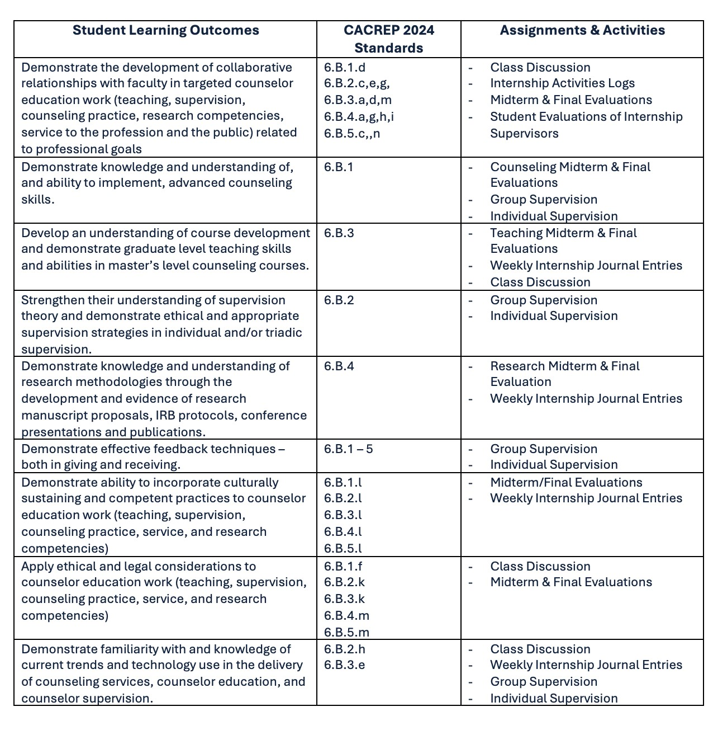

ETHICAL STANDARDS
Students engaged in all professional experiences, including Practicums and Internship, are required to follow the Counselor Education Doctoral Program, Auburn University, Practicum and Internship Site, and professional standards and practices. This includes following guidelines and standards related to HIPAA and FERPA compliance, and adhering to the American Counseling Association Ethical Standards (2014):
https://www.counseling.org/resources/ethics

PROFESSIONAL LIABILITY INSURANCE
All College of Education students at Auburn University are covered under the Department of Education’s Limited Professional Liability Policy. Each student is automatically billed for the insurance during the fall semester of each year of enrollment. If the student needs verification of the liability insurance, they may request a Certificate of Verification of Insurance form the Department of Risk Management and Safety, 334-844-4870.

As required by CACREP, 6.C.3 (2024) students are required to be covered by both the university liability insurance coverage and by individual professional counseling liability insurance policies while engaged in counseling or supervision as part of their doctoral program.

Students can purchase this insurance through several organizations including professional organizations (HSPO, AMHCA, ASCA). At the present time, student membership in the American Counseling Association does not include liability insurance for doctoral students.

WORK SAMPLES AND DEMONSTRATIONS
Specific practicums and the doctoral internship require work samples and documentation which are specified in course syllabi. Work samples may include recorded sessions or demonstrations. In all instances, students should follow ACA Ethical Standards (2014) and related HIPAA and FERPA policies. Students are required to provide documentation and work samples within the timeframe specified in course syllabi (e.g. 48 hours prior to supervision or evaluation meetings).

The Counselor Education Doctoral Program specifies the following in reference to policies regarding recording and documentation during Practicums and Doctoral Internship:

RECORDING
- In practicums that require work samples (e.g., Counseling, Supervision) students are required to use the appropriate consent documents to record all sessions. The consent documents may include site specific documents. If those are not provided, students will use the AU consent document provided as part of the course materials.
- During Teaching Practicum, the Instructor (Doctoral Student) should review class policies related to recording the class session. If the class does not have a policy related to recording sessions, the Instructor (Doctoral Student) must notify students (digital or live delivery) that the session is being recorded and the purpose of the recording, following Auburn University guidelines regarding recording of class sessions. These policies also apply to Internship components that include the taping of demonstrations and work samples.

METHODS OF RECORDING
In reference to recording methods, please refer to site specific policies and procedures related to recording and retaining recordings (HIPPA, ACA 2016, FERPA). In addition, course syllabi provide specific requirements related to the type and nature of recordings in Practicums and Internship. Students can only use approved encrypted devices, provided by the COE Learning Resource Center, to record work samples and recordings must be deleted no later than the end of classes unless requested by instructor and/or supervisor.

Auburn University Counselor Education Program also provides students with the facilities to record, including the Counseling Labs (1220, 1219, 1218). Supervision sessions conducted at Auburn University by Doctoral Supervisors must be recorded in the individual rooms provided in the Counseling Labs. Teaching demonstrations can be recorded in classrooms that have smart technology or using other formats or technology to record the demonstration. Students can use Panopto or Zoom to record class demonstrations.

Auburn provides HIPAA Compliant Zoom for students in clinical practice areas that require the use of recorded work samples. Work samples and documentation must not contain identifiable information. Samples and documentation (including all practicum and internship experiences) can be stored in secured BOX folders with access provided only to the doctoral student and approved University supervisors. When documenting and evaluating supervisee work or academic teaching experiences (COUN 8910 Teaching Practicum) Doctoral students also need to adhere to FERPA policies pertaining to student records.

DOCUMENTATION
As noted, all documentation and recording needs to follow ethical standards and include the consent of the client and/or supervisee. Storage of demonstrations, work samples, and documentation should also follow site policies, course syllabi, and program requirements.

Once counseling sessions are recorded, they are immediately uploaded to a secure password protected BOX folder (AU) and deleted from the recording device. Supervisors will upload sessions to a secure password protected BOX folder immediately after the session and cannot store sessions on the computers in the Counseling Labs. You will be required to select the Link Settings in Box that include the option of a password protected file. You are only permitted to share these files with your supervisor.

Teaching demonstrations are also to be stored in a secured BOX folder. All required documentation follows confidentiality policies and practices (ACA, 2014, site specific) and can only be retained in a secured password protected BOX folder. As a reminder, you are required to notify students that the session is being recorded.

Auburn University Counselor Education policies require that all counseling and supervision work samples and corresponding documentation (not site-specific documentation except approved consent documents that address recording) must be destroyed and erased at the conclusion of the semester. The only exception is when a University Supervisor requests or requires the documentation; in this case the University Supervisor will retain the documentation and/or work sample in a separate secured BOX folder.

Class Policy Statements:
- Course communication: University e-mail (NOT messages through Canvas) will be the primary avenue of communication with the instructor in between class sessions. Canvas will be used as the medium to transfer educational materials for this course. Students will upload completed assignments to Canvas and bring them to class only when instructed. Final documentation will be uploaded to both Canvas and Tevera. Auburn provides students with helpful tips for proper email etiquette which can be found here.
- Attendance: Students may miss up to one class for any reason without penalty. Additional absences (without prior or retroactive excusal) will result in a 5-point grade reduction. Students will be held responsible for any content covered in the event of an absence. Students are expected to be on time for class.
- Excused Absences: Students are granted excused absences from class for the following university approved reasons. When feasible, the student must notify the instructor prior to the occurrence of any excused absences, but in no case shall notification occur more than one week after the absence. Appropriate documentation for all excused absences is required. Please see the Student EPolicy Handbook for more information on excused absences.
- Make-Up Policy: Arrangement to make up a missed major examination (e.g., hour exams, midterm exams) due to properly authorized excused absences must be initiated by the student within one week of the end of the period of the excused absence(s). If you miss an assignment, you have one week to contact the instructor and address the issue. Except in extraordinary circumstance, no make-up exams will be arranged during the last three days before the final exam period begins.
- Academic Honesty: All portions of the Auburn University student academic honesty code (Title XII) found in the Student Policy eHandbook will apply to university courses. All academic honesty violations or alleged violations of the SGA Code of Laws will be reported to the Office of the Provost, which will then refer the case to the Academic Honesty Committee.
- Course Contingency: If normal class and/or lab activities are disrupted due to illness, emergency, or crisis situation, the syllabus and other course plans and assignments may be modified to allow completion of the course. If this occurs, and addendum to your syllabus and/or course assignments will replace the original materials.
- Professionalism: As faculty, staff, and students interact in professional settings, they are expected to demonstrate professional behaviors as defined in the College’s conceptual framework. These professional commitments or dispositions are listed below:
  - Engage in responsible and ethical professional practices
  - Contribute to collaborative learning communities
  - Demonstrate a commitment to diversity ▪ Model and nurture intellectual vitality

Justification for Graduate Credit: This course includes advanced content on pedagogical methods in counselor education. This includes content as specified by the Council for the Accreditation of Counseling and Related Programs (CACREP, 2016). All academic content approved by CACREP is for advanced Master’s and/or Doctoral graduate study. This includes rigorous evaluation standards of students completing the student learning outcomes specified in this syllabus.

Attendance/Subject to Change: The course schedule and assignments are designed with the most upto-date information and policies in mind. If the situation changes, I will make every effort to keep the schedule as consistent as possible; however, please note that the due dates for assignments and tests may be changed during the semester in response to the changing health and safety requirements or
policies of the University. When changes are made, they will be communicated via Canvas Announcement, Canvas message, and all assignment due dates will be updated.

Policy Related to the Use of AI for Classroom Assignments
The Counselor Education Programs (CED) has a comprehensive policy on the use of Artificial Intelligence (AI). As the acceptable use of AI varies, please consult your instructor on how AI can be used within specific courses and/or clinical settings. Please understand that violations of this policy can be considered a form of plagiarism. Please see the CED Programs Handbook for the full AI policy.

Policy Related to the Use of Zoom for Class Meetings
Zoom participation requires you to keep your video on and your microphone muted when you are not speaking.
- If you have a need for technology to support your participation in this class or do not have a space conducive for participating - SERC provides private individual counseling spaces (Counseling Lab) that you can reserve and use for class sessions.
- Please know that you can blur your background if you are not comfortable sharing your space or environment during classes conducted online.
- Please limit all distractions such as your phone or attending to other work on your computer. It is often very apparent that a student is distracted and that impacts the class environment for everyone.
- Students can turn off their cameras briefly if needed (e.g., break). These pauses should be short. Having students on camera provides a higher level of engagement for all participants.
- If you have questions during class, you can raise your hand (in real time or via Zoom).
- Please know that sometimes it is challenging to be teaching and attending to students and reading messages in Chat, especially if I am also sharing content. If I don’t respond to a comment or discussion in Chat, please let me know.
- Although you may be participating from your domicile, our Zoom meetings are professional interactions.
  - You should dress and behave as you would in a normal F2F classroom. o Please minimize distractions in the background as much as possible. o Participating in spaces that are not conducive to zoom attendance (e.g., public spaces, vehicles) should be discussed with the instructor prior to the class session and should only be used when there are no other alternatives.
- Recording Sessions: Due to the nature of our classes and the possibility that we may be discussing content that is confidential in nature:
  - Instructors can record sessions and will notify students when the class session is being recorded (e.g., teaching demonstrations, making the session available to other students, speakers)
    - Confidential content (e.g., supervision sessions) will be retained following appropriate ethical and legal practices as well as CED policies (e.g., password protected BOX folders).
    - Students can request that the recording be stopped if they wish to discuss a topic that they do not want recorded. In areas such as supervision this may not be possible.
  - You should participate in spaces that allow for these discussions and do not have others present in the room while you are using it for class or supervision.
  - As per University policies, I reserve the right to dismiss anyone from a Zoom meeting whose environment or behavior is distracting or problematic.
  - If you have any issues with sharing your video feed, adhering to this policy, or anything else related to your use of Zoom please notify me via email in the first week of class so we can discuss if accommodations are possible.

Diversity Statement
A central foundation of the mission of the Counselor Education programs is the preparation of counselors and counselor educators to work in an increasingly diverse society. The program’s understanding of diversity encompasses culture, sexual and gender identity, race, ethnicity, socioeconomic status, ability, and other aspects of individual identity. The program believes that meeting these goals requires that students and faculty engage in advocacy, equity, inclusion, and culturally sustaining practices. This includes students demonstrating these principles in their academic, clinical practice and professional development engagement.
These principles are in alignment with our professional, ethical, and accreditation standards including:
Council for the Accreditation of Counseling and Related Programs (2024 standards) American
Counseling Association’s Code of Ethics (ACA, 2016), American Rehabilitation Counseling Association
(ARCA), the Commission on Rehabilitation Counselor Certification (CRCC), American Mental Health Counselors Association (AMCHA), and the American School Counselor Association (ASCA). Overall, we seek to create educational and learning environments that support, sustain, and challenge students to address their development as professionals related to and representative of culturally sustaining practice.

Accommodations Statement
Auburn University and the Counselor Education program are committed to ensuring student success by providing them with the appropriate supportive resources when necessary. We encourage students to exercise their right under the Americans with Disabilities Act to access academic accommodations. Students who need accommodations should submit their approved accommodations through the AIM Student Portal on AU Access and follow up with the instructor about an appointment. It is important for the student to complete these steps as soon as possible; accommodations are not retroactive. Students who have not established accommodations through the Office of Accessibility but need
accommodations should contact the Office of Accessibility at ACCESSIBILITY@auburn.edu or (334) 8442096 (V/TT). The Office of Accessibility is located in Haley Center 1228. Once a student has begun the process for accommodations, they are responsible for scheduling a meeting with faculty to discuss how these accommodations will be implemented in practice. Faculty are committed to working with students to support their needs in conjunction with the Office of Accessibility.

Mental Health
If you or someone you know needs support, you are encouraged to contact Auburn Cares at 334-8441305. Auburn Cares will help you navigate any difficult circumstances you may be facing by connecting you with the appropriate resources or services.
Student Counseling & Psychological Services provides confidential, no-cost mental health counseling and psychiatric services to Auburn Students. You can speak with a counselor 24/7/365 by calling 334844-5123. Learn more about mental health information on campus at auburn.edu/scps.

Basic Needs
Any student experiencing food insecurity or an unexpected financial crisis is encouraged to contact Auburn Cares at 334-844-1305 for resources and support.

Sexual Misconduct Resources Statement
Auburn University faculty are committed to supporting our students and upholding gender equity laws as outlined by Title IX. Please be aware that if you choose to confide in a faculty member regarding an issue of sexual misconduct, dating violence, or stalking, we are obligated to inform the Title IX Office, who can assist you with filing a formal complaint, No-Contact Directives, and obtaining supportive measures.
If you would like to speak with someone confidentially, Safe Harbor (334-844-7233) and Student Counseling & Psychological Services (334-844-5123) are both confidential resources. Safe Harbor provides support to students who have experienced sexual or relationship violence by connecting them with academic, medical, mental health, and safety resources.

SYLLABUS DISCLAIMER
The instructor reserves the right to make changes to the syllabus as needed. In the event that changes are deemed necessary, the instructor will inform students at the earliest date possible in class or via university email.

