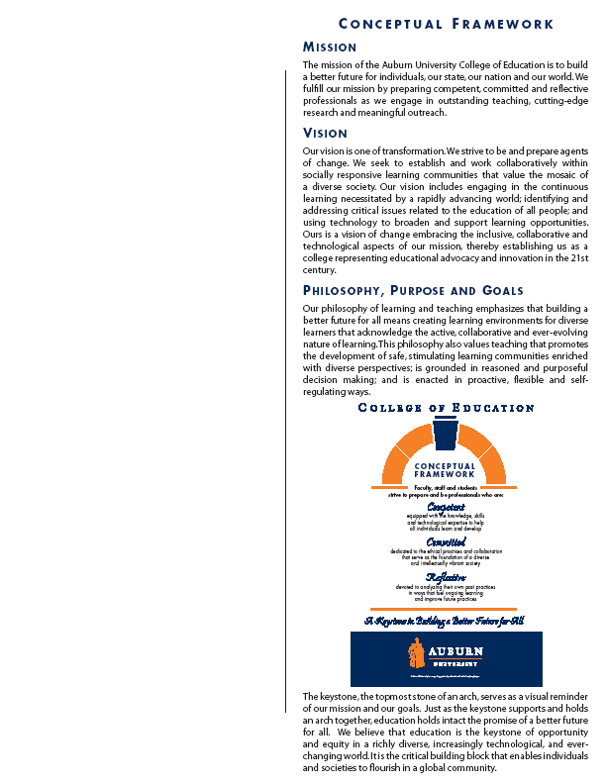
COLLEGE OF EDUCATION

KINE 8970: RESEARCH ETHICS
Fall 2010

Professor: David D. Pascoe (844-1479/pascodd@auburn.edu)

1. Course Number: KINE 8970
Course Title: Ethics
Credit Hours 3 semester hours
Prerequisite: Graduate Standing, Departmental approval
Corequisite: None

2. Date Syllabus Prepared: August 2010.

3. Readings: Belmont Report, Code of Federal Regulations, Ethics Primer.

4. Course Description: Research ethics (basic philosophical concepts, theories, scientific scholarship, IRB/IACUC, ethical debates, and ethical themes in movies.

5. Course Objectives: Upon completion of this course, students will discuss and understand the issues pertaining to the ethics of:
A. Basic philosophical and theories of ethics
B. Scientific Scholarship
i. conflict of interest
ii. mentor/mentee responsibilities and relationships
iii.. collaborative research and working with industry
a. Disclosure agreements
iv. peer review/scientific integrity
v. project concept and data ownership
vi. research misconduct, reporting misconduct
- authorship and credit
- IRB/IACUC rule, regulations and research
- Discuss and Debate controversial ethical situations.
- Evaluate the ethics as demonstrated in movies with ethical dilemma.

6. Course Content and Schedule: The course will consist of readings, lecture, debates, class discussions, movie reviews related to scientific and research ethics.

7. Course Requirements/Evaluation:

Evaluation measures for determining course grade: Students will complete class readings, participate in required debates, actively participate in discussions an movie reviews.

Notebook (ethical principles/theories, IRB/IACUC, Scientific scholarship) 20 points
CITI Training 10 points
Class Debates (2) 50 points
Class discussions/movie review/participation/attendance 20 points
_________
Total 100 points

The Developed course curriculum will be graded on a ten-point scale.

A = 90-100%
B = 80-89%
C = 70-79%
D = 60-69%
F = <59%

8. Class Policy Statements:

Participation - It is expected that students will attend every scheduled class meeting, will actively participate in class discussions if relevant, and will meet all project, term paper, or presentation deadlines. Please refer to the current edition of the Tiger Cub (http://www.auburn.edu/tigercub) for the definition of excused absences. Students are responsible for initiating arrangements for missed work.

Unannounced Quizzes – There will be no unannounced quizzes in this class.

Accommodations - Students who need special accommodations in class, as provided for by the American Disabilities Act, should arrange a confidential meeting with the instructor during office hours the first week of classes - or as soon as possible if accommodations are needed immediately. You must bring a copy of your Accommodation Memo and an Instructor Verification Form to the meeting. If you do not have these forms but need accommodations, make an appointment with the Program for Students with Disabilities, 1244 Haley Center, 844-2096

Honesty Code – The University Academic Honesty Code and the Tiger Cub Rules and Regulations pertaining to Cheating will apply to this class.

Professionalism – As faculty, staff, and students interact in educational settings, they are expected to demonstrate professional behaviors as defined in the College of Education’s conceptual framework. These professional commitments or dispositions are as follows: 1) engage in responsible and ethical practices, 2) contribute to collaborative learning communities, 3) demonstrate a commitment to diversity, and 4) model and nurture intellectual vitality.

Note: The discussion of ethical controversial issues can invoke emotional feelings that may interfere with the discussion of the topic material. Students are NOT permitted to make discussions personal attacks. Leave the emotions out of the discussions. In some cases, students may be discussing or debating ideas that are contrary to their personal beliefs.

9. Justification of Graduate Credit:

The content of this course is of sufficient depth and complexity to justify graduate credit; the material goes well beyond the introductory level and requires students to consider not only basic knowledge, but also detailed aspects and controversial issues at the cutting edge of topics. The prerequisite for this course is graduate standing. The content of this course develops the critical and analytical skills appropriate to mastery of the discipline of kinesiology by requiring students to investigate and synthesize advanced concepts. Students are required to analyze, explore, question, reconsider, and synthesize old and new knowledge and skills. Rigorous standards are applied to the evaluation of class assignments.

