COLLEGE OF EDUCATION
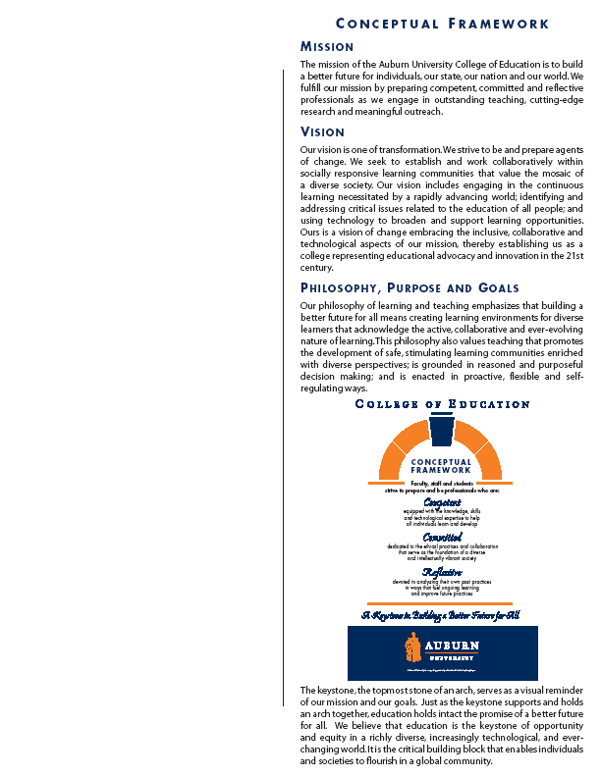
Health and Human Performance
Course Syllabus
1. Course Number: KINE 7970-002
Course Title: Physiological Basis of Training and Conditioning
Credit Hours: 2 semester hours
Prerequisite: None
Corequisite: None

2. Date Syllabus Prepared- August 2012

3. Text - None

4. Course Description
In this course students will investigate common exercise science myths about performance, movement, nutrition, or exercise.

5. Course Objectives: The student will:
A. Demonstrate an understanding of the basic metabolic, circulatory, respiratory, muscular, and environmental responses as related to various myths pertaining exercise science.
B. Demonstrate an understanding of the available literature regarding the efficacy of various products, devises, or supplements that are suggested for enhancement of movement, performance, nutrition, or exercise.

6. Course Content
A. Describe the myth:
What, when, where, why, dose…….
B. Possible mechanism(s):
Other than placebo effect, how is this supposed to work?
C. Review of literature (Pro and Con):
Performance effect, benefit?
Problems, side effects?
D. Decision:

Supported Not Supported Undecided (anecdotal)

Specifics No scientific evidence Brief Research
(Not tested) Proposal

Pilot Project
(If practical)

Project (if interested)
E. Class Design:
First Day: Syllabus, Myth Search
Class Day 2: What is Truth? The Placebo Effect
Class Day 3: Ergogenic Effects-Discussion, debate
Remaining 12 weeks: Myth Busting (Detective Teams)
Each student ≥ two myths, no involvement limit over 2,
Produce group report/class discussion; Individual’s must provide “authorship percentage” to group

F. Class Ethics:
- Assignments are proprietary to Dr. Pascoe and class.
- Research idea is proprietary to detective group, can be relinquished. Waiver
must be obtained (written).
- If class materials are used for development of a distance course, student’s
contribution must be greater than 50% to receive individual acknowledgement.

7. Course Requirements
Students are required to research their topics. This research should not only seek a knowledge base regarding the myth topic , but also include claims made on the efficacy of the intervention.

8. Grading and Evaluation Procedures
Possible Pts. Total Points
Two projects 40 points/each 80
Class Participation 20 20
Semester Total 100

Grading Scale
A = 90-100
B = 89 – 80
C = 79 -70
D = 69 - 60
F < 60

9. Class Policy Statement

Participation: Students are expected to participate in all class discussions and participate in all exercises. It is the student’s responsibility to contact the instructor if assignment deadlines are not met. Students are responsible for initiating arrangements for missed work.

Attendance/Absences: Attendance in class is required and imperative for the students to obtain the information and be active in the class discussions. Missed classes can result in grade points lost under the category of class participation.

Unannounced quizzes: There will be no unannounced quizzes.

Accommodations: Students who need special accommodations in class, as provided for by the American Disabilities Act, should arrange a confidential meeting with the instructor during office hours the first week of classes - or as soon as possible if accommodations are needed immediately. You must bring a copy of your Accommodation Memo and an Instructor Verification Form to the meeting. If you do not have these forms but need accommodations, make an appointment with the Program for Students with Disabilities, 1244 Haley Center, 844-2096

Honesty Code: The University Academic Honesty Code and the Tiger Cub Rules and Regulations pertaining to Cheating will apply to this class.

Professionalism: As faculty, staff, and students interact in professional settings, they are expected to demonstrate professional behaviors as defined in the College’s conceptual framework. These professional commitments or dispositions are listed below:
    - Engage in responsible and ethical professional practices
    - Contribute to collaborative learning communities
    - Demonstrate a commitment to diversity
    - Model and nurture intellectual vitality

10. Justification for Graduate Credit

The content of this course is of sufficient depth and complexity to justify graduate credit;
The course material goes well beyond the introductory level and requires students to consider the read and interpret the literature concerning the potential myths. The project reports that are turned in will be graded to reflect the efforts and capabilities of students within the Kinesiology graduate program.

