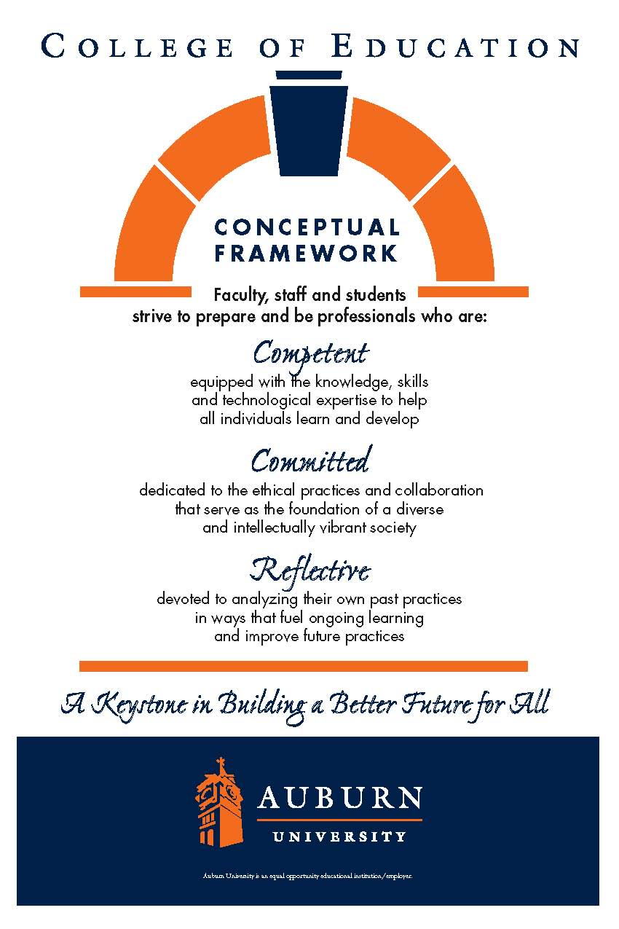

**CTEC 4200**

**Auburn University**

Department: Curriculum & Teaching

Program: Early Childhood Education

Course Title: The Constructivist Teacher:

Strategies and Techniques

Course Number: CTRD 4200, Section 002

Course Credit: 3 hours

Semester: Fall 2014

Instructor: Kelly Hill, PhD

Email Address: klh0055@auburn.edu

Phone Number: Office: 334-844-6769

Cell: 205-936-9730

Office: 5078 Haley Center 5th floor

Office Hours: M 1:00-4:00 & T 3:00-4:00,

by appointment

Schedule: Tuesday / Thursday 1:00-2:25

Classroom: 2438 Haley Center

Prerequisites: Admission to Teacher Education,

CTEC 3030/4911

Corequisites: CTEC 4912 Primary Practicum

(Cary Woods Elementary School)

**1. COURSE DESCRIPTION**

**Catalog Description:**

Students construct operational knowledge of established constructivist strategies and techniques, a set of guidelines on which to base wise curriculum decisions, and operational knowledge of the field of early childhood education, including state and national curriculum standards for the field.

**Text:**

**Required:**

Branscombe, N. A., Burcham, J. G., Castle, K., Surbeck, E., Dorsey, A. G., Taylor, J. B. (2014).

Early childhood curriculum: A constructivist perspective (2nd ed.). New York: Routledge.

DeVries, R., & Zan, B. (2012). *Moral classrooms, moral children: Creating a*

*constructivist atmosphere in early education* (2nd ed.). New York: Teachers College Press.

Ray, K. W. & Laminack, L. L. (2001). The writing workshop: working through the hard parts (and

they’re all hard parts). Urbana, Illinois: NCTE.

**Suggested:**

Heard, G. (2013). Finding the heart of nonfiction: Teaching 7 essential craft tools with mentor texts.

Portsmouth, NH: Heinemann.

Jacobson, J. (2010). “No more I’m done!” Fostering independent writers in the primary grades.

Portland, Maine: Stenhouse.

**Course Objectives:**

The Early Childhood program provides the pre-service teacher the opportunity to construct knowledge and refine their practice through experiences that support empirical and theoretical decision-making. To this end, this course will provide pre-service teachers the opportunity to observe and participate in supervised practicum experiences [NAEYC 6.1] with young children of diverse ages and reflecting diverse family systems [NAEYC 6.2 & 6.3] in order to:

1. Set goals to facilitate children's development and skills in communication, inquiry, creative expression, reasoning, and interpersonal relationships. [ECE 2.b.3] [NAEYC 5.7]
2. Develop integrated learning experiences for young children in all areas: cognitive, language, physical, social, emotional, aesthetic and technological. [ECE 2.b.3] [NAEYC 2.1.4 & 2.1.8] [TS 2.viii]
3. Plan, implement, and evaluate developmentally appropriate content and methodologies for young children that integrate all curriculum areas including biological and physical sciences, fine arts, health education, language arts, mathematics, physical education, and social studies.[ECE 2.b.4] [NAEYC 2.1.5, 4.1.1, 5.5 & 5.6]
4. Plan, implement, and evaluate strategies that foster mutual respect and understanding through verbal and nonverbal communication and that insure equitable and effective access to all instructors and materials. [ECE 2.b.3][NAEYC 2.1.2, 5.5 & 5.6] [TS 2.iii]
5. Promote and manage a positive classroom environment. [ECE 2.b.4] [PS 2.c.1 (v)]
6. Evaluate, select, and create materials based on long-range, unit, and daily objectives. [ECE 2.b.4] [NAEYC 4.1.3] [ECE 2.b.7]
7. Use manipulative materials and play as instruments for enhancing development and learning. [ECE 2.b.1] ][NAEYC 2.1.2]  2
8. Select and use appropriate equipment and technology. [PS 2.c.1 (v) & 2.c.2.(iv)] [NAEYC 2.1.6] [TS 2.v]
9. Communicate with parents/guardians for the purpose of involving them in the education of young children. [ECE 2.b.6][NAEYC 3.1.1, 3.1.3, 3.4, 3.5, 4.1.5, & 5.7] [ECE 2.b.9]
10. Use shared reading experiences and the structure of natural learning as a basis for literacy instruction. [ECE 2.b.2] ][NAEYC 2.1.2]
11. Respond to and conference with children at the appropriate developmental level. [ECE 2.b.5]
12. Utilize a variety of instructional methods and materials appropriate for particular topics and situations, emphasizing student participation in hands-on activities and relate to colleagues in a professional manner. [ECE 2.b.4]
13. Implement basic health, nutrition, and safety management practices for young children, including specific procedures for infants and toddlers and procedures regarding childhood illness and communicable diseases.[NAEYC 2.4.3 & NAEYC 2.4.4 & 5.8]
14. Use reflection and self-evaluation as a basis for program planning and modification for the needs of young children, including children with special needs and children from diverse backgrounds. [NAEYC 5.1]
15. Observe, record, and assess children's behavior and development. [ECE 2.a.5]
16. Use school and/or community resources to enhance the programs for young children. [NAEYC 3.4 & 3.5]
17. Function as a member of an instructional team and relate to colleagues in a professional manner. [NAEYC 5.6]
18. Advance children’s development in the use of written language [ECE 2.b.8]
19. Advance children’s use of the stages of the writing process [ECE 2.b.8]

**Course Content:**

**General Topics:**

* Integrated Curriculum
* Child Guidance and Classroom Governance
* Effective Teaching Strategies for Active, Engaged Learning
* Literacy Instruction and Experiences Across the Curriculum
* Developmentally Appropriate Practice

**Apply Theory -** Each student will use knowledge gained in CTEC 3200/3030 to construct materials and develop teaching strategies that will positively impact on primary grade children's learning.

**Understand and use supervising teacher strategies -** Students are responsible for classroom tasks that benefit the children, such as providing materials for activities, displays, field trips, etc. Students have the opportunity to work with experienced teachers and a supervisor who will guide them within the classroom. Students will also practice the creation and management of classroom routines and rituals, such as taking children to the bathroom, supervising arrivals and departures, monitoring centers, group work, and project work, assisting with attendance, and other teaching tasks.

**2. COURSE REQUIREMENTS**

**Attendance:**

Excused absences are defined in the *AU Bulletin*: You may be excused for personal illness, a serious illness or death of someone in your immediate family, a field trip, a religious holiday (one week prior notice), or a subpoena. For a provisional excuse, please notify me on or before the day you miss by leaving a message by e-mail or telephone. For a fully excused absence (and full attendance/participation points), you will need to provide documentation.

Quizzes missed because of unexcused absences may not be made up. Late assignments lose 10% credit per unexcused *weekday* late (including weekdays when we do not meet) to a maximum of 30% lost credit. For example, a 20-point assignment due Tuesday would be worth at most 14 points by Friday. If your absence is excused, any assignment will be due the following weekday and will begin to incur late penalties on the second weekday unless you provide daily updates of continuing excusing information. Assignments may be sent by course e-mail to avoid late penalties. If you do send work by e-mail, address it carefully and watch for error messages or for my acknowledgement. Note: *E-mail errors will not negate late penalties.*

**Grading Plan:**

**Course Assignments:** Total Possible Points = 500

*Please note that this is only a plan; assignments and point totals may change during the semester

1. Weekly Reading Assignments - 15 @ 10 points each = 150

2. Formal papers (5 pages, double spaced) written around specific course topics - 2 @ 25 points each = 50

3. Teaching Philosophy - 25 points

4. Classroom environment / behavior plan (letter to parents) - 15 Points

5. Class Participation / Interactive Notebook - 30 X 2= 60 points

*2 points may be earned for attendance / participation in each class session or for a fully

excused absence (1 point for a provisionally excused absence OR for late arrival to class).

6. Writing Workshop Unit of Study (group project) - 100 Points

7. Integrated Unit (individual project – Final Exam) - 100 Points

**EXTRA POINTS:**

1. Joining the Plains Reading Council = +5 points (must join before September)

-Membership information available on Canvas

2. Attending Alabama Reading Association conference in Birmingham = +25

-Registration information available on Canvas

(Registration is $25)

**3. University and College Policies**

**Participation**:

All students are expected to participate in all class discussions and participate in all exercises. It is the student’s responsibility to contact the instructor if assignment deadlines are not met and for initiating arrangements for missed work.

**Unannounced Quizzes:**

There will be no unannounced quizzes.

**Accommodations:**

Students who need special accommodations in class, as provided for by the American Disabilities Act, should arrange a confidential meeting with the instructor during office hours the first week of classes – or as soon as possible if accommodations are needed immediately. You must bring a copy of your Accommodation Memo and an Instructor Verification Form to the meeting. If you do not have these forms but need accommodations, make an appointment with the Program for Students with Disabilities, 1244 Haley Center, 844-2096.

**Academic Honesty Policy:**

All portions of the Auburn University student [Academic Honesty Code](https://sites.auburn.edu/admin/universitypolicies/Policies/AcademicHonestyCode.pdf) (Title XII) will apply to this class. All academic honesty violations or alleged violations will be reported to the Office of the Provost, which will then refer the case to the Academic Honesty Committee.

**Professionalism:**

Faculty, staff, and students in professional settings are expected to demonstrate professional behaviors as defined in the College’s conceptual framework. These professional commitments or dispositions are as follows: Engage in responsible and ethical professional practices; contribute to collaborative learning communities; demonstrate a commitment to diversity; model and nurture intellectual vitality.

**Writing Center:**

The Miller Writing Center provides free support on any writing you are doing while at Auburn, whether for a course or not. Trained consultants are available to work with you as you plan, draft, and revise your writing. For students in distance courses and students temporarily away from Auburn’s campus, the Miller Writing Center offers synchronous online consultations. Please check the Miller Writing Center website ([www.auburn.edu/writingcenter](http://www.auburn.edu/writingcenter)) for instructions and information about scheduling online appointments. If you have questions about the Miller Writing Center, please email [writctr@auburn.edu](mailto:writctr@auburn.edu) or call 334-844-7475 M-F  7:45am-4:45pm.

**Student eHandbook:**

Please refer to <http://www.auburn.edu/student_info/student_policies/> for all AU student policies.

ECE=Alabama and National Council for the Accreditation of Teacher Education Standards for Early Childhood Education

PS=Alabama and National Council for the Accreditation of Teacher Education Standards for Professional Studies, Basic Programs.

NAEYC= National Association for the Education of Young Children

4. TENTATIVE SCHEDULE

Reading Assignments:

ECC – Early Childhood Curriculum: A Constructivist Perspective, 2nd ed.

WW – The Writing Workshop: Working through the Hard Parts (And They’re All Hard Parts)

MC – Moral Classrooms, Moral Children: Creating a Constructivist Atmosphere in Early Education, 2nd ed.

|  |  |  |  |
| --- | --- | --- | --- |
| **Class Dates:** | **Session:** | **Guiding Questions:** | **Reading for the following class:** |
| Aug. 19 & 21 | 1 | What is our plan?  -Introductions & Syllabus  *Interactive Notebook Setup | ECC – Chap. 1-3  *\*Additional reading provided by Professor* |
| Aug. 26 & 28 | 2 | What is the aim of education? What is knowledge? How does one come to “know” something? How do constructivist assumptions and principles guide teaching practices? | ECC – Chap. 4-5  *\*Additional reading provided by Professor* |
| Sept. 2 & 4 | 3 | What are the components of constructivist curriculum? How do teachers plan for and include these components as a part of existing (sometimes even mandated) school curriculum? | ECC – Chap. 6-7  *\*Additional reading provided by Professor* |
| Sept. 9 & 11 | 4 | What do we do when problems arise? What are the characteristics of a caring classroom community and how can teachers foster it? | ECC – Chap. 8-10  *\*Additional reading provided by Professor* |
| Sept. 16 & 18 | 5 | What constructivist practices should be in our curriculum and instruction? What role does authentic assessment play in constructivist education? | *\*Reading provided by Professor* |
| Sept. 23 & 25 | 6 | How are reading and writing connected? How can teachers make this connection apparent and useful for students? | *\*Reading provided by Professor* |
| Sept. 30 & Oct. 2 | 7 | What is writing? What are the stages of writing development? How do children grow and change as writers? | WW – Chap. 1-5 |
| Oct. 7 & 9 | 8 | What is writing workshop? How does it fit within a constructivist teaching approach? | WW – Chap. 6-10  **Suggested Text - “No More I’m Done!” chap. 1-3 & 6 |
| Oct. 14 (16th – No Class, Fall Break) | 9 | How do we foster autonomous and independent writers in the primary grades? | WW – Chap. 11- 13  *\*Additional reading provided by Professor*  **Suggested Text - “No More I’m Done!” - chap. 4-5 |
| Oct. 21 & 23 | 10 | What are units of study in writing? How can I use focused mini-lessons to help children grow as writers? What impact does the Common Core / College & Career Ready Standards have on the teaching of writing? | *\*Reading provided by Professor*  **Suggested Text – Finding the Heart of Nonfiction |
| Oct. 28 & 30 | 11 | What are mentor texts? How can teachers use these to inspire writers and ignite a passion for writing? | WW – Chap. 14- 17 |
| Nov. 4 & 6 | 12 | How can teachers be responsive yet intentional during a writing conference? How can we transform the process of sharing to not only celebrate writing, but also inform and support writers? What is the role of assessment in writing and writing workshop? | MC – Chap. 1-4 |
| Nov. 11  (13th, ARA Conf.*) | 13 | What are “moral classrooms” and “moral children?” How do teachers establish a constructivist sociomoral atmosphere? | MC – Chap. 5-8 |
| Nov. 18 & 20 | 14 | How do constructivist teaching strategies apply to conflict resolution in the classroom? What are the roles and responsibilities of children in conflict resolution and decision making in the classroom? | MC – Chap. 9-10  *\*Additional reading provided by professor* |
| Happy Thanksgiving! (24th- 28th No Class) | | | |
| Dec. 2 & 4 | 15 | What is moral judgment and how do children develop sociomorally? How do constructivist teaching strategies guide discipline approaches in the classroom? | NA |
| Dec. 8-12 (Final Exams) Integrated Unit – Due Dec. 8 by 11:59 PM | | | |