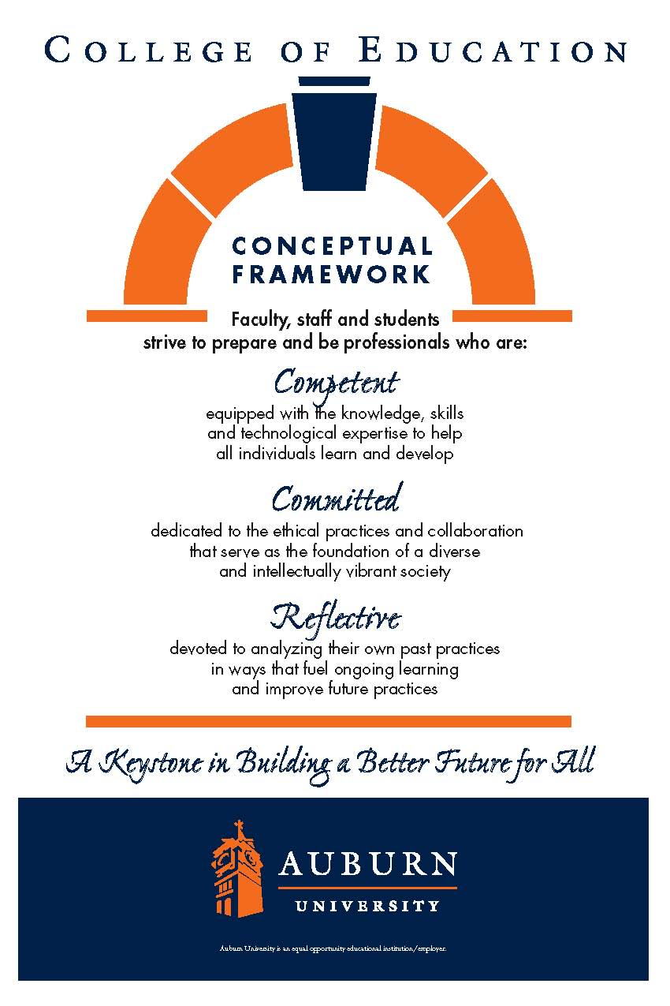

**CTEC 4200**

**Auburn University**

Department: Curriculum & Teaching

Program: Early Childhood Education

Course Title: The Constructivist Teacher:

Strategies and Techniques

Course Number: CTEC 4200

Course Credit: 3 hours

Semester: Fall 2015

Instructor: Nicole Mitchell

Email Address: nsm0009@auburn.edu

Phone Number: TBA

Cell: 252-367-9084**

Office: 5014 Haley Center 5th floor

Office Hours: T/Th 12:30-1, Friday 9-12

by appointment

Schedule: Tuesday / Thursday 1:00-2:30

Classroom: 2442 Haley Center

Prerequisites: Admission to Teacher Education

**Not to be distributed

**1. COURSE DESCRIPTION**

**Catalog Description:**

Students construct operational knowledge of established constructivist strategies and techniques, a set of guidelines on which to base wise curriculum decisions, and operational knowledge of the field of early childhood education, including state and national curriculum standards for the field.

**Text:**

**Required:**

Branscombe, N. A., Burcham, J. G., Castle, K., Surbeck, E., Dorsey, A. G., Taylor, J. B. (2014).

Early childhood curriculum: A constructivist perspective (2nd ed.). New York: Routledge. Helm, J. H., Katz, L. (2011). Young investigators: The project approach in the early years (2nd ed.).

Teachers College Press: New York.

Johnston, P. H. (2004). *Choice words: How our language affects children’s learning.* Portland, ME: Stenhouse.

**Course Objectives:**

The Early Childhood program provides the pre-service teacher the opportunity to construct knowledge and refine their practice through experiences that support empirical and theoretical decision-making. To this end, this course will provide pre-service teachers the opportunity to observe and participate in supervised practicum experiences [NAEYC 6.1] with young children of diverse ages and reflecting diverse family systems [NAEYC 6.2 & 6.3] in order to:

1. Set goals to facilitate children's development and skills in communication, inquiry, creative expression, reasoning, and interpersonal relationships. [ECE 2.b.3] [NAEYC 5.7]
2. Develop integrated learning experiences for young children in all areas: cognitive, language, physical, social, emotional, aesthetic and technological. [ECE 2.b.3] [NAEYC 2.1.4 & 2.1.8] [TS 2.viii]
3. Plan, implement, and evaluate developmentally appropriate content and methodologies for young children that integrate all curriculum areas including biological and physical sciences, fine arts, health education, language arts, mathematics, physical education, and social studies.[ECE 2.b.4] [NAEYC 2.1.5, 4.1.1, 5.5 & 5.6]
4. Plan, implement, and evaluate strategies that foster mutual respect and understanding through verbal and nonverbal communication and that insure equitable and effective access to all instructors and materials. [ECE 2.b.3][NAEYC 2.1.2, 5.5 & 5.6] [TS 2.iii]
5. Promote and manage a positive classroom environment. [ECE 2.b.4] [PS 2.c.1 (v)]
6. Evaluate, select, and create materials based on long-range, unit, and daily objectives. [ECE 2.b.4] [NAEYC 4.1.3] [ECE 2.b.7]
7. Use manipulative materials and play as instruments for enhancing development and learning. [ECE 2.b.1] ][NAEYC 2.1.2]  2
8. Select and use appropriate equipment and technology. [PS 2.c.1 (v) & 2.c.2.(iv)] [NAEYC 2.1.6] [TS 2.v]
9. Communicate with parents/guardians for the purpose of involving them in the education of young children. [ECE 2.b.6][NAEYC 3.1.1, 3.1.3, 3.4, 3.5, 4.1.5, & 5.7] [ECE 2.b.9]
10. Use shared reading experiences and the structure of natural learning as a basis for literacy instruction. [ECE 2.b.2] ][NAEYC 2.1.2]
11. Respond to and conference with children at the appropriate developmental level. [ECE 2.b.5]
12. Utilize a variety of instructional methods and materials appropriate for particular topics and situations, emphasizing student participation in hands-on activities and relate to colleagues in a professional manner. [ECE 2.b.4]
13. Implement basic health, nutrition, and safety management practices for young children, including specific procedures for infants and toddlers and procedures regarding childhood illness and communicable diseases.[NAEYC 2.4.3 & NAEYC 2.4.4 & 5.8]
14. Use reflection and self-evaluation as a basis for program planning and modification for the needs of young children, including children with special needs and children from diverse backgrounds. [NAEYC 5.1]
15. Observe, record, and assess children's behavior and development. [ECE 2.a.5]
16. Use school and/or community resources to enhance the programs for young children. [NAEYC 3.4 & 3.5]
17. Function as a member of an instructional team and relate to colleagues in a professional manner. [NAEYC 5.6]
18. Advance children’s development in the use of written language [ECE 2.b.8]
19. Advance children’s use of the stages of the writing process [ECE 2.b.8]

**Course Content:**

**General Topics:**

* Integrated Curriculum
* Child Guidance and Classroom Governance
* Effective Teaching Strategies for Active, Engaged Learning
* Literacy Instruction and Experiences Across the Curriculum
* Developmentally Appropriate Practice

**2. COURSE REQUIREMENTS**

**Attendance:**

Excused absences are defined in the *AU Bulletin*: You may be excused for personal illness, a serious illness or death of someone in your immediate family, a field trip, a religious holiday (one week prior notice), or a subpoena. For a provisional excuse, please notify me on or before the day you miss by leaving a message by e-mail or telephone (50% participation points). For a fully excused absence (and full attendance/participation points), you will need to provide documentation. Being late to class will result in 50% deduction of participation points for the day.

Quizzes missed because of unexcused absences may not be made up. Late assignments lose 10% credit per unexcused *weekday* late (including weekdays when we do not meet) to a maximum of 30% lost credit. For example, a 20-point assignment due Tuesday would be worth at most 14 points by Friday. If your absence is excused, any assignment will be due the following weekday and will begin to incur late penalties on the second weekday unless you provide daily updates of continuing excusing information. Assignments may be sent by course e-mail to avoid late penalties. If you do send work by e-mail, address it carefully and watch for error messages or for my acknowledgement. Note: *E-mail errors will not negate late penalties.*

**Grading Plan:**

**Course Assignments:** Total Possible Points = 500

*Please note that this is only a plan; assignments and point totals may change during the semester

1. Weekly Reading/Discussion Board Assignments - 15 @ 10 points each = 150

*Will be posted on Canvas

2. Tests – 2 @ 50 points each = 100 Points

3. Formal observations 2 @ 25 points each = 50

4. Teaching Philosophy - 100 points

*Rubric and instructions will be given in class and posted on Canvas

5. Writing Case Study (Final Exam) - 100 Points

*Rubric and instructions will be given in class and posted on Canvas

**EXTRA POINTS:**

1. There may be 2-3 opportunities for extra credit throughout the semester. Extra credit assignments will be given in class and must be turned in on due date to qualify toward final average.

**3. University and College Policies**

**Participation**:

All students are expected to participate in all class discussions and participate in all exercises. It is the student’s responsibility to contact the instructor if assignment deadlines are not met and for initiating arrangements for missed work.

**Unannounced Quizzes:**

There will be no unannounced quizzes.

**Accommodations:**

Students who need special accommodations in class, as provided for by the American Disabilities Act, should arrange a confidential meeting with the instructor during office hours the first week of classes – or as soon as possible if accommodations are needed immediately. You must bring a copy of your Accommodation Memo and an Instructor Verification Form to the meeting. If you do not have these forms but need accommodations, make an appointment with the Program for Students with Disabilities, 1244 Haley Center, 844-2096.

**Academic Honesty Policy:**

All portions of the Auburn University student [Academic Honesty Code](https://sites.auburn.edu/admin/universitypolicies/Policies/AcademicHonestyCode.pdf) (Title XII) will apply to this class. All academic honesty violations or alleged violations will be reported to the Office of the Provost, which will then refer the case to the Academic Honesty Committee.

**Professionalism:**

Faculty, staff, and students in professional settings are expected to demonstrate professional behaviors as defined in the College’s conceptual framework. These professional commitments or dispositions are as follows: Engage in responsible and ethical professional practices; contribute to collaborative learning communities; demonstrate a commitment to diversity; model and nurture intellectual vitality.

**Writing Center:**

The Miller Writing Center provides free support on any writing you are doing while at Auburn, whether for a course or not. Trained consultants are available to work with you as you plan, draft, and revise your writing. For students in distance courses and students temporarily away from Auburn’s campus, the Miller Writing Center offers synchronous online consultations. Please check the Miller Writing Center website ([www.auburn.edu/writingcenter](http://www.auburn.edu/writingcenter)) for instructions and information about scheduling online appointments. If you have questions about the Miller Writing Center, please email [writctr@auburn.edu](mailto:writctr@auburn.edu) or call 334-844-7475 M-F  7:45am-4:45pm.

**Student eHandbook:**

Please refer to <http://www.auburn.edu/student_info/student_policies/> for all AU student policies.

ECE=Alabama and National Council for the Accreditation of Teacher Education Standards for Early Childhood Education

PS=Alabama and National Council for the Accreditation of Teacher Education Standards for Professional Studies, Basic Programs.

NAEYC= National Association for the Education of Young Children

4. TENTATIVE SCHEDULE

**CTEC 4200– Course Schedule**

**Fall 2015**

|  |  |  |
| --- | --- | --- |
| **Date** | **Topic** | **Readings/Assignments** |
| August 18 | Introduction to course | Syllabus |
| 20 | Our identities as teachers; Our images of children | <http://www.reggioalliance.org/downloads/malaguzzi:ccie:1994.pdf> |
| 25 | Constructivism:  Aims and Assumptions | Chapter 1  Branscombe et al. |
| 27 | Constructivist Curriculum: What does it look like? | Chapters 2, 3  Branscombe et al. |
| September 1 | DAP and Constructivism:  What does it look like? | Chapter 4  Branscombe et al. |
| 3 | Play and Observation:  Image of the Teacher | <https://www.youtube.com/watch?v=K7vna8raRdc> |
| 8 | Strategies for Observation | Supplemental Resources- TBA |
| 10 | Play and Problems:  Strategies and Provocations  **Observation #1 due** | Chapter 5  Branscombe et al. |
| 15 | Play and Problems:  Strategies and Provocations | Chapter 6  Branscombe et al. |
| 17 | Strategies to Create a  Caring Community | Chapter 7  Branscombe et al. |
| 22 | Building Curriculum:  The Project Approach | Chapter 8  Branscombe et al.  Chapter 1: Young Investigators |
| 24 | Getting Started with Projects | Chapter 2: Young Investigators |
| 29 | Developing Projects | Chapter 3: Young Investigators |
| October 1 | Developing Projects | Chapter 4: Young Investigators |
| 6 | Interest Areas and Content Areas: Image of the Environment | TBA |
| 8 | Image of the Environment  Continued | TBA |
| 13 | **Observation #2 due**  **Test 1** |  |
| 15 | **Fall Break** |  |
| 20 | The Role of Language in the Constructivist Classroom  Continued | Chapters 1, 2  Johnston |
| 22 | Strategies for Building Identity and Agency | Chapters 3, 4  Johnston |
| 27 | Recognizing and Co-constructing: Children’s Theories | Chapters 5, 6  Johnston |
| 29 | The Importance of Nature | **http://www.childrenandnature.org/** |
| November 3 | Documenting children’s learning and development:  Why Bother? | TBA |
| 5 | Documentation: Logistics | TBA |
| 10 | Democratic Learning | Chapter 7  Johnston |
| 12 | Examples of social/constructivist curriculum | Readings from Early Childhood Research and Practice |
| 17 | Constructivist curriculum in the primary grades | Readings from Young Children |
| 19 | Strategies for Addressing Holidays  **Philosophy of Education due** | NAEYC Resources  (Code of Ethics, website) |
| 23-27 | Thanksgiving Break |  |
| December 1 | The continuous challenge that is early childhood education Course Wrap-up |  |
| 3 | **Test 2**  **Writing Case Study (Final Exam) due** |  |
| **This schedule may be modified based upon the determined needs of instruction and student understanding.** | | |