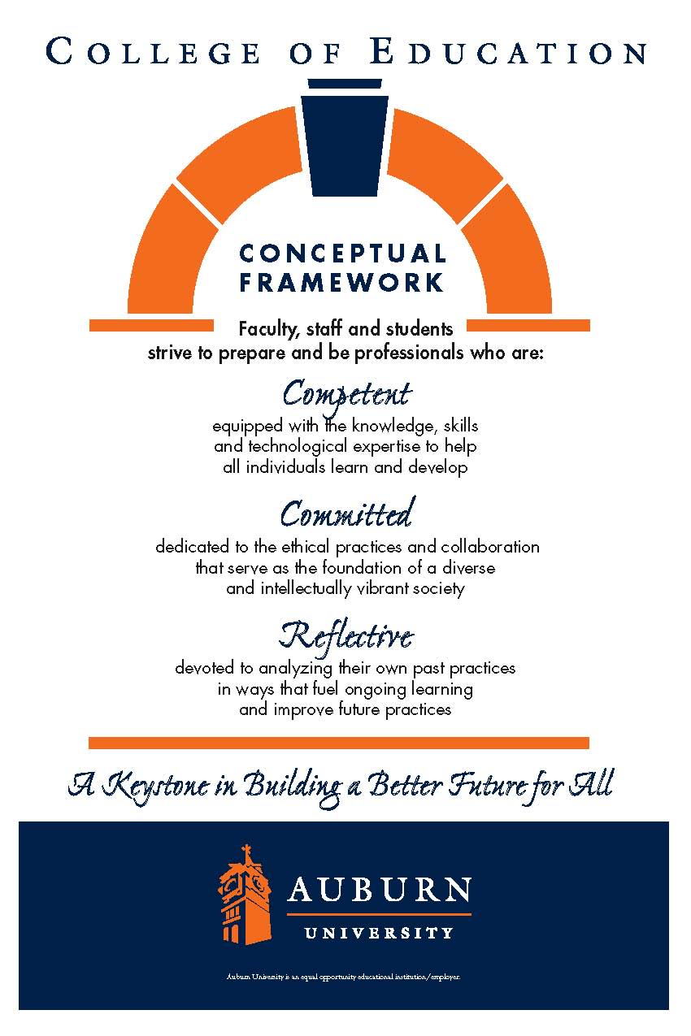

**CTRD 50003/6000/60006**

**Auburn University**

Department: Curriculum & Teaching

Program: Reading

Course Title: Language and Literacy in the Content Areas

Course Credit: 3 hours

Semester: Fall 2016

Instructor: Gwendolyn Williams, PhD

Email Address: gmw0015@auburn.edu

Phone Number: (334) 844-6775

Office: Haley Center 5078

Office: Haley Center 5078

Office Hours: Tues. 10-1; Wed. 4:30-5:30

*Online -by appointment

Schedule: Online

Prerequisites: Admission to Teacher Education

(CTRD 5003 Only)

**1. COURSE DESCRIPTION**

**Catalog Description:**

Strategies to help fluent readers and English language learners learn content in the disciples by strategic reading of texts.

**Text:**

Vacca, R.T., Vacca, J.L., & Mraz, M. (2014). *Content area reading: Literacy and learning across the curriculum.* Boston: Pearson.

All additional readings will be made available in Canvas Course Content.

**Course Objectives:**

Course objectives include a subset of key indicators from the Alabama State Department of Education preservice teacher continuum (.03), English language arts program-specific standards (.10), and advanced technology standards (.42). Final assessment of the advanced technology standards (.42) are in this course.

**Preservice Teacher Continuum (.03)**

*Literacy*

3.3 Uses age-appropriate instructional strategies to improve learners’ skills in fluency, vocabulary, and comprehension

3.4 Integrates narrative and expository reading strategies across the curriculum

3.7 Identifies and integrates available emerging technology into the teaching of all content areas

3.8 Facilitates learners’ individual and collaborative use of technology and evaluates their technological proficiency

*Diversity*

4.1 Develops culturally responsive curriculum and instruction

4.4 Supports learners to accelerate language acquisition

4.5 Guides 2nd language acquisition and utilizes English Language Development (ELD) strategies

4.6 Differentiates between learner difficulties related to cognitive or skill development and those that relate to language learning

4.7 Understands and recognizes the characteristics of exceptionality in learning to assist in appropriate identification and interventions

**English Language Arts Program-specific Standards (.13)**

Create meaning-including comprehension, interpretation, evaluation and appreciation-from texts. (2) (a)3. (ii)(i)

Select Appropriate research based strategies and materials to meet the needs of struggling readers, including those identified in the Alabama Reading Initiative publication Essential Skills of Teaching Reading. (2) (a) 3. (ii) (lll)

**Advanced Technology Standards (.42) - Graduate Students Only**

|  |
| --- |
| With regard to designing, implementing, and assessing technology-based learning experiences to engage students and improve learning; prepare students for successive education, careers and college; enrich professional practice; and provide positive models for students, colleagues, and the community, individuals enrolled in Class A programs shall demonstrate ability to: |
| 1. Facilitate and inspire student learning and creativity by providing a variety of learning environments that foster collaboration and innovative thinking to solve real world issues and authentic problems using digital tools and resources. |
| 1. Design, develop, use, manage, and assess authentic digital-age learning experiences that are aligned with subject-area content and the *Alabama Course of Study: Technology Education* to maximize content learning and address diverse learning styles, incorporating the use of formative and summative measurement tools to better inform learning. |
| 1. Model and facilitate innovative digital-age work and learning experiences through the effective use of current and emerging tools to ensure success in a global and digital world whereby the teacher and learner locate, analyze, evaluate, manage, and report information as well as communicate and collaborate online fluently using a variety of technology-based media formats. |
| 1. Promote, model, and communicate the safe, legal, and ethical principles of digital citizenship, equitable access, digital etiquette, and responsible online social interactions in a global culture including respect for copyright, intellectual property, the appropriate documentation of sources, and Internet user protection policies. |
| 1. Engage in professional growth and leadership activities, including modeling lifelong learning by participating in face to face and online learning communities to continuously improve professional practice using existing and emerging digital tools, resources, and current research that focuses on improved student learning, as well as promotes professional development of other educators. |

**2. COURSE REQUIREMENTS**

A. Participate in all asynchronous and synchronous class activities.

1. Complete all assigned readings.
2. Complete all class activities on Canvas.

D. Maintain a professional presence in the online environment for this course.

E. Frequently check the course website for updates, email, and assignments.

Attendance and Participation: Class content and processes related to literacy and inquiry are based on social interaction, applications of cooperative learning activities, shared reader responses, and collaboration. Due to the participatory nature of learning experiences in this class, students are expected to have an ACTIVE online presence and adhere to all course requirements explained in class policies.

Assigned Readings: All assigned texts and course materials will be available in Canvas Course Content for this class. Readings will be discussed in various manners ranging from course Canvas discussions to embedded in-class assignments. These readings contain information that will be included in the reflections, projects, examinations, and other course requirements.

Activities: Class activities can be found in the “Student Responsibilities” section of each weekly module. ALL assignments are expected to be complete.

Technology Assignments:

Internet Inquiry WebQuest Project: Students will produce a WebQuest that incorporates Internet resources, publish it, and submit through Canvas, so other classmates can review and evaluate the usefulness of the WebQuest. The WebQuest will be developed as an electronic resource for engaging elementary, middle, or high school students in literacy and inquiry that corresponds to state and national course of study standards. The grade for this project will be based on rubric evaluation completed by the instructor and possibly other class members. Qualitative and quantitative rubric criteria will be used to evaluate the extent to which the WebQuest has been revised and edited for on-line publication and has potential for involving participants in:(1) meaningful, personally relevant content, questions, tasks and processes; (2) reading and responding to a variety of appropriate information sources that take advantage of the timeliness of the internet; (3) interactions with texts that integrate content area reading, writing, and technology; (4) inquiry that promotes critical reading, thinking, and synthesis across multiple sources and from multiple perspectives; (5) appropriate scaffolding for English learners (6) and rubric assessment of standards-based learning goals. Guidelines and resources for producing and publishing the WebQuest for Internet access will be available on Canvas.

WIX: Students will create classroom home pages that incorporate before, during, and after reading strategies that also reflect strategies that support English learners, publish it, and submit the hyperlink through Canvas, so other classmates can review and evaluate the usefulness of the class resource page. The WIX will be developed as an electronic resource for students to use anytime, anywhere as they are working on their unit of study. The grade for this project will be based on rubric evaluation completed by the instructor. Guidelines and resources for producing and publishing the WIX will be available on Canvas.

PathBrite Final Exam Portfolio Reflection: Students will develop a PathBrite Portfolio to submit a full compilation of all course requirements using forward, inward and backward reflection for each assignment. . Each student will submit the URL internet address for the plan to the Instructor who will evaluate the reflections and the final submission of all assignments. Guidelines and resources for producing and submitting PathBrite e-Portfolio will be available on Canvas.

GRADUATE STUDENTS ONLY

Research Report. Graduate students enrolled in CTRD 6000 or 6006 must complete a research report in which they summarize, evaluate, and make recommendations based on the results of at least five research articles published in refereed journals for their content area. Articles selected for the research report must present findings that relate to improving and/or accelerating reading fluency, vocabulary, and/or comprehension for elementary or secondary students in working with content area texts and materials. In the report, describe how reading strategies/ practices improve in reading instruction in your content area. The research report should be a minimum of five full pages without the list of references and include citations for each article in the body of the text and a reference list on the last page that follow guidelines from the American Psychological Association (APA) Style Manual. The research report must be typed and edited thoroughly to make sure there are no semantic, syntactic, or spelling errors.

**Grading and Evaluation:**

The final grade for the course will be based on the following:

Late assignments will result in a 10% grade deduction per calendar day. The grading scale will be: 90-100% = A; 80-89.9% = B; 70-79.9% = C; 60-69.9% = D; 0-59.9% = F

*** Please note that points will be deducted for work turned in late as explained in each assignment.

**3. University and College Policies**

**Participation**:

Students are expected to participate in all asynchronous, synchronous assignments. It is the student’s responsibility to contact the instructor if deadlines for exercises and assignments are not met. Students are responsible for initiating arrangements for submitting missed work.

You will need to log in and participate each week. There will be four "real-time" meetings scattered throughout the semester in which you must participate. You will be notified of these dates as soon as possible, so you can make arrangements. Points will be awarded based on your activities in the course and your participation on the Discussion boards and assignments.

**Unannounced Quizzes:**

There will be no unannounced quizzes.

**Accommodations:**

Students who need special accommodations in class, as provided for by the American Disabilities Act, should arrange a confidential meeting with the instructor during office hours the first week of classes – or as soon as possible if accommodations are needed immediately. You must bring a copy of your Accommodation Memo and an Instructor Verification Form to the meeting. If you do not have these forms but need accommodations, make an appointment with the Program for Students with Disabilities, 1244 Haley Center, 844-2096.

**Academic Honesty Policy:**

All portions of the Auburn University student [Academic Honesty Code](https://sites.auburn.edu/admin/universitypolicies/Policies/AcademicHonestyCode.pdf) (Title XII) will apply to this class. All academic honesty violations or alleged violations will be reported to the Office of the Provost, which will then refer the case to the Academic Honesty Committee.

**Professionalism:**

Faculty, staff, and students in professional settings are expected to demonstrate professional behaviors as defined in the College’s conceptual framework. These professional commitments or dispositions are as follows: Engage in responsible and ethical professional practices; contribute to collaborative learning communities; demonstrate a commitment to diversity; model and nurture intellectual vitality.

**Writing Center:**

The Miller Writing Center provides free support on any writing you are doing while at Auburn, whether for a course or not. Trained consultants are available to work with you as you plan, draft, and revise your writing. For students in distance courses and students temporarily away from Auburn’s campus, the Miller Writing Center offers synchronous online consultations. Please check the Miller Writing Center website ([www.auburn.edu/writingcenter](http://www.auburn.edu/writingcenter)) for instructions and information about scheduling online appointments. If you have questions about the Miller Writing Center, please email [writctr@auburn.edu](mailto:writctr@auburn.edu) or call 334-844-7475 M-F  7:45am-4:45pm.

**Student eHandbook:**

Please refer to <http://www.auburn.edu/student_info/student_policies/> for all AU student policies.

4. TENTATIVE SCHEDULE

*Please note that this is a tentative summary of the schedule and may change during the semester. Follow the assignments on the weekly modules in Canvas.

|  |  |  |  |  |
| --- | --- | --- | --- | --- |
| Week | Concept for the Week | Reading  (*Each week read/view the information in “Merging Voices from the Field” for the module and check out the accompanying videos and teaching resources) | Assignments | Point Value |
| 1-2  Aug, 16-29 | Welcome Module & Text Identification / Evaluation |  | *Voice Thread assignment  *Textbook Selection  *Textbook scan  *Bader Textbook Analysis | 30  Complete/Incomplete  15 |
| 3  Aug 30-Sept. 6 (Due the 6th because of Labor Day) | Culturally Responsive Teaching in Diverse Classrooms | -Chapter 3 – Vacca text  Articles:  -Practitioner Brief: Addressing Diversity in Schools: Culturally Responsive Pedagogy  -teachperspectives.org  (read / explore website) | *Discussion Posting | 20 |
| 4  Sept. 6-12 | Language Acquisition | Article:  -Diaz-Rico Reading | *Mind Map Graphic Organizer  *KWL Notes | 15  15 |
| 5  Sept 13-19 | Effective Teaching & Professional Development | -Chapter 12 – Vacca text | SIOP Instrument | 30 |
| 6  Sept 20-26 | New Literacies | -Chapter 2 – Vacca text  -2 articles provided in Merging Voices from the Field | Webquest  *Post WebQuest link in Discussion | 40  Complete/Incomplete |
| 7  Sept 27-Oct. 3 | Assessment and Text | -Levine & McCloskey – Chap. 11 | Pre & Post Assessment | 40 |
| 8  Oct 4- 10 | Vocabulary | -Chapter 8 – Vacca text | Tiered Vocabulary Lesson Plan | 25 |
| 9  Oct 11-17 | Planning and Instruction for EBs | Literacy Instruction for ELLs (Cloud, Genesee, & Hamayan) – Chap. 4 | Alternate Text for EBs | 20 |
| 10  Oct 18-24 | Strategies to Enhance Learning | -Chapter 6 – Vacca text | No written undergrad assignment this week  Research Report for Grad Students due 10/24. |  |
| 11  Oct 25-31 | Guided Reading | -Chapter 7 – Vacca text | Developing Before, During and After Reading Strategies (WIX)  *Post your WIX link in the Discussion board | 30  Complete/Incomplete |
| 12  Nov. 1-7 | Writing Across the Content Areas | -Chapter 9 – Vacca text  -Strong Chap. 6  -Writing Next Summary  -Ideas/Examples of Writing | Content Area Writing Assignment | 30 |
| 13  Nov. 8-14 | Text Features | -Chapter 10 – Vacca text | Student Profile Justification | 20 |
| 14  Nov. 15-21 | Learning with Trade books | -Chapter 11 – Vacca text  Articles:  -Children’s Informational Picture Books Visit a Secondary ESL Classroom  - | Picture –Trade books | 100 |
| 15 Nov. 21- 25 | Thanksgiving Break | | | |
| 16  Nov. 28- Dec 5 | Final Exam |  | Pathbrite E-Portfolio  Reflective Process | 100 |
|  |  |  |  |  |
|  |  |  |  |  |