**Exercise Physiology**

**(KINE 3680) Course Syllabus**

**Fall 2017**

**Instructor**: C. Brooks Mobley, M.Ed., CSCS

**Office**: 236 School Kinesiology

**Lab**: 245 School of Kinesiology

**Phone**: N/A

**E-mail**: [moblecb@auburn.edu](mailto:moblecb@auburn.edu)

**Office hours**: Monday- Friday: 2-3 p.m.

**Prerequisites**: none

**Co-requisites**: none

**Class schedule**: MWF: 8:00-8:50 a.m.

**Location:** 257 STACT

**\*Please email me to schedule an appointment that fits your schedule if needed.**

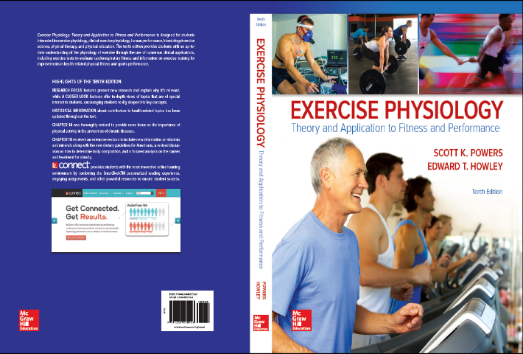**Course description**: This course will focus on the physiological, anatomical and biochemical/molecular aspects of exercise physiology.

**Syllabus prepared**: 07-7-2017

**“Required” text**:

Powers, S.K & Howley, E. T. (2015 or 2017).

*Exercise Physiology: Theory and Application to Fitness and Performance. (9th or 10th Ed.)* New York, NY: McGraw-Hill Humanities

**Best preparation:** print off class notes from Canvas prior to coming to class and come to class!!!

**Class Objectives:** upon completion of this course students should demonstrate an understanding of:

* + The physiological adaptations that occur in response to exercise
  + The physiological aspects of muscle, respiratory, cardiovascular responses to exercise
  + Basic concepts of bioenergetics, muscle, respiratory & cardiovascular physiology

**Semester Grading Rubric:**

|  |  |  |
| --- | --- | --- |
| Assignments | Description | Points |
| Exams | **(3)** Lecture based exams  **\*100 points each** | **300 / 55%** |
| Final Exam | 1. Cumulative Final Exam | **150 / 25%** |
| Quizzes | **(4)** Lecture based quizzes on Canvas  **\* 25 points each** | **100 / 20%** |
| Total | - | 550 / 100% |

***\*Lecture based exams will be given on scheduled exam days.***

***\*Lecture based quizzes will be given on Canvas and will be announced in class.***

***\*Cumulative Final Exam will be given on a scheduled day according to Auburn University’s final exam schedule posted by the Office of the Registrar.***

**Grading Scale:**

|  |  |  |
| --- | --- | --- |
| **Letter Grade** | **Point Range** | **Percent Scale** |
| A | 495 - 550 | 90-100 |
| B | 440 - 494 | 80-89 |
| C | 385 - 439 | 70-79 |
| D | 330 - 384 | 60-69 |
| F | <329 | <60 |

**Attendance and Late-work Policies**

Attendance is highly encouraged; however, it is not required. If s/he, the student, were to miss a class due to a foreseen circumstance (e.g., wedding, funeral, etc.), then make-up quizzes or exams can be re-scheduled. For unforeseen circumstances (slept late, flat tire, etc.) it is the student’s responsibility to obtain class notes from fellow students and/or online.

**Disability and other accommodations**

Students who need special accommodations in class, as provided by the Americans with Disabilities Act, should follow university-approved procedures. If you need assistance, make an appointment with the Program for Students with Disabilities, 1244 Haley Center 844-2096. Accommodations for examinations should be discussed with the instructor at least one week prior to the scheduled examination.

**Academic Honesty and Conduct**

All portions of the Academic Honesty code on <https://fp.auburn.edu/studentaffairs/policies.aspx> apply.

**Diversity**

Auburn University is committed to providing a working and academic environment free from discrimination and harassment and to fostering a nurturing and vibrant community founded upon the fundamental dignity and worth of all its members.

**Contingency Plan**

If the normal schedule is disrupted, the syllabus and other course plans may be modified to allow for completion of the course. Your instructor is aware that things may arise and affect the course of work as a class; in that case, your instructor will provide an addendum to your current syllabus with revised course assignments which will then replace this syllabus and all its content.

**NO CHEATING TOLERATED!**

**Also, NO NEWSPAPERS!**

**NO SLEEPING!**

**NO TEXTING!**

**\*Students may use computers and/or tablets to view class materials and/or take notes; however, if students are suspected of browsing the internet during class time, pop-up quizzes may be given without notice.**

|  |  |  |
| --- | --- | --- |
| **Date** | **Syllabus** | **Reading** |
| 8/21 Monday | Introduction and syllabus | --- |
| 8/23 Wednesday | Control of the Internal Environment | Chapter 2 |
| 8/25 Friday | Control of the Internal Environment | Chapter 2 |
| 8/28 Monday | Control of the Internal Environment | Chapter 2 |
| 8/30 Wednesday | The Nervous System | Chapter 7 |
| 9/1 Friday | The Nervous System | Chapter 7 |
| **9/4 Monday** | **LABOR DAY – NO CLASS** | **---** |
| 9/6 Wednesday | The Nervous System | Chapter 7 |
| 9/8 Friday | Skeletal Muscle | Chapter 8 |
| 9/11 Monday | Skeletal Muscle | Chapter 8 |
| 9/13 Wednesday | Skeletal Muscle | Chapter 8 |
| 9/15 Friday | Bioenergetics | Chapter 3 |
| 9/18 Monday | Bioenergetics | Chapter 3 |
| 9/20 Wednesday | Bioenergetics | Chapter 3 |
| **9/22 Friday** | **UAB SYMPOSIUM – NO CLASS** | --- |
| **9/25Wednesday** | **Exam 1** | **Chapters 2, 7, 8, 3** |
| 9/27 Wednesday | Exercise Metabolism | Chapter 4 |
| 9/29 Friday | Exercise Metabolism | Chapter 4 |
| 10/2 Monday | Cell Signaling and the Hormonal Responses to Exercise | Chapter 5 |
| 10/4 Wednesday | Circulatory Response to Exercise | Chapter 9 |
| **10/6 Friday** | **NO CLASS** | **---** |
| 10/9 Monday | Circulatory Response to Exercise | Chapter 9 |
| 10/11 Wednesday | Respiration During Exercise | Chapter 10 |
| **10/13 Friday** | **FALL BREAK – NO CLASS** | **---** |
| 10/16 Monday | Respiration During Exercise | Chapter 10 |
| 10/18 Wednesday | Acid-Base Balance During Exercise | Chapter 11 |
| 10/20 Friday | Acid-Base Balance During Exercise | Chapter 11 |
| 10/23 Monday | Acid-Base Balance During Exercise | Chapter 11 |
| 10/25 Wednesday | Temperature Regulation | Chapter 12 |
| 10/27 Friday | Temperature Regulation | Chapter 12 |
| **10/30 Monday** | **\*Exam 2** | **Chapters 4, 5, 9, 10, 11** |
| 11/1 Wednesday | The Physiology of Training | Chapter 13 |
| 11/3 Friday | The Physiology of Training | Chapter 13 |
| 11/6 Monday | Body Comp., Nutrition and Performance | Chapter 18/23 |
| 11/8 Wednesday | Body Comp., Nutrition and Performance | Chapter 18/23 |
| 11/10 Friday | Factors Affecting Performance | Chapter 19 |
| 11/13 Monday | Factors Affecting Performance | Chapter 19 |
| 11/15 Wednesday | Training for Performance | Chapter 21 |
| 11/17 Friday | Training for Performance | Chapter 21 |
| **11/20 – 11/24** | **THANKSGIVING BREAK** | **---** |
| 11/27 Monday | Ergogenic Aids for Performance | Chapter 25 |
| **11/29 Wednesday** | **\*Exam 3** | **Chapters 12, 13, 18, 23, 19** |
| 12/1 Friday | Ergogenic Aids for Performance | Chapter 25 |
| **12/8 Friday** | **Final Exam Review** | **ALL Previous Chapters plus 21 & 25** |
| **12/15 Friday** | **\*FINAL EXAM** | **8:00-10:30 a.m.** |

* **\* - Due to change**