**CTES7420_7426 Fall 2019**

**Auburn University**

Department: Curriculum & Teaching

Course Title & Credit: Applied Linguistics in SLA; 3 hrs

Room and Schedule: HC 2461; Thur 4:00 – 6:50 p.m.

Instructor: Dr. Jamie Harrison [jlh0069@auburn.edu](mailto:jlh0069@auburn.edu)

Phone Number: 334-844-8278

Office: Haley Center 5080

Office Hours: By appointment

**1. COURSE DESCRIPTION**

This course will introduce you to the major components of language, theories of second language acquisition, and factors that contribute to successful language learning outcomes all within the practical experience of your own language learning. You will come away from this course with a better understanding of yourself as a language learner, the connections among languages, and ideas about how to use this knowledge in your work with English language learners.

**Text:**

Freeman, D. E. & Freeman, Y. S., (2014) *Essential linguistics: What teachers need to know to teach ESL, reading, spelling, grammar.* Portsmouth, NH: Heinemann.

Lightbown, P. M. & Spada, N. (2013). *How languages are learned, 4th edition.* United Kingdom: Oxford University Press.

Other readings as provided by instructor

**Course Objectives:**

Engaged learners in this course can look forward to:

* Knowing more about themselves as language learners
* Making linguistic connections between English and multiple other languages
* Analyzing factors (including learner variability) contributing to successful language learning experiences
* Synthesizing multiple L1 and SLA theories into a personal foundational platform for teaching ESL
* Conducting research in an area of interest related to Applied Linguistics
* Demonstrating advanced critical thinking skills, interpersonal and leadership skills in group work

Active Learning Environment

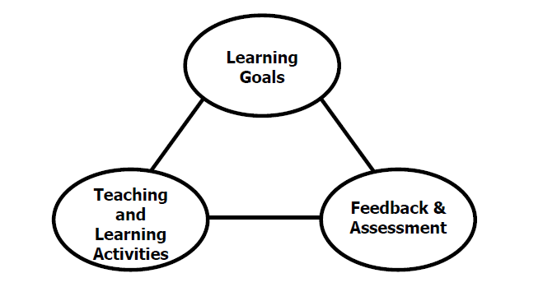

Figure 1. The key components of an integrated course design. (Fink, 2003).

This course has been designed with an active learning framework intended to integrate learning goals, teaching & learning activities, and feedback & assessment. This means you should expect to see a direct relationship between course goals, what we do in class, and how you are assessed. My hope is that you can use this course as a guide for developing your own English language courses.

A variety of teaching and learning experiences have been designed for this course to support the six key dimensions of significant learning (Fink, 2003).

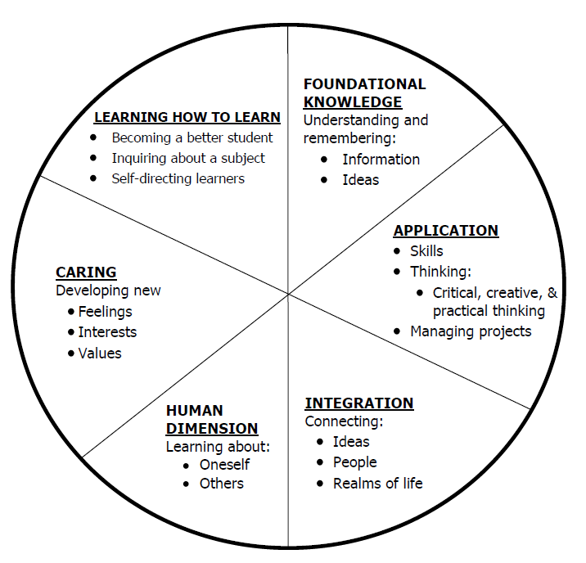

Figure 2. The taxonomy of significant learning (Fink, 2003).

Fink, L.D. 2003. A Self Directed Guide to Designing Courses for Significant Learning. San Fransisco: Jossey-Bass, pp. 37.

**2. COURSE REQUIREMENTS**

**A. Weekly Assignments (20%)**

**Weekly Attendance and Participation**

**Issues in Linguistics Lead (Online)**

**B. Assignments (40%)**

**Language Learning Reflective Journal Assignment**

**Reading Responses**

**Midterm – SLA Theories and Application**

**Online Language Learning Module**

**C. Major Projects (30%)**

**Linguistic Sustainability Project**

**D. Final Exam (10%)**

Grading and Evaluation:

The grading scale will be:

**A = 100 – 90 average**

**B = 89 – 80 average**

**C = 79 – 70 average**

**D = 69 – 60 average**

**F = 59 or below average**

Attendance and Participation: Active learning experiences are only as powerful as you, the students in class, make them. Therefore, it is really important that you come to class each week and that you come prepared for group interactions and class discussions. As graduate level students, you should be able to prepare outside of class up to three hours per hour in class. That is up to nine hours of preparation. So, as part of this weekly preparation, please be sure to read and view any required material prior to class each week, study and practice Korean for the 10-week Korean Learning Module, reflect on your language learning experiences, conduct your own discourse analysis work, and prepare for your group Issues in Linguistics Workshop.

Distance Student Requirements: The distance section is "asynchronous" for distance students. The following will be available to distance students:

- full Panopto recording of weekly F2F class sessions

- Canvas modules that outline weekly expectations

- Canvas distance discussion boards

- 3 set 1 hour live "drop in" office hours via Zoom (details will be sent later)

- other Zoom chat sessions as requested

Distance students follow the same weekly schedule as F2F students, and adhere to all assignment due dates as listed in the syllabus or outlined in Canvas as the course proceeds.*Attendance and participation: distance students will be required to participate weekly in Distance Discussion Boards.*

Late Assignments: Late assignments lose 10% credit per unexcused day late to a maximum of 30% lost credit.

Assigned Readings: Beyond the required textbooks, some additional readings will be available in Canvas. Readings will be discussed in various manners ranging from course Canvas discussions to embedded in class assignments. These readings contain information that will be included in the group quizzes, reflections, projects, examinations, and other course requirements.

Justification for Graduate Credit: CTES 7420 is a comprehensive study of theories of second language acquisition. The course covers SLA from three perspectives: psycholinguistics, sociolinguistics and neurolinguistics. The course requires students not only to interpret and analyze theoretical models of SLA, it requires students to make clear the connections between research and effective practice in SLA programs. Crucial to the success of second language teaching and learning is educators’ in-depth understanding of how processes of second language acquisition are theorized and researched. The rigorous examination of SLA and its implications for teaching and learning English as a second language justify the placement of this course at the graduate level.

.

**2. COLLEGE AND UNIVERSITY POLICIES**

**Participation:** Students are expected to attend class and participate in all class discussions, exercises, and activities.

It is the student’s responsibility to contact the instructor if assignment deadlines are not met. Students are responsible

for initiating arrangements for missed work.

**Attendance/Absences:** **Excused Absences**: Students are granted excused absences from class for the following reasons: Illness of the student or serious illness of a member of the student’s immediate family, death of a member of the student’s immediate family, trips for student organizations sponsored by an academic unit, trips for University classes, trips for participation in intercollegiate athletic events, subpoena for a court appearance and religious holidays. Students who wish to have an excused absence from this class for any other reason must contact the instructor in advance of the absence to request permission. The instructor will weigh the merits of the request and render a decision. When feasible, the student must notify the instructor prior to the occurrence of any excused absences, but in no case shall such notification occur more than one week after the absence. Appropriate documentation for all excused absences is required.

**Make-Up Policy:** Arrangements to make up missed major examination (e.g. hour exams, mid-term exams) due to properly authorized excused absences. Except in unusual circumstances, such as continued absence of the student or the advent of University holidays, a make-up exam will take place within two weeks from the time the student initiates arrangements for it. Except in extraordinary circumstance, no make-up exams will be arranged during the last three days before the final exam period begins. The format of the make-up exam will be (as specific by the instructor).

**Late Assignments:** Late assignments lose 10% credit per unexcused day late to a maximum of 30% lost credit.

**Unannounced Quizzes:** There will be no unannounced quizzes.

**Accommodations:** Students who need special accommodations in class, as provided for by the American Disabilities Act, should arrange a confidential meeting with the instructor during office hours the first week of classes – or as soon as possible if accommodations are needed immediately. You must bring a copy of your Accommodation Memo and an Instructor Verification Form to the meeting. If you do not have these forms but need accommodations, make an appointment with the Program for Students with Disabilities, 1244 Haley Center, 844-2096.

**Academic Honesty Policy:** All portions of the Auburn University student [Academic Honesty Code](https://sites.auburn.edu/admin/universitypolicies/Policies/AcademicHonestyCode.pdf) (Title XII) will apply to this class. All academic honesty violations or alleged violations will be reported to the Office of the Provost, which will then refer the case to the Academic Honesty Committee.

**Professionalism:** Faculty, staff, and students in professional settings are expected to demonstrate professional behaviors as defined in the College’s conceptual framework. These professional commitments or dispositions are as follows: Engage in responsible and ethical professional practices; contribute to collaborative learning communities; demonstrate a commitment to diversity; model and nurture intellectual vitality.

**Writing Center:** The Miller Writing Center provides free support on any writing you are doing while at Auburn, whether for a course or not. Trained consultants are available to work with you as you plan, draft, and revise your writing. For students in distance courses and students temporarily away from Auburn’s campus, the Miller Writing Center offers synchronous online consultations. Please check the Miller Writing Center website ([www.auburn.edu/writingcenter](http://www.auburn.edu/writingcenter)) for instructions and information about scheduling online appointments. If you have questions about the Miller Writing Center, please email [writctr@auburn.edu](mailto:writctr@auburn.edu) or call 334-844-7475 M-F  7:45am-4:45pm.

**Student eHandbook:** Please refer to <http://www.auburn.edu/student_info/student_policies/> for all AU student policies.

**Distance Learning Students**: Unless specific instructions have been given for a designated course, students in distance education courses shall take all closed resource examinations under the supervision of an approved proctor. Examples of approved proctors include a school superintendent, a principal of a high school, or a dean or department head of a college. Proctors shall be verified and exams shall be sent directly to the proctor who will manage the examination in a secure manner, requiring students to present a picture ID.

**Additional Resources:**

***Student Policy eHandbook:*** <http://www.auburn.edu/student_info/student_policies/>

***Health and Wellness Resources*** <https://cws.auburn.edu/studentAffairs/healthAndWellness/>

***Academic Support Services:*** <http://www.auburn.edu/academic/provost/undergrad_studies/support/>

4. TENTATIVE SCHEDULE

*Please note that this is a tentative summary of the schedule and activities/due dates may change during the semester. Follow the assignments as posted on the weekly modules in Canvas. Pay attention to Announcements as I often clarify assignments & due dates that way.

|  |  |  |  |  |
| --- | --- | --- | --- | --- |
| Week | Topics | Prior to Class Meeting | In Class Plan | Assignments |
| **1: 8/22** | -Introduction to Language and Language Learning  -Syllabus and Canvas | Read Syllabus  Read 2 pdfs about good language learners | Characteristics of language learners |  |
| **2: 8/29** | What is linguistics? How & why do linguists study language?  Linguistic Sustainability | Read Freeman & Freeman (F&F), ch 1  Read Linguistic Sustainability (pdf) |  | Reading Response 1 |
| **3: 9/5** | 1st language acquisition and language learning in early childhood | Read F&F, ch 2  Read Lightbown & Spada (L&S), ch 1 | Language Lesson 1 | Reading Response 2  Linguistic Issue 1 (Online discussion) |
| **4: 9/12** | 2nd language acquisition & learning  Individual differences in 2nd language learning | Read F&F, ch 3  Read L&S, ch 3  Read L&S, ch 4 | Overview of discourse analysis and project  Language Lesson 2 | Reading Response 3 Language learning reflection journal 1 (due Sunday)  Linguistic Issue 2 (Online discussion) |
| **5: 9/19** |  | L&S, ch 2 | Language Lesson 3 | Linguistic Issue 3 (Online discussion) |
| **6: 9/26** | English phonology & Implications  Discourse Analysis Project Work Session | F&F, ch 4 & 5 – complete Reading Response  Other Readings: Phonology | Phonology explorations  Language Lesson 4 | Reading Response 4 Language learning reflection journal 2 (due Sunday)  Linguistic Issue 4 (Online discussion) |
| **7: 10/3** | English phonology & Implications |  | Phonology explorations  Language Lesson 5 | Linguistic Issue 5 (Online discussion) |
| **8: 10/10 (Fall Break)** |  | MID TERM EXAM |  | Language learning reflection journal 3 (due Sunday)  Linguistic Issue 6 (Online discussion) |
| **9: 10/17** | English orthography | Read F&F, ch 6  Outside readings: orthography | Orthography explorations  Language Lesson 6 | Reading Response 5  Linguistic Issue 7 (Online discussion) |
| **10: 10/24** | English morphology & Implications | Read F&F, ch 7 & 8  Outside Readings: Morphology | Morphology explorations Language Lesson 7 | Reading Response 6 Linguistic Sustainability Project DUE  Linguistic Issue 8 (Online discussion) |
| **11: 10/31** | English morphology & Implications |  | Morphology explorations Language Lesson 8 | Language learning reflection journal 4 (due Sunday)  Linguistic Issue 9 (Online discussion) |
| **12: 11/7** | English syntax & implications | F&F, ch 9 & 10  Outside Readings: Syntax | Syntax Explorations  Language Lesson 9 | Reading Response 7  Linguistic Issue 10 (Online discussion) |
| **13: 11/14** | English syntax & implications |  | Syntax Explorations  Language Lesson 10 | Linguistic Issue 11 (Online discussion) |
| **14: 11/21** |  |  |  | Linguistic Issue 12 (Online discussion) |
| **11/28** | NO CLASSES: BREAK | | | |
| **15: 12/6** |  |  |  | Language learning reflection journal 5 (final reflection) (due Sunday) |
| **FINAL EXAM** | TBA |  |  |  |
|  |  |  |  |  |

*15th day of class: September 9

*Classes end: December 6

*Study days: December 7 – 8

*Final Exam: December 9 – 13

*Commencement: December 14