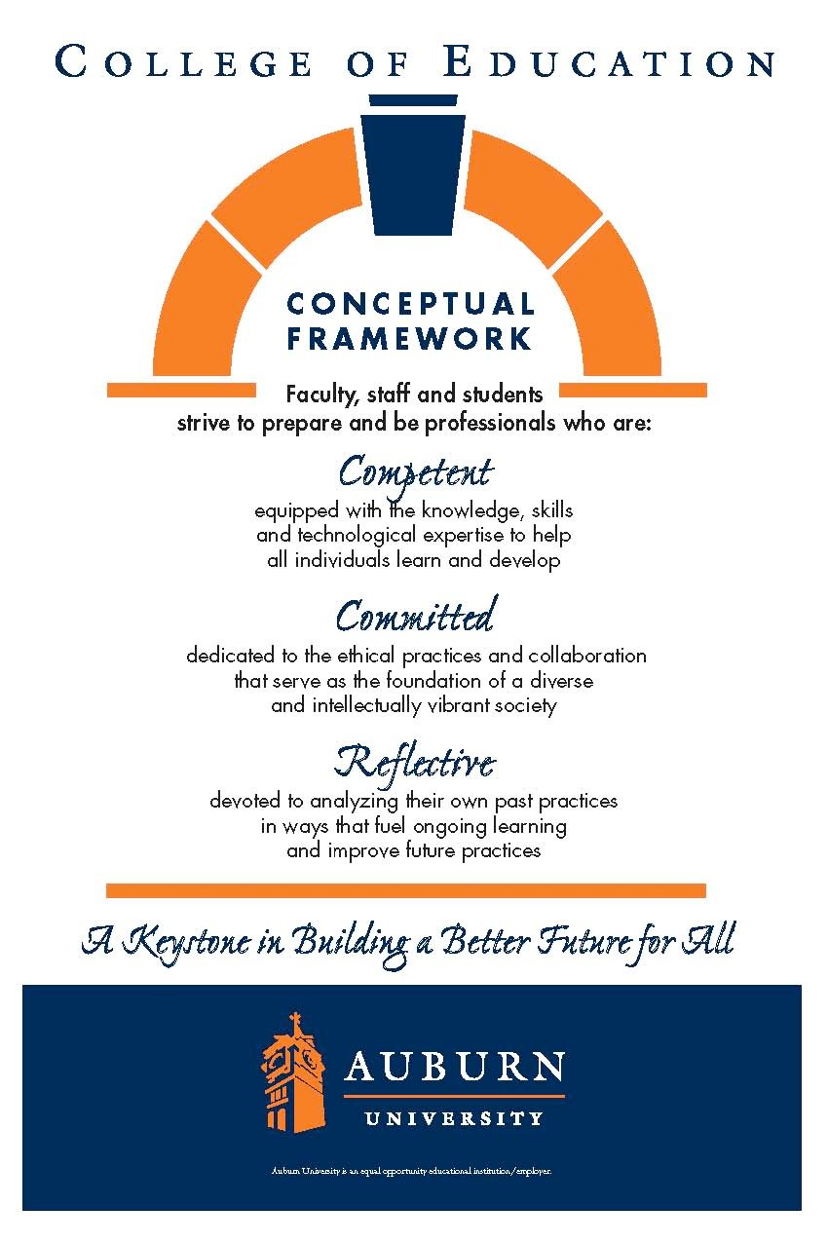
CTEE 7420/7426
Auburn University
Date Syllabus Prepared: August 2020
Department: Department of Curriculum &
Teaching Elementary Education
Program: Elementary Education Course Title: Curriculum and Teaching
Language Arts Credit Hours: 3 semester credit Prerequisites: Graduate standing Course Number: CTEE 7420/7426 Course Credit: Fall 2020
Instructor: Victoria Cardullo
Email Address: vmc0004@auburn.edu
Phone Number: (c)386.295.9346 Text or call
Office: 5022 Haley Center 5th floor
Office Hours: Virtually
Schedule: See Calendar

Texts or Major Resources: Required Texts:
Readings will be available on Canvas

Additional Resources:
APA 7th edition Manual-Highly recommended
CCRS available at http://www.corestandards.org/ELA-Literacy/ Alabama Course of Study for Language Arts
International Reading Association (www.reading.org)

Course Description: Throughout this course, learners will explore age-appropriate content and pedagogical practices which enhance the instruction of children in kindergarten through grade six in the language arts to promote meaningful learning across the elementary school curriculum.

*****See calendar for scheduling an individual ZOOM session.

Course Objectives:
As a result of participation in this course students will:
- discuss concepts, principles, theories, and inquiry tools associated with language arts
- read, reflect, and discuss assigned readings
- discuss the role of the following in the language arts: reading, writing, listening, speaking
- design and assess learner-centered lessons that use appropriate and effective learner- centered lessons that integrate technology and address identified ACOS and NCTE guidelines
- select and support the use of instructional strategies that meet the needs of diverse learners
- demonstrate effective oral and written communication
- identify the resources for enhancing professional growth using technology
- utilize culturally responsive pedagogy in developing student-centered learning activities [
- demonstrate reflection and self-evaluation as a basis for professional growth
- demonstrate knowledge of safe, responsible, legal and ethical uses of technologies including fair-use and copyright guidelines and Internet user protection policies

Course Content and Schedule:
Course Requirements/Evaluation – M. Ed./Ph.D
See canvas for individual assignments

Course Assignments:
All assignments are due no later than Sunday midnight, except for online discussions as noted in Canvas
Voice Thread Assignment (20 + 10 points) Voice Threads are used to develop an introduction to who you are.
Research Interest Assignments- There are multiple steps that move you toward your literature review (See Canvas for individual assignment)
Library Tutorial – 10 points
Theory and Action Research -10 points
Multicultural Book Review (10 points total)
This assignment provides an opportunity for you to explore high quality, multicultural children’s literature and consider how it might be utilized in the elementary classroom. You will turn in one copy and upload a copy to the Discussion board for your classmates to download. Assignment and grading criteria will be posted on the class website.
Common Core and State Standards Paper (25 points)
For this assignment, you review the Common Core standards for grades K-6, as well as state standards for those states that have not adopted Common Core. You will compare and contrast these standards and support the acceptance or rejection of Common Core in a 4-5 pages paper using APA style. Assignment and grading criteria will be posted on the class website.
Peer Review and final Literature Review (25 + 70 points)
This assignment provides an opportunity for you to explore extant literature on a topic of your choice related to language arts paper written using APA style.
Assignment and grading criteria will be posted on the class website.
Online Discussions
As you read the assigned pieces each week, you will reflect on your reading and post to the class discussion board. Your reflections should consider your feelings to the overall article, areas in which you may agree and areas you may disagree, and the possible discussion topics listed in the course schedule. If there is a lecture to accompany the week’s readings, it should be included in the discussion as well. You should post no later than midnight on Wednesday of the week the reading is due. Additionally, you will be expected to read others’ posts and comment on at least 2 each week no later than midnight on Sunday of that same week. Assignment and grading criteria will be posted on the class website.

Course Policy Statements:
- Attendance: Students are expected to attend all classes and will be held responsible for any content covered in the event of an absence.

- Excused Absences: Students are granted excused absences from class for the following reasons: illness of the student or serious illness of a member of the student’s immediate family, the death of a member of the student’s immediate family, trips for student organizations sponsored by an academic unit, trips for university classes, trips for participation in intercollegiate athletic events, subpoena for a court appearance, and religious holidays. Students who wish to have an excused absence from class for any other reason must contact the instructor in advance of the absence to request permission. The instructor will weigh the merits of the request and render a decision. When feasible, the student must notify the instructor prior to the occurrence of any excused absences, but in no case shall such notification occur more than one week after the absence. Appropriate documentation for all excused absences is required. Please see the Tiger Cub for more information on excused absences.

- Make-Up Policy: Arrangement to make up a missed major examination (e.g., hour exams, mid-term exams) due to properly authorized excused absences must be initiated by the student within one week of the end of the period of the excused absences(s). Except in unusual circumstances, such as the continued absence of the student or the advent of university holidays, a make-up exam will take place within two weeks of the date that the student initiates arrangements for it. Except in extraordinary circumstance, no make-up exams will be arranged during the last three days before the final exam period begins.

- Academic Honesty Policy: The University Student Academic Honesty Code on the University Policies site (https://sites.auburn.edu/admin/universitypolicies/default.aspx) pertaining to cheating apply to this class.

- Disability Accommodations: Students who need special accommodations in class, as provided by the Americans with Disabilities Act, should arrange for a confidential meeting with the instructor during office hours in the first week of classes (or as soon as possible if accommodations are needed immediately). The student must bring a copy of their Accommodations Letter and an Instructor Verification Form to the meeting. If the student does not have these forms, they should make an appointment with the Program for Students with Disabilities, 1288 Haley Center, 844-2096 (V/TT).

- Course contingency: If normal class and/or lab activities are disrupted due to illness, emergency, or crisis situation, the syllabus and other course plans and assignments may be modified to allow completion of the course. If this occurs, an addendum to your syllabus and/or course assignments will replace the original materials.

- Cell Phones/Electronic Devices: Students are expected to keep all cell phones on vibrate/silent ring during class time.

- Professionalism: As faculty, staff, and students interact in professional settings, they are expected to demonstrate professional behaviors as defined in the College’s conceptual framework. These professional commitments or dispositions are listed below:
- Engage in responsible and ethical professional practices
- Contribute to collaborative learning communities
- Demonstrate a commitment to diversity
- Model and nurture intellectual vitality

Grading Plan:
The final grade for the course is based on the following:
90%-100%= A
80%-89% = B
70%-79% = C
60%-69% = D
Below 60% = F

*Please note that this is only a plan; point totals for the course may change during the semester if assignments are added or deleted. Detailed instructions will be available in Canvas.
- Course Schedule

One synchronous session to discuss the literature review assignment will be held during the semester. The session is to provide an opportunity for you to ask questions about the major assignment for the semester. The session will occur individually through ZOOM. Please see the Calendar to schedule your meeting. I anticipate the meeting will last approximately 15-30 minutes, depending on how prepared you are for the meeting. You will need to sign up for an individual conference in Canvas. Select Calendar on the left side to schedule an appointment.

 | Week Of | Topic | Topics
1 | Aug 17-23 | Intro to Language Arts | Introduction to the language arts  Voice Thread
2 | Aug 24-30 | Identifying our Research Topics | Zoom Session  Area of Interest in Research  Outline of research
3 | Aug 31- Sept. 6 | How do I find the research? | Library Tutorial
4 | Sept 8-13 | Intentionally left open for individual conferences – research sources, theoretical perspectives… One on Once conference- ZOOM Session
5 | Sept. 14-20 | How do I read research and carefully cite others work? | Identifying Sources
6 | Sept. 21-28 | Common Core State Standards Literature Review | Persuasive Writing
7 | Sept. 29-Oct. 4 | Literature review Part one | Literature Review -**  Part one of your literature review
8 | Oct. 5-11 | Multicultural Literature Theories aligned with Language arts and/ or your research | Culturally Responsive Teaching  Diverse Perspective
9 | Oct. 12-18 | Literature review Writers workshop | Peer Review  Continue working on
10 | Oct. 19-25 | Theoretical perspectives | Action Research and theoretical views  Continue to work on Literature paper
11 | Oct. 26-Nov. 1 | Peer Review
12 | Nov. 2-Nov. 8 | Final Submission of Literature Review | Final submission.
13 | Nov.9-15 | Reading and Writing in the Content Area | Reading and Writing Comprehension in the Classroom
14 | Nov.16-22 | Digital Writing and Editing | Digital Writing and Editing

