**CTES7420 and 7420D Fall 2021**

**Auburn University**

Department: Curriculum & Teaching

Course Title & Credit: Applied Linguistics in SLA; 3 hrs

Room and Schedule: Haley Center 2456; Thur 4:00 – 6:50 p.m.

Instructor: Dr. Jamie Harrison [jlh0069@auburn.edu](mailto:jlh0069@auburn.edu)

Phone Number: 334-844-8278

Office: Haley Center 5080

Office Hours: Tues/Thurs 1 – 3, in office or Zoom; by appointment

**1. COURSE DESCRIPTION**

This course will introduce you to the major components of language, theories of second language acquisition, and factors that contribute to successful language learning outcomes all within the practical experience a second language learning experience. You will come away from this course with a better understanding of yourself as a language learner, the connections among languages, and ideas about how to use this knowledge in your work with emergent multilingual learners.

**Text:**

Freeman, D. E. & Freeman, Y. S., (2014) *Essential linguistics: What teachers need to know to teach ESL, reading, spelling, grammar.* Portsmouth, NH: Heinemann.

Lightbown, P. M. & Spada, N. (2013). *How languages are learned, 4th edition.* United Kingdom: Oxford University Press.

**Course Objectives:**

Engaged learners in this course can look forward to:

* Knowing more about themselves as language learners
* Making linguistic connections between English and multiple other languages
* Analyzing factors (including learner variability) contributing to successful language learning experiences
* Synthesizing multiple SLA theories into a personal foundational platform for teaching ESL
* Conducting research in an area of interest related to Applied Linguistics
* Demonstrating advanced critical thinking skills, interpersonal and leadership skills in group work

Active Learning Environment

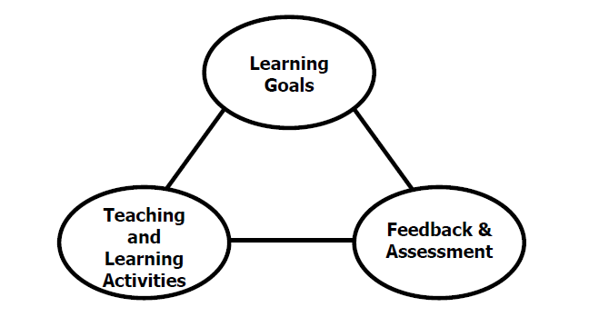

Figure 1. The key components of an integrated course design. (Fink, 2003).

This course has been designed with an active learning framework intended to integrate learning goals, teaching & learning activities, and feedback & assessment. This means you should expect to see a direct relationship between course goals, what we do in class, and how you are assessed. My hope is that you can use this course as a guide for developing your own English language courses.

A variety of teaching and learning experiences have been designed for this course to support the six key dimensions of significant learning (Fink, 2003).

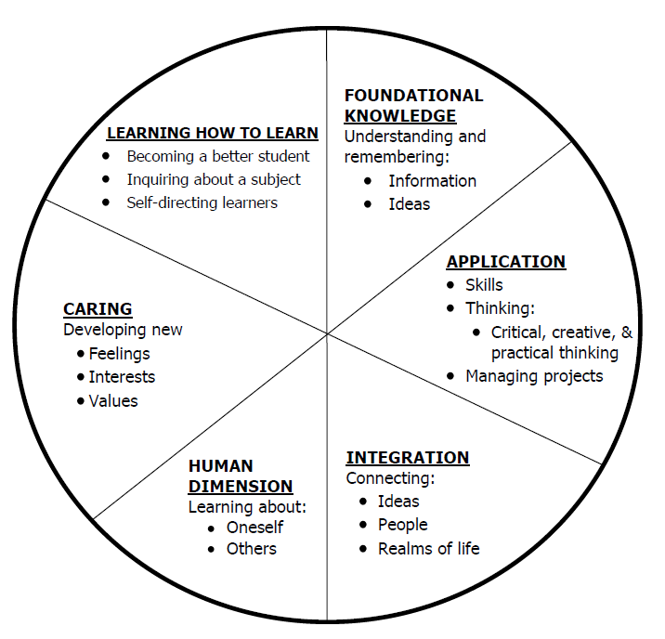

Figure 2. The taxonomy of significant learning (Fink, 2003).

Fink, L.D. 2003. A Self Directed Guide to Designing Courses for Significant Learning. San Fransisco: Jossey-Bass, pp. 37.

**2. COURSE REQUIREMENTS**

**A. Assignments**

**Reading Response Guides (20 points x 10 = 200 points)** Reading response activities (15 points) will prepare you to participate in class discussions about the reading and help you keep track of the major concepts in the field of SLA and TESOL. You will be asked to get started with the weekly discussion by posting your response to a posed question from the readings in the discussion board. (5 points)

**MLL Shadowing Field Experience (50 points)** As part of this course, you will be required to complete a 6-hour field experience which will include shadowing a multilingual learner (MLL) and reflecting on their language opportunities in an academic setting. You will identify a multilingual learner to shadow for a minimum of 6 hours. You will complete the shadowing protocol and write a reflective summary of the experience making connections to language acquisition theory and classroom implications.

**Endangered Language Presentation (100 points)** You will research and prepare an in-class presentation about an endangered language in the world. Your analysis should include current event(s) and/or cultural information that relate to the topic.

-Prepare digital presentation of the endangered language

-Include how and why the language has become endangered

-include summary of a news article, current event, or cultural information

-include both cultural and language information

-if possible, include audio or video of the sounds of the language

-include visuals and other items of interest

**B. Projects**

**Parsi Language Learning Notebook and Reflections (110 points)** You will keep a learning notebook of your Parsi language course, individual work, and reflections. Guidelines will be given in class.

**Parsi Language Learning Modules (20 points each x 5 modules = 100 points)** You will complete 5 online language learning modules that complement the in-class Parsi instruction. These are already in Canvas and will be completed during appropriate weeks as assigned.

**Language Analysis Portfolio (250 points)** You will create a digital language analysis portfolio.

Part 1: The Language Learning Experience (50 points)

Draw or construct a map of the Island of Language. Include 6 – 8 different destinations on your map (for example, Morphology Mountain). Include: How does one (a new language learner) get around on this island (what theories of language acquisition influence transportation)? Include: Are there rules about which parts of the island one can go to and in which order (stages and sequence of language acquisition)?

Part 2: The Language Learner (50 points)

Describe and illustrate the ideal visitor to this island (what are the characteristics of a good language learner?)

Part 3: The Language Teacher (50 points)

Describe and illustrate the ideal guide to this island (what are the characteristics of an effective language teacher?) What does effective language instruction look like? What does an effective language classroom look like?

Part 4: The Tour Guide (100 points)

Create a tour guide of your island for visitors who speak three different languages (English, Parsi, and another language of your choice). Compare and contrast these languages in relation to the aspects of language that you included on your island. Add charts, graphs, descriptions, examples in each area of your island to show these comparisons and contrasts. This can either be added directly to your map in some way or devised as one comprehensive guide book that would accompany your map.

**C. Exams**

**Mid-term Exam – Parts 1, 2, and 3 of Language Analysis Portfolio**

**Final Exam – Reflection on Language Learning and Teaching (100 points)**

Grading and Evaluation:

The grading scale will be:

**A = 1000 – 900 average**

**B = 899 – 800 average**

**C = 799 – 700 average**

**D = 699 – 600 average**

**F = 599 or below average**

Attendance and Participation: Active learning experiences are only as powerful as you, the students in class, make them. Therefore, it is really important that you come to class each week and that you come prepared for group interactions and class discussions. As graduate level students, you should be able to prepare outside of class up to three hours per hour in class. That is up to nine hours of preparation. So, as part of this weekly preparation, please be sure to read and view any required material prior to class each week, study and practice the target language for the Persian Langauge Learning Experience, and reflect on your language learning experiences. You may also want to dedicate weekly time to work on other outside projects and presentations.

Distance Student Requirements: The distance section can be accessed both synchronously or asynchronously. Please let me know your intentions at the start of the semester so we can make arrangements. Synchronous students will use the Zoom platform and be assigned an in-class “buddy”. The following will be available to distance students:

- full recording of weekly F2F class sessions

- Canvas modules that outline weekly expectations

- Canvas discussion boards

- 3 set 1 hour live "drop in" office hours via Zoom (details will be sent later)

- other Zoom chat sessions as requested

Distance students follow the same weekly schedule as F2F students, and adhere to all assignment due dates as listed in the syllabus or outlined in Canvas as the course proceeds.*Attendance and participation: asynchronous distance students will be required to participate weekly in discussion boards.*

Late Assignments: Late assignments lose 10% credit per unexcused day late to a maximum of 30% lost credit. Late assignments will not be accepted past 2 weeks of due date. No late discussion posts will be accepted.

Assigned Readings: Beyond the required textbooks, some additional readings will be available in Canvas. Readings will be discussed in various manners ranging from course Canvas discussions to embedded in class assignments. These readings contain information that will be included in the group quizzes, reflections, projects, examinations, and other course requirements.

Justification for Graduate Credit: CTES 7420 is a comprehensive study of theories of second language acquisition. The course covers SLA from three perspectives: psycholinguistics, sociolinguistics and neurolinguistics. The course requires students not only to interpret and analyze theoretical models of SLA, it requires students to make clear the connections between research and effective practice in SLA programs. Crucial to the success of second language teaching and learning is educators’ in-depth understanding of how processes of second language acquisition are theorized and researched. The rigorous examination of SLA and its implications for teaching and learning English as a second language justify the placement of this course at the graduate level.

.

**2. COLLEGE AND UNIVERSITY POLICIES**

**Participation:** Students are expected to attend class and participate in all class discussions, exercises, and activities.

It is the student’s responsibility to contact the instructor if assignment deadlines are not met. Students are responsible

for initiating arrangements for missed work.

**Attendance/Absences:** **Excused Absences**: Students are granted excused absences from class for the following reasons: Illness of the student or serious illness of a member of the student’s immediate family, death of a member of the student’s immediate family, trips for student organizations sponsored by an academic unit, trips for University classes, trips for participation in intercollegiate athletic events, subpoena for a court appearance and religious holidays. Students who wish to have an excused absence from this class for any other reason must contact the instructor in advance of the absence to request permission. The instructor will weigh the merits of the request and render a decision. When feasible, the student must notify the instructor prior to the occurrence of any excused absences, but in no case shall such notification occur more than one week after the absence. Appropriate documentation for all excused absences is required.

**Make-Up Policy:** Arrangements to make up missed major examination (e.g. hour exams, mid-term exams) due to properly authorized excused absences. Except in unusual circumstances, such as continued absence of the student or the advent of University holidays, a make-up exam will take place within two weeks from the time the student initiates arrangements for it. Except in extraordinary circumstance, no make-up exams will be arranged during the last three days before the final exam period begins. The format of the make-up exam will be (as specific by the instructor).

**Unannounced Quizzes:** There will be no unannounced quizzes.

**Accommodations:** Students who need special accommodations in class, as provided for by the American Disabilities Act, should arrange a confidential meeting with the instructor during office hours the first week of classes – or as soon as possible if accommodations are needed immediately. You must bring a copy of your Accommodation Memo and an Instructor Verification Form to the meeting. If you do not have these forms but need accommodations, make an appointment with the Program for Students with Disabilities, 1244 Haley Center, 844-2096.

**Academic Honesty Policy:** All portions of the Auburn University student [Academic Honesty Code](https://sites.auburn.edu/admin/universitypolicies/Policies/AcademicHonestyCode.pdf) (Title XII) will apply to this class. All academic honesty violations or alleged violations will be reported to the Office of the Provost, which will then refer the case to the Academic Honesty Committee.

**Professionalism:** Faculty, staff, and students in professional settings are expected to demonstrate professional behaviors as defined in the College’s conceptual framework. These professional commitments or dispositions are as follows: Engage in responsible and ethical professional practices; contribute to collaborative learning communities; demonstrate a commitment to diversity; model and nurture intellectual vitality.

**Writing Center:** The Miller Writing Center provides free support on any writing you are doing while at Auburn, whether for a course or not. Trained consultants are available to work with you as you plan, draft, and revise your writing. For students in distance courses and students temporarily away from Auburn’s campus, the Miller Writing Center offers synchronous online consultations. Please check the Miller Writing Center website ([www.auburn.edu/writingcenter](http://www.auburn.edu/writingcenter)) for instructions and information about scheduling online appointments. If you have questions about the Miller Writing Center, please email [writctr@auburn.edu](mailto:writctr@auburn.edu) or call 334-844-7475 M-F  7:45am-4:45pm.

**Student eHandbook:** Please refer to <http://www.auburn.edu/student_info/student_policies/> for all AU student policies.

**Distance Learning Students**: Unless specific instructions have been given for a designated course, students in distance education courses shall take all closed resource examinations under the supervision of an approved proctor. Examples of approved proctors include a school superintendent, a principal of a high school, or a dean or department head of a college. Proctors shall be verified and exams shall be sent directly to the proctor who will manage the examination in a secure manner, requiring students to present a picture ID.

**Additional Resources:**

***Student Policy eHandbook:*** <http://www.auburn.edu/student_info/student_policies/>

***Health and Wellness Resources*** <https://cws.auburn.edu/studentAffairs/healthAndWellness/>

***Academic Support Services:*** <http://www.auburn.edu/academic/provost/undergrad_studies/support/>

## COVID Policies

**Physical Distancing**

Face coverings are not a substitute for physical distancing. Students shall observe physical distancing guidelines where possible in the classroom, laboratory, studio, creative space setting and in public spaces.

Students should avoid congregating around doorways before or after class sessions. If the instructional space has designated entrance and exit doors students are required to use them. Students should exit the instructional space immediately after the end of instruction to help ensure social distancing and allow for the persons attending the next scheduled class session to enter.

**Face Covering Policy**

In response to COVID-19, and in alignment with Auburn University's Presidential directives, and local, state, and national health official guidelines face coverings are required at all times while on campus, except when alone in a private office. This includes the classroom, laboratory, studio, creative space, or any type of in-person instructional activity, and public spaces. "A “face covering” is defined as a “covering that fully covers a person’s nose and mouth, including without limitation, cloth face mask, surgical mask, towels, scarves, and bandanas.

If a student has a medical exception to the face covering requirement, please contact the Office of Accessibility to obtain appropriate documentation.

**Possibility of Going Remote**

In the event that the University is forced to move to fully online instruction, please be assured that the learning goals and outcomes of the course will not change; however, some aspects of the course will change in terms of the mode of delivery, participation, and testing methods. Those details will be shared via a Canvas Announcement within 24 hours of the announcement that we are going remote. Please be prepared for this contingency by ensuring that you have access to a computer and Internet.

**In the Event that a Student in the Class Tests Positive**Students must conduct daily health checks in accordance with [CDC guidelines (Links to an external site.)](https://www.cdc.gov/coronavirus/2019-ncov/symptoms-testing/symptoms.html). Students testing positive for COVID-19, exhibiting COVID-19 symptoms or who have been in direct contact with someone testing positive for COVID-19 will not be allowed to attend in-person instructional activities and must leave the venue immediately. Students should contact the [Student Health Center (Links to an external site.)](https://cws.auburn.edu/aumc/) or their health care provider to receive care and who can provide the latest direction on quarantine and self-isolation. Contact your instructor immediately to make instructional and learning arrangements.

**In the Event that the Instructor Tests Positive**If I am unable to attend our F2F portions of the class, we will transition to a fully online course until I am allowed to return. If I become ill or unable to lead the class, a backup instructor will be identified and they will communicate any changes or updates to the course schedule or mode of instruction as soon as possible.

**Zoom Policies**

When we meet on Zoom, your attendance, attention, and participation are expected. Zoom participation requires you to keep your video on and your microphone muted when you are not speaking. Although you may be participating from your residence, our Zoom meetings are professional interactions. To the extent possible, please minimize distractions in the background. I reserve the right to dismiss anyone from a Zoom meeting whose environment or behavior is distracting or problematic. If you have any issues with sharing your video feed, adhering to this policy, or anything else related to your use of Zoom please notify me via email in the first week of class. I’m happy to consider and provide accommodations, but you will need to be in communication with me.

4. TENTATIVE SCHEDULE

*Please note that this is a tentative summary of the schedule and activities/due dates may change during the semester. Follow the assignments as posted on the weekly modules in Canvas. Pay attention to Announcements as I often clarify assignments & due dates that way.

**If normal class and/or lab activities are disrupted due to illness, emergency, or crisis situation, the syllabus and other course plans and assignments may be modified to allow completion of the course. If this occurs, an addendum to your syllabus and/or course assignments will replace the original materials.

Here is a link to the official AU academic calendar: <http://www.auburn.edu/main/auweb_calendar.php>

|  |  |  |  |  |
| --- | --- | --- | --- | --- |
| Week | Topics | Prior to Class Meeting | In Class Plan | Assignments |
| **1: 8/19** | Introduction to Language and Language Learning  Characteristics of language learners  Language learning aptitude | Read/review Syllabus  Read pdf about good language learners  Take language aptitude test: <http://paulnoblelanguageinstitute.blogspot.com/2011/06/try-our-language-aptitude-test.html> | Overview of syllabus  Ovierview of Canvas  Class Discussion  Introduction to Persian course | Introduction Post  MLL Shadowing Field Experience |
| **2: 8/26** | What is linguistics? How & why do linguists study language?  Understanding our linguistic footprint | Reading 1: Freeman & Freeman (F&F), ch 1  Reading 2: Linguistic Sustainability (pdf) pages 1 - 6 | Intro to Endangered Language Research & Analysis  Analyze linguistic footprint  Parsi Lesson 1 | Reading Response 1  Discussion Post 1 |
| **3: 9/2** | 1st language acquisition and language learning in early childhood  Basic elements of language - overview | Reading 1: F&F, ch 2  Reading 2: Lightbown & Spada (L&S), ch 1 | Reading discussion  Parsi Lesson 2  Introduce Portfolio Assignment | Reading Response 2  Discussion Post 2 |
| **4: 9/9** | 2nd language acquisition/learning Individual differences in 2nd language learning | Reading 1: F&F, ch 3  Reading 2: L&S, ch 2 & 3 | Reading discussion  Parsi Lesson 3 | Reading Response 3  Discussion Post 3 |
| **5: 9/16** | SLA Applications  Understanding Discourses | Reading 1: L&S, ch 4  Viewing: The Linguists | Reading discussion  Parsi Lesson 4 | Reading Response 4  Discussion Post 4 – The Linguists |
| **6: 9/23** | Social Justice in TESOL  Classroom applications | Reading 1: De-centering whiteness (pdf)  Reading 2: L&S, ch 5 & 6  Reading 3: Sociocultural perspectives | Reading discussion  Parsi Lesson 5 | Reading Response 5  Discussion Post 5 |
| **7: 9/30** | English phonology & Implications, Pronunciation and Accent | Reading 1: F&F, ch 4 & 5  Viewing: American Accents, Part 1 <https://www.youtube.com/watch?v=H1KP4ztKK0A> | Reading discussion  Parsi Lesson 6  Phonology explorations | MIDTERM EXAM (PORTFOLIO PARTS 1, 2, 3) Reading Response 6  Discussion Post 6  Parsi Module 1 – Phonology |
| **8: 10/7 Fall Break – no class session this week – enjoy your break!** | | | | |
| **9: 10/14** | English morphology & Implications | Reading 1: F&F, ch 7 & 8  Reading 2: TBA | Reading discussion  Parsi Lesson 7  Morphology explorations  Group portfolio work | Reading Response 7  Discussion Post 7  Parsi Module 2 – Morphology |
| **10: 10/21** | English semantics | Reading 1: TBA  Reading 2: TBA | Reading Discussion  Parsi Lesson 8  Semantics explorations | Reading Response 8  Discussion Post 8  Parsi Module 3 - Semantics |
| **11: 10/28** | English syntax & implications | Reading 1: F&F, ch 9 & 10  Reading 2: TBA | Reading discussion  Parsi Lesson 9  Syntax Explorations | Reading Response 9  Discussion Post 9  Parsi Module 4 - Syntax |
| **12: 11/4** | English orthography & Implications | Reading 1: F&F, ch 6  Reading 2: TBA | Reading discussion  Parsi Lesson 10  Orthography explorations  Group portfolio work | Reading Response 10  Discussion Post 10  Parsi Module 5 - Orthography |
| **13: 11/11** |  |  | Parsi Lesson 11 | Endangered Language Presentations |
| **14: 11/18** |  |  | Parsi Lesson 12 | Endangered Language Presentations |
| **X: 11/25** | **THANKSGIVING HOLIDAY No in-class meeting this week** | | | |
| **15: 12/2** | **Parsi Final Test/Parsi Celebration/Award Ceremony**  Portfolio Assignment 4 DUE | | | |
| FINAL EXAM | Online - TBA |  |  |  |

Important dates:

Classes begin: Aug 16

Labor day: Sept 6

Fall break: Oct 7 – 8

Thanksgiving break: Nov 22 – 26

Last day of classes: Dec 3

Final exams: Dec 6 – 10

Commencement: Dec 10 - 11