**CTSE 6010 and 6010D Fall 2021**

**Auburn University**

Department: Curriculum & Teaching

Course Title & Credit: Language Study for Teachers; 3 hrs

Room and Schedule: Haley Cener 2456; **Tue 4:00 – 6:50 p.m.**

Instructor: Dr. Jamie Harrison [jlh0069@auburn.edu](mailto:jlh0069@auburn.edu)

Phone Number: 334-844-8278

Office: Haley Center 5080

Office Hours: Tues and Thurs 1 – 3 p.m.

**1. COURSE DESCRIPTION**

The goal of this course is to explore the English language beyond the prescriptive rules commonly taught and to develop an in-depth understanding of the challenges English language learners have with grammar. We will also explore the ways grammar impacts writing and speaking, best practices for grammar instruction, and considerations in error correction. Key grammar lessons will be developed and practiced.

**WHY IS THIS COURSE IMPORTANT?**

Knowing about the language you teach is an essential component of effective language teaching. Having a deep understanding of how the English language functions will help you respond to student language needs and errors from an informed perspective. You will come away from this course confident in your knowledge of English grammar and in your ability to teach grammar to English learners.

**Text:**

Folse, K. (2017). *Keys to teaching grammar to English language learners: A practical handbook, 2nd edition*. Ann Arbor, MI: University of Michigan Press.

Larsen-Freeman, D. (2003). *Teaching language: From grammar to grammaring.* Boston, MA: Heinle

Other readings as required and provided via Canvas

**Course Objectives**

Engaged learners in this course can look forward to:

* Demonstrating high level of competence in English grammar
* Increasing positive perceptions about grammar and grammar instruction
* Developing and utilizing active-learning grammar mini-lessons for an authentic audience
* Analyzing authentic writing samples and providing authentic feedback
* Conducting research in an area of interest related to grammar
* Demonstrating advanced critical thinking skills, interpersonal and leadership skills in group work

Active Learning Environment

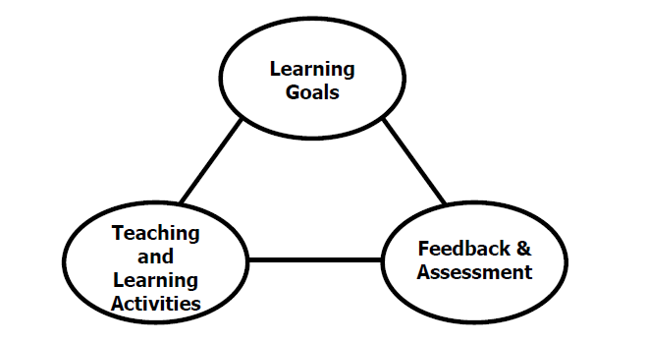

Figure 1. The key components of an integrated course design. (Fink, 2003).

This course has been designed with an active learning framework intended to integrate learning goals, teaching & learning activities, and feedback & assessment. This means you should expect to see a direct relationship between course goals, what we do in class, and how you are assessed. My hope is that you can use this course as a guide for developing your own English language courses.

A variety of teaching and learning experiences have been designed for this course to support the six key dimensions of significant learning (Fink, 2003).

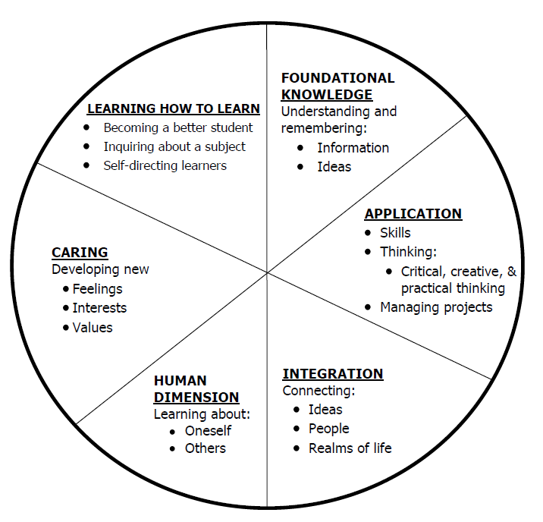

Figure 2. The taxonomy of significant learning (Fink, 2003).

Fink, L.D. 2003. A Self Directed Guide to Designing Courses for Significant Learning. San Fransisco: Jossey-Bass, pp. 37.

**2. COURSE REQUIREMENTS**

**A. Assignments**

**Discussion Posts (10 points x 10 = 100 points)** You will be asked to get started with the weekly discussion by posting some of your thoughts about the reading each week. Topics will come from the reading.

**Discussion Lead: Issues in Grammar Teaching & Learning (100 points)** You will work individually to research and prepare an in-class presentation about an issue of grammar, grammaring, grammar learning, grammar teaching, etc. and the research associated with it.

**Grammar Modules (40 points x 5 = 200 points)** There are five grammar modules that will include a variety of activities to support your learning of the target grammar. Various assignments will be embedded into the modules for practice and class time will also include practice. There will be one assignment per module to be completed for a grade. These assignments will help you determine the focus of your Sustainability Unit.

**Grammar Quizzes (20 points each x 5 = 100 points)** These will be based on the material presented in the Grammar Modules.

**B. Projects**

**Sustainability Grammar Unit (200 points)**

**Field Experience in Grammar Teaching (200 points)**

**Grammar Game Outreach Event (100 points)**

**C. Exams**

**Final Exam – Grammar Portfolio – as you proceed through the course, document your beliefs about grammar along with your growing understanding about grammar and grammar teaching. Collect artifacts of your reflection and learning.**

Grading and Evaluation:

The grading scale will be:

**A = 100 – 90 average**

**B = 89 – 80 average**

**C = 79 – 70 average**

**D = 69 – 60 average**

**F = 59 or below average**

Attendance and Participation: Active learning experiences are only as powerful as you, the students in class, make them. Therefore, it is really important that you come to class each week and that you come prepared for group interactions and class discussions. As graduate level students, you should be able to prepare outside of class up to three hours per hour in class. That is up to nine hours of preparation. So, as part of this weekly preparation, please be sure to read and view any required material prior to class each week, complete all assigned grammar homework, do extra grammar practice as you feel necessary to master the topics, and prepare for all group and individual assignments. **More than two unrequested and/or unexcused absences will result in a 10% reduction on your final average.**

Distance Student Requirements: The distance section is "asynchronous" for distance students. The following will be available to distance students:

- full Panopto recording of weekly F2F class sessions

- Canvas modules that outline weekly expectations

- Canvas distance discussion boards

- 3 set 1 hour live "drop in" office hours via Zoom (details will be sent later)

- other Zoom chat sessions as requested

Distance students follow the same weekly schedule as F2F students, and adhere to all assignment due dates as listed in the syllabus or outlined in Canvas as the course proceeds.*Attendance and participation: distance students will be required to participate weekly in Distance Discussion Boards. Lack of participation in more than 2 discussion boards will result in a 10% reduction on your final average.*

Late Assignments: Late assignments lose 10% credit per unexcused day late to a maximum of 30% lost credit. Late work will not be accepted past 2 weeks from due date. No late discussion posts will be accepted.

Assigned Readings: Beyond the required textbooks, some additional readings will be available in Canvas. Readings will be discussed in various manners ranging from course Canvas discussions to embedded in class assignments. These readings contain information that will be included in the group quizzes, reflections, projects, examinations, and other course requirements.

Justification for Graduate Credit: CTSE 6010 is a comprehensive study of language for teachers of ESOL. The course requires students to master English grammar as well as to synthesize and analyze grammar theory and grammar instruction from multiple perspectives. The rigorous examination of grammar, its place in the instruction of ESL students, and its implications for teaching and learning English as a second language justify the placement of this course at the graduate level.

.

**3. COLLEGE AND UNIVERSITY POLICIES**

**Participation:** Students are expected to attend class and participate in all class discussions, exercises, and activities.

It is the student’s responsibility to contact the instructor if assignment deadlines are not met. Students are responsible

for initiating arrangements for missed work.

**Attendance/Absences:** **Excused Absences**: Students are granted excused absences from class for the following reasons: Illness of the student or serious illness of a member of the student’s immediate family, death of a member of the student’s immediate family, trips for student organizations sponsored by an academic unit, trips for University classes, trips for participation in intercollegiate athletic events, subpoena for a court appearance and religious holidays. Students who wish to have an excused absence from this class for any other reason must contact the instructor in advance of the absence to request permission. The instructor will weigh the merits of the request and render a decision. When feasible, the student must notify the instructor prior to the occurrence of any excused absences, but in no case shall such notification occur more than one week after the absence. Appropriate documentation for all excused absences is required.

**Make-Up Policy:** Arrangements to make up missed major examination (e.g. hour exams, mid-term exams) due to properly authorized excused absences. Except in unusual circumstances, such as continued absence of the student or the advent of University holidays, a make-up exam will take place within two weeks from the time the student initiates arrangements for it. Except in extraordinary circumstance, no make-up exams will be arranged during the last three days before the final exam period begins. The format of the make-up exam will be (as specific by the instructor).

**Unannounced Quizzes:** There will be no unannounced quizzes.

**Accommodations:** Students who need special accommodations in class, as provided for by the American Disabilities Act, should arrange a confidential meeting with the instructor during office hours the first week of classes – or as soon as possible if accommodations are needed immediately. You must bring a copy of your Accommodation Memo and an Instructor Verification Form to the meeting. If you do not have these forms but need accommodations, make an appointment with the Program for Students with Disabilities, 1244 Haley Center, 844-2096.

**Academic Honesty Policy:** All portions of the Auburn University student [Academic Honesty Code](https://sites.auburn.edu/admin/universitypolicies/Policies/AcademicHonestyCode.pdf) (Title XII) will apply to this class. All academic honesty violations or alleged violations will be reported to the Office of the Provost, which will then refer the case to the Academic Honesty Committee.

**Professionalism:** Faculty, staff, and students in professional settings are expected to demonstrate professional behaviors as defined in the College’s conceptual framework. These professional commitments or dispositions are as follows: Engage in responsible and ethical professional practices; contribute to collaborative learning communities; demonstrate a commitment to diversity; model and nurture intellectual vitality.

**Writing Center:** The Miller Writing Center provides free support on any writing you are doing while at Auburn, whether for a course or not. Trained consultants are available to work with you as you plan, draft, and revise your writing. For students in distance courses and students temporarily away from Auburn’s campus, the Miller Writing Center offers synchronous online consultations. Please check the Miller Writing Center website ([www.auburn.edu/writingcenter](http://www.auburn.edu/writingcenter)) for instructions and information about scheduling online appointments. If you have questions about the Miller Writing Center, please email [writctr@auburn.edu](mailto:writctr@auburn.edu) or call 334-844-7475 M-F  7:45am-4:45pm.

**Student eHandbook:** Please refer to <http://www.auburn.edu/student_info/student_policies/> for all AU student policies.

**Distance Learning Students**: See section 2.

**Additional Resources:**

***Student Policy eHandbook:*** <http://www.auburn.edu/student_info/student_policies/>

***Health and Wellness Resources*** <https://cws.auburn.edu/studentAffairs/healthAndWellness/>

***Academic Support Services:*** <http://www.auburn.edu/academic/provost/undergrad_studies/support/>

## COVID Policies

**Physical Distancing**

Face coverings are not a substitute for physical distancing. Students shall observe physical distancing guidelines where possible in the classroom, laboratory, studio, creative space setting and in public spaces.

Students should avoid congregating around doorways before or after class sessions. If the instructional space has designated entrance and exit doors students are required to use them. Students should exit the instructional space immediately after the end of instruction to help ensure social distancing and allow for the persons attending the next scheduled class session to enter.

**Face Covering Policy**

In response to COVID-19, and in alignment with Auburn University's Presidential directives, and local, state, and national health official guidelines face coverings are required at all times while on campus, except when alone in a private office. This includes the classroom, laboratory, studio, creative space, or any type of in-person instructional activity, and public spaces. "A “face covering” is defined as a “covering that fully covers a person’s nose and mouth, including without limitation, cloth face mask, surgical mask, towels, scarves, and bandanas.

If a student has a medical exception to the face covering requirement, please contact the Office of Accessibility to obtain appropriate documentation.

**Possibility of Going Remote**

In the event that the University is forced to move to fully online instruction, please be assured that the learning goals and outcomes of the course will not change; however, some aspects of the course will change in terms of the mode of delivery, participation, and testing methods. Those details will be shared via a Canvas Announcement within 24 hours of the announcement that we are going remote. Please be prepared for this contingency by ensuring that you have access to a computer and Internet.

**In the Event that a Student in the Class Tests Positive**Students must conduct daily health checks in accordance with [CDC guidelines (Links to an external site.)](https://www.cdc.gov/coronavirus/2019-ncov/symptoms-testing/symptoms.html). Students testing positive for COVID-19, exhibiting COVID-19 symptoms or who have been in direct contact with someone testing positive for COVID-19 will not be allowed to attend in-person instructional activities and must leave the venue immediately. Students should contact the [Student Health Center (Links to an external site.)](https://cws.auburn.edu/aumc/) or their health care provider to receive care and who can provide the latest direction on quarantine and self-isolation. Contact your instructor immediately to make instructional and learning arrangements.

**In the Event that the Instructor Tests Positive**If I am unable to attend our F2F portions of the class, we will transition to a fully online course until I am allowed to return. If I become ill or unable to lead the class, a backup instructor will be identified and they will communicate any changes or updates to the course schedule or mode of instruction as soon as possible.

**Zoom Policies**

When we meet on Zoom, your attendance, attention, and participation are expected. Zoom participation requires you to keep your video on and your microphone muted when you are not speaking. Although you may be participating from your residence, our Zoom meetings are professional interactions. To the extent possible, please minimize distractions in the background. I reserve the right to dismiss anyone from a Zoom meeting whose environment or behavior is distracting or problematic. If you have any issues with sharing your video feed, adhering to this policy, or anything else related to your use of Zoom please notify me via email in the first week of class. I’m happy to consider and provide accommodations, but you will need to be in communication with me.

4. TENTATIVE SCHEDULE

*Please note that this is a tentative summary of the schedule and activities/due dates may change during the semester. Follow the assignments as posted on the weekly modules in Canvas. Pay attention to Announcements as I often clarify assignments & due dates that way.

**If normal class and/or lab activities are disrupted due to illness, emergency, or crisis situation, the syllabus and other course plans and assignments may be modified to allow completion of the course. If this occurs, an addendum to your syllabus and/or course assignments will replace the original materials.

Here is a link to the official AU academic calendar: <http://www.auburn.edu/main/auweb_calendar.php>

|  |  |  |  |
| --- | --- | --- | --- |
| Week | Topics | Prior to Class Meeting | Assignments |
| 1: 8/17 | English Language Grammar Pre-Test  Introduction & Syllabus  Grammar Teaching Myths |  | Grammar pre-test (online)  Grammar discussion lead sign up  Discussion post 1 |
| 2: 8/24 | Theory: The History of Grammar Instruction Grammar: Module 1 - Morphology & Parts of Speech, Word Forms & Classes, Word Functions | Read: Grammar & its teaching: Challenging the myths  Read: The grammar we teach, Bourke  Read: The teacher’s grammar, pg 28 – 38, Cowan | Discussion post 2  Grammar module task 1 |
| 3: 8/31 | Theory: Defiining Language & exploring the dynamics of language  Challenging conceptions of grammar  Grammar: Module 1 - Morphology & Parts of Speech, Word Forms & Classes, Word Functions | Read: From theory into practice: Grammar learning and teaching, Larsen-Freeman  Read: Larsen-Freeman, chapters 1 – 3 | Discussion post 3  Grammar Quiz 1 |
| 4: 9/7 | Theory: The 3 Dimensions, rules & reasons, grammar of choice  Grammar: Module 2  10 Sentence Patterns and parts of sentences; Intro to sentence Diagramming | Read: Current issues in teaching of grammar: An SLA perspective  Read: Larsen-Freeman, ch 4 – 6 | Discussion post 4  Grammar module task 2 |
| 5: 9/14 | Theory: Chaos Theory  Grammar of discourse  Insights from SLA  Output & production  Grammar: Module 2  10 Sentence Patterns and parts of sentences; Intro to sentence Diagramming | Read: Chaos Theory reading - TBA  Read: Larsen-Freeman, ch 7 – 9 | Discussion post 5 |
| 6: 9/21 | Prescriptivism vs. Descriptivism  Inductive vs. Deductive  Implicit vs. Explicit  Synthesis: Introduce Grammar Unit  Grammar: Module 2 -  10 Sentence Patterns and parts of sentences; Intro to sentence Diagramming | Read: Folse, ch 5  Read: Folse: Keys 2, 3, 4, 5 (Jigsaw) | Grammar Quiz 2  Grammar Discussion Lead |
| 7: 9/28 | Synthesis: Grammar Unit continued  Grammar: Module 3 Phrases vs. Clauses; Kinds of Sentences | Folse: Keys 6, 7, 8, 9 (Jigsaw) | Grammar module task 3  Grammar Discussion Lead |
| 8: 10/5 | Grammar: Module 3 Phrases vs. Clauses; Kinds of Sentences  Synthesis: Grammar Unit continued | Complete: Grammar module 4  Folse: Keys 10, 11, 12, 13 (Jigsaw) | Grammar Discussion Lead |
| 9: 10/12 | Grammar: Module 3 Phrases vs. Clauses; Kinds of Sentences  Synthesis: Grammar Unit continued | Complete: Grammar module 5  Folse: Keys 14, 15, 16, 17 (Jigsaw) | Grammar Quiz 3  Grammar Discussion Lead |
| 10: 10/19 | Grammar: Module 4 - Verbs & Verb Phrases; Verb Strings  Application: Community English Grammar Class or K12 Individual Tutoring Sessions |  | Grammar module task 4  Micro-teaching 1  Micro-teaching 2 |
| 11: 10/26 | Grammar: Module 4 - Verbs & Verb Phrases; Verb Strings  Application: Community English Grammar Class or K12 Individual Tutoring Sessions |  | Micro-teaching 3  Micro-teaching 4 |
| 12: 11/2 | Grammar: Module 4 - Verbs & Verb Phrases; Verb Strings  Application: Community English Grammar Class or K12 Individual Tutoring Sessions |  | Grammar Quiz 4  Micro-teaching 5  Micro-teaching 6 |
| 13: 11/9 | Grammar: Module 5 Adverb and Adjective Phrases & Clauses, Diagramming Complex Sentences  Application: Community English Grammar Class or K12 Individual Tutoring Sessions |  | Grammar module task 5  Micro-teaching 7  Micro-teaching 8 |
| 14: 11/16 | Grammar: Module 5 Adverb and Adjective Phrases & Clauses, Diagramming Complex Sentences  Application: Community English Grammar Class or K12 Individual Tutoring Sessions |  | Grammar Quiz 5  Micro-teaching 9 |
| 11/23 | Thanksgiving Holiday |  |  |
| 15: 11/30 | Grammar Games Outreach Event |  |  |
| 16 | FINAL EXAM - Online |  |  |
|  |  |  |  |

Important dates:

Classes begin: Aug 16

Labor day: Sept 6

Fall break: Oct 7 – 8

Thanksgiving break: Nov 22 – 26

Last day of classes: Dec 3

Final exams: Dec 6 – 10

Commencement: Dec 10 - 11