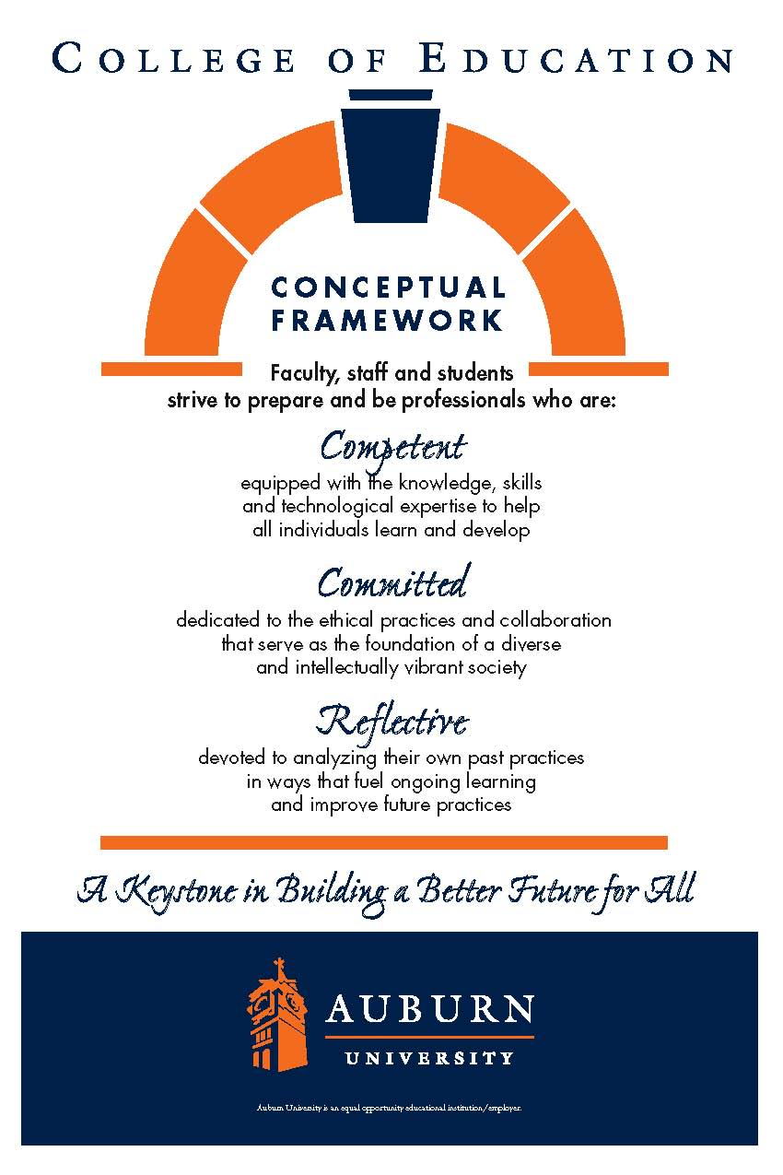**CTSE7000 and 7000D Summer 2021**

**Auburn University**

Department: Curriculum & Teaching

Course Title & Credit: Orientation to Teaching & Learning

Room and Schedule: Haley Center 2467

Monday 9:00 – 9:50 a.m.

Instructor: Dr. Jamie Harrison [jlh0069@auburn.edu](mailto:jlh0069@auburn.edu)

Phone Number: 334-844-8278

Office: Haley Center 5080

Office Hours: By appointment

**1. COURSE DESCRIPTION**

This course is an orientation to teaching and learning and will give the student an opportunity to explore the Department of Curriculum and Teaching and the various graduate programs offered while engaging in graduate level discourse about general topics related to curriculum and teaching. Students will be guided in aspects of graduate research and will have multiple experiences to support their upcoming work in their chosen degree program.

**Text:**

*Flinders, D. & Thornton, S. (Eds; 2017). *The Curriculm Studies Reader.* New York, NY: Routledge.

*Note: this text will also be used in CTSE7800

**Course Objectives:**

1. Develop an appropriate plan of study

2. Successfully navigate the AU library

3. Employ APA for writing style

4. Implement appropriate educational technology

5. Evaluate current and past research

6. Develop an appropriate research proposal

**2. COURSE REQUIREMENTS**

|  |  |
| --- | --- |
| Description | Percentage |
| CITI Training Completion | 10% |
| Technology Assignment | 10% |
| Plan of Study | 10% |
| Annotated Bibliography | 30% |
| Research Plan | 10% |
| ePortfolio Analysis | 10% |
| Research Proposal Presentation | 15% |
| Discussion Posts | 15% |
| **Total** | **100%** |

CITI TRAINING: Complete CITI training to facilitate obtaining appropriate permission as needed to work in schools and study human subjects. Submit completed CITI training documents to Canvas.

TECHNOLOGY ASSIGNMENT: Develop an ***interactive*** lesson utilizing a technology app of your choice. The lesson should be situated within your own field of instruction.In addition:Why do you like it? How can it be useful in a classroom? What are benefits to students? What are challenges for teachers?

PLAN OF STUDY: Create a tentative plan of study. Send this to your advisor for feedback. Submit the plan of study and email exchange with your advisor.

ANNOTATED BIBLIOGRAPHY: Students will prepare an annotated bibliography using the Publication Manual of the American Psychological Association (6th edition). Students will use library resources and evaluate prior research.

RESEARCH PLAN: Submit research topic and question for approval along with a list of 5 articles you plan to use for review.

ePORTFOLIO ANALYSIS: You will review examples of ePortfolio and analyze one of them according to a series of questions provided. This will be foundational for your preparation of your own ePortfolio.

DISCUSSION POSTS: You will be given weekly prompts for discussion. You will be asked to write your response to the prompt in the online discussion forum. Your responses can then be used in class to help stimulate our F2F discussion.

RESEARCH PROPOSAL: You will prepare a 5-slide presentation for the class that showcases your research topic/question, summarizes your literature review, and details your plan of action for collecting data for a theoretical research project of interest.

Grading and Evaluation:

The grading scale will be:

**A = 100 – 90 average**

**B = 89 – 80 average**

**C = 79 – 70 average**

**D = 69 – 60 average**

**F = 59 or below average**

Attendance and Participation: This is a one-hour course. We will meet weekly for one hour, but you should plan to spend up to three hours outside of class preparing for class or doing work for the class. Be prepared to participate in class as a group, individually, or online in discussion posts.

Distance Student Requirements: The distance section is "asynchronous" for distance students. The following will be available to distance students:

- full Panopto recording of weekly F2F class sessions

- Canvas modules that outline weekly expectations

- Canvas distance discussion boards

- 3 set 1 hour live "drop in" office hours via Zoom (details will be sent later)

- other Zoom chat sessions as requested

Distance students follow the same weekly schedule as F2F students, and adhere to all assignment due dates as listed in the syllabus or outlined in Canvas as the course proceeds.

Late Assignments: Late assignments lose 10% credit per unexcused day late to a maximum of 30% lost credit. Late assignments will not be accepted after 2 weeks from due date.

Assigned Readings: Readings will be available in Canvas. Readings will be discussed in various manners ranging from course Canvas discussions to embedded in class assignments.

Justification for Graduate Credit: CTSE 7000 is an orientation course for a graduate level teaching and learning degree program. During the semester students will (a) select a topic of study related to their area of specialization, (b) prepare an annotated bibliography, and (c) write a proposal to include a description of the study, objectives, methodology (including resources), and evaluation. Students will become informed consumers of applicable teacher education research.

.

**3. COLLEGE AND UNIVERSITY POLICIES**

**Participation:** Students are expected to attend class and participate in all class discussions, exercises, and activities.

It is the student’s responsibility to contact the instructor if assignment deadlines are not met. Students are responsible

for initiating arrangements for missed work.

**Attendance/Absences:** **Excused Absences**: Students are granted excused absences from class for the following reasons: Illness of the student or serious illness of a member of the student’s immediate family, death of a member of the student’s immediate family, trips for student organizations sponsored by an academic unit, trips for University classes, trips for participation in intercollegiate athletic events, subpoena for a court appearance and religious holidays. Students who wish to have an excused absence from this class for any other reason must contact the instructor in advance of the absence to request permission. The instructor will weigh the merits of the request and render a decision. When feasible, the student must notify the instructor prior to the occurrence of any excused absences, but in no case shall such notification occur more than one week after the absence. Appropriate documentation for all excused absences is required.

**Make-Up Policy:** Arrangements to make up missed major examination (e.g. hour exams, mid-term exams) due to properly authorized excused absences. Except in unusual circumstances, such as continued absence of the student or the advent of University holidays, a make-up exam will take place within two weeks from the time the student initiates arrangements for it. Except in extraordinary circumstance, no make-up exams will be arranged during the last three days before the final exam period begins. The format of the make-up exam will be (as specific by the instructor).

**Late Assignments:** Late assignments lose 10% credit per unexcused day late to a maximum of 30% lost credit.

**Unannounced Quizzes:** There will be no unannounced quizzes.

**Accommodations:** Students who need special accommodations in class, as provided for by the American Disabilities Act, should arrange a confidential meeting with the instructor during office hours the first week of classes – or as soon as possible if accommodations are needed immediately. You must bring a copy of your Accommodation Memo and an Instructor Verification Form to the meeting. If you do not have these forms but need accommodations, make an appointment with the Program for Students with Disabilities, 1244 Haley Center, 844-2096.

**Academic Honesty Policy:** All portions of the Auburn University student [Academic Honesty Code](https://sites.auburn.edu/admin/universitypolicies/Policies/AcademicHonestyCode.pdf) (Title XII) will apply to this class. All academic honesty violations or alleged violations will be reported to the Office of the Provost, which will then refer the case to the Academic Honesty Committee.

**Professionalism:** Faculty, staff, and students in professional settings are expected to demonstrate professional behaviors as defined in the College’s conceptual framework. These professional commitments or dispositions are as follows: Engage in responsible and ethical professional practices; contribute to collaborative learning communities; demonstrate a commitment to diversity; model and nurture intellectual vitality.

**Writing Center:** The Miller Writing Center provides free support on any writing you are doing while at Auburn, whether for a course or not. Trained consultants are available to work with you as you plan, draft, and revise your writing. For students in distance courses and students temporarily away from Auburn’s campus, the Miller Writing Center offers synchronous online consultations. Please check the Miller Writing Center website ([www.auburn.edu/writingcenter](http://www.auburn.edu/writingcenter)) for instructions and information about scheduling online appointments. If you have questions about the Miller Writing Center, please email [writctr@auburn.edu](mailto:writctr@auburn.edu) or call 334-844-7475 M-F  7:45am-4:45pm.

**Student eHandbook:** Please refer to <http://www.auburn.edu/student_info/student_policies/> for all AU student policies.

**Distance Learning Students**: See section 2.

**Additional Resources:**

***Student Policy eHandbook:*** <http://www.auburn.edu/student_info/student_policies/>

***Health and Wellness Resources*** <https://cws.auburn.edu/studentAffairs/healthAndWellness/>

***Academic Support Services:*** <http://www.auburn.edu/academic/provost/undergrad_studies/support/>

4. TENTATIVE SCHEDULE

*Please note that this is a tentative summary of the schedule and activities/due dates may change during the semester. Follow the assignments as posted on the weekly modules in Canvas. Link to university academic calendary: <http://www.auburn.edu/main/auweb_calendar.php>

|  |  |  |  |  |
| --- | --- | --- | --- | --- |
| Week | Module Topics | Module Activities | Reading | Assignments |
| 1: 8/16 | Module: Orientation to Curriculum & Teaching | Review syllabus | Read: The Top 10 Characteristics of High Performing Graduate School Students <https://education.cu-portland.edu/blog/admissions-tips/top-10-characteristics-of-high-performing-graduate-school-students/> | **Week 1 Discussion:** Introduce yourself, your background, your educational goals. What characteristics do you have that will help you be successful in graduate school? |
| 2: 8/23 | Module:  Navigating your degree in C&T  Guest: Ms. Lisa Ross, Administrator III, Academic Programs, Department of Curriculum and Teaching | Review AU College of Education and Curriculum & Teaching Websites: <http://www.education.auburn.edu/curriculum-and-teaching>  Review Auburn University Graduate School Website: <http://graduate.auburn.edu/current-students/> | ***Reading 1***  Curriculum Studies Reader (CSR) ch 3: My Pedagogic Creed by John Dewey | **Week 2 Discussion:** Discuss the main tenets of John Dewey’s beliefs – how do these resonate with you?Choose 1 to describe and make personal applications to.  **Assignment 1: Plan of Study** |
| 3: 8/30 | Module: Navigating the AU Library & Its Resources  Guest: Mr. Todd Shipman, Education and Foreign Languages and Literature Librarian III/Associate Professor of Research and Instruction | Review Auburn University Library Website <http://www.lib.auburn.edu/>  Conduct academic searches into your field of study. Limit your search to the past 5 years. Be ready to discuss. |  | **Week 3 Discussion:**  What are you interested in about ‘teaching’? teaching your subject area?  What research topics are you interested in? What are you curious about?  **Assignment 2: Research topic/question and review plan** |
| 4: 9/6 | Labor Day – NO CLASSES ON MONDAY |  | ***Reading 2***  CSR ch 7: Basic Principles of Curriculum and Instruction by Ralph W. Tyler | **Week 4 Discussion:** Agree or disagree with the following statement: “Education is a process of changing the behavior patterns of people.” |
| 5: 9/13 | Module: Navigating APA & Avoiding Plagiarism  Guest: Dr. Susan Bannon, EFLT Associate Professor and Director of the Learning Resources Center | Read: Plagiarism article provided  View: <https://study.com/academy/lesson/what-is-apa-format-style-definition-quiz.html> |  | **Week 5 Discussion:** Read 1 of the plagiarism articles (see 2 articles about plagiarism attached in Module)  Write the APA Citation of the article and a summary of the article. Then, respond to this question: In what ways should a student's culture be considered in questions of plagiarism?  **Assignment 3: CITI Training** |
| 6: 9/20 | Module: Navigating Technology in Teaching  Guest: Ms. Jessica Garrett | Tech Tools for Education - Search and explore a variety of tech tools used in education in general and in your specific educational field. Share a list of what you find for this week’s discussion. |  | **Week 6 Discussion:** Share a list of your top 10 apps. What is the name, include a link, short description of its usefulness – in general or field specific.  **Assignment 4: Technology Demonstration (sign up for presentation date)** |
| 7: 9/27 | Module: Navigating doctoral programs  Guest: Dr. Gwendolyn Williams, Associate Professor of ESOL Education, Curriculum & Teaching | Tips for applying for doctoral programs  Reference Letters,who, when, how? | ***Reading 3***  CSR ch 8: Was there Really a Social Efficiency Doctrine? The uses and abuses of an idea in educational history by T. Fallace & V. Fantozzi | **Week 7 Discussion:** Describe the Social Efficiency doctrine. How do we or do we not see it in use today? |
| 8: 10/4 | Tech demo rough draft review |  |  |  |
| 9: 10/11 | Module: Navigating Academic Writing  Guest: Miller Writing Center representative | Review Auburn University’s Miller Writing Center website:  <http://wp.auburn.edu/writing/>  Read: <https://www.gradschools.com/get-informed/surviving-graduate-school/study-skills-grad-school/10-rules-graduate-level-writing> | ***Reading 4***  CSR ch 5:The Public School and the Immigrant Child | **Week 9 Discussion:** How are the words of Jane Addams still relevant (or not) today? |
| 10: 10/18 | Module: Navigating Issues of Diversity  Guest: TBD | Review a set of curriculum objectives for your field.  Read Luis Moll article provided | ***Reading:*** *By this time you should be actively reading and summarizing your chosen articles related to your research interest, so there will be no additional readings.* | **Week 10 Discussion:** What are some challenges with your curriculum and objectives in relation to aspects of diversity?How can you use funds of knowledge in your teaching field and context? |
| 11: 10/25 | Module: Navigating ePortfolios  Guest: TBD |  | ***Reading:*** *By this time you should be actively reading and summarizing your chosen articles related to your research interest, so there will be no additional readings* | **Week 11 Discussion:** After reviewing the ePortfolios, what will you be sure to include in yours? What kinds of documents will you need to collect during your program of study? |
| 12: 11/1 | Tech demo 1  Tech demo 2 |  | ***Reading:*** *By this time you should be actively reading and summarizing your chosen articles related to your research interest, so there will be no additional readings* | **Assignment 5: ePortfolio analysis**  **Week 12 Discussion:** Compare and contrast 2 of the 5 research articles you are reading. How do the studies relate to each other? What are the implications for the classroom? |
| 13: 11/8 | Tech demo 3  Tech demo 4 |  | ***Reading:*** *By this time you should be actively reading and summarizing your chosen articles related to your research interest, so there will be no additional readings* |  |
| 14: 11/15 | ePortfolio set up work session |  |  | **Assignment 6: Annotated bibliography due** |
| 11/22 Thanksgiving Break – NO CLASSES ALL WEEK | | | | |
| 15: 11/29 | Final Presentations |  |  | **Assignment 7: Research Proposal Presentation** |
|  |  |  |  |  |

Important dates:

Classes begin: Aug 16

Labor day: Sept 6

Fall break: Oct 7 – 8

Thanksgiving break: Nov 22 – 26

Last day of classes: Dec 3

Final exams: Dec 6 – 10

Commencement: Dec 10 - 11