Syllabus RSED 5010 & COUN 7010

Medical, Vocational, & Psychosocial Aspects of Disability

Department of Special Education, Rehabilitation, and Counseling

**Professor: Jill M. Meyer, Ph.D., LCPC, CRC**

**Office: 2004 Haley Center**

**Email (best way to reach me):** [**Jill.Meyer@Auburn.edu**](mailto:Jill.Meyer@Auburn.edu)

**Office Hours: By appointment**

**TA – JC Ausmus** [**jza0079@auburn.edu**](mailto:jza0079@auburn.edu)

**Office Hours: By appointment**

**COURSE SCHEDULE:** Thursdays 9:00 – 11:30

**YOU ARE REQUIRED TO WEAR A MASK (OVER YOUR NOSE AND MOUTH) DURING CLASS or in HC 3472**

**You will find all materials, lectures, power points, articles, etc., in CANVAS by Module. We will use Modules to organize your materials which will be grouped by each of the 3 major exams. We will have a discussion board to promote clear communication and exchange of ideas and information for this course. You can find everything you need for this course in the Modules.**

**REQUIRED TEXTS:**

Falvo, D.R. (2018). *Medical and psychosocial aspects of chronic illness and disability*

*(6th ed.).* Sudbury, MA: Jones and Bartlett Publishers.

**Supplemental Readings/Reference:**

American Psychological Association. (2020). *Publication manual of the American Psychological Association* *(7th ed.)*. https://doi.org/10.1037/0000165-000

American Psychiatric Association. (2013). *Diagnostic and statistical manual of mental*

*disorders (5th ed.): DSM-5*. Washington DC: American Psychiatric Association.

Beers, M.H. & Berkow, R.(eds.). (2001). The Merck Manual of Diagnosis and Therapy.

Whitehouse Station, N.J.: Merck Research Laboratories.

Prendergast, A.V. (1991). Medical Terminology: A text/workbook. 3rd ed. Redwood

City: Addison/Wesley Nursing.

Additional material as assigned by the instructor.

**COURSE DESCRIPTION:**

This class serves as an introduction to medical terminology, basic body systems, common physical and mental malfunctions, therapeutic services, restorative techniques, and psychosocial and vocational considerations of disability. This course will introduce unique characteristics of various disability groups and discuss the vocational and psychosocial implications of each type of disability and/or condition.

**CACREP Standards**

**Course Objectives:** Upon completion of this course, students will be able to demonstrate these knowledge and skills related to these objectives:

F.1.e. Advocacy processes needed to address institutional and social barriers that impede access, equity, and success for clients

F.2.d. The impact of heritage, attitudes, beliefs, understandings, and acculturative experiences on an individual’s views of others

F.3.e. Biological, neurological, and physiological factors that affect human development, functioning, and behavior

F.3.f. Systemic and environmental factors that affect human development, functioning, and behavior

F.3.g. Effects of crisis, disasters, and trauma on diverse individuals across the lifespan

F.3.h. A general framework for understanding differing abilities and strategies for differentiated interventions

F.3.i. Ethical and culturally relevant strategies for promoting resilience and optimum development and wellness across the lifespan

F.4.b. Approaches for conceptualizing the interrelationships among and between work, mental well-being, relationships, and other life roles and factors

F.4.d. Approaches for assessing the conditions of the work environment on clients’ life experiences

**Clinical Rehabilitation Counseling Standards**

A.1.a. History and development of rehabilitation counseling

A.1.b. Theories and models related to rehabilitation counseling

A.1.c. Social science theory that addresses psychosocial aspects of disability

A.1.d. Principles, models, and documentation formats of biopsychosocial case conceptualization and treatment planning

A.1.f. Etiology and effects of disabilities and terminology relevant to clinical rehabilitation counseling

A.2.b. Relationships between clinical rehabilitation counselors and medical and allied health professionals, including interdisciplinary treatment teams

A.2.c. Rehabilitation service delivery systems, including housing, independent living, case management, public benefits programs, educational programs, and public/proprietary vocational rehabilitation programs

A.2.d. Rehabilitation counseling services within the continuum of care, such as inpatient, outpatient, partial hospitalization and aftercare, and the rehabilitation counseling services networks

A.2.h. Impact of crisis and trauma on individuals with disabilities

A.2.i. Impact of biological and neurological mechanisms on disability

A.2.j. Effects of co-occurring disabilities on the client and family

A.2.k. Effects of discrimination, such as handicapism, ableism, and power, privilege, and oppression on clients’ life and career development

A.2.m. Effects of the onset, progression, and expected duration of disability on clients’ holistic functioning (i.e., physical, spiritual, sexual, vocational, social, relational, and recreational)

A.2.n. Transferable skills, functional assessments, and work-related supports for achieving and maintaining meaningful employment for people with disabilities

A.2.o. Role of family, social networks, and community in the provision of services for and treatment of people with disabilities

A.2.p. Environmental, attitudinal, and individual barriers for people with disabilities

A.2.q. Assistive technology to reduce or eliminate barriers and functional limitations

A.3. d. Strategies for interfacing with medical and allied health professionals, including interdisciplinary treatment teams

**INSTRUCTIONAL METHODS:**

This course will be online and on campus. In CANVAS you will find 3 Modules grouped by exam with all the materials needed to study. The course objectives will be achieved through assigned readings, lectures, and discussions. The Modules will consist of lectures with discussions, and graduate student test-prep study guides and power points. This course covers a preponderance of information presented on a weekly basis, but is often a lifetime of study. Therefore, the instructor will focus the class lectures and textbook readings providing an overview of those disease/disabling processes and psychosocial aspects most commonly encountered in counseling and rehabilitation practice. Due to the amount of information to be covered in these areas, a lecture format will be utilized, with liberal use of Power Points. **The Power Points and lectures in Panopto are your primary resources for studying for quizzes and exams.**

**COURSE REQUIREMENTS:**

**Graduate Student Test Prep Presentations:**

Graduate Students are responsible for providing test prep information on the *medical terminology of the body system and vocational and psychosocial implications being covered for each exam*. Graduate students should develop PowerPoint slides or other format to accompany the test prep. **“Think Medical Jeopardy.”- see example in Modules.** Students in all sections will use this as a study guide for each of the three exams. This will need to be done 10 business days in advance of the exam to allow delivery to all students one week in advance of the test, so they have time to use it to study for the each of the three major exams.

***\*\*The PowerPoint presentation (or other format) must be emailed to Dr. Meyer & Ms. Ausmus (***[***Jill.Meyer@Auburn.edu***](mailto:Jill.Meyer@Auburn.edu) ***and*** [***jza0079@auburn.edu***](mailto:jza0079@auburn.edu) ***)***

***\*\*\* 10 business days PRIOR to the exam to allow the test prep to be posted in CANVAS. \*\*\****

***DE graduate students can partner with on campus students for the presentation or they can record their test prep study guide using Panopto and upload into CANVAS.***

In the presentation, students should provide an explanation of basic terms and definitions used with those body systems for the exam. In presenting the information for the body systems and vocational & psychosocial implications, students can make liberal use of technology. You can make it like a game show format.

***Test Prep Presentations should be expected to last a minimum of 30 minutes.***

***PRACTICE YOUR PRESENTATIONS TO DETERMINE THE LENGTH and practice pronouncing the medical terms. This can be a Q & A format for students to review for the exam. Like Medical Jeopardy- see example in Modules.***

**Quizzes – ALL Students:**

There are five quizzes, which should be taken after the class lectures. **Please bring/use a laptop or tablet to take the quiz**. Each quiz is worth 5 points.

**ALL Quizzes will be taken through CANVAS and will be timed for 15 minutes. The quizzes will be timed for all students. The quizzes are closed book, but they are timed, so proctoring is NOT required for quizzes.**

**ON-CAMPUS STUDENTS WILL TAKE QUIZZES IN CLASS AS SCHEDULED**

**ONLINE STUDENTS will have two days (Thursday & Friday) to take each quiz. There are five quizzes (5 quizzes).**

**The quizzes are timed; once you start you have to finish it. You cannot save and return. Once you open it you must finish. If you open you cannot return at another time. DO NOT open it until you are ready to take it. You have only one chance to take a quiz. See Schedule for dates.**

**EXAMS (THERE ARE THREE MAJOR EXAMS):**

**Online/ DE Students - Exams require PROCTORING. We will use Respondus Lockdown Browser + Monitor ($15 for the year)**

**ALL STUDENTS - YOU MUST USE A COMPUTER (not a phone)**

**FOR THE EXAMS WHILE.**

**On campus students will take the exams in class.**

**Online and DE students will use Respondus LockDown Browser + Monitor**

Three major exams are taken through CANVAS, in multiple-choice format with some true/false items. Questions will cover assigned readings and lecture-presented material from the last exam through the class prior to the test. The third and final exam will be given the last day of class for on-campus students (Online - the last Thursday and Friday) and will not be a comprehensive final, but instead will cover material after the second exam through the end of the semester.

**ONLINE/ DE STUDENTS – your exams will be open for TWO days. Please see the weekly schedule for dates. All exams are closed book, no notes or internet use (no open browsers). No Cheating…**

**For Quizzes, you do not need to use proctoring, but the quizzes are timed and are closed book/notes. See the weekly schedule or CANVAS for times.**

**Class Participation:**

While lecture formats often preclude extensive class discussion, it is anticipated that you will have a number of questions, comments, or personal knowledge of the information. Please share these thoughts, comments, or questions as you have them. ***You are encouraged to post your questions and comments on the discussion board in each Module.***

|  |  |  |
| --- | --- | --- |
| **Assignment** | **Possible Points** | **CACREP Standards** |
| Quiz 1 | 5 points | F.1.e, F.3.e, A.1.a., A.1.b., A.1.c., A.1.d.,  A.1.f., A.2.i., A.3.d.  F.3.g., F.4.b., A.1.f., A.2.b., A.2.d,  A.2.h, A.2.i., A.2.m., A.2.o., A.2.p. |
| Quiz 2 | 5 points | F.1.e., F.3.e., F.3.g., F.4.b., A.1.f., A.2.b., A.2.d.A.2.h., A.2.i., A.2.j., A.2.k., A.3.d.  A.2.m., A.2.o., A.2.p. |
| Exam 1 | 25 points | F.1.e, F.3.e, A.1.a., A.1.b., A.1.c., A.1.d.,  A.1.f., A.2.i., A.3.d.  F.3.g., F.4.b., A.1.f., A.2.b., A.2.d,  A.2.h, A.2.i., A.2.j., A.2.k., A.2.m., A.2.o., A.2.p., A.3.d. |
| Quiz 3 | 5 points | F.3.g., F.3.h., F.4.b., A.1.f., A.2.b., A.2.d,  A.2.h, A.2.i., A.2.m., A.2.o., A.2.p.  F.3.i., F.4.d., A.2.c., A.2.j., A.2.k., A.2.m.  A.2.n., A.2.o., A.2.q. |
| Quiz 4 | 5 points | F.3.g., F.4.b., A.1.f., A.2.b., A.2.d,  A.2.h, A.2.i., A.2.m., A.2.o., A.2.p.  A.2.j., A.2.c., A.1.b., A.2.k. |
| Exam 2 | 25 points | F.3.g., F.3.h., F.4.b., A.1.b., A.1.f., A.2.b., A.2.d,, A.2.h, A.2.i., A.2.m., A.2.n., A.2.o., A.2.p., A.2.q., F.3.i., F.4.d., A.2.c., A.2.j., A.2.k., A.2.m., A.2.n., |
| Quiz 5 | 5 points | F.3.g., F.4.b., A.1.f., A.2.b., A.2.c., A.2.d,  A.2.h, A.2.i., A.2.m., A.2.o., A.2.p.  F.3.i., F.4.d., A.2.c., A.2.j., A.2.k.,  A.2.n., A.2.o., A.2.q., A.3.d. |
| Exam 3 | 25 points | F.3.g., F.4.b., A.1.f., A.2.b., A.2.c., A.2.d,  A.2.h, A.2.i., A.2.m., A.2.o., A.2.p.  F.3.i., F.4.d., A.2.c., A.2.j., A.2.k.,  A.2.n., A.2.o., A.2.q., A.3.d. |
|  |  |  |
| **Total Points Possible** | **100** |  |

**GRADES:**

**Undergraduates:**

**The grading for this course is based on the following criteria:**

Quizzes (5): 25 points (5 points per quiz)

Exams (3): 75 points (25 points per exam)

**TOTAL 100 points**

**Undergraduate Grading Scale:**

**A = 90 – 100 B = 80 - 89 points C = 70 - 79 points D = 60- 69 points F = 59**

**Graduate Students Only:**

**Test Prep covering course material for an exam: *10 points in addition t*o the 5 quizzes and 3 exams**

**GRADUATE STUDENTS TOTAL - 110 points**

Quizzes (5): 25 points (5 points per quiz)

Exams (3): 75 points (25 points per exam)

Group Presentations 10 points for the group test prep presentation

**TOTAL 110 points**

**A = 100 - 110 B = 89 - 99 points C = 78 - 88 points F = 77 & below**

M**ake-Up Policy:**

**Arrangements to make up a missed major examinations (i.e., hour exams - 1, 2, & 3) –**

**properly authorized excused absences must be initiated by the student within one week of the end of the period of the excused absence(s)**. Except in unusual circumstances, such as the continued absence of the student or the advent of university holidays, a make-up exam will take place within two weeks of the date that the student initiates arrangements for it. Except in extraordinary circumstances, no make-up exams will be arranged during the last three days before the final exam begins.

**ACADEMIC INTEGRITY:**

As students of Auburn University (Clinical Rehabilitation Counseling and Rehabilitation Counseling & Disability Studies), you will be held to the highest standards of academic conduct. Academic misconduct will be dealt with according to Auburn University Policy.

All your work in this class should be **original to you and to this class**. You are expected to explore, analyze, and discuss the ideas of others, but you must give them proper credit through citations and references. The bottom line is ALWAYS (on exams, on papers, on projects, on presentations) do your own, original work, give credit to others for their ideas, and if in doubt ask your professor. **Do not acquire assignments from previous students. Using work from previous students is considered cheating/plagiarizing and will be addressed according to AU policy.**

Plagiarism is a very serious offense, both in college and in the “real world.” When you consult sources for a paper, you must document ideas or words deriving from them both by listing the sources in a bibliography at the end of the paper and by citing sources in the text itself. To cite a source is to make clear to the reader 1) who originated the idea or quotation that you have used and 2) where it can be found. This then allows the reader to do further research or check your evidence. It also prevents you from taking credit—deliberately or inadvertently—for someone else’s work or ideas.”

**INSTRUCTIONAL MODIFICATION:**

Students who have a disability or health condition that may impair the ability to complete assignments or otherwise satisfy course requirements as assigned are encouraged to meet with the professor to identify, discuss, and document any feasible instructional modifications or accommodations. Students should notify the professor at the beginning of the semester or as soon as possible if the condition is diagnosed during the semester. **If you have a condition that may have some impact upon your work in this class or for which you may require accommodations, please contact the Office of Accessibility.**

**Semester Outline**

**Online and On-campus Format**

**Class Topic Readings/ Assignments CACREP Standards**

1. 8/19 Introductions/Course Overview Falvo: Chs. 1, 2, & F.1.e, F.3.e, A.1.a., A.1.b., A.1.c., A.1.d.,

Disability & Medical Terminology Appendix A & B A.1.f., A.2.i., A.3.d.

*Grads – 3 Groups Test-Prep Study Guide*

*Sign Up*

*ALL ONLINE/ DE – DOWNLOAD RLB*

2. 8/26 Cardiovascular System & Falvo: Ch. 28 F.3.g., F.4.b., A.1.f., A.2.b., A.2.d,

Vocational & Psychosocial Implications **QUIZ 1 (Classes 1 & 2)** A.2.h, A.2.i., A.2.m., A.2.o., A.2.p.

**(ONLINE/ DE - 8/26 & 8/27)**

3. 9/02 Psychiatric Disabilities

Cancer & VPI Falvo: Ch. 13, 14 & 21, 22 F.1.e., F.3.e., F.3.g., F.4.b., A.2.b., A.2.d.

A.2.h., A.2.i., A.2.j., A.2.k., A.3.d.

4. 9/09 Respiratory System & VPI Also known as Pulmonary F.3.g., F.4.b., A.1.f., A.2.b., A.2.d,

*Review for Exam 1* Falvo: Ch. 29 A.2.h, A.2.i., A.2.m., A.2.o., A.2.p.

**QUIZ 2 (Covers Classes 3 & 4)**

**(ONLINE/ DE - 9/09 & 9/10)**

**5. 9/16**  **Exam 1 (Conditions & VPI)** **EXAM 1 Includes the above cited standards**

Disability **(ONLINE/ DE - 9/16 & 9/17) for content (classes 1, 2, 3, & 4)**

Medical Terminology  **for Exam 1**

Cardiovascular System **Online/ DE use RLB**

Cancer **with COMPUTER OR TABLET**

Psychiatric Disabilities

Respiratory System

All VPI

6. 9/23 Musculoskeletal System & VPI Falvo: Ch. 24 F.3.g., F.3.h., F.4.b., A.1.f., A.2.b., A.2.d,

A.2.h, A.2.i., A.2.m., A.2.o., A.2.p.

F.3.i., F.4.d., A.2.c., A.2.j., A.2.k., A.2.m.

A.2.n., A.2.o., A.2.q.

7. 09/30 Hematology & Immunology & VPI **QUIZ 3 (Covers Classes 6 & 7)** F.3.g., F.4.b., A.1.f., A.2.b., A.2.d, Endocrine System  **(ONLINE/ DE - 09/30 & 10/01)** A.2.h, A.2.i., A.2.m., A.2.o., A.2.p.

A.2.k.

Falvo: Ch. 18, 19, 20, 23

**10/07/2021 FALL BREAK. FALL BREAK FALL BREAK. FALL BREAK**

8. 10/14 Amputation

Rheumatic Disorders Falvo: Ch. 25, 26, 27 F.3.g., F.4.b., A.1.f., A.2.b., A.2.d,

Chronic Pain A.2.h, A.2.i., A.2.m., A.2.o., A.2.p.

& VPI A.2.k.A.2.q.

9. 10/21 Alcohol; Drug Abuse & VPI Falvo: Ch. 15 F.3.g., F.4.b., A.1.f., A.2.b., A.2.d,

*REVIEW for EXAM 2* **QUIZ 4 (Covers Classes 8 & 9)** A.2.h, A.2.i., A.2.m., A.2.o., A.2.p.

**(Online/ DE- 10/21 & 10/22)** A.2.j., A.2.i., A.2.c., A.1.b.

**10. 10/28** **Exam 2 (Conditions & VPI)** **EXAM 2 Includes the above cited standards**

Endocrine **(Online/ DE 10/28 & 10/29) for content (classes 6, 7, 9, & 10)**

Hematology/ Immunology  **for Exam 2**

Musculoskeletal System

Rheumatic Disorders

Amputation

Alcohol & Drug Abuse **Online/ DE Students use RLB**

All VPI **with Computer or tablet**

Chronic Pain

11. 11/04 Vision Falvo: Chs. 16, 17, & 30 F.3.g., F.4.b., A.1.f., A.2.b., A.2.d,

Hearing A.2.h, A.2.i., A.2.m., A.2.o., A.2.p.

Renal System F.3.i., F.4.d., A.2.c., A.2.j., A.2.k.,

& VPI A.2.n., A.2.o., A.2.q.

12. 11/11 Neurological System & VPI F.3.g., F.4.b., A.1.f., A.2.b., A.2.d

Falvo: Chs. 3, 4, 5, 6, 8, A.2.h, A.2.i., A.2.j, A.2.m., A.2.o., A.2.p.

A.2.k.A.2.q., A.2.c., A.3.d.

13. 11/18 Back & Neck Falvo: Ch. 7 & 9 F.3.g., F.4.b., A.1.f., A.2.b., A.2.d

Spinal Cord Injury & VPI A.2.h, A.2.i., A.2.j, A.2.m., A.2.o., A.2.p.

(Neurological Conditions) A.2.k.A.2.q., A.2.c., A.3.d.

**QUIZ 5 (Covers classes 11, 12, & 13)**

*REVIEW EXAM 3* **(Online/ DE - 11/18 & 11/19)**

**11/25/201 THANKSGIVING THANKSGIVING THANKSGIVING THANKSGIVING**

14. **12/02** **Exam 3 (Conditions & VPI) EXAM 3 Includes the above cited standards**

Neurological System/Conditions **(Online/ DE – 12/02 & 12/03) for content (classes 12, 13, & 14) for**

Vision  **Exam 3**

Hearing

Renal System

Back & Neck

Spinal Cord Injury **Online/ DE Students use RLB**

**With Computer or Tablet**

**Respondus Lockdown Browser + Monitor (RLB)**

**Online & DE Students You will need Proctoring for your 3 major exams. You will not use it with your 5 quizzes.**

**Download the Lockdown Browser for Canvas Exams ($15 per year)**

<http://wp.auburn.edu/biggio/respondus/>

If your test in Canvas requires the Lockdown Browser, you can download and install the browser through Canvas (NOT through AU Install).

Within your course, navigate to the exam you want to take. Although the button is labeled “Take the Quiz,” it will not actually begin the quiz/exam.

To download the browser, click “Take the Quiz.”

**Note: If the Lockdown Browser is required, this button does not start the quiz/exam.**

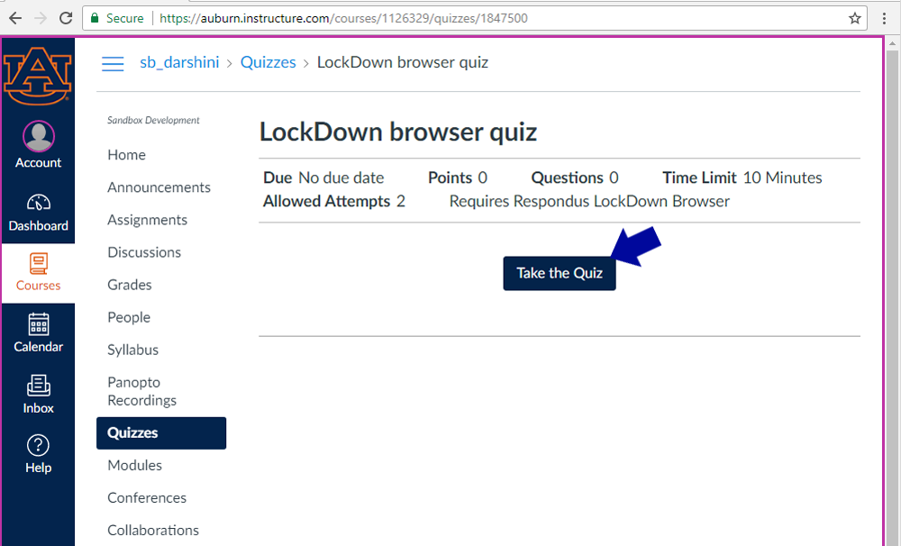

Click the link to the download page. Follow the instructions on the following page for PC or Mac. Once installed, launch the Lockdown Browser, log into Canvas using the Lockdown Browser, and then take the exam.

Note: If you have trouble installing the Lockdown Browser, please contact the [OIT Service Desk](http://www.auburn.edu/oit/servicedesk/) at 844-4944 or [servicedesk@auburn.edu](mailto:servicedesk@auburn.edu). We also recommend informing your instructor of any issues, if they occur.

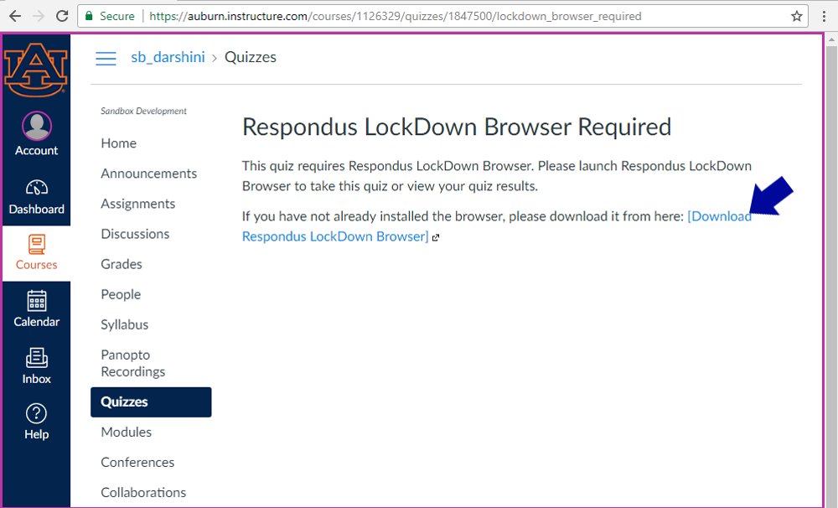

*Last modified: October 1, 2018*

## **Respondus Monitor**

Starting August 1st, Respondus Monitor will switch from an institution-paid to a student-paid model. Monitor functionality will remain the same, but students will need to purchase a yearly license for 15 dollars through Respondus the first time they take a quiz.

[Step-by-step instructions](http://wp.auburn.edu/biggio/wp-content/uploads/2020/07/Monitor-Student-Purchase-Screenshots.pdf) are available for students purchasing Respondus Monitor.

[Live help](https://web.respondus.com/student-help-livechat/) is also available 24/7 through Respondus.

From the FAQ:

**How do students purchase a Respondus Monitor subscription?**

Students make the purchase the first time Respondus Monitor is required by an exam in a course. The process is simple, and payment can be made via credit card, debit card, or Paypal.

**How many exams or courses can you use with a Respondus Monitor subscription?**

A student-purchased subscription of Respondus Monitor is valid for 12 months (365 days) and can be used with any online course or exam requiring it at the institution.

# Help Center for LockDown Browser & Respondus Monitor

**Note to students:** The LockDown Browser download link and application are different for each institution. Contact your institution's help desk to obtain the correct download URL. View more [LockDown Browser Student Help here](https://web.respondus.com/student-help/).

**Help Center** is a feature for LockDown Browser and Respondus Monitor that enables students and help desks to more easily troubleshoot technical issues with a student's computer.

The Help Center button will appear on the toolbar in LockDown Browser once a student has accessed a course in their LMS.

The Respondus Monitor Help Center contains three areas:

* **Pre-exam Webcam Check** – Enables a student to check their webcam functionality, prior to an exam.
* **System & Network Check** – Runs a series of diagnostic checks to make sure the student's computer is functioning properly and meets the minimum requirements. The results of the system check can be emailed to a help desk for further troubleshooting.
* **Knowledge Base** – This student-centric knowledge base provides answers to the top questions or issues that relate to using LockDown Browser and a webcam (ie. Respondus Monitor).