COUN 2000
Living & Communicating in a Diverse Society

Monday, Wednesday, and Friday
10:00 AM – 10:50 AM

- - - - - - - - -

Department of Special Education, Rehabilitation, and Counseling

College of Education

Instructor Information:
Courtney Williams
Instructor
Chw0036@aburn.edu

- - - - - - - - -
Office Hours:

Wednesdays from 11:00am-12:00pm
or by appointment

SYLLABUS

1. Course Number: COUN 2000 (3 semester hours)
Course Title: Living & Communicating in a Diverse Society
University: Auburn University
Prerequisites: None
Instructor: Courtney Williams
Contact Info: chw0036@auburn.edu
Class Meeting: Haley 1435, MWF 10:00-10:50AM

2. Date Syllabus Prepared: August 2022

3. Required Readings and Media Content:

Text:
Johnson, A. (2018). Privilege, Power, and Difference (3rd Ed). McGraw Hill.

Chapters and Articles:

Note: Please keep in mind that readings maybe added throughout the semester

Blumenfeld, W. (2006). Christian Privilege and the Promotion of “Secular” and Not-So “Secular” Mainline Christianity in Public Schooling and in the Larger Society. Equity & Excellence in Education, 39(3), 195–210.

Brzuzy, S. (1997). Deconstructing Disability. Journal of Poverty, 1(1), 81-91.

Crenshaw, K. (2016, October). The Urgency of Intersectionality [Video]. TED. https://www.ted.com/talks/kimberle_crenshaw_the_urgency_of_intersectionality?language=en#t-140471

Dancy, T. E., II, Edwards, K. T., & Earl Davis, J. (2018). Historically White Universities and Plantation Politics: Anti-Blackness and Higher Education in the Black Lives Matter Era. Urban Education, 53(2), 176–195

The New York Times. (2019, May 31). The Stonewall You Know Is a Myth. And That’s O.K [Video]. YouTube. https://www.youtube.com/watch?v=S7jnzOMxb14

Norton, M. I., & Ariely, D. (2011). Building a Better America-One Wealth Quintile at a Time. Perspectives on Psychological Science, 6(1), 9–12.

Sacred Land Film Prokect. (2015, May 26). Indigenous Reflections on Christianity [Video]. YouTube. https://www.youtube.com/watch?v=OoxNyNWFvZw

Starr, B. (2017, July 26). Through the eyes of women: Joan Trumpauer Mulholland shares how “she should for freedom” [Audio Podcast] Retrieved from https://www.khsu.org/post/through-eyes-women-joan-trumpauer-mulholland-shares-how-she-stood-freedom#stream/0

4. Course Description:
This course meets SLO 9. The class focuses on content addressing the cultural context of relationships, issues and trends in a multicultural and diverse society related to such factors as culture, ethnicity, nationality, age, gender, sexual orientation, mental and physical characteristics, education, family values, religious and spiritual values, socioeconomic status and unique characteristics of individuals, couples, families, ethnic groups, and communities. Because successful living in a diverse society requires successful communicating, the course also focuses on communication around difficult topics (often referred to as difficult dialogues).

5. Course Objectives:
The assumption in this course is that all students in the College of Education are working to be competent, committed, and reflective professionals.

Upon course completion students will:
- Knowledge of multicultural and pluralistic trends, including characteristics and concerns between and within diverse groups nationally and internationally
- Attitudes, beliefs, understandings, and acculturative experiences, including specific experiential learning activities
- Individual, couple, family, group, and community strategies for working with diverse populations and ethnic groups
- Cultural self-awareness; understanding citizens’ roles in social justice, advocacy and conflict resolution, the nature of biases, prejudices, processes of intentional and unintentional oppression and discrimination, and other culturally supported behaviors that are detrimental to the growth of the human spirit, mind, or body
- Awareness of advocacy processes needed to address institutional and social barriers that impede access, equity, and success for diversity individuals
- Understanding of value of cultural diversity in a progressive society
- Ability to engage in conversations about race, ethnicity, and culture in ways that are respectful, increase understanding among participants in the conversation, and support intergroup and intragroup cohesion to work toward common solutions

Course Philosophy

As individuals living in a diverse society, there is value in understanding the culture of those around us. This course will expose students to opportunities to learn about other cultures, challenge beliefs they may hold about individuals from other cultures that may impede their ability to work and live in a diverse society, and gain awareness of ways diversity in society is enriches society. The class will blend the tradition of knowledge acquisition with experiential learning and self-exploration/reflection. It is critical in classes such as this that the environment is one of respect and sensitivity and is a safe environment for people to speak and share. As such, I expect that you will approach the content of this course as a student and good citizen who values others people as human beings. This means that you are expected to make a distinction between your ideas/beliefs that reflect your worldview and those that reflect the body of knowledge. Finally, this also means that hateful speech and actions will not be allowed in the class.
Each of us has cultural beliefs and a worldview that shapes how we see the world, what we value, and biases we hold. I ask that you develop an awareness of when your ideas and views reflect your culture and worldview rather than an absolute of what is right or wrong or good or bad. A fundamental part of this class is to identify ways in which the diversity of values and worldviews adds to the society in which we live.

6. Course Content and Schedule:

This course schedule (including assignments, requirements, and mode of instruction delivery) is tentative and may change at the instructor’s discretion. Any changes to the schedule will be announced in class and/or via email and it is the students’ responsibility to be aware of such announced changes.

WEEK |  | TOPIC | READINGS DUE |  | DUE
1 | Aug 17 | Introduction to Course  Engaging COUN 2000  Having Difficult Dialogues  The Basic Concepts / Language & Terminology  Sensoy & DiAngelo, 2017 (Chapter 1)
 | Aug 19 | Reflecting on Resistance  Critical Thinking and Theory  How Am I Reacting  Sensoy & DiAngelo, 2017 (Chapter 2) |  |  | Pretest  DUE: August 19
2 | Aug 22 | We’re in Trouble: Discrimination in the US | Introduction & Chapter 1
 | Aug 24 | We’re in Trouble (continued)  Ep. 011 Good Ancestor Podcast
 | Aug 26 | Discussion: We’re in Trouble |  |  | IAT Tests  DUE: August 26
3 | Aug 29 | Privilege, Oppression, and Difference | Chapter 2
 | Aug 31 | Privilege, Oppression, and Difference
 | Sept 2 | Privilege, Oppression, and Difference
4 | Sept 5 | No Class: Labor Day
 | Sept 7 | Intersectionality | Crenshaw, 2016
 | Sept 9 | Racial Identity Models  Racial Healing Handbook Exercise
5 | Sept 12 | Making Privilege and Oppression Happen | Chapter 4
 | Sept 14 | Racism & Microaggressions  Sue et al., 2007 | Dancy et al., 2018
 | Sept 16 | Racism & Microaggressions  Sue et al., 2007 |  |  | Reflection 1 Identity Models DUE:  September 16
6 | Sept 19 | Lee County Remembrance Project
 | Sept 21 | Lee County Remembrance Project
 | Sept 23 | Oppression: Who’s Problem Is It? | Chapter 5
7 | Sept 26 | Capitalism, Class, and Domination | Chapter 3
 | Sept 28 | Capitalism, Class, and Domination | Norton & Ariely, 2011
 | Sept 30 | Capitalism, Class, and Domination |  |  | Reflection 2  Lee County Remembrance  DUE: Sept 30
8 | Oct 3 | The House we Live in  (PBS “Race-The power of Illusion”)  Oppression: What Does It Have To Do With Me?  How Racism Harms White Americans | Chapter 6
 | Oct 5 | The House we Live in  (PBS “Race-The power of Illusion”)  Oppression: What Does It Have To Do With Me?  How Racism Harms White Americans
 | Oct 7 | No Class: FALL BREAK
9 | Oct 10 | How Privilege Works | Chap 7 |  | Video Project Poverty Podcast & Exercise  DUE: OCT 10
 | Oct 12 | Privilege and Understanding Isms  Sensoy & DiAngelo, 2017 (pg. 65)
 | Oct 14 | Privilege and Understanding Isms  Sensoy & DiAngelo, 2017 (pg. 65)
10 | Oct 17 | Ableism | Brzuzy, 1997
 | Oct 19 | Ableism
 | Oct 21 | Ableism
11 | Oct 24 | Sexism  SteelFisher et al., 2019
 | Oct 26 | Sexism  SteelFisher et al., 2019 |  |  | Group Video Project: Discussion on Ableism  DUE: Oct 26
 | Oct 28 | Heterosexism and Cissexism  Singh, 2015 | NYT, 2019
12 | Oct 31 | Religion and Oppression | Blumenfeld, 2006  Sacred Land Film Project, 2015
 | Nov 2 | Religion and Oppression
 | Nov 4 | Defense Modes: Denial, Minimization, and  Discomfort | Chapter 8 |  | Reflection: Disclosure Documentary  DUE: Nov 4
13 | Nov 7 | Myths & Rebuttals  Sensoy & DiAngelo, 2017 (Chapter 11)
 | Nov 9 | Myths & Rebuttals
 | Nov 11 | What Can We Do? | Chapter 9
14 | Nov 14 | Advocacy and Action
 | Nov 16 | Advocacy and Action |  |  | Video Project: Local History  DUE: Nov 16
 | Nov 18 | Advocacy and Action | Through The Eyes of Women: Joan Trumpauer Mulholland Shares How “She Stood For Freedom”
 | Nov 21-25 | THANKSGIVING BREAK
15 | Nov 28 | Final Review
 | Nov 30 | TBD
 | Dec 2 | Classes End
16 | Dec 7 | FINAL EXAM: Wednesday, Dec 7  8:00 am – 10:30am

7. Course Requirements/Evaluation:

Readings: At the beginning of each week, you should have assigned readings completed prior to attending class. The readings are extremely important as they will introduce you to the discussion for the day. You will be expected to be knowledgeable about the assigned material.

Implicit Association Test (IAT): You will take the following tests and bring your results to the synchronous class meeting (NOTE – you will not be required to share your results with the class if you are not comfortable doing so – but you will need to submit your results to get credit for the assignment):
Go to this link and take the following tests: https://implicit.harvard.edu/implicit/selectatest.html
- Age
- Race
- Gender-Science
- Sexuality

Reflection Assignments (2pgs double-spaced + Reference Page, 12pt Times New Roman Font):
You will have three (3) reflection assignments in this course:
- Racial Identity Models
- Lee County Remembrance Project
- Disclosure Documentary

The reflection assignments should BE CREATIVE and interesting, and should have some sort of theme that connects to who you are as an individual.

- Reflection Assignment for Racial Identity Models (2pgs double-spaced + Reference Page, 12pt font; 5 points)
Write a paper addressing the following prompts after reviewing all the Racial Identity Development Models and viewing the lecture that incorporates Racial Identity.

- 1 pt: Use of the chosen Racial identity development model that best fits you
- 1 pt: Exploration of at least 2 stages you feel most closely align with where you fit from said model. This should include a description of the stages and practical applications from your own life (e.g., descriptive examples that indicate being at said stage)
- 1 pt: Examination of how your identity and experiences have helped your racial identity development growth.
- 1 pt: Examination of how your identity and experiences have hindered your racial identity development growth.
- 1 pt: Based on what you presented above regarding the different oppressions and privilege you experience, how are your opinions, those you have empathy for, biases, prejudices, and life goals influenced by these experiences? Give us 2-3 examples.
- Loss Points (-2): Failure to reach page requirement OR failure to include references will result in a point deduction from the overall paper score.

- Reflection Assignment for Lee County Remembrance Project (2 pgs double-spaced + Reference Page, 12pt font; 10 points)
Write a paper answering the following prompts after viewing the Lee Country Remembrance Project Guest Lecture
- 6 pts: Provide a detailed description of the 3 most important pieces of information you learned from the LCRP lecture (2pts per detailed description). What is “most important” to you will be subjective: for example, these could be points connected to your identity, information that surprised you, connections to our class content, or points that caused an emotional reaction.
- 2 pts: Explore in detail whether the information presented to you was new. What did you learn that you had not been previously aware of before this lecture? What experiences in life led to you not being aware of this history?
- 1 pt: What information did you already know before this lecture? What experiences facilitated you already being aware of this history? If you were not aware of any of this information, discuss what you wish you had known before today.
- 1 pts: Finally, discuss how what you have learned from the LCRP presentation should be incorporated into this class as we continue our learning? For instance, how might you imagine an instructor can use this knowledge to further learning for future students taking this course?
- Loss Points (-3): Failure to reach page requirement OR failure to include references will result in a point deduction from the overall paper score.

- Reflection Assignment for Disclosure Documentary (2pgs double-spaced + Reference Page, 12pt font; 10 points)
Write a paper answering the following prompts after watching the documentary Disclosure
- 4 pts: Provide a detailed description of the 2 most important pieces of information you learned from the Disclosure documentary (2pts per detailed description). What is “most important” to you will be subjective: for example, these could be points connected to your identity, information that surprised you, connections to our class content, or points that caused an emotional reaction.
- 2 pts: Explore in detail whether the information presented to you was new. What did you learn that you had not been previously aware of before this lecture? What experiences in life led to you not being aware of this history? Integrate into this conversation, a description of any defenses or reactions you noticed throughout the presentation (Some questions to get you started: Did you notice a desire to distance yourself from the material? Did you noticed a desire to suppress any emotional reactions? Where did you feel tension?)
- 2 pts: As you answer these questions, consider your personal gender identity and the experiences you’ve had as a result of your gender identity. Discuss the first time you can remember seeing them represented on screen. How difficult was it for you to remember this? What do you think made it easy/hard to remember? How was the character portrayed in your memory? What were your emotional reactions to this portrayal? Be thorough as you consider your identity with these questions.
- 2 pts: Based on what you presented above, consider how your opinions, biases, empathy for, and/or prejudice toward transgender individuals were shaped by the media you were exposed to and other life experiences. Give us 2-3 well-articulated examples.
- Loss Points (-3): Failure to reach page requirement OR failure to include references will result in a point deduction from the overall paper score.

Video Project - Poverty: 3-4 minutes (10 points)
Discuss the following questions on video after listening to the appropriate podcasts and engaging in the appropriate poverty simulation:
- 2 pts: Describe your relationship, understanding of, and experiences with money and/or socioeconomic status. Utilize 1-2 key life experiences (i.e. experiences that helped you grow, molded you, or had a deep impact) to illustrate this relationship.
- 3 pts: Discuss how your identity intersected or influenced the experiences your described above. How does your intersectionality influence how you think and engage economics. (For help here, listed to Robin DiAngelo’s description of how her understanding that she was White distanced her from her understanding of being poor to help frame your own ideas of how your intersectionality may have influenced you).
- 2pts: Discuss the aspects of the podcast and/or simulation that were most eye opening or meaningful to your learning.
- 2pts: Based on what you presented above regarding your intersectionality, how are your opinions, those you have empathy for, biases, prejudices, and/or life goals influenced by your intersectionality and your understanding of poverty in America? Give us 2-3 examples.
- 1 pt: Presentation is creative and interesting

Group Video Project - Ableism: 25-30 minutes (15 points)
Record a group discussion on Zoom after each of you watch the documentary Crip Camp—A Disability Revolution. Your group should hold a thorough and nuanced discussion of the documentary which should include the following:
- 4 pts: Each member should provide a description of the 1 most important pieces of information gained in the documentary. What is “most important” to you will be subjective: for example, these could be points connected to your identity, information that surprised you or caused an emotional reaction.
- 6 pts: Group members will engage in a thorough discussion including posing and answering questions with one another. This discussion should be organic, as if members are talking with one another naturally about the documentary. Points will be awarded based on the a) questions are insightful and reflective of a thorough understanding of the documentary, b) answers from group members are shared across the group, c) question and answers connect to other course content learned across the semester, and d) it is clear from question and answer content that all group members have reflected on their personal identities as they related to the documentary.
- 3 pts: Based on the group discussion, the group will consider together how their opinions, biases, empathy for, and/or prejudice for diverse abilities have been shaped and impact their engagement.
- 2 pts: Presentation is creative and interesting. All are respectful and engaged in challenging conversation throughout the discussion. Recording is 25-30 minutes long.

Video Project – Local History: 8-10 minutes (15 points)
Record a creative multimedia project after researching more about your local history. You can pick a place where you grew up, the place where you spent the most years or had the most attachment to, or Auburn, AL.
- 1 pt: Identify clearly the location of your research. Tell a little about the basic history (e.g. when “founded” officially, by whom, town growth, etc.)
- 3 pt: Locate any indigenous history in your town. Who did the land belong to and when/how was it stolen? Reflect on how this may have shaped your town in the early years.
- 4 pt: Provide detailed descriptions of any other ways in which your town has been shaped by oppressive forces. Include original sources and multimedia when possible (e.g., images, interviews). Be clear and descriptive when discussing what forms of oppression shaped the community you selected to research. This could include anything from laws and local ordinances to statues/symbols of respect for White supremacists to buildings that are inaccessible. Be thorough and creative in what you research and connect this to your understanding of intersectionality.
- 2 pts: Detail any attempts that you can find of community members attempting to make changes toward diversity, inclusion, and justice in your town. What were they trying to change? How did they try to change it? WHO was trying to change it? For example, was there ever a push for changes in laws, civil rights, changed polices? What about local court cases where someone fought for rights for the community?
- 2 pts: In what ways have you benefitted from the oppressive structures in place in your town? In what ways have you been disadvantaged? In what ways have you been complicit throughout your lifetime in maintaining oppressive forces (i.e. in what ways have you been inactive because your town “is the way it is”)?
- 2 pts: What reactions did you notice in your body as you researched your town? What emotions came to the surface? What tensions did you feel? What do you think led to these reactions? Did you find this exercise physically or mentally exhausting in any way? If so, discuss. If not, describe what you think may have kept it from being exhausting.
- 1 pts: Video is 3-6 minutes long. References are included on the video (read or written).

Final Exam
The final exam will be administered using an online format. If you do not have capabilities to access an online exam (smart phone, laptop, tablet, etc.), please contact your instructor immediately after the first class. Exam format will be multiple choice and short-answer response questions, based on the readings, videos, class lectures, and discussions. The best way to do well is to stay actively involved in the course material (i.e., take notes as you read, review lectures, quiz yourself, and so on).

Assignment Grading System

Class Activities
Synchronous Meetings & Class Activities (5) 15 points
IAT Test 5 points

Reflections
Racial Identity Models 5 points
Lee County Remembrance Project 10 points
Disclosure Documentary Discussion 10 points

Video Projects
Poverty Podcast & Exercise 10 points
Group Video Project: Ableism 15 points
Video Project: My Local History 15 points

Assessments
Final Exam 15 points

Total 100 points

Grade Criteria (grades will be rounded to nearest whole number):

A 90 - 100 points
B 80 – 89 points
C 70 – 79 points
D 60 – 69 points
F < 60 points

- Respect for Diversity

It is my intent that students from all diverse backgrounds and perspectives be well-served by this course, that students' learning needs be addressed both in and out of class, and that the diversity that the students bring to this class be viewed as a resource, strength and benefit. Your suggestions are encouraged and appreciated. Please let your instructor know ways to improve the effectiveness of the course for you personally, or for other students or student groups.

I will attempt to foster an environment in which each class member is able to hear and respect each other. It is critical that each class member show respect for all worldviews expressed in class. It is expected that some of the material in this course may evoke strong emotions, please be respectful of others' emotions and be mindful of your own. Please let your instructor know if something said or done in the classroom, by either myself or other students, is particularly troubling or causes discomfort or offense. While our intention may not be to cause discomfort or offense, the impact of what happens throughout the course is not to be ignored and is something that I consider to be very important and deserving of attention. If and when this occurs, there are several ways to alleviate some of the discomfort or hurt you may experience:
- Discuss the situation privately with your instructor. I am always open to listening to students' experiences, and want to work with students to find acceptable ways to process and address the issue.
- Discuss the situation with the class. Chances are there is at least one other student in the class who had a similar response to the material. Discussion enhances the ability for all class participants to have a fuller understanding of context and impact of course material and class discussions.
- Notify your instructor of the issue through another source such as your advisor, a trusted faculty member, or a peer. If you do not feel comfortable discussing the issue directly with your instructor, I encourage you to seek out another, more comfortable avenue to address the issue.

Diversity Statement Adapted from Lynn Hernandez, Behavioral and Social Sciences, School of Public Health, Brown University

9. Class Policy Statements:

Late Assignment Policy: Late assignments are not acceptable. It is expected that you have completed all assignments by 11:59 pm on the day it is due. All assignments will be turned in via Canvas. If you run into technology difficulties on Canvas it is your responsibility to make sure the assignment is still completed and received on time. Contingency plans include an email with the assignment attached or a link to the assignment in a University box folder. Failure to turn an assignment in on time OR failure for the instructor to access the electronic version of an assignment will result in unsatisfactory completion of that course requirement, and in many instances, would mean an inability to pass the class. It is therefore imperative that students complete all course requirements on time. I reserve the right to allow exceptions to this policy, for example, in the event of an emergency.

Late papers/assignments will NOT be graded and be given an automatic zero

Attendance Policy: Attendance is required. Students are expected to attend all class meetings. Active, cooperative, and collaborative learning are strongly emphasized in this class. Thus, open and active participation is expected from students. This means being present and not engaging in side conversations or other tasks. Students with more than two unexcused absence will result in an Unsatisfactory grade in this class. After one unexcused tardy or early departure of 15 minutes or more, each subsequent tardiness or early departure will be considered an unexcused absence from class.

All lectures will be available on Canvas after they are discussed. If you are unable to attend a lecture or turn in an assignment on time due to an excused absence please contact your instructor immediately. Students are granted excused absences for the following reasons: illness of the student or serious illness of a member of the student’s immediate family, death of a member of the student’s immediate family, trips for student organizations sponsored by an academic unit, trips for university classes, trips for participation in intercollegiate athletic events, subpoena for a court appearance, and religious holidays. Students who wish to have excused absences from class for any other reason must contact the instructor in advance of the absence to request permission. The instructor will weigh the merits of the request and render a decision. When feasible, the student must notify the instructor prior to the occurrence of any excused absences, but in no case, shall notification occur more than one week after the absence. Appropriate documentation for all excused absences is required. Please see the Student Policy eHandbook at www.auburn.edu/studentpolicies for more information on excused absences. For an excused absence to not count against the attendance grading requirement, students must make up the missed class period in a manner acceptable to the course instructor within one week of the absence or notification of absence (in cases when notice prior to the absence is not possible—but again, all excused absences must be communicated to the instructor no later than one week of the absence).

Office Hours: I am available during my office hours and by appointment via Zoom. Campus email is the best way to reach your instructor to schedule an appointment. I encourage you to make an appointment with your instructor if you have any questions or concerns about the course or your performance in it. I am happy to meet with you via Zoom at any time throughout the semester.

Email: Outside of class, I will communicate primarily through email. Therefore, all students are expected to regularly check their Auburn email for class updates and announcements. Additionally, if you have any questions regarding class material, feel free to email me using your official Auburn email or stop by my office. If you do not receive a response from me within 24 to 48 hours of sending an email, please be sure to follow-up with me.

Accommodations: Students who need accommodations are asked to electronically submit their approved accommodations through AU Access and to arrange a zoom meeting with your instructor during the first week of classes, or as soon as possible if accommodations are needed immediately. If you have not established accommodations through the Office of Accessibility, but need accommodations, make an appointment with the Office of Accessibility, 1228 Haley Center, 844-2096 (V/TT).

Honesty Code: All portions of the Auburn University student academic honesty code (Title XII) found in the Student Policy eHandbook (http://www.auburn.edu/student_info/student_policies/) will apply to this class. All academic honesty violations or alleged violations of the SGA Code of Laws will be reported to the Office of the Provost, which will then refer the case to the Academic Honesty Committee.

Professionalism: As faculty, staff, and students interact in professional settings, they are expected to demonstrate professional behaviors as defined in the College’s conceptual framework. These professional commitments or dispositions are listed below:

Student Mental Health and Well-Being: If you or someone you know is feeling overwhelmed, depressed, and/or in need of support, services are available. For help, contact Student Counseling and Psychological Services (SCPS) at (334) 844-5123and http://wp.auburn.edu/scs during and after hours, on weekends and holidays, or through its counselors physically located in the Medical Clinical and Haley Center. The East Alabama Mental Health Center has a toll free number that may be called 24 hours a day, 365 days a year for emergencies at 800-815-0630. The clinician on-call will assist you as needed.

Title 1X: Auburn University is committed to providing an environment that is free from discrimination and harassment based on protected class. If you believe you have been the victim of harassment or discrimination based on race, color, religion, national origin, disability, age, or sex (including sexual orientation, gender identity, and gender expression), we encourage you to report it. If you report sexual assault or sexual misconduct to a faculty member, the faculty member is obligated to notify the University’s Title IX Coordinator about the basic facts of the incident. For more information about your Title IX reporting and resource options at Auburn University, please go to: www.auburn.edu/titleix

10. COVID Related Policies:
Zoom Policy:
- You are required to have your camera on during zoom meetings.
- Mute microphone when you are not speaking.
- Your attention is required during zoom meetings. This means that you must minimize distractions and be in a quiet place where you will have minimal disruptions.
- Dress appropriately, as if you were in a face-to-face class.
- Behave appropriately, as if you were in a face-to-face class.
- If you have any issues that arise that pertain to zoom and/or your ability to please email me the first week of class.
- I reserve the right to dismiss someone from a zoom meeting if they do not follow these guidelines.

Due to the Coronavirus pandemic, public health measures have been implemented across Auburn’s campus. Students should stay current with these practices and expectations through the campus reentry plan, ​A Healthier U (Links to an external site.)​. The sections below provide expectations and conduct related to COVID-19 issues.
As of Monday, August 15, 2022, Auburn University does not mandate face coverings inside all Auburn University buildings and university transportation. If policy changes to where masks are mandated, students agree to obey and wear face coverings until the final date of the course.

Health and Participation in Class:
You are expected to complete your Health check screener daily. Your health and safety, and the health and safety of your peers, are my top priorities. If you are experiencing any symptoms of COVID-19, or if you discover that you have been in close contact with others who have symptoms or who have tested positive, you must follow the instructions on the Healthcheck app. My hope is that if you are feeling ill or if you have been exposed to someone with the virus, you will stay home to protect others.
Please do the following in the event of an illness or COVID-related absence:
- Notify me in advance of your absence, if possible
- Provide me with medical documentation, if possible
- Keep up with coursework as much as possible
- Participate in class activities and submit assignments remotely as much as possible
- Notify me if you require a modification to the deadline of an assignment or exam
- Finally, if remaining in a class and fulfilling the necessary requirements becomes impossible due to illness or other COVID-related issues, please let me know as soon as possible so we can discuss your options.
Students with questions about COVID-related illnesses should reach out to the COVID Resource Center at (334) 844-6000 or at ​ahealthieru@auburn.edu​.

11. Textbook Information: All Access
What is All Access?
All Access is Auburn’s program of delivering course materials to you digitally. Sometimes this will be a textbook, sometimes an access code. Your instructor has coordinated with the Bookstore to deliver this content for the course and help make sure you have what you need. All Access makes sure you are ready the first day of class, and the material is so much cheaper with this delivery that it’s the best way we can help you succeed in your courses at Auburn....financially and academically.

What content am I getting?
For this course, COUN 2000/2007, you’re getting access for the semester to Privilege, Power, and Difference by Johnson. This comes with Connect access, and is required content for the course.

How do I find it?
Your instructor will let you know where to find access to the material in class.

What does it cost?
For the first two weeks of class, everyone gets this content for free. All students in this course start as opted in to pay for the content for the course. The discounted price you’ll be billed is $70.95. The print price used to be $107.95, so you’re saving about $35.
If you want to opt out and not be charged, all you have to do is follow the instructions (see https://www.aubookstore.com/t-txt_allaccessoptout1.aspx ). You’ll lose access at the end of the two weeks unless you’ve purchased it on your own.
· If you’re still opted in on September 6, then we’ll send the charge to your next ebill. This will be labeled as the course on your ebill so you’ll know. You’ll get a reminder on September 3 to remind you about the deadline.

What if I’m on scholarship?
We can charge All Access content to any scholarship that we charge at the Bookstore. Those will be done automatically when we bill. If you are a scholarship student and would prefer print, please come by the textbook customer service window and we can order print copies for you. These are done as requested, and take three to five business days to arrive. Most scholarships will not pay for All Access and a print copy of the book.

What is the refund policy?
After the opt out deadline, we can only offer refunds to students who have dropped the course or withdrawn from the university. That’s why the opt out deadline will be crucial for you to decide if you want to be charged or not.

An extra perk...you can get a print copy, too.
If you remain opted into All Access, the publisher has made a low-cost print version available for $24.95. Request a copy at the textbook customer service window or email a request to MNH0016@auburn.edu with your course information included. These are usually available for purchase the third week of class.

What if I need help?
·McGraw-Hill customer service is always an option at 800-338-3987.
· For most digital content in All Access, Google Chrome works best as a browser and you’ll want to make sure it’s up to date.
·I’m always happy to help as well, especially if you have a question about All Access or something doesn’t look right. Russell Weldon books@auburn.edu or 844-1352
·You can also come see us at the Bookstore for in-person help.
·Also, http://aub.ie/allaccess has more info as well.

IMPORTANT: If you do decide to OPT IN or OUT of AU Access, use the following directions to do so. Please reach out with any questions.

To opt in or out of an All Access class:
1.Log into AU Access, and then Select Student Menu:
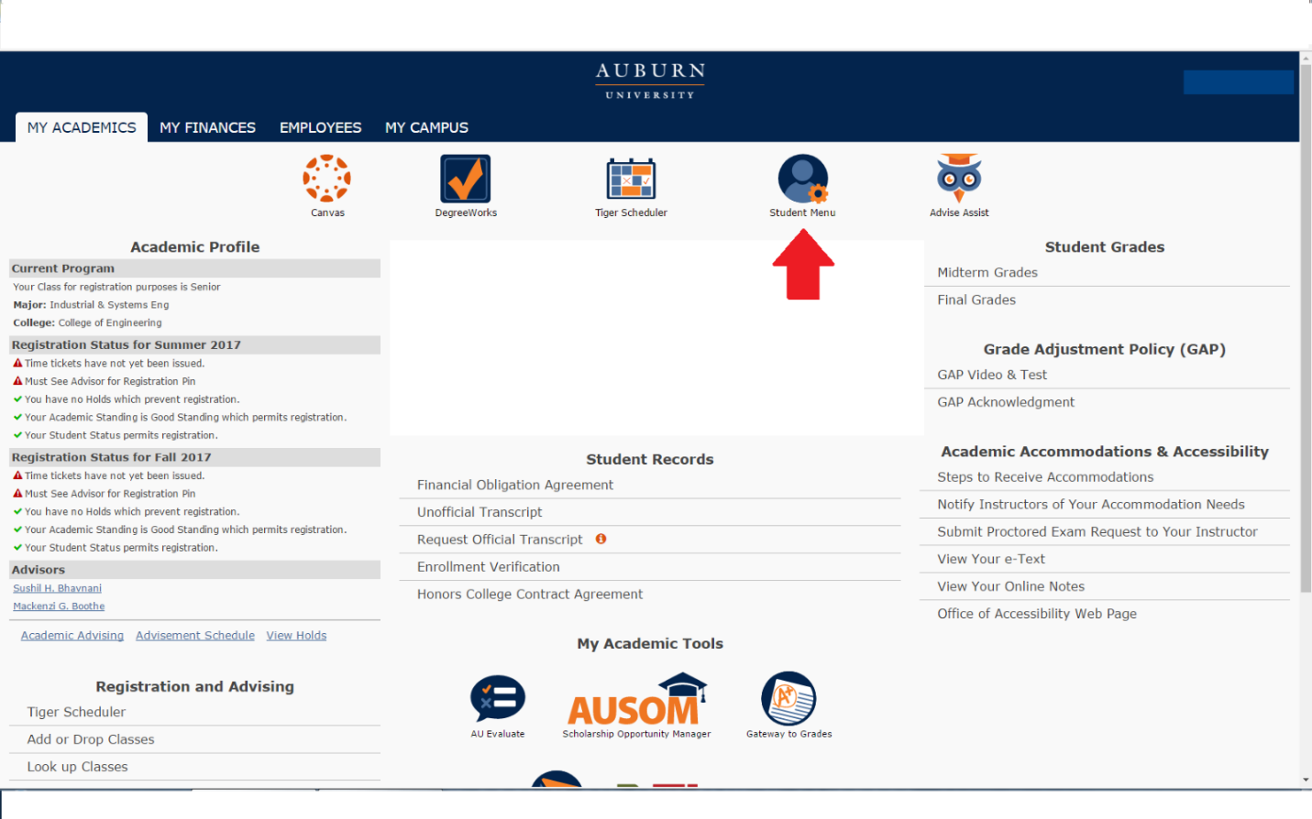
2. Near the bottom, students will see an All Access tab. Select it to view classes.



3. Once in here, they will select their the current term:
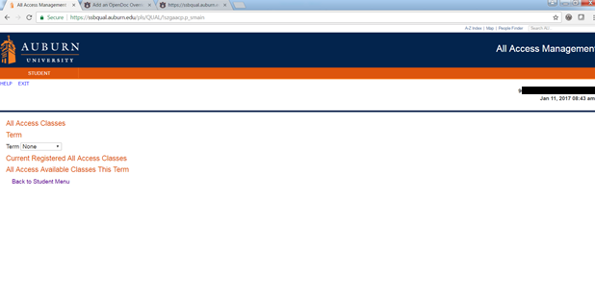
4. Once the current term is selected, All Access courses will populate with options to change out to the right.

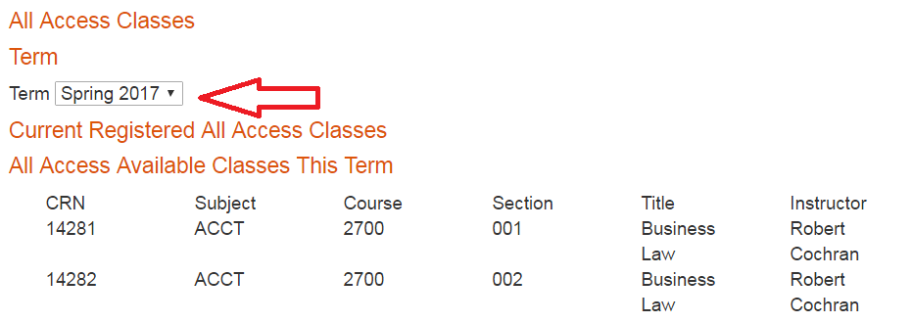

5. Students can click the change button to opt in or out of the All Access material. NOTE: This does not change your registration in the class, just your purchase option for the course materials.
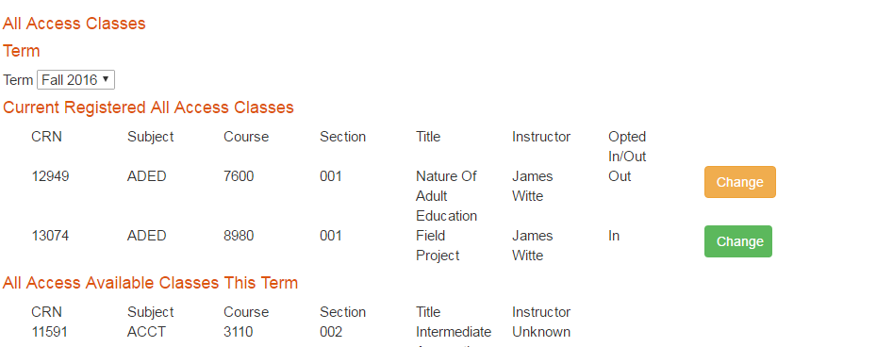

6. You will be prompted to provide a reason for opting out of the class.

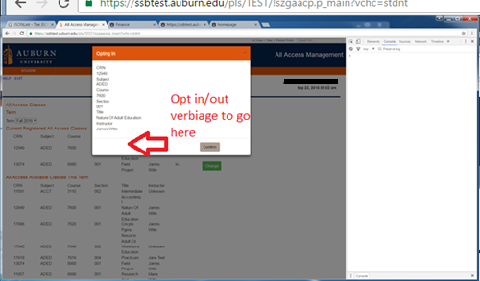

7. If completed correctly, there will be a green ‘Success’ near the middle of the page.
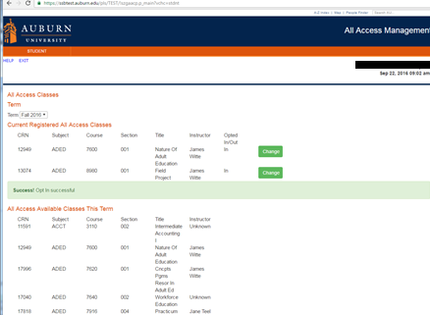

You may opt in or out at any time before the fifteenth-class day. After that day, charges are sent to the Bursar to be applied to your e-bill. We may not be able to reverse the charge after that date.

We are able to apply All Access charges for course materials to scholarships that are normally handled through our scholarship counter in store. We will also apply charges for student athletes to the Athletic Department if a student’s scholarship covers course materials.

